# Name:Akshat Yadav

# Batch: C3

**Roll No: 16010122221**

# Tutorial No. 6: Sampling Using R Date: 15/03/2024

**Q1.** A random sample of 200 observations has mean 6.5 cm. Can it be a random sample from a population whose mean is 7 cm and variance is 8.5 cm?

CODE

pm=7 # population mean

sm=6.5 # sample mean

sd=2.91 # standard deviation of sample or population

n= 200 # size of sample

zcal= abs((sm-pm)/(sd/sqrt(n)))

cat("absolute value of z-calculated is ",zcal)

cat("name & rollno,Q.no.","Akshat Yadav & 16010122221")

OUTPUT

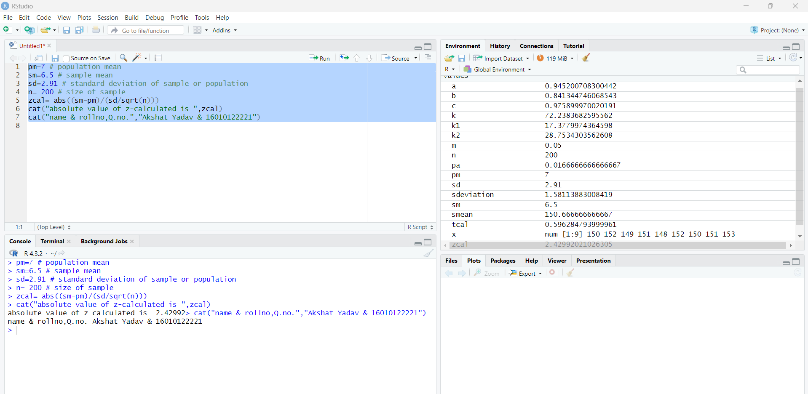

ANSWERS

1. H0: 𝜇= 7

2. H1: 𝜇 ≠ 7 (Nature of the test is two-tailed)

3. LOS is 5%

4. Table value of 𝑍𝛼 is 1.96

5. Calculated value of Z: 𝑍𝑐𝑎𝑙 = 2.42992

6. 𝑍𝑐𝑎𝑙 > 𝑍𝛼 ∴ H0 is rejected

7. NO, it cannot be said that the random sample cannot be chosen from a population whose mean is 7 cm and variance is 8.5 cm.

* 1. An examination of the weight of 9 apples provided the following data : 150, 152, 149, 151, 148, 152, 150, 151 and 153 grams. Investigate whether the weight of the apples can be assumed to be 151 grams.

CODE

pm=151 # population mean

x <- c(150, 152, 149, 151, 148,152, 150, 151, 153)

smean=mean(x) # sample mean

sdeviation=sd (x) # sample sd

n= 9 # size of sample

tcal= abs((smean-pm)/(sdeviation/sqrt(n-1)))

cat("absolute value of t-calculated is ",tcal)

cat("name & rollno","Akshat yadav & 16010122221")

OUTPUT

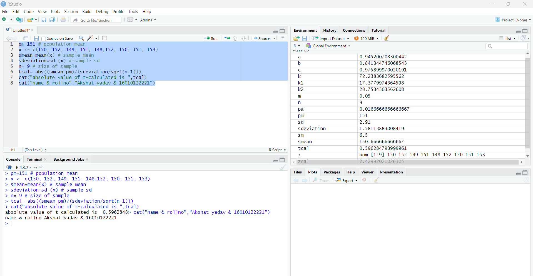

ANSWERS

1. H0: 𝜇 = 151

2. H1: 𝜇 ≠ 151 (Nature of the test is two-tailed) 3. LOS is 5%, d.o.f. = n – 1 = 8

1. Table value of 𝑡𝛼 is 2.306
2. Calculated value of t: 𝑡𝑐𝑎𝑙 = 0.59628.

6. 𝑡𝑐𝑎𝑙 < 𝑡𝛼 ∴ 𝐻0 is accepted

7. We can say that the weight of the apples can be assumed to be 151 grams.

* 1. Twenty students participated in a mathematics competition. They were provided with additional tutoring sessions for a month before participating in another similar competition. The scores of each student in both competitions were recorded. Test if the scores provided below indicate that the tutoring sessions had a positive impact on the students' performance. Scores in Competition 1: 85, 78, 72, 90, 93, 65, 79, 81, 70, 75, 87, 69, 82, 74, 86, 88, 91, 73, 77, 84 Scores in Competition 2: 88, 80, 75, 91, 95, 68, 82, 84, 73, 79, 89, 71, 85, 77, 90, 92, 94, 76, 78, 83

CODE

x1 <- c(85,78,72,90,93,65,79,81,70,75,87,69,82,74,86,88,91,73,77,84)

x2 <- c(88,80,75,91,95,68,82,84,73,79,89,71,85,77,90,92,94,76,78,83)

x=x2-x1

sm= mean (x) # mean of sample difference

sd=sd(x) # standard deviation of sample difference

n= 20 # size of sample

tcal= abs(sm/(sd/sqrt(n-1)))

cat("absolute value of t-calculated is ",tcal)

cat("name & rollno","Akshat yadav & 16010122221") OUTPUT

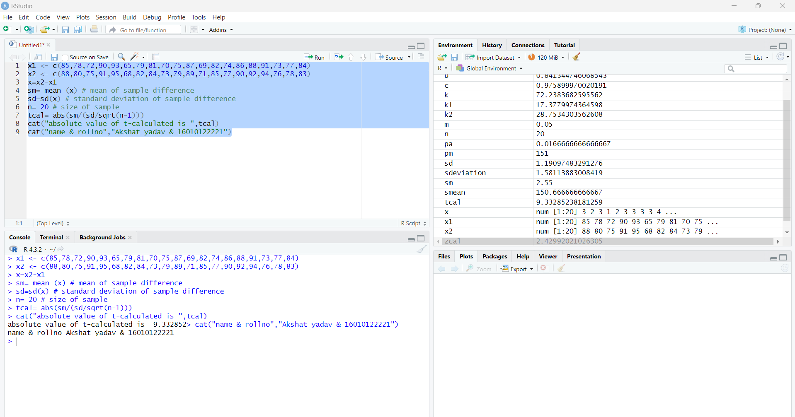

ANSWERS 1. H0: 𝜇 = 0

2. H1 𝜇 > 0 (Nature of the test is one-tailed) 3. LOS is 10%, d.o.f. = n – 1 = 19

1. Table value of 𝑡𝛼 is 1.729
2. Calculated value of t: 𝑡𝑐𝑎𝑙 = 9.33285

6. 𝑡𝑐𝑎𝑙 > 𝑡𝛼 ∴ H0 is rejected

7. We can say that additional tutoring sessions for a month had a positive impact on the students’ performance