Roll No:16010122221 Batch-C1

Experiment No.1

**Title:** Problem Definition and Design of Extended-Entity-Relationship diagram

**Objective:** To define a Database Problem and Design an EER diagram for a business domain.

# Expected Outcome of Experiment:

**CO 1:** Design entity-relationship diagrams to represent different database application scenarios.

# Books/ Journals/ Websites referred:

1. G. K. Gupta :”Database Management Systems”, McGraw – Hill
2. Korth, Slberchatz, Sudarshan : “Database Systems Concept”, 6th Edition , McGraw Hill
3. Elmasri and Navathe, “Fundamentals *of Database Systems*”, 5thEdition, PEARSON Education.

**Dia Software: A software to Design ER Model**

Dia is one of the convenient open source tool which runs on multiple platforms including Linux, Windows and MacOS. Dia has a number of "sheets" each of which includes diagram objects for different modeling tools, such as UML, ER diagrams, flowcharts, etc.

The ER tool has objects for entities, relationships, attributes (using the oval notation), edges, and so on. The properties boxes for each of these elements allow you to specify cardinality constraints, total participation, identifying relationship, etc.

It supports many common formats to store diagrams such as jpeg, png, eps, etc.

**Pre Lab/ Prior Concepts:**

The ER data model was developed to facilitate the database design by allowing specification of an enterprise schema that represents the overall logical structure of the database. The ER model is one of the several data models. The semantic aspect of the model lies in its representation of the meaning of the data. The ER model is very useful many database design tools drawn on concepts from the ER model. The ER model employs 3 basic notations: entity set, relationship set and attributes.

**Symbols Used in ER Notation**

|  |  |  |
| --- | --- | --- |
| **Sr. No.** | **Diagram** | **Explanation** |
|  | Entity | **Entity set:** An entity is a set of entities of the same type that share the properties or attributes. |
|  | Entity | **Weak entity set:** An entity set may not have sufficient attributes to form a primary key. Such an entity set is termed as weak entity set |
|  | R | **Relationship Set:** A relationship is an association among several entities. A relationship set is a set of relationship of the same type. |
|  | R | **Identifying relationship set for weak entity set:** The relationship associating the weak entity set with the |
|  | A | **Primary key:** The primary key is used to denote a candidate key that is chosen by the database designers as the principal means of identifying entities within an entity set. |
|  | N  1  R | **Many to Many Relationship** |
|  | 1  1  R | **One to One relationship** |
|  | A | **Attribute** |
|  | A | **Multi valued** |

**Extended Entity Relationship Diagram:**

The EER model includes all of the concepts introduced by the ER model. Additionally it includes the concepts of a [subclass](https://en.wikipedia.org/wiki/Subclass_(computer_science)" \o "Subclass (computer science)) and [superclass](https://en.wikipedia.org/wiki/Superclass_(computer_science)" \o "Superclass (computer science)) ([Is-a](https://en.wikipedia.org/wiki/Is-a" \o "Is-a)), along with the concepts of [specialization](https://en.wikipedia.org/wiki/Inheritance_(computer_science)" \l "Specialization" \o "Inheritance (computer science)) and [generalization](https://en.wikipedia.org/wiki/Generalization" \o "Generalization). Furthermore, it introduces the concept of a [union](https://en.wikipedia.org/wiki/Union_(computer_science)" \o "Union (computer science)) type or category, which is used to represent a collection of objects that is the union of objects of different [entity](https://en.wikipedia.org/wiki/Entity" \o "Entity) types. EER model also includes EER diagrams that are conceptual models that accurately represent the requirements of complex databases.

**Example Case Study**: List the data requirements for the database of the company which keeps track of the company employee, department and projects. The database designers provide the following description

* 1. The company is organized into departments. Each department has unique name, unique number, and particular employee to manage the department. We keep track of the start date and the employee begins managing the department. The department has several locations.
  2. The department controls a number of projects each of which has a unique name, unique number and a single location.
  3. We store each employee names social security number, address, salary, sex and dob. An employee is assigned one department but may work on several projects which are not necessarily controlled by the same department. We keep track of the department of each employee works on each project and for insurance purpose. We keep each dependents first name, gender, date of birth and relation.

# Procedure for doing the ER diagram experiment

1. Identifying the Entities (Strong and weak entities)
2. Identify attributes of the Entity (keys, partial key, simple, composite, multivalued, derived)
3. Identify relationship(recursive)
4. Identify the structural constraints of the relationship (cardinality ratio, participation constraints**)**

# Sample ER- Diagram for company Case Study Database:

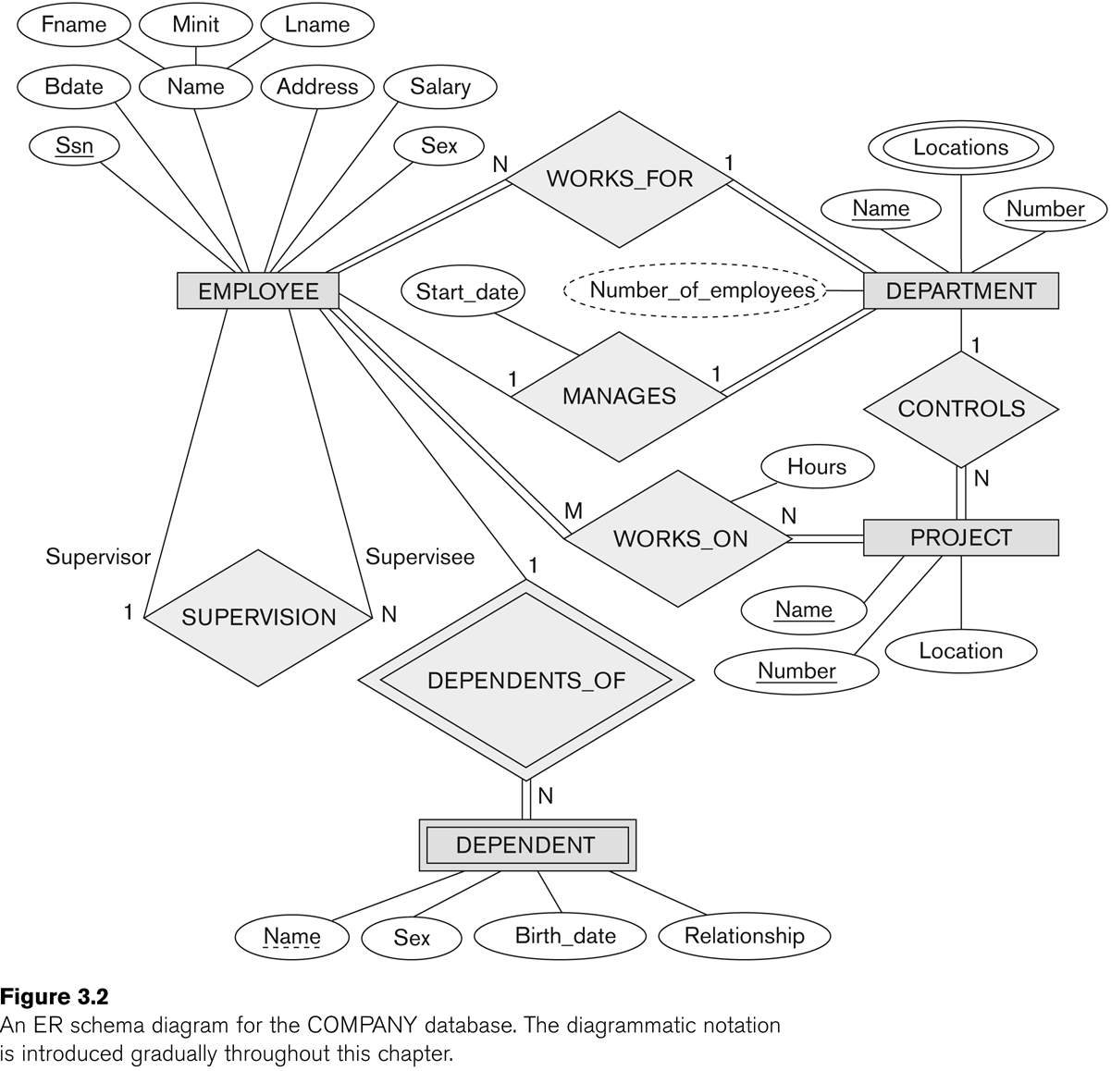

E R Diagram of Company Database

**Problem Definition:**

To Design and implement a SQL-based database for a blog site that allows multiple users to create and manage their own blogs, while also providing functionality for users to view, search, and comment on other blogs. The database should store information on entities consisting of users, blogs and comments. The database will support CRUD operations for each entity, along with the support for querying of blogs by title or content, and all blogs and comments associated with a specific user and all comments associated with a specific blog .The attributes for users would be it’s ID, username, email, hashed password. The Attributes for blogs would be it’s ID, user ID, title, content, comments id. And lastly for comments would be it’s ID, User ID, Blog ID and the content itself.

**Design of EER:**

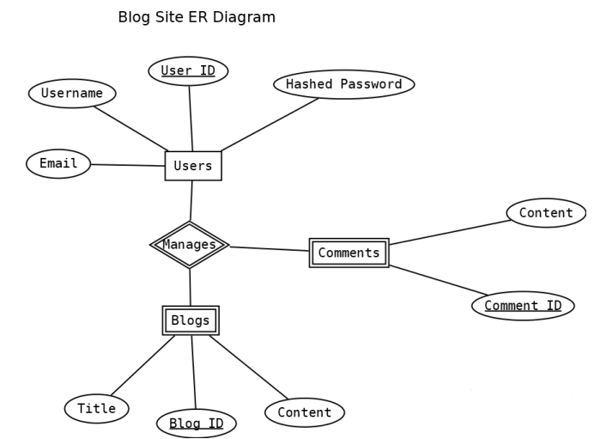

# Post Lab Descriptive Questions: `

1. In the Academic database a Grade is issued to each STUDENT for each COURSE taken and stored in the STUDENT COURSE DETAIL entity. A STUDENT may decide to re-take a COURSE to better their GRADE. The administration would like to keep a record of the old/previous Grade as well as the new Grade. Show ER diagram to include historical Grades if the students should have them.

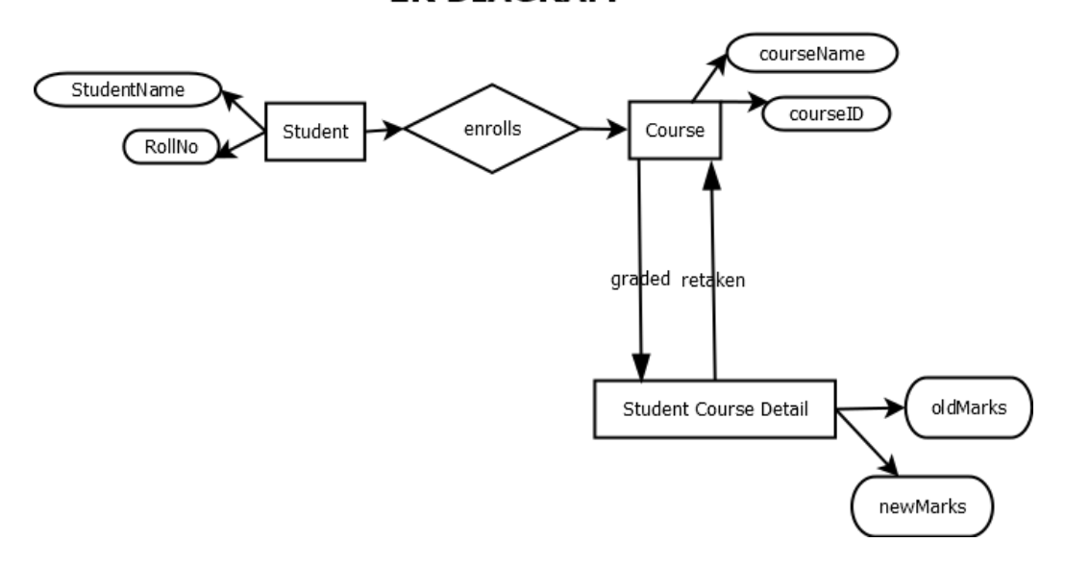

1. Discuss the concept of aggregation. Give an example. How to represent aggregation in ER model (if aggregation is not supported in EER diagram) .

Aggregation represents relationship between a whole object and its component. Using aggregation we can express relationship among relationships. It is a process when relation between two entities is treated as a single entity.

In this example, employee works on a job in a particular branch and is represented via

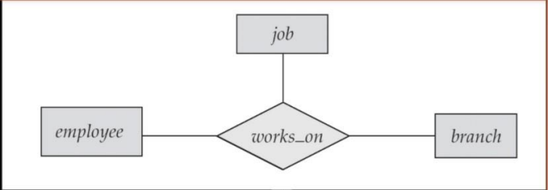

1. Two separate banks which decide to merge. Both banks use same ER database schema(Assume the ER diagram). If the merged bank is to have a single database, there are several potential problems:

* The possibility that two original banks have branches with the same name
* The possibility that some customers are customers of both original banks
* The possibility that some loan or account numbers were used at both original banks

Discuss for each of these potential problems , why there is indeed potential difficulty in database based on ER model. Propose a solution to a problem. For your solution, explain any changes that would have to be made and describe what their effect would be on the ER database schema and the data.

-- In a scenario where two banks with the same ER database schema merge, there are potential difficulties with branches with the same name, customers who are customers of both original banks, and loans or account numbers used at both original banks. To resolve these difficulties, unique identifiers can be assigned to each branch, customer, loan, and account before the merge. This would ensure that there is no overlap in names, customers, loans, or account numbers in the merged database.

To implement these solutions, additional attributes, such as "Branch ID", "Customer ID", "Loan ID", or "Account ID" would need to be added to the respective entities in the ER database schema, ensuring that each entity has a unique identifier for easy differentiation.