

| **TITLE:** **Design the static web pages with the help of HTML5** |
| --- |

**AIM:** To create static Web Pages using HTML5.

**______________________________________________________________________**

**Expected Outcome of Experiment:** Design static web pages using various HTML tags.

**________________________________________________________________**

**Books/ Journals/ Websites referred:**

**_____________________________________________________________________**

**Problem Statement:**

Develop an online book store website facilitating user registration, book browsing, cart management, and secure checkout. Users can browse books by title, author, or genre, add items to their cart, and securely complete purchases with shipping and payment details. User profiles enable managing personal information and viewing order history. Additionally, users can leave reviews and ratings for books. Administrators have access to a dashboard for managing books, orders, and user accounts. The website ensures security of user data and transactions while remaining scalable to accommodate potential growth. Overall, it aims to provide a seamless and secure platform for purchasing and exploring books online.

**HTML tags Used :**

1. `<!DOCTYPE html>`: Defines the document type and version of HTML being used.

2. `<html lang="en">`: Defines the root element of the HTML document, indicating that the document is written in English (`lang="en"`).

3. `<head>`: Contains meta-information about the HTML document, such as the title, character set, stylesheets, and scripts.

4. `<title>`: Sets the title of the HTML document, which appears in the browser's title bar or tab.

5. `<meta>`: Provides metadata about the HTML document, such as the viewport settings for responsive design.

6. `<style>`: Defines internal CSS styles for styling the HTML elements.

7. `<body>`: Contains the content of the HTML document that is displayed in the browser.

8. `<header>`: Represents a header section, typically containing introductory content or navigation links.

9. `<nav>`: Defines a navigation section containing navigation links or menus.

10. `<ul>`: Represents an unordered list of items.

11. `<li>`: Represents a list item within an ordered or unordered list.

12. `<a>`: Defines a hyperlink that links to another webpage or resource.

13. `<footer>`: Represents a footer section typically containing copyright information or other supplementary content.

Additionally, the `<img>` tag is used to embed an image within the HTML document.

**Description of the application implemented with output.**

**Code:**

**<!DOCTYPE html>**

**<html lang="en">**

**<head>**

**<title>Online Book Store</title>**

**<meta name="viewport" content="width=device-width, initial-scale=1.0">**

**<style>**

**body {**

**margin: 0;**

**padding: 0;**

**font-family: 'Arial', sans-serif;**

**height: 90vh;**

**width: 100%;**

**background: linear-gradient(to bottom, #2395a6 10%, #64b6df 50%);**

**}**

**header {**

**height: 100px;**

**background: linear-gradient(to bottom, #206fa3 10%, #80c9ee 50%);**

**color: white;**

**text-align: center;**

**line-height: 100px;**

**}**

**nav {**

**width: 20%;**

**float: left;**

**height: 100vh;**

**background: linear-gradient(to bottom, #2395a6 10%, #64b6df 50%);**

**padding: 20px;**

**}**

**#content {**

**width: 60%;**

**text-align: center;**

**padding: 20px;**

**display: flex;**

**flex-direction: column;**

**align-items: center;**

**justify-content: center;**

**}**

**#content h2 {**

**color: #ffffff;**

**}**

**nav ul {**

**list-style: none;**

**padding: 0;**

**}**

**nav li {**

**margin-bottom: 10px;**

**}**

**nav a {**

**text-decoration: none;**

**color: #ffffff;**

**transition: color 0.5s;**

**}**

**nav a:hover {**

**color: #1e90ff;**

**}**

**footer {**

**clear: both;**

**background: linear-gradient(to bottom, #206fa3 10%, #80c9ee 50%);**

**color: white;**

**text-align: center;**

**padding: 10px;**

**}**

**</style>**

**</head>**

**<body>**

**<header>**

**<h1>Online Book Store</h1>**

**</header>**

**<nav>**

**<h2>Categories</h2>**

**<ul>**

**<li><a href="#">Fiction</a></li>**

**<li><a href="#">Non-Fiction</a></li>**

**<li><a href="#">Sci-Fi</a></li>**

**<li><a href="#">Mystery</a></li>**

**</ul>**

**</nav>**

**<div id="content">**

**<h2>Welcome to our Online Book Store!</h2>**

**<p>Explore the wide range of books and find your next great read.</p>**

**</div>**

**<img src="6383034.jpg" alt="book cover">**

**<footer>**

**<p>&copy; 2024 Online Book Store. All rights reserved.</p>**

**</footer>**

**</body>**

**</html>**

**Output:**

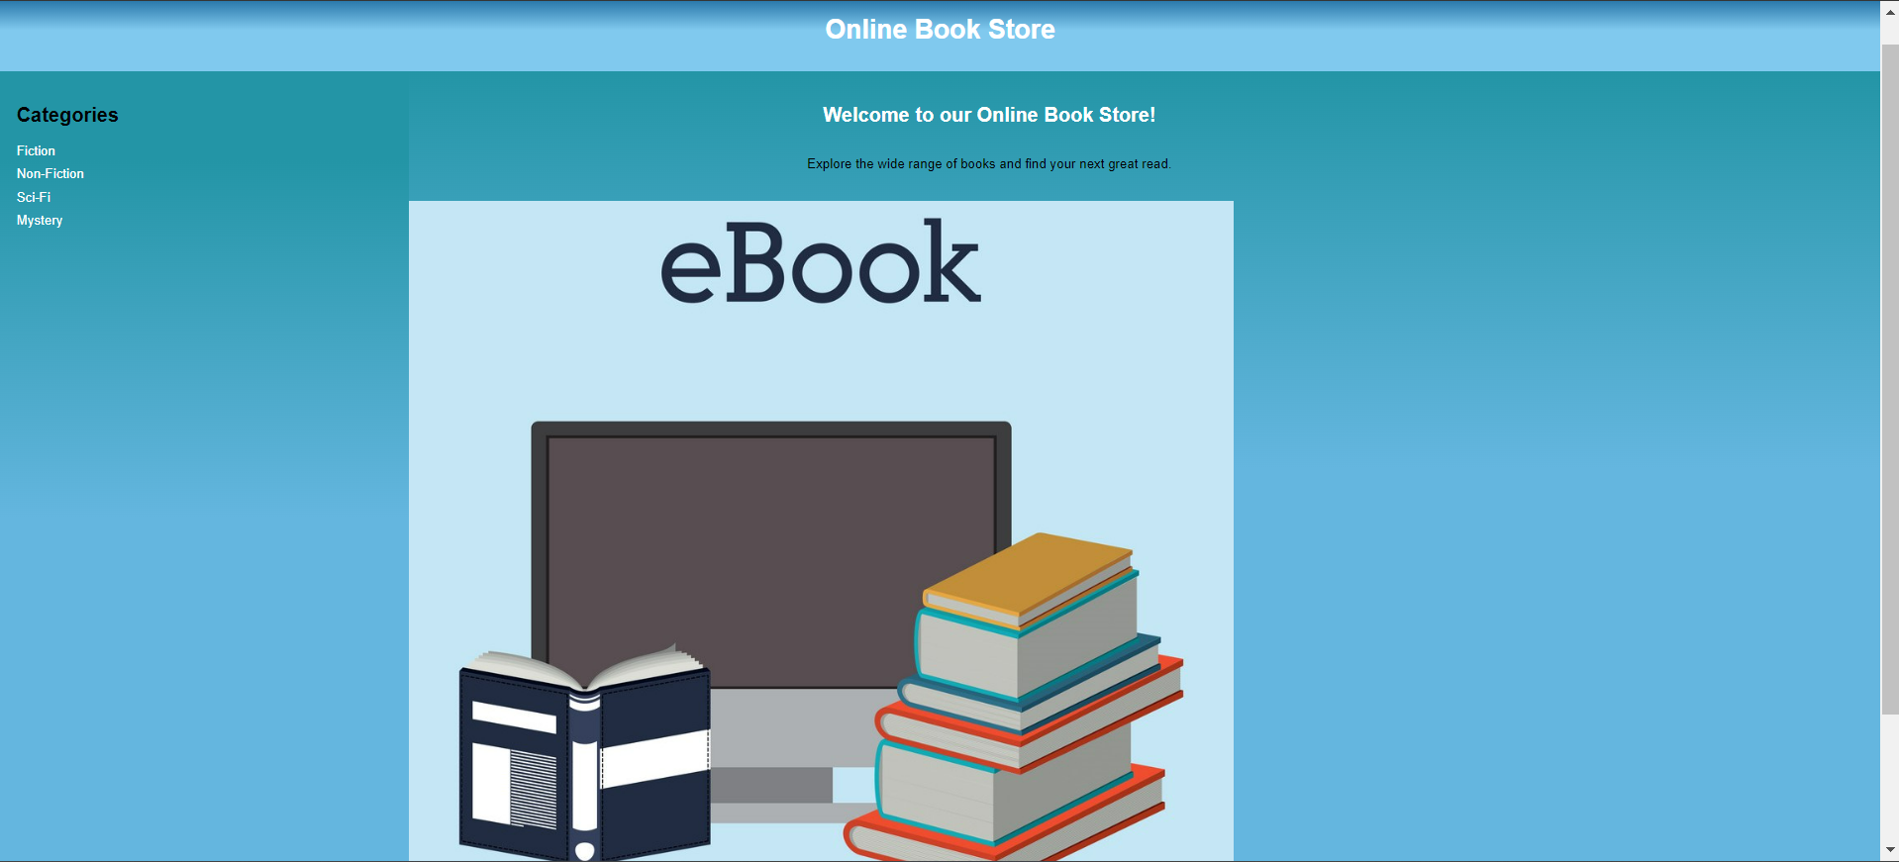

# 1. Header Section:

# - The header contains the title of the online book store, "Online Book Store", which serves as the main branding element of the website.

# 2.Navigation Section:

# - The navigation section (`<nav>`) presents a list of categories for books, including "Fiction", "Non-Fiction", "Sci-Fi", and "Mystery". These links are currently placeholders and would typically lead to pages or sections dedicated to books in those categories.

# 3. Content Section:

# - The content section (`<div id="content">`) provides a welcoming message inviting users to explore the online book store and discover a wide range of books. It serves as a central area for displaying introductory content or promotions.

# 4. Image Section:

# - An image (`<img>`) is included below the content section, presumably displaying a book cover. In the provided code, the `src` attribute is set to "6383034.jpg", indicating that it references an image file named "6383034.jpg". However, without the actual image file, we can't see what image is being displayed.

# 5.Footer Section:

# - The footer section (`<footer>`) contains copyright information, stating "© 2024 Online Book Store. All rights reserved.". This provides legal information about the ownership of the website content.

# The HTML code sets up a basic structure for an online book store website, including navigation links, welcoming content, and copyright information. However, it lacks dynamic functionality, such as interactivity and real-time data retrieval, which would typically be implemented using JavaScript and backend technologies.

**Post Lab Objective with Ans (Min 5):**

**Students need to mention and explain with syntax the tags used for problem statement they have selected.**

1. `<head>`:

- Explanation: Contains meta-information about the HTML document, such as the title, character set, stylesheets, and scripts.

- Syntax: `<head>`

2. `<title>`:

- Explanation: Sets the title of the HTML document, which appears in the browser's title bar or tab.

- Syntax: `<title>Online Book Store</title>`

3. `<style>`:

- Explanation: Defines internal CSS styles for styling the HTML elements.

- Syntax: `<style> /* CSS styles */ </style>`

4. `<body>`:

- Explanation: Contains the content of the HTML document that is displayed in the browser.

- Syntax: `<body>`

5. `<header>`:

- Explanation: Represents a header section, typically containing introductory content or navigation links.

- Syntax: `<header>`

6. `<nav>`:

- Explanation: Defines a navigation section containing navigation links or menus.

- Syntax: `<nav>`

7. `<ul>`:

- Explanation: Represents an unordered list of items.

- Syntax: `<ul>`

8. `<li>`:

- Explanation: Represents a list item within an ordered or unordered list.

- Syntax: `<li>`

9. `<a>`:

- Explanation: Defines a hyperlink that links to another webpage or resource.

- Syntax: `<a href="#">Link Text</a>`

10. `<footer>`:

- Explanation: Represents a footer section typically containing copyright information or other supplementary content.

- Syntax: `<footer>`

**Date: Signature of faculty in-charge**