**Batch: C1 Roll No.: 16010122221**

**Experiment No. 03**

|  |
| --- |
| **TITLE:** **Demonstrate the use of Bootstrap** |

AIM: To use bootstrap (open source front-end development framework) for the creation of web pages.

**______________________________________________________________________**

**Expected Outcome of Experiment:** Re_design of web pages using various HTML, CSS tags with bootstrap.

**_______________________________________________________________**

**Books/ Journals/ Websites referred:**

http://getbootstrap.com/getting-started

**_____________________________________________________________________**

**Problem Statement:**

1. **Students have to re-design web-pages developed in Experiment 1 and 2 by using bootstrap.**
2. **Create a web page using bootstrap with following features,**

i) use a container to set the content's margins dealing with the responsive behaviors of layout.

ii) shape the image into a circle

iii) use bootstrap grid system

iv) create basic pagination

v) insert search icon(glyphicon)

**Description of the application implemented with output**:

<!DOCTYPE html>

<html lang="en">

<head>

  <meta charset="UTF-8">

  <meta name="viewport" content="width=device-width, initial-scale=1.0">

  <title>Practice Website</title>

  <link rel="stylesheet" href="https://stackpath.bootstrapcdn.com/bootstrap/4.5.2/css/bootstrap.min.css">

  <link rel="stylesheet" href="styleexp2.css">

  <link rel="stylesheet" href="https://cdnjs.cloudflare.com/ajax/libs/font-awesome/5.15.4/css/all.min.css">

</head>

<body>

  <div class="container">

    <header class="header">

      <nav class="navbar">

        <h2 class="logo"><a href="#">akkkshat</a></h2>

        <input type="checkbox" id="menu-toggle" />

        <ul class="links">

          <li><a href="#">Home</a></li>

          <li><a href="#">About Me</a></li>

          <li><a href="#">Services</a></li>

          <li><a href="#">Portfolio</a></li>

          <li><a href="#">Contact Me</a></li>

        </ul>

        <div class="buttons">

          <a href="#" class="signin">Sign In</a>

          <a href="#" class="signup">Sign Up</a>

        </div>

      </nav>

    </header>

    <section class="sect">

      <div class="row">

        <div class="col-md-6">

          <div class="hero">

            <h2>Web Development</h2>

            <p>Web Developer</p>

            <div class="buttons">

              <a href="#" class="Tap Tap">Tap Tap</a>

              <a href="#" class="learn">Learn More</a>

            </div>

          </div>

        </div>

        <div class="col-md-6">

          <div class="img">

            <img src="https://media.giphy.com/media/v1.Y2lkPTc5MGI3NjExcmRqY2d1ZzB2bGRmcGlqeHhwZzVkaWg4eDMzMmczbjN0Z3pjYnZrZyZlcD12MV9pbnRlcm5hbF9naWZfYnlfaWQmY3Q9Zw/qgQUggAC3Pfv687qPC/giphy.gif" alt="main image" class="rounded-circle">

          </div>

        </div>

      </div>

    </section>

    <nav aria-label="Page navigation">

      <ul class="pagination">

        <li class="page-item"><a class="page-link" href="#">Previous</a></li>

        <li class="page-item"><a class="page-link" href="#">1</a></li>

        <li class="page-item"><a class="page-link" href="#">2</a></li>

        <li class="page-item"><a class="page-link" href="#">3</a></li>

        <li class="page-item"><a class="page-link" href="#">Next</a></li>

      </ul>

    </nav>

    <div class="input-group mb-3">

      <input type="text" class="form-control" placeholder="Search" aria-label="Search" aria-describedby="basic-addon2">

      <div class="input-group-append">

        <span class="input-group-text" id="basic-addon2"><i class="fas fa-search"></i></span>

      </div>

    </div>

  </div>

  <script src="https://code.jquery.com/jquery-3.5.1.slim.min.js"></script>

  <script src="https://cdn.jsdelivr.net/npm/popper.js@1.16.0/dist/umd/popper.min.js"></script>

  <script src="https://stackpath.bootstrapcdn.com/bootstrap/4.5.2/js/bootstrap.min.js"></script>

</body>

</html>

# 1.

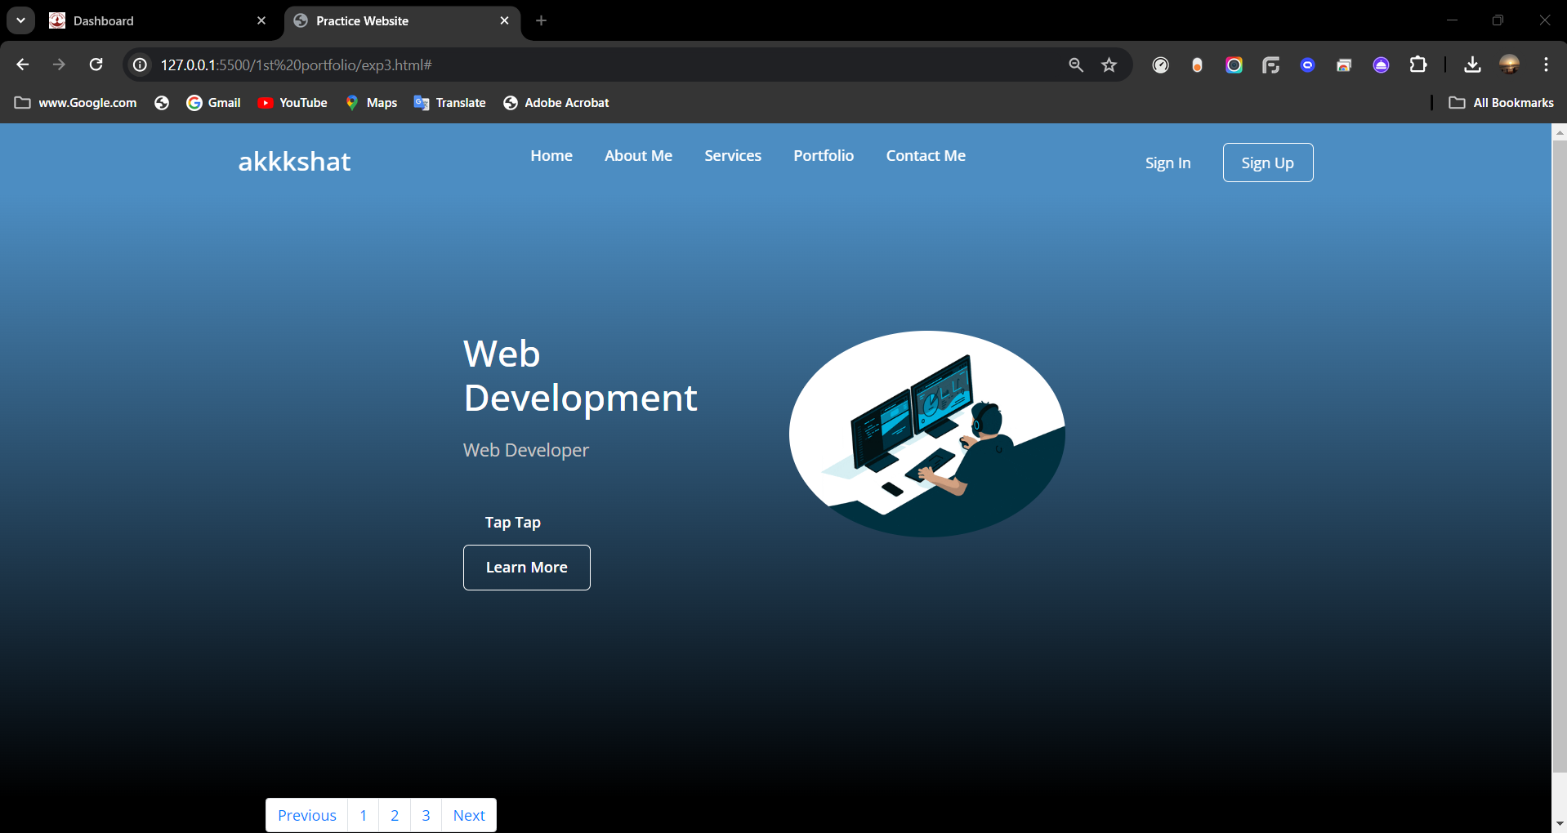

**Post Lab Questions:**

1. **What is the use of containers in bootstrap? Explain in detail.**

**Ans:**

**Containers are the most basic layout element in Bootstrap and are required when using our default grid system. Containers are used to contain, pad, and (sometimes) center the content within them. While containers can be nested, most layouts do not require a nested container.**

**Bootstrap comes with three different containers:**

**.container, which sets a max-width at each responsive breakpoint**

**.container-fluid, which is width: 100% at all breakpoints**

**.container-{breakpoint}, which is width: 100% until the specified breakpoint**

1. **Name the classes to achieve the different button styles in bootstrap.**

**Ans:**

**1. Primary Button**

**2. Secondary Button**

**3. Success Button**

**4. Danger Button**

**5. Warning Button**

**6. Info Button**

**7. Light Button**

**8. Dark Button**

**9. Outline Button**

**10. Link Button**

1. **Write details about the Bootstrap Grid system.**

**Ans:**

Bootstraps’sgrid system allows up to 12 columns across the page.

If you do not want to use all 12 column individually, you can group the columns together to create wider columns. Bootstrap's grid system is responsive, and the columns will re-arrange depending on the screen size: On a big screen it might look better with the content organized in three columns, but on a small screen it would be better if the content items were stacked on top of each other. Grid columns should add up to 12 for a row. If exceeded columns will stack no mater the viewport.