

| **TITLE:** **Develop and demonstrate JavaScript with POP-UP boxes and functions** |
| --- |

**AIM:** To demonstrate the functionalities of JavaScript using HTML and CSS

**______________________________________________________________________**

**Expected Outcome of Experiment:** Design static web pages using various HTML tags.

**_______________________________________________________________**

**Books/ Journals/ Websites referred:**

**_____________________________________________________________________**

Describe and utilize Javascript programming concepts such as variables, arrays, conditionals, and loops.

Write and deploy Javascript code to solve practical web design problems.

**Problem Statement: Description of the application implemented with output**:

**a) Input**: Click on Display Date button using onclick( ) function

**Output:** Display date in the textbox

**b) Input:** A number n obtained using prompt

**Output:** Factorial of n number using alert

**c) Input:** A number n obtained using prompt

**Output:** A multiplication table of numbers from 1 to 10 of n using

d**) Write JavaScript to validate the following fields for the registration page**.

Name (Name should contain alphabets and the length should not be less than 6 characters).

Password (Password should not be less than 6 characters length).

E-mail id (should not contain any invalid and must follow the standard pattern

name@domain.com)

Phone number (Phone number should contain 10 digits only).

**Javascript Basic Concepts Learned With Syntax:**

**1st:**

**function validateForm() {**

**var name = document.getElementById('name').value;**

**var email = document.getElementById('email').value;**

**var phone = document.getElementById('phone').value;**

**var password = document.getElementById('password').value;**

**if(!/^[a-zA-Z]{6,}$/.test(name)) {**

**alert('Invalid name');**

**return false;**

**}**

**if(!/^\w+([\.-]?\w+)*@\w+([\.-]?\w+)*(\.\w{2,3})+$/.test(email)) {**

**alert('Invalid email');**

**return false;**

**}**

**if(!/^\d{10}$/.test(phone)) {**

**alert('Invalid phone number');**

**return false;**

**}**

**if(password.length < 6) {**

**alert('Password must be at least 6 characters');**

**return false;**

**}**

**return true;**

**}**

**</script>**

**</head>**

**<body>**

**<form onsubmit="return validateForm()">**

**<input type="text" id="name" placeholder="Name" required>**

**<br>**

**<input type="email" id="email" placeholder="Email" required>**

**<br>**

**<input type="tel" id="phone" placeholder="Phone" required>**

**<br>**

**<input type="password" id="password" placeholder="Password" required>**

**<br>**

**<input type="submit" value="Submit">**

**</form>**

**2nd:**

**var headOne = document.getElementById("clickButton1");**

**var headTwo = document.getElementById("clickButton2");**

**var headThree = document.getElementById("clickButton3");**

**function showAlert() {**

**document.getElementById("dataTextbox").value = "i am inside box";**

**}**

**headOne.addEventListener("click", function() {**

**document.write("I am clicked")**

**})**

**headTwo.addEventListener("mouseover", function() {**

**headTwo.textContent = "Mouse currently over";**

**headTwo.style.color = "red";**

**})**

**headTwo.addEventListener("mouseout", function() {**

**headTwo.textContent = "Hover over me";**

**headTwo.style.color = "black";**

**})**

**headThree.addEventListener("dblclick", showAlert)**

**var headfour = document.getElementById("clickButton4");**

**function calculateSquare() {**

**var n = prompt("Number enter kro ji");**

**n = parseInt(n);**

**var square = n*n;**

**alert("square of " + n + " hai ji " + square);**

**}**

**headfour.addEventListener("click", calculateSquare);**

**Description of the application implemented with output**:

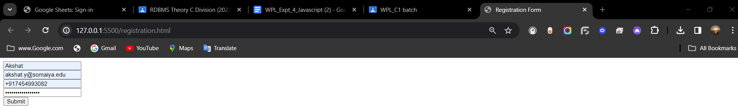

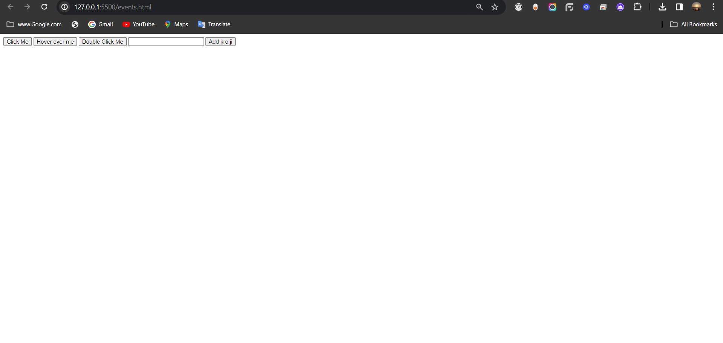

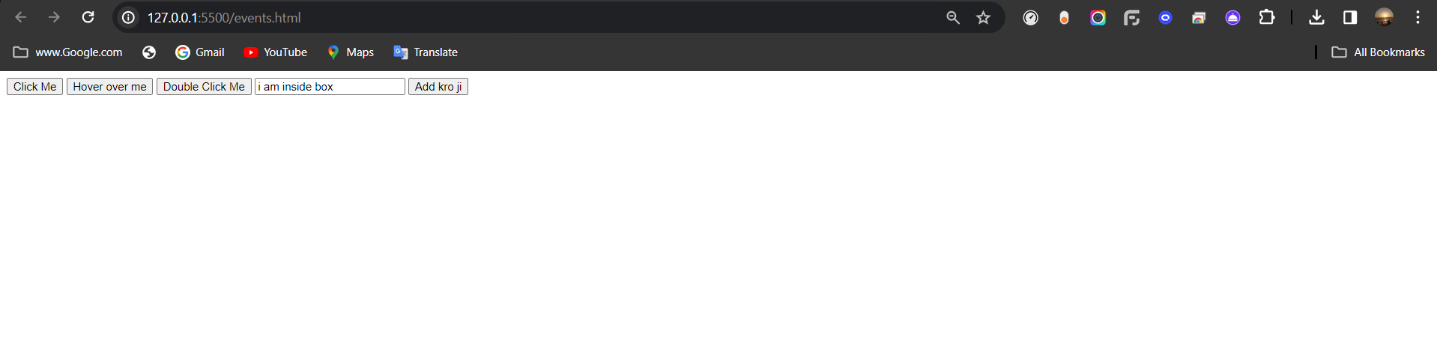

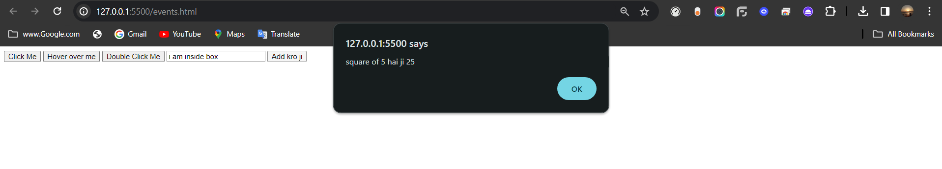

**Post Lab Objective with Ans :**

What are the possible ways to create objects in JavaScript?

In JavaScript, objects can be created using object literals, constructor functions with the `new` keyword, class syntax introduced in ES6, and the `Object.create()` method. Object literals define objects directly, constructor functions initialize objects with properties and methods, classes provide a blueprint for object creation, and `Object.create()` creates objects with a specified prototype.

What is the Difference between = = and = = = operators?

In JavaScript, `==` is a loose equality operator, which means it compares two values after converting them to a common type. It does type coercion, so values of different types can be considered equal.

On the other hand, `===` is a strict equality operator. It checks for both value and type equality, meaning it only returns true if both the value and the type are the same.

For example:

- `1 == '1'` returns true because `1` is coerced to a string.

- `1 === '1'` returns false because they are of different types.

Using `===` is generally recommended for comparisons to avoid unexpected type coercion.

What is the difference between let and var?

* Scope:
  + Variables declared with var have function scope or global scope if declared outside of a function.
  + Variables declared with let have block scope, meaning they are limited to the block in which they are declared (e.g., within loops or conditionals).
* Hoisting:
  + Variables declared with var are hoisted to the top of their function scope and initialized with undefined. This means you can access them before they are declared in the code.
  + Variables declared with let are also hoisted, but they are not initialized. They remain in the "temporal dead zone" until they are declared. Accessing them before declaration results in a ReferenceError.