**Batch:C1**

**Roll No.:16010122221**

**Experiment No. 08**

**TITLE: Demonstrate the Super Global Variables and File Uploading in PHP**

**AIM:** To understand various file operations and file upload in PHP

**Expected Outcome of Experiment:** Process external files in PHP.

**Books/ Journals/ Websites referred:**

**Problem Statement: Description of the application implemented with output**: **To implement read,deletion updation,display of input using php files.**

**PHP Basic Concepts Learned With Syntax**

<?php if(isset($_FILES['image'])){

$file_name = $_FILES['image']['name'];

$file_size = $_FILES['image']['size'];

$file_tmp = $_FILES['image']['tmp_name'];

$file_type = $_FILES['image']['type'];

$file_ext = strtolower(pathinfo($file_name, PATHINFO_EXTENSION));

$allowed_extensions = array('txt', 'jpg', 'jpeg', 'png');

if(!in_array($file_ext,

$allowed_extensions)){

echo "Error: Only TXT, JPG, and PNG files are allowed.";

}

elseif($file_size > 5 * 1024 * 1024){ echo "Error: File size exceeds 5MB

limit.";

}

elseif(move_uploaded_file($file_tmp, "C:/xampp/htdocs/newphp/".$file_name)){

echo "Successfully uploaded";

$uploaded_file_path = "C:/xampp/htdocs/newphp/".$file_name;

if ($file_ext == 'txt') {

$file_handle = fopen($uploaded_file_path, "r");

if ($file_handle) {

$file_contents = fread($file_handle, filesize($uploaded_file_path));

fclose($file_handle); echo "<pre>" .

htmlspecialchars($file_contents) . "</pre>";

} else {

echo "Error: Could not open uploaded file for reading.";

}

}

elseif ($file_ext == 'jpg' || $file_ext

== 'jpeg' || $file_ext == 'png') {

echo '<img src="' .

$uploaded_file_path . '" alt="Uploaded Image">';

}

}

else{

echo "Error: Could not upload. Please try again later.";

}

}

?>

<!DOCTYPE html>

<html lang="en">

<head>

<meta charset="UTF-8">

<meta name="viewport" content="width=device- width, initial-scale=1.0">

<title>File Upload</title>

</head>

<body>

<form action="" method="post" enctype="multipart/form-data">

<input type="file" name="image">

<input type="submit" value="Upload">

</form>

</body>

</html>

**Description of the application implemented with output**:

This code is a PHP script that handles file upload functionality. Here's a breakdown of what it does:

1. It checks if the `$_FILES['image']` array is set, which indicates that a file has been uploaded.
2. If a file has been uploaded, it extracts various file details such as the name, size, temporary location, and type.
3. It then checks if the file extension is one of the allowed extensions (TXT, JPG, JPEG, or PNG).
4. If the file size exceeds the 5MB limit, it displays an error message.
5. If the file is within the allowed size and extension, it attempts to move the uploaded file to the "C:/xampp/htdocs/newphp/" directory.
6. If the file is successfully uploaded, it displays a "Successfully uploaded" message.
7. Depending on the file extension, it either displays the contents of the TXT file or the uploaded image.
8. If any error occurs during the upload process, an error message is displayed.
9. The HTML code at the end creates a simple file upload form where users can select a file to upload.

Overall, this script demonstrates how to handle file uploads in PHP, including validation of file type and size, and displaying the uploaded content based on the file type.



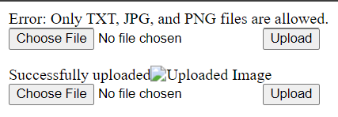

**Post Lab Questions:**

**1. Perform following file operations with respect to problem statement/application:**

Open, read and write with various modes, append, delete and downloading file.

**Answer: Code with output screenshots**

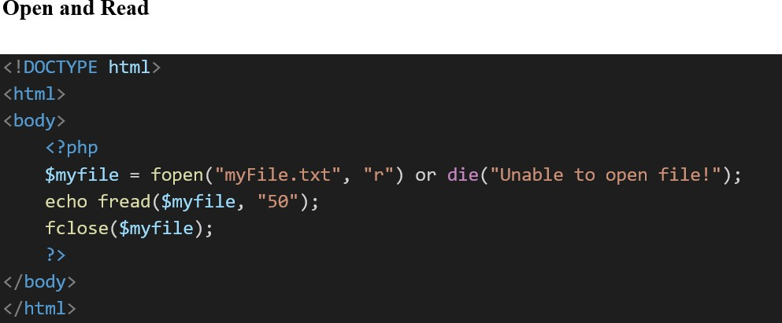

**Write**



<!DOCTYPE html>

<html>

<body>

<?php

$fp = fopen("myFile.txt", "w");

fwrite($fp, "Akshat_221"); fclose($fp); echo "File written successfully";

?>

</body>

</html>