**sumInput() Function**

**function sumInput() {**

**let numbers = [];**

**while (true) {**

**let value = prompt("Enter a number", "");**

**if (value === "" || value === null || !isFinite(value)) break;**

**numbers.push(+value);**

**}**

**let sum = 0;**

**for (let number of numbers) {**

**sum += number;**

**}**

**alert("Sum: " + sum);**

**}**

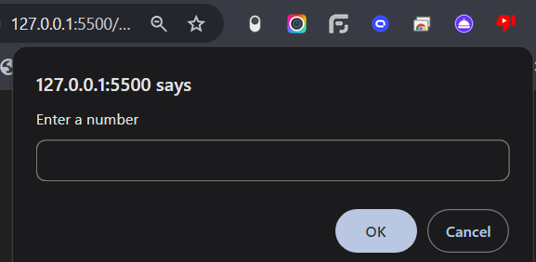

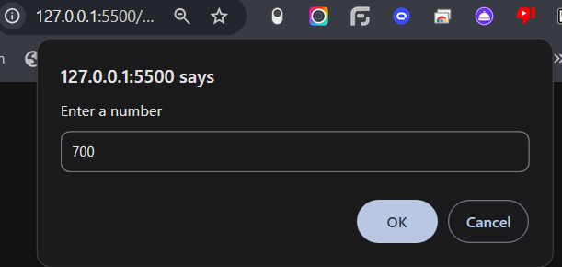

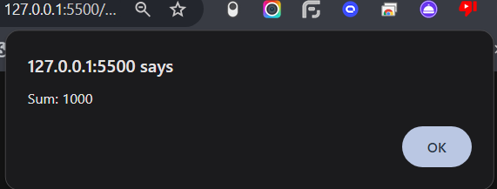

**getMaxSubSum(arr) Function**

**function getMaxSubSum(arr) {**

**let maxSum = 0, currentSum = 0;**

**for (let num of arr) {**

**currentSum = Math.max(num, currentSum + num);**

**maxSum = Math.max(maxSum, currentSum);**

**}**

**return maxSum;**

**}**

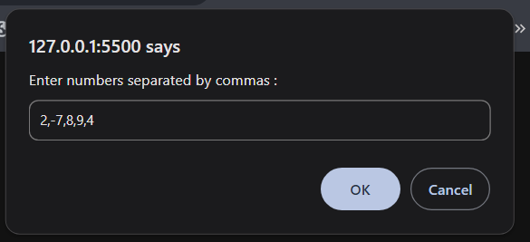

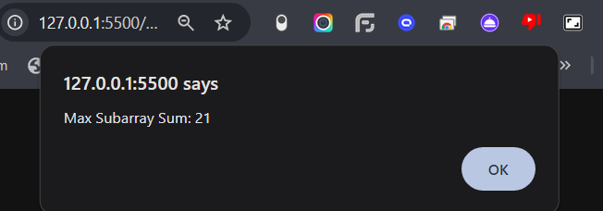

**unique(arr) Function**

**function unique(arr) {**

**return Array.from(new Set(arr));**

**}**

