CENG 3005 DATABASE MANAGEMENT SYSTEMS

PROJECT REPORT

Abdullah Akkoloğlu 190709067

* What’s the name/purpose of your project? Why did you pick this topic?

This dataset contains data for a City Hotel and Resort Hotel reservations made between 1 July 2015 and 31 August 2017. With this dataset we can compare the data of two different hotels. We chose this dataset because the tourism and hotel industry is a satisfactory industry in terms of data diversity.

* How many files exist?

6 table exist.

* How many rows and columns do they contain?

119390 rows and 36 columns.

* How many string(non-numeric) columns do you have?

We have 13 string(non-numeric) columns.

<https://www.kaggle.com/datasets/mojtaba142/hotel-booking>

**3) 11 Questions About Our Dataset:**

* How many assigned-room-type and reserved-room-type are different?
* How many customers we have their reservations online and then cancelled?
* How many customers came from Portugal(PRT)?
* What is the average week night time that the visitors with two children spend in these hotels?
* How many customers who have a lead time of 300 and have booked for the month of July.
* What is the number of reservations that choose BB type meal and have a weekend stay?
* How many families with both children and babies preffered a refundable deposit type?
* How many French customers are not repeated customers?
* What is the maximum lead time?
* What is the minimum adr in 2016?
* How many customers are left in each room?

**4)** <https://bitbucket.org/U190709067/databaseproject/src/master/hotel_db.mwb>

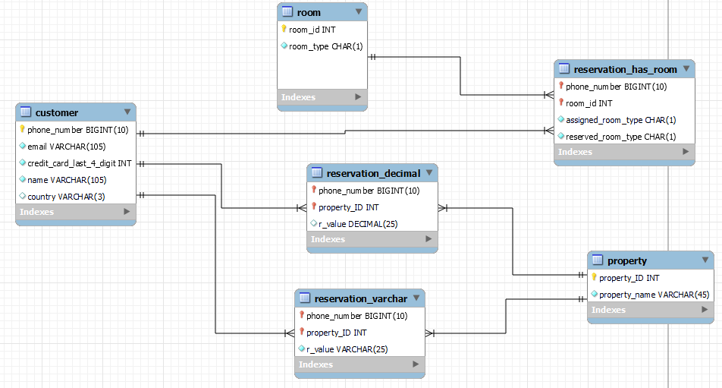

**5)Write at least 5 SQL statements that will implement the English questions from of your target queries.**

1)How many customers are left in each room?

select count(*), reserved_room_type

from reservation_has_room

group by reserved_room_type;

2) What is the number of reservations that choose BB type meal and have a weekend stay?

select count(*)

from reservation_varchar

where r_value='BB'and phone_number in(

select phone_number

from reservation_decimal

where r_value != 0 and property_ID in(

select property_ID

from property

where property_name="stays_in_weekend_nights"))

3) How many customers are from France and they are not repeated guest?

select count(*)

from customer

where country = 'FRA' and phone_number in(

select phone_number

from reservation_decimal

where r_value = 0 and property_ID in(

select property_ID

from property

where property_name = 'is_repeated_guest'

)

);

4)What is the average week night time that the visitors with two children spend in these hotels?

select avg(r_value)

from reservation_decimal

where phone_number in (

select phone_number

from reservation_decimal

where r_value = 2 and property_ID in (

select property_ID

from property

where property_name = 'childeren')) and property_ID in(

select property_ID

from property

where property_name='stays_in_week_nights')

5) What is the minimum adr in 2016?

select min(r_value)

from reservation_decimal

where phone_number in(select phone_number

from reservation_decimal

where r_value=2016 and property_ID in(

select property_ID

from property

where property_name="arrival_date_year")

) and property_ID in (

select property_ID from property

where property_name='adr');

**6) Provide a proposal of how you will load the database with values.**

We got our data from kaggle. First of all, we converted our data to an excel file and made arrangements. We have converted some columns in Date format to Date format that mySQL will accept (DD.MM.YYYY -> YYYY-MM-DD). We've changed some column names to be more understandable (hotel -> hotel_type). We've removed the unnecessary * marks in the credit_card column. Then we converted it back to csv format. We’ve removed the dashes(-) from phone_number column(NNN-NNN-NNNN -> NNNNNNNNNN). And we imported it.

**7) Are you going to implement any front-end user interface?**

We are not going to implement any front-end user.

This IN procedure lists guests from the countries that name you have written.

DELIMITER $$

CREATE PROCEDURE GetCustomersByCountery(IN countryName VARCHAR(3))

BEGIN

select *

from customer

where country = countryName;

END $$

DELIMITER ;

This OUT procedure returns the total number of people left in the room you entered.

DELIMITER $$

CREATE PROCEDURE NumberOfInRooms(IN room varchar(2), OUT total INT)

BEGIN

select count(*)

INTO total

from reservation_has_room

where reserved_room_type=room;

END $$

DELIMITER ;

This view procedure returns Portuguese customers.

create view PRTcustomers as

select name, email, country

from customer

where country = "PRT";

**8)** I will use MySQL 8.0.30 Community Edition on my home computer Huawei Matebook D15 with AMD Ryzen 5 3500U with Radeon Vega Mobile Gfx 2.10 GHz with 8,00 GB memory.