- The code intends to get a Chuck Norris jokefrom the public API and print it.
- tt["value"] is astring, not a nested dictionary. This will throw aKeyError: 'joke'when run.
Webbrowser is imported but never used
No error handling
json.loads(data.text) can be replaced with data.json() (built-inrequestsmethod, more concise).
No messages if the request is in progress or fails
- 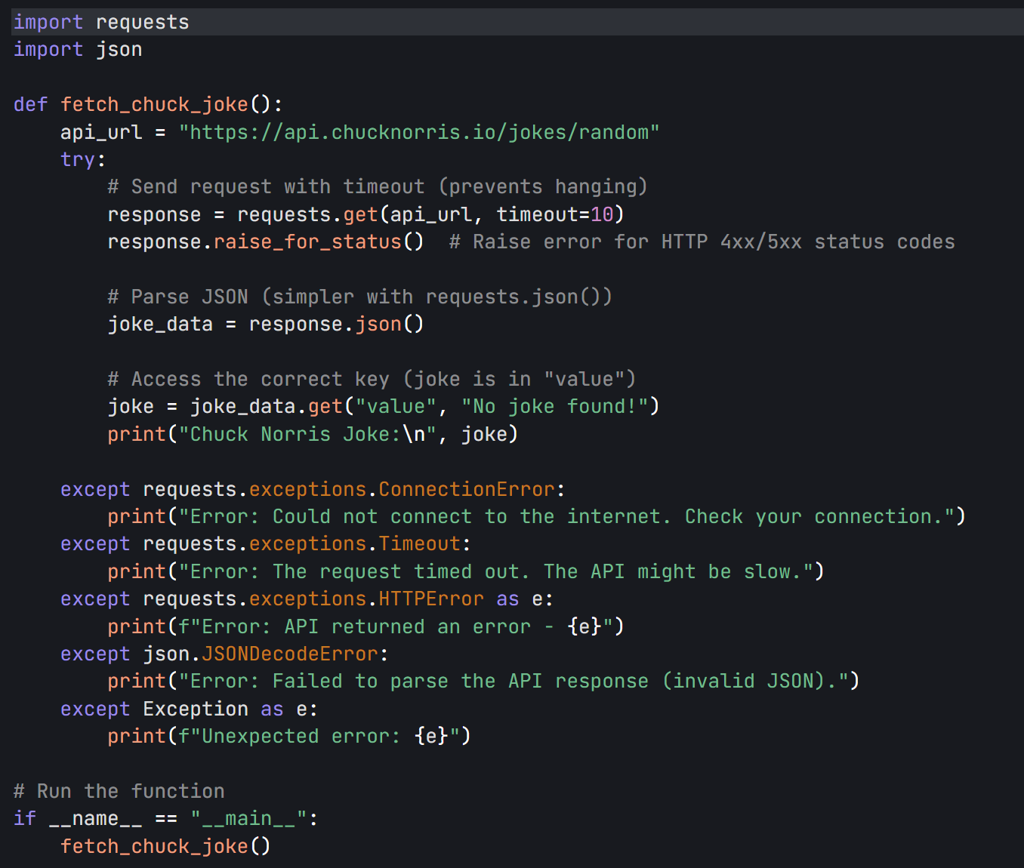
- Addictional QS：
An API endpoint is a specific URL (or URI) that acts as the "access point" for an API to provide or receive data.
The webbrowser module is a built-in Python library that lets you programmatically control web browsers on your computer.

