Setup Git Hooks

This document describes how to configure the hooks in local and server repository for preventing when user push the unwanted commits to server.

* First, We need to fetch the Git repository of your project.

**In Your Server,**

* Make sure the server ssh key is added in Git else it blocks the git to clone..
* If not we need to add ssh key in Git Settings -> SSH and GPG Keys -> Click New SSH Key -> Paste your ssh key --> and click Add ssh key button.
* Create a bare repo in a server anywhere in the location
* Clone with ssh url, open Terminal, and type as follows:

> git clone --bare git@github/user/my-project /home/user/server/my-project

If clone from same location, then we need to specify (.) dot as follows

> git clone --bare git@github/user/my-project .

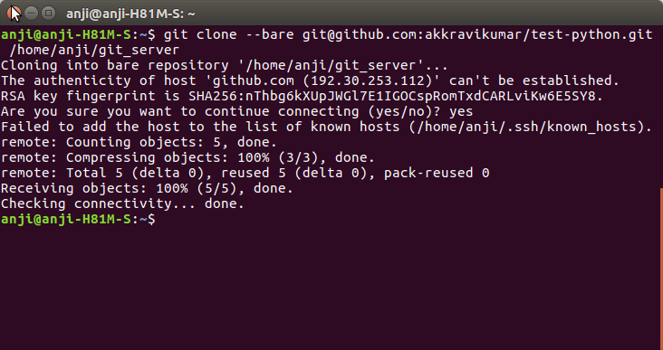

When executing above commends it has cloned git repository files as follows

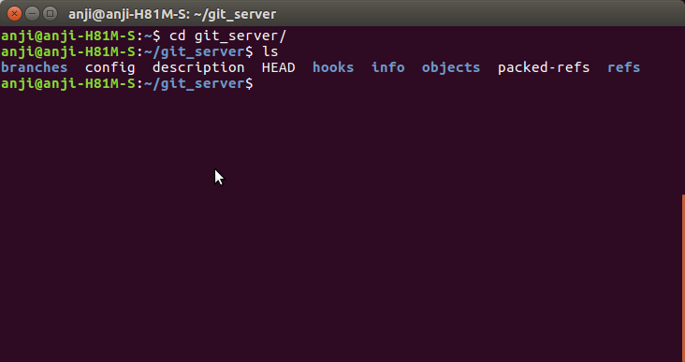

### Installing Hooks

Hooks reside in the .git/hooks directory of every Git repository. Git automatically populates this directory with example scripts when you initialize a repository. If you take a look inside .git/hooks, you’ll find the following files:

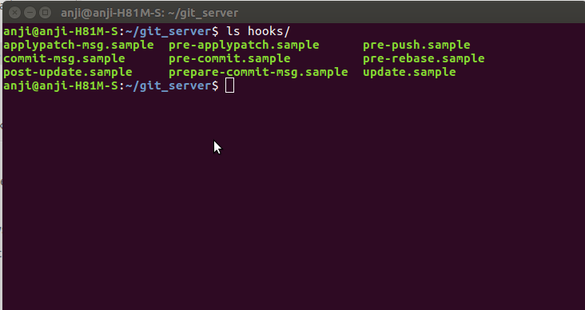

These represent most of the available hooks, but the .sample extension prevents them from executing by default. To “install” a hook, all you have to do is remove the .sample extension. Or, if you’re writing a new script from scratch, you can simply add a new file matching one of the above filenames, minus the .sample extension.

* We should add pre-receive file inside the hooks folder.
* Make permission to pre-receive file as follows

> chmod +x hooks/pre-receive

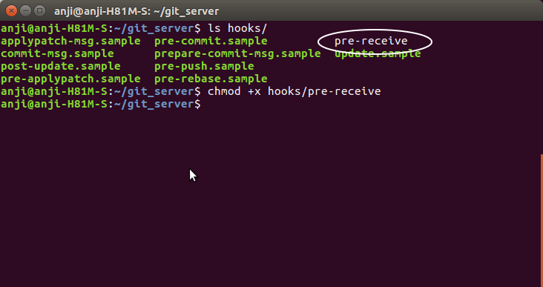

Hooks need to be executable, so you may need to change the file permissions of the script if you’re creating it from scratch. For example, to make sure that prepare-commit-msg is executable.

**In Your local machine**

* On your local machine, add a new remote to deploy on this freshly new repository in any location.
* Make sure git is initialized in the current folder.

> git init

> git remote add prod ssh:[//me@my_server](mailto://me@my_server):port/home/user/local

**Note**: Port 22 is default. So not need to mention the port number as below image.

* + 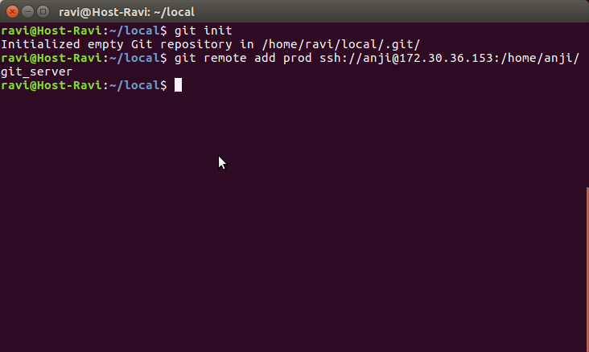Pull the repository from server as follow

> git pull prod master

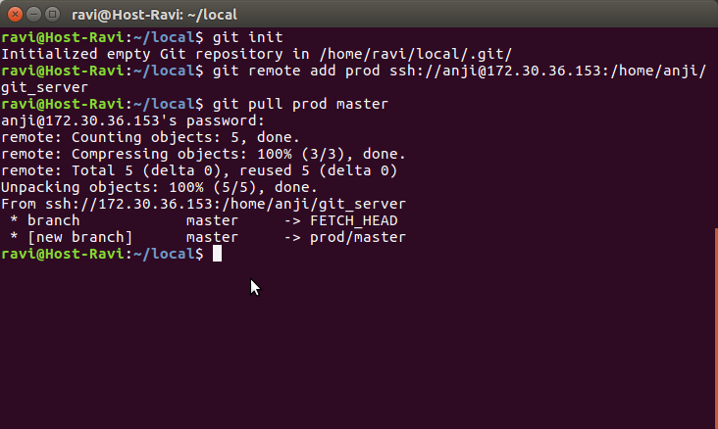

This is not the default configured remote for the current branch, we must specify a branch on the command line.

* We need to add commit-msg and prepare-commit-msg files inside the .git/hooks folder for validating messages.
* Make permission to pre-receive file as follows

> chmod +x hooks/commit-msg

> chmod +x hooks/prepare-commit-msg

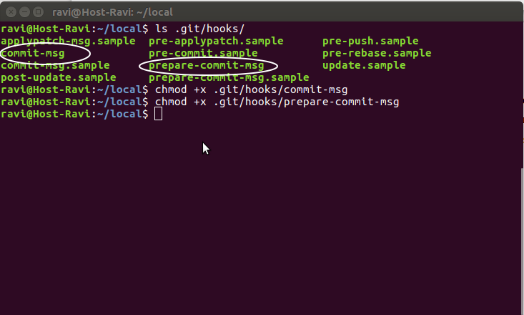

Now successfully configured the git hook both local and server.

The following screens are how it works

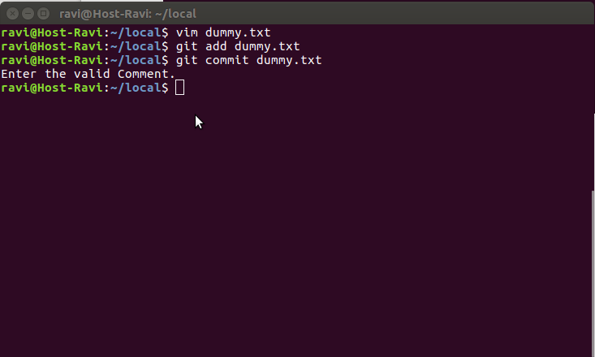

We must provide the valid Bug Id followed by comment. For instance:

“Bug Id:<bug_id>-your_comment_here”

