Make sure python is installed in server windows, if not, install python with administrator from here.

<https://www.python.org/downloads/>

Setup the python path in system environment variables as follows

Go to Control-Panel -> Select System and Security -> Select System - > Advanced System settings -> Select Environment Variables -> Select path and press Edit Button

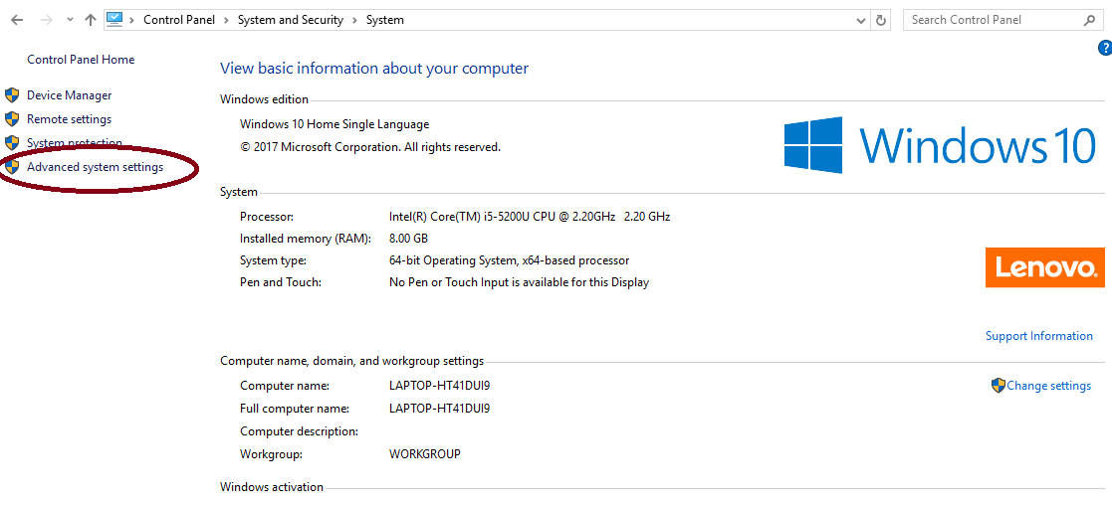

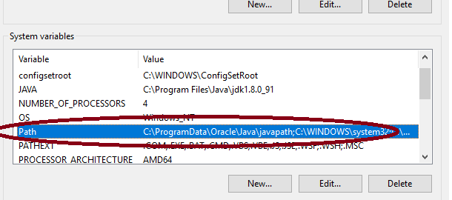

Click New and enter python path then save it and exit.

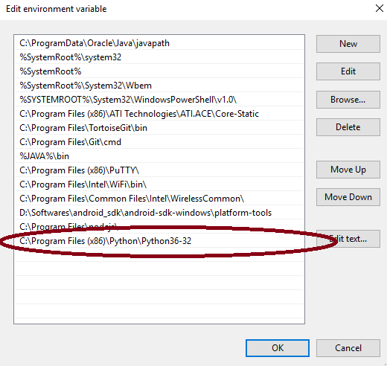

Now close and reopen the command-prompt then check the python version by using below command

* Python –version

**We need to add the path of pip installation to PATH system environment variable as above same step for installing django**. By default, pip is installed to C:\Program Files(x86)\Python\Python36-32\Scripts\pip (pip now comes bundled with new versions of python), so the path "C:\Program Files(x86)\Python\Python36-32\Scripts" needs to be added to your PATH variable

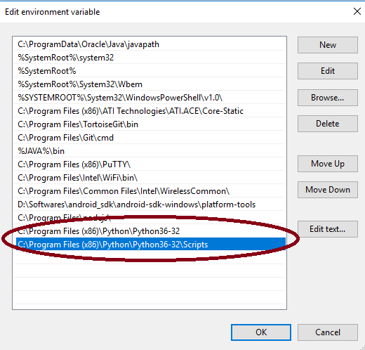

Now close and open command-prompt with **Run as administrator**, then install django by using below comment

* pip install django

Once installed the django. We need to setup server system IP in django project settings file.

Open settings.py file from the django project directory. For Instance, C:\Project\python-django\ mybugs\mybugs\Setting.py file. Set us current IP to “ALLOWD_HOSTS” as follows

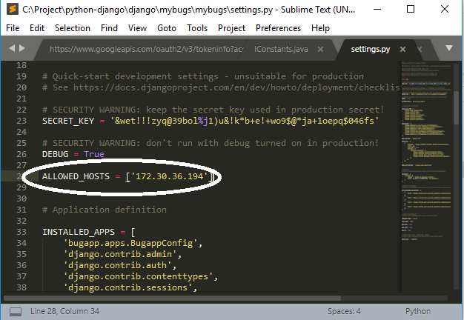

Now go to the django main directory folder. Open command prompt and navigate to django main directory in command prompt.

* cd C:\Project\python-django\django\mybugs

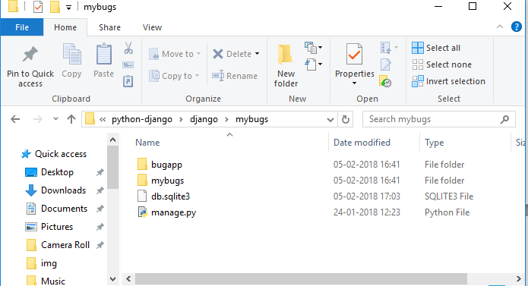

Run the django project as follows

* python manage.py runserver 0.0.0.0:8080

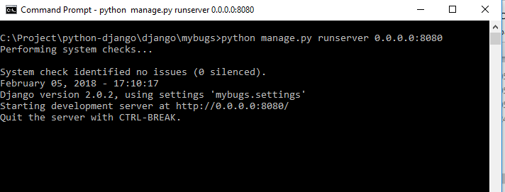

Now open browser, enter the URL as “http://server_ip:8080/bugapp/login_auth/”

The Rest Api’s are configured successfully. Now we need to setup the valid API to pre-receive file

Go to the server which is configured the Git hooks. Open the file under the /home/user/git_server/hooks/pre-receive

And change the valid URL as following.

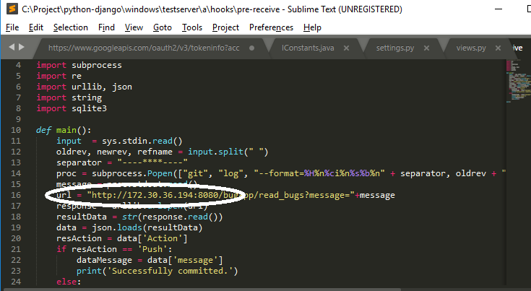

All git configurations is done. We can ready to push and commit the codes