This document describes how to setup linux remote server with windows local machine.

Make sure to git installed in windows machine. If not, download the Git Git-2.16.1-64-bit version. Because of bug in the latest updated version for connecting with remote server, manifested in 2.16.1 and 2.16.2 (exe file attached in github)

Bug ref : (https://ru.stackoverflow.com/questions/780008/error-cannot-spawn-git-function-not-implemented)

Create working directory anywhere in the location of your windows machine and open the Command prompt and redirect the same directory location.

We need to configure the remote machine with local for pull and push the source, so run the following in Command prompt

**> git init**

**> git remote add production server_ip:port/home/user/git_server**

Note: if port 22 is default then not need to mention. Check the following image.

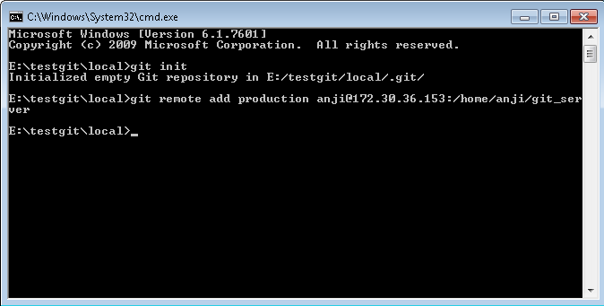

Linux remote server is configuration is success. Now check pull the source from remote server.

