Once the code is compiled:

Put in 0 in the amount and deploy the contract by putting in the addresses of the employees and hitting transact:

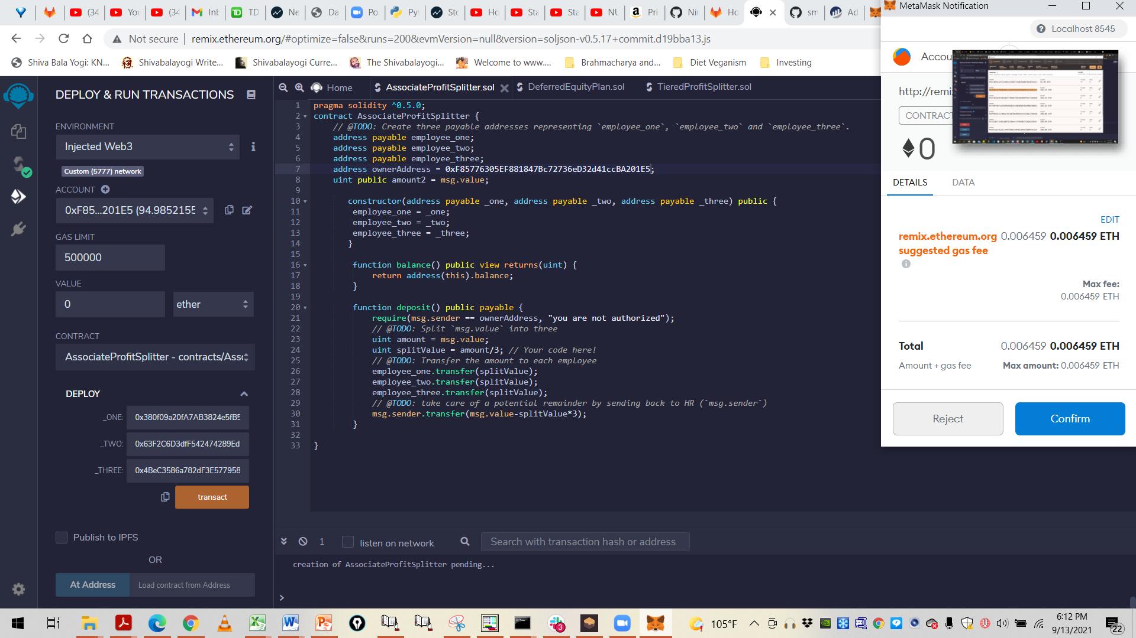

Hit Confirm on Metamask to deploy the contract. This essentially adds the employee addresses to the contract and deploys it:

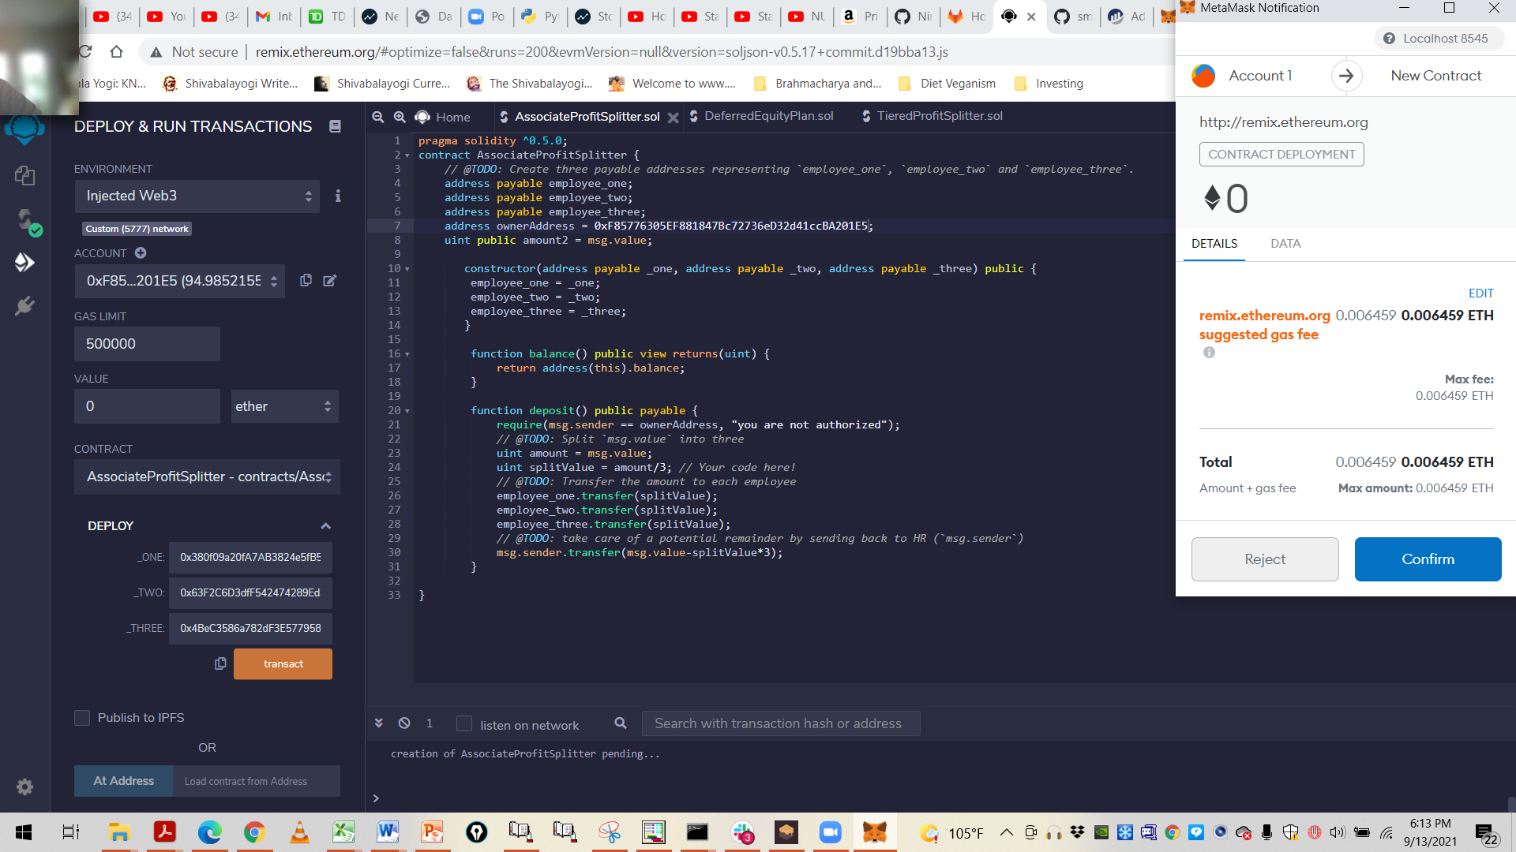

Put in a value on amount to distribute to the employees. In this case 5 ether was put in to be distributed equally amongst the employees:

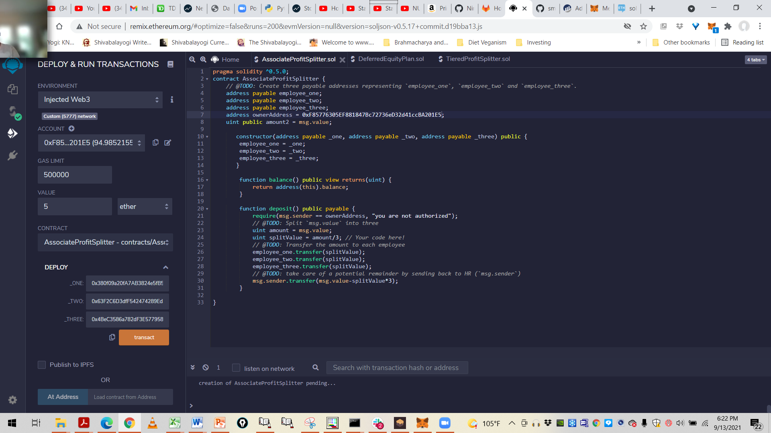

Hit deposit to spread the amount equally to the employees:

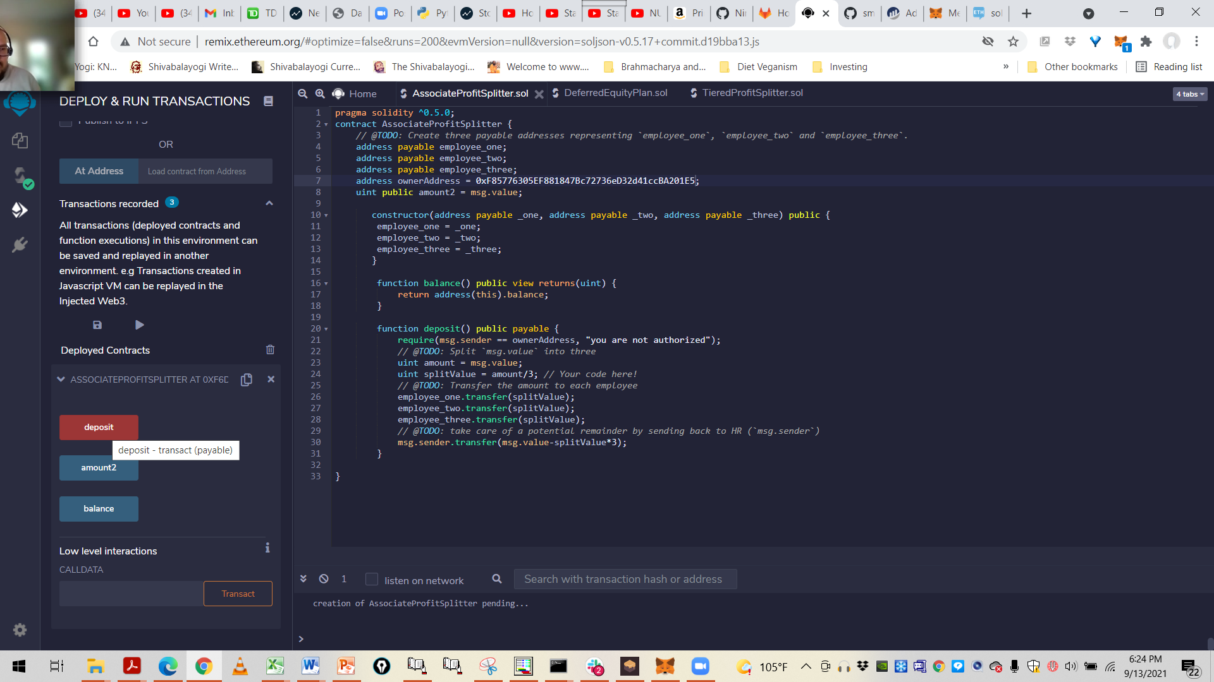

Hit confirm on Metamask to confirm the deposit:

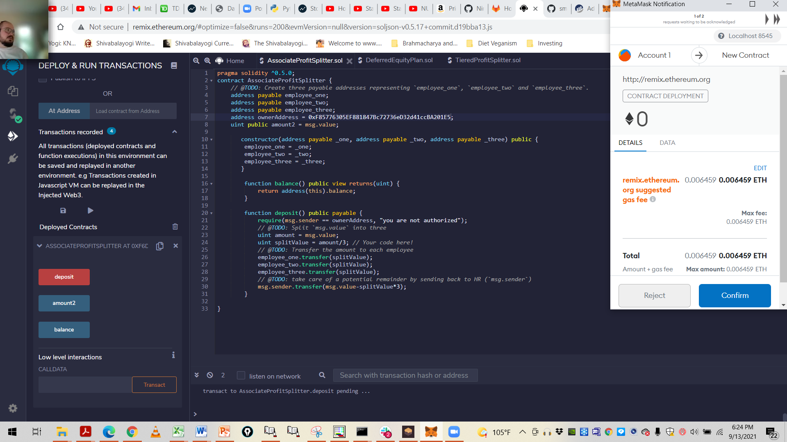

The amount value appears. Hit confirm again:

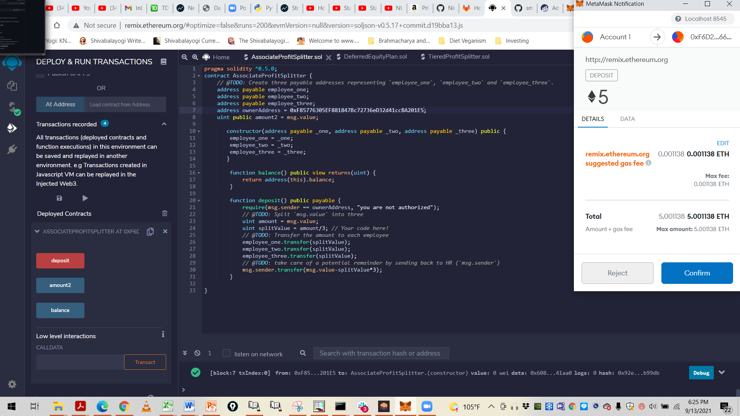

This is the final result with the amount distributed equally to the employees. Each gets 1.67 ether:

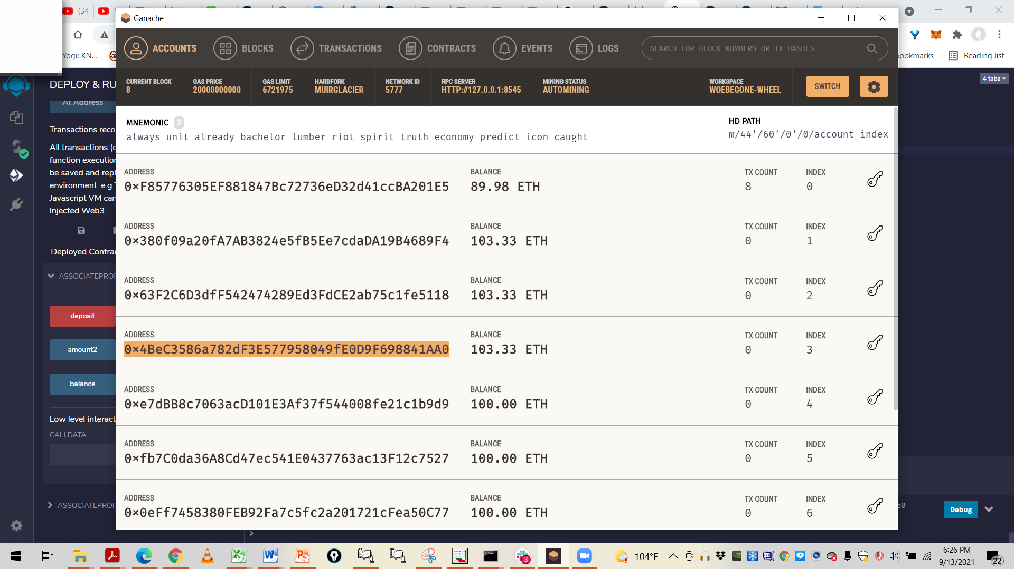

Note that the three addresses have 1.67 ETH each. The initial values were 94.99 for the owner and 101.67 for the three employees. The totals after are given above. Here is the final result as shown in metamask:

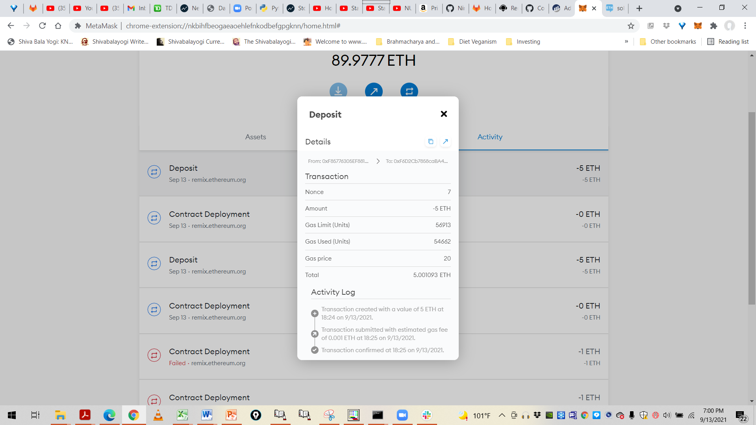

I have submitted the steps for AssociateProfitSplitter.sol. However I am also submitting the codes for the other contracts as well for your perusal.