**Observations**

**Experiment 1**

Screenshot:

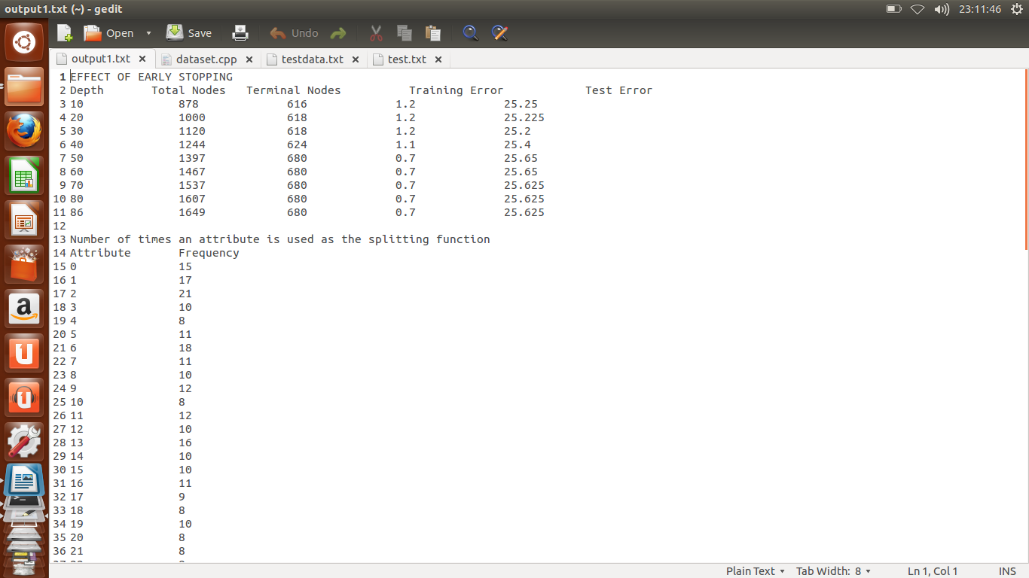

As we can see in the above screenshot that as we increase the depth of the tree the training error increase and test error decrease.

By this observation we can predict that our tree may be going through Overfitting, since its training error is very less but test error is significantly high.

Graph: Depth vs test error

**Experiment 2**:

Screenshot:

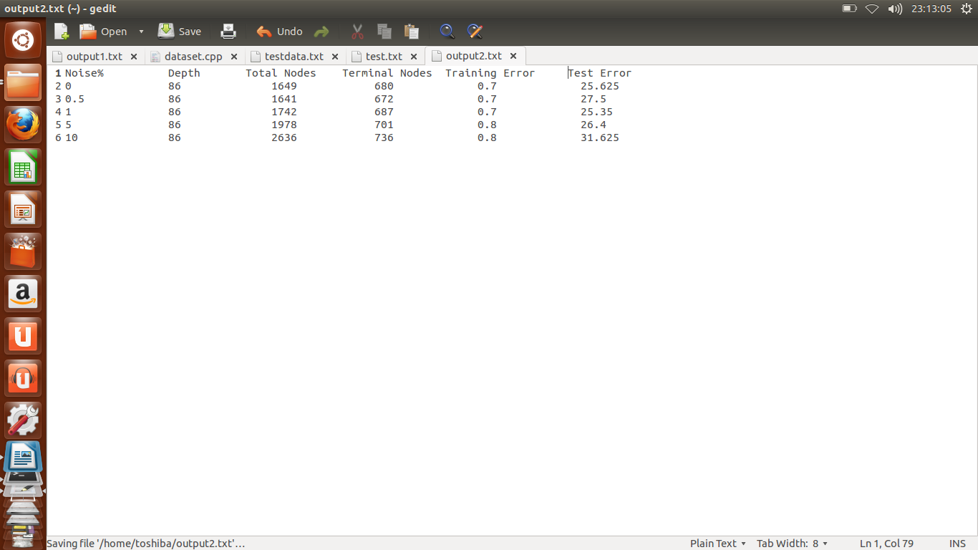

As we can observe from above screenshot that as we are increasing the amount of noise in our dataset the amount of error is increasing in the training as well as test scenario.

**Experiment 3:**

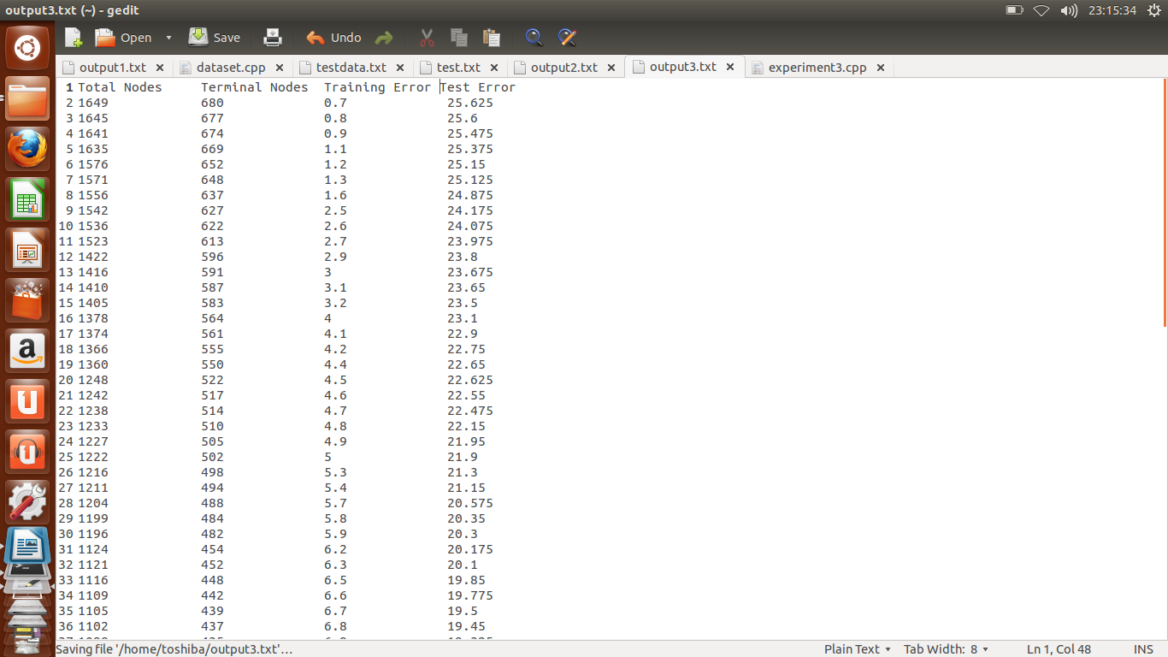

From the above observations, we see that as we prune the data, total number of terminal nodes decreases, decreasing the total number of nodes. Also, the test error decreases, while the training error generally increases.

**Experiment 4:**

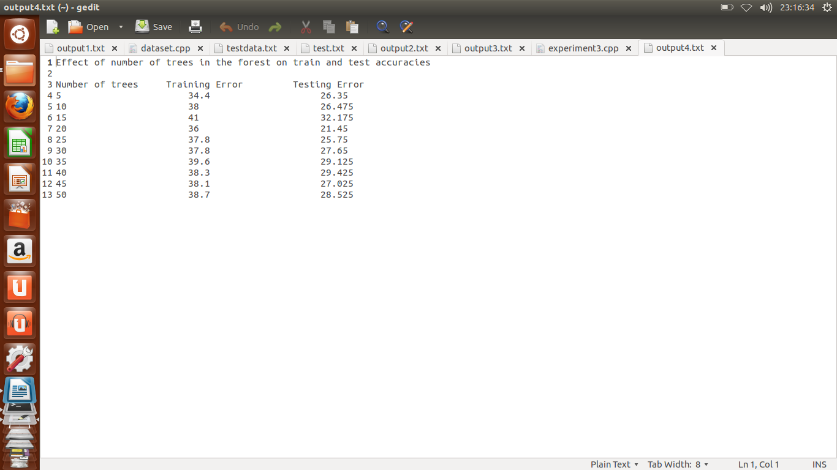

Num,ber of features used here are sqrt(n)~9

In feature bagging, the testing error decreases until some number of trees, after which the correlation between the features increases, leading to increase in testing error.