**Artificial intelligence in self-driving cars**

By Sutanay Bera August, 2022

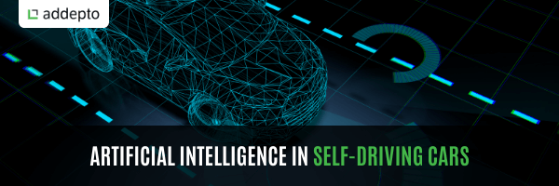

Until recently, self-driving cars were just an ambitious idea, unlikely to happen. Today, it’s our reality. Of course, they are still not a common sight on the roads, but the technology is ready to use. Self-driving cars have become possible thanks to a number of AI-related technologies, primarily deep learning and computer vision. What do you need to know about artificial intelligence in self-driving cars?

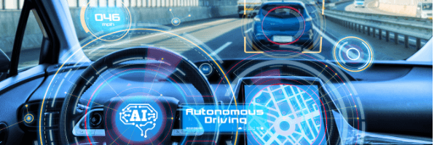

First off, let’s talk about the basics. Artificial intelligence has been present in modern cars for some time now. It has all started with smart driver’s assistants that monitor the vehicle’s surroundings and support the driver or alert them in case of an emergency or an accident risk. Such systems allow drivers to benefit from such solutions as:

* Emergency braking: For example, Volvo’s CWAB system can use full braking power to stop the car and avoid the accident.
* Night vision: These systems use thermographic cameras to increase the seeing distance in darkness or poor weather conditions. Mercedes offers such a solution.
* Enhanced communication and alerts: Voice commands, weather alerts, etc.
* Lane control: The vehicle alerts you when you drive off your lane. BMW offers such assistant.

## How AI is used in self-driving cars

## Self-driving cars have become possible primarily thanks to computer vision and deep learning. CV uses high-resolution cameras and lidars that detect what happens in the car’s immediate surroundings. As a result, car systems can react to possible obstacles and avoid accidents. Of course, CV is not enough. You also have to teach car systems how to drive according to traffic rules. And this is where machine learning, backed up by deep learning, steps into the game.

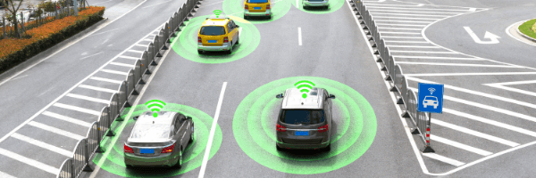

Deep learning is one of the most advanced AI technologies that works similarly to the human brain. Every piece of data (concerning self-driving cars, we talk about data received by the vehicle’s sensors) goes through the multi-layered neural network, enabling analyzing images in a much more comprehensive way. This solution allows carmakers to achieve a much higher level of complexity and accuracy. In effect, self-driving cars are really smart and can operate even in congested cities.

## Benefits of self-driving cars

## Self-driving cars are a huge milestone not just from the technological standpoint but also from the operational point of view. You see, these vehicles have everything it takes to make our everyday work accelerated and facilitated. With self-driving cars:

* Companies running them can save time and money (e.g., drivers can focus on more complicated work) and even operate 24/7, all year round.
* The number of accidents decreases (AI algorithms are never tired, intoxicated, or sleepy)