# Name-SANTU JANA

College Roll- CSE/21/L-146 University Roll No- 10700121127

# MAR ACTIVITY

|  |  |  |  |  |
| --- | --- | --- | --- | --- |
| Serial Number on Mar list | Programe name | Points | Expected Point | Page no |
| 1 | QUIZ | MAX 20 POINTS | 10 | 1 |
| 2 | PARTICIPATION IN RELIEF CAMPS | (MAX 40 POINTS) | 10 | 2 |
| 3 | MEMBER OF PROFESSIONAL SOCIETY | (MAX POINT 20) | 10 | 3 |
| 4 | PUBLICATION OF WALL MAGAZINE IN INSTITUTIONAL LEVEL | (MAX POINT 32) | 10 | 4 |
|  |  |  |  |  |

TOTAL EXPECTED POINT:40

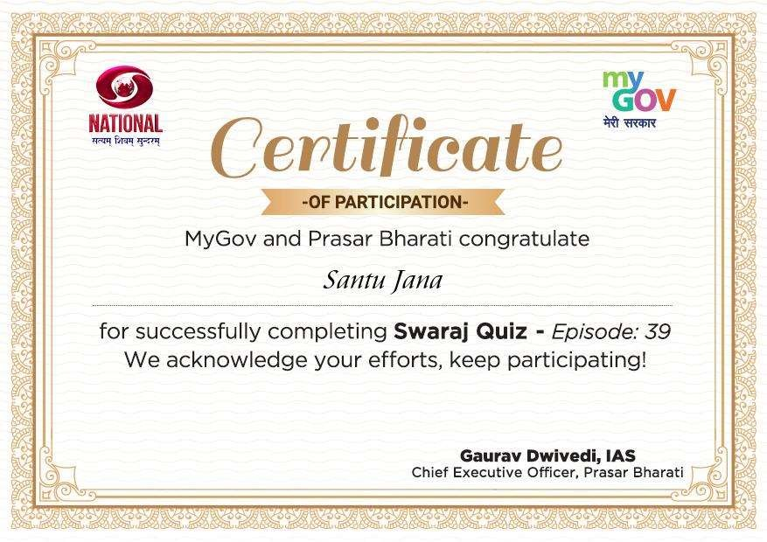

8945007301, [janaa7223@gmail.com](mailto:janaa7223@gmail.com)

**Contribution Summary** 10 May, 2023, 04:11 PM



**BENEFICIARY FUND**

**PM CARES Fund**

Prime Minister s Office, South Block, New Delhi-110011

|  |  |
| --- | --- |
| **DETAILS OF CONTRIBUTION** | |
| Contribution Amount | 5.00 |
| Mode of Payment | WALLET-Paytm Cash |
| Paytm Order ID | 21027388149 |
| Amount Paid | 5.00 |

**DETAILS OF CONTRIBUTOR SANTU JANA**



For any queries please check Help & Support section in your Profile on Paytm App

*Subject to Terms and Conditions on Paytm.com



**Member ID: NITTSD/STUDENT/85482** Date: **10/05/2023**

**Member Registration Certificate**

**This is to Certify that Mr. / Ms. SANTU JANA**

**has successfully registered & became the member of "National Institute For Technical Tranining & Skill Development".**

**Congratulation!**





**(Councilor, NITTSD)**

# [www.nittsd.com](http://www.nittsd.com/)

The following students participated in the Departmental Wall Magazine.

ABHISAKE MANNA (CSE21L145) ABIRA SARKAR (CSE20003) ARABINDA MAHATA (CSE20071) ARNAB SOM (CSE21L138) ARPITA ROY (CSE20050) ARUNIMA DAS (CSE20127) ARUP JANA (CSE20001)

AVIJIT PAL (CSE21L141) DEYASINI ADAK (CSE20019) JAYITA GHORAI (CSE20091)

KALIPADA CHAKRABORTY (CSE21L147) PRITAM DAS (CSE20T129)

PRITHWISH ADHIKARI (CSE20075) RITWICK GHOSH (CSE20013) SAMPAD PRADHAN (CSE22L158)

SAMPURNA CHATTOPADHYAY (CSE21086) SANTU JANA (CSE21L146)

SHREYASI HAZRA (CSE21098) SOUMYAJIT DAS (CSE20059) SUPRIYA MANDAL (CSE20115) SUTANAY BERA (CSE21L137) SWARNAMONI MAHATO (CSE21L140)

The following students organized the Departmental Wall Magazine.

ABIRA SARKAR (CSE/20/003) SWATI MANDAL (CSE/20/009) DEYASINI ADAK (CSE/20/019) ARPITA ROY (CSE/20/050) ARABINDA MAHATA (CSE/20/071) PRITHWISH ADHIKARI (CSE/20/075)