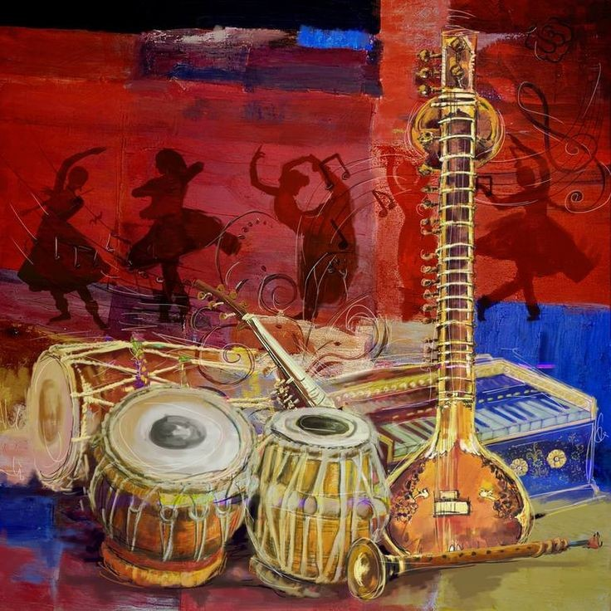**RABINDRA BHARATI UNIVERSITY**

**RBU ,B.T.ROAD,MAIN CAMPUS,KOLKATA**



**NAME : DEYA MUKHERJEE**

**COURSE : GEC-4.1**

**SUBJECT : PERCUSSION(TABLA)**

**Reg NO : 210543 of 2021-2022**

**Exam roll : Rab/nfas/210261**

**DEPT : VOCAL MUSIC**

**YEAR : 2022-2023**