CO1 – AT1 – CONCEPT MAPPING

- Concept Map 1: Cloud Computing Fundamentals. Include definition, characteristics, benefits, and limitations.

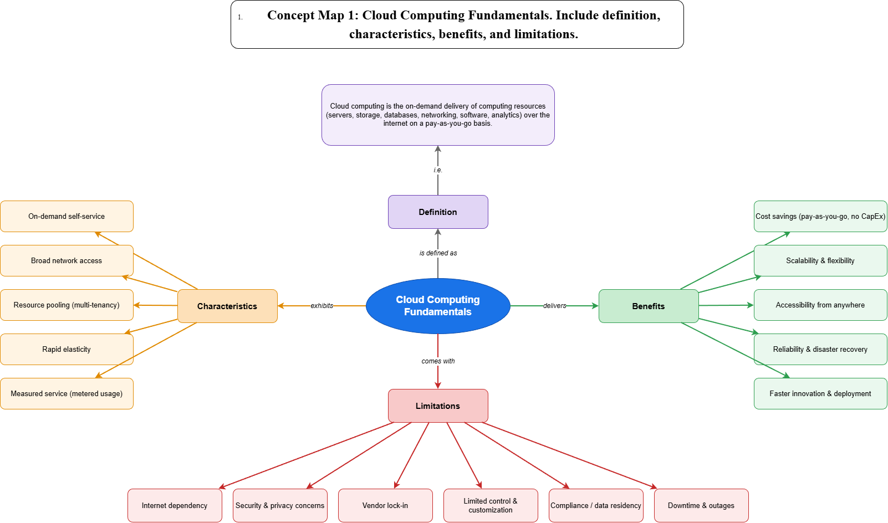

- Concept Map 2: Evolution of Cloud Computing. Connect hardware evolution, internet software evolution, distributed systems, and service delivery.

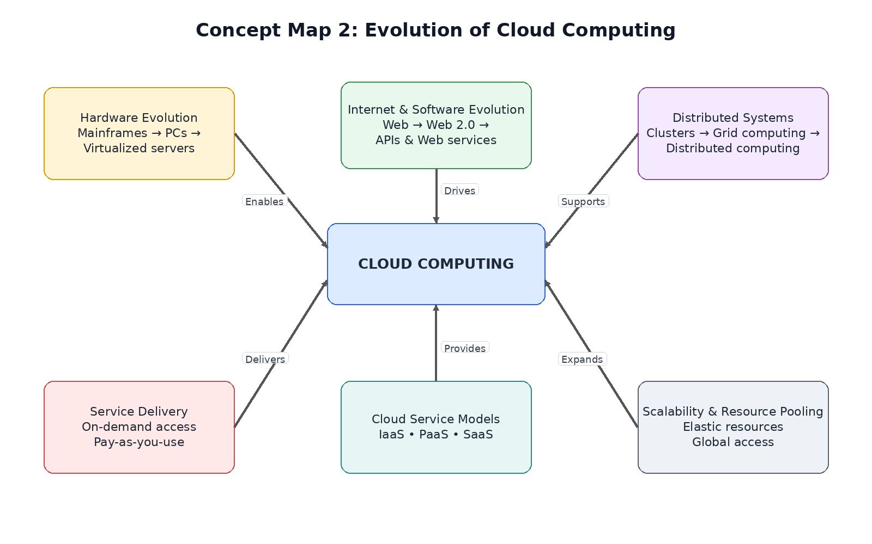

- Concept Map 3: Service Models. Map IaaS, PaaS, SaaS, and XaaS with provider responsibilities and user responsibilities.

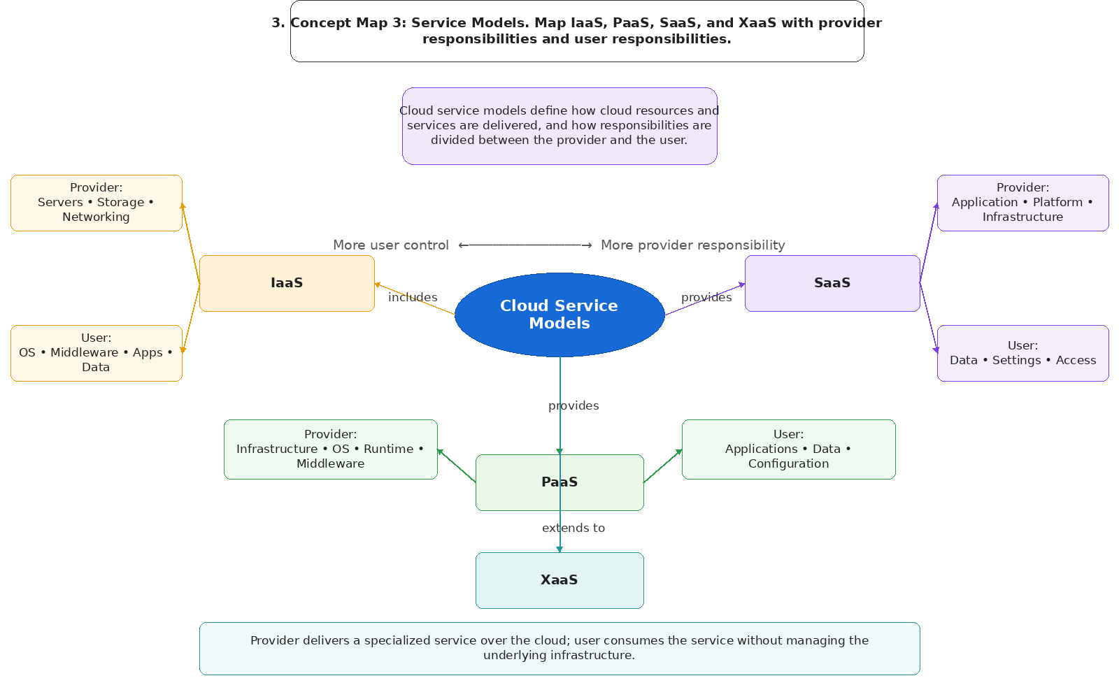

- Concept Map 4: Virtualization and Web Services as Enablers of Cloud. Show how these two concepts support cloud deployment and scalability.

