Name_____________________________

Peanut Butter/Jelly Stories

You’re going to write a narrative story that somehow concerns peanut butter or jelly. Peanut butter/jelly could either play a huge role (perhaps the main character is a jar of peanut butter) or a small role (perhaps Billy eats a spoonful of jelly for the first time, but the story primarily focuses on Billy’s adventures in the school cafeteria) or any other role you want. Think about your work with the 5 senses as you write this story. How can you use the senses (how peanut butter/jelly tastes, smells, looks, feels, and sounds) to make your story more descriptive? You don’t need to incorporate all 5 senses, but your story should show consideration for at least 3. Most importantly, be creative!

First we’ll do a pre-write. After you’re done with the pre-write, you’ll compose a rough draft. The rough draft should be 1.5-2 pages double-spaced. You should use size 12 Times New Roman font. We’ll peer edit these rough drafts. You’ll then make edits and hand in your final version. I’ll be looking at your papers as we go along and helping you as best I can, but won’t collect your rough drafts (whereas for future assignments, I’ll likely collect them).

Formatting is important. Remember to follow the formatting guidelines I’ve given you.

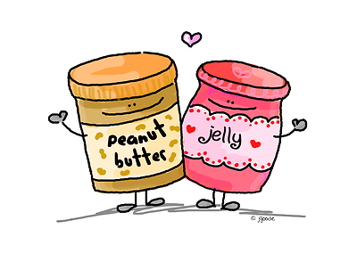

**Important Dates**

Monday, 9/21: Pre-write

Thursday, 9/24: Finish pre-write and start rough draft

Friday, 9/25: Work on RD

Wednesday, 9/30: Work on RD

Thursday, 10/1: Work on RD/begin peer-editing

Friday, 10/2: Peer-editing/make edits for final paper

Wednesday, 10/7: Make edits for final paper

Friday, 10/9: Hand in final drafts

Name____________________

Peanut Butter/Jelly Story Rubric

Stimulating Ideas 2 4 6 8 10

* Focuses on a specific event or experience
* Presents an engaging picture of the action and people involved
* Contains specific details and dialogue
* Makes readers want to know what happens next

Logical Organization 2 4 6 8 10

* Includes a clear beginning that pulls readers into the essay
* Presents ideas in an organized manner
* Uses transitions to link sentences and paragraphs
* Flows smoothly from one idea to the next

Engaging Voice 2 4 6 8 10

* Speaks knowledgably and/or enthusiastically
* Shows that the writer is truly interested in the subject
* Contains specific nouns, vivid verbs, and colorful modifiers

Grammar/Conventions 2 4 6 8 10

* Sentence structure and variety
* Spelling, punctuation, capitalization
* Word choice and usage

Specific Requirements Fulfilled 2 4 6 8 10

* Peanut butter or jelly somehow included in narrative
* Descriptions include at least 3 of 5 main human senses;
* Descriptions are strong

Formatting 1 2 3 4 5

* Header done correctly
* Typed
* Double-spaced
* Times New Roman 12 pt. font

Total ___________/55