Name:

Date:

Other Group Members:

Bridge to Terabithia: Final Project

1) Circle your assigned theme:

Friendship Courage Transformation Ambition

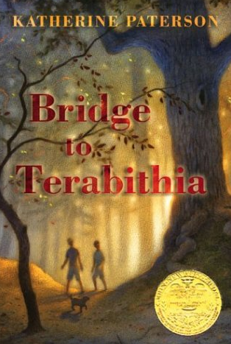2) In your group, think through several song possibilities that reflect your assigned theme. Write down the names and artists of your top 3 here. Remember, you’re in school and your selections should be school appropriate.

1.

2.

3.

3) Use a Chromebook to find the lyrics to your songs. Read through the lyrics, line by line, and discuss images you feel reflect and express the words and ideas.

4) Divide the images up among your group members. Images can be drawn, made on the computer, printed out, clipped from magazines/newspapers, etc. Some of this work will be done at home. Each group member is responsible for 3-4 images.

5) Have a group member print the lyrics at home or in the school library.

6) Jen will give you a piece of poster board. At the top, write the name of the book, the author’s name, and your assigned theme. Paste the lyrics and the images onto the poster board in an artistic way.

7) With your group members, choose the song you feel best represents your theme. Tell Jen what song that is. She’ll set it up so that during your presentation, you’ll be able to play it for the class.

**TURN OVER**

8) Rehearse your presentation. **Each** group member should speak to your theme. Discuss the 3 songs you chose and why. Make sure to talk about the development of your theme in the book. Your presentation should be 5-7 minutes long.

9) Present your poster!

**Class Time:**

Thursday, 10/1 🡪Work on projects

Wednesday, 10/7 🡪Work on projects

Thursday, 10/8 🡪Work on projects; Begin presentations

Friday, 10/9 🡪Finish presentations; final *Bridge to Terabithia* discussion