Seasonality & Momentum: Persistent Inefficiencies in Commodities and Crypto
Alexander K. Laudano
Applied Market Inefficiency Research — 2025

Executive Summary
This study evaluates the weak-form Efficient Market Hypothesis (EMH) across equities, commodities, and digital assets using more than two decades of historical return data. While equities show no statistically significant seasonality, agricultural commodities, gold, coffee, and Bitcoin exhibit meaningful excess returns driven by either seasonal cycles or momentum continuation. These findings provide evidence of persistent, theoretically explainable market inefficiencies.

Data & Methods
Historical monthly and weekly returns were obtained from Yahoo Finance and Macrotrends.com, covering 1915–2025.
- Assets: Corn, Wheat, Soybeans, Cotton, Coffee, Gold, Bitcoin, and Dow Jones (control) - Return Frequency: Monthly (commodities, gold, equities), Weekly (Bitcoin) - Statistical Tests:
- ANOVA for seasonal quarterly differences in commodities
- One-sample t-tests for momentum drift in Gold and Coffee
- Wilcoxon signed-rank test for Bitcoin (non-parametric momentum)
The analysis compares conditional mean returns during inefficiency conditions to unconditional monthly average returns across the full sample.

Asset | Inefficiency Type | Conditional Return | Unconditional Return | Excess (∆) | Significance
Corn | Q4 seasonality | +2.15% | +0.05% | +2.10 pp | F = 13.23, p < 0.001
Wheat | Q4 seasonality | +2.50% | +0.48% | +2.02 pp | F = 8.03, p < 0.001
Soybeans | Q2 seasonality | +1.61% | +0.53% | +1.08 pp | F = 9.37, p < 0.001
Coffee | Momentum continuation | +1.26% | +0.49% | +0.77 pp | t = 2.27, p = 0.024
Gold | Momentum continuation | +1.27% | +0.50% | +0.77 pp | t = 2.27, p = 0.024
Bitcoin | Weekly momentum | +2.06% | +0.88% | +1.18 pp | p = 0.014
Dow Jones | (Control) | — | — | ~0.00 pp | p = 0.756
Figure 1. Conditional vs. Unconditional Mean Returns
This table shows the difference in the conditional and unconditional mean returns for the conditions tested across the different assets; if the weak-form EMH was true, there should be no statistically significant excess return (Δ = 0). These findings indicate there is statistically significant evidence that the weak-form EMH does not hold across all types of assets.

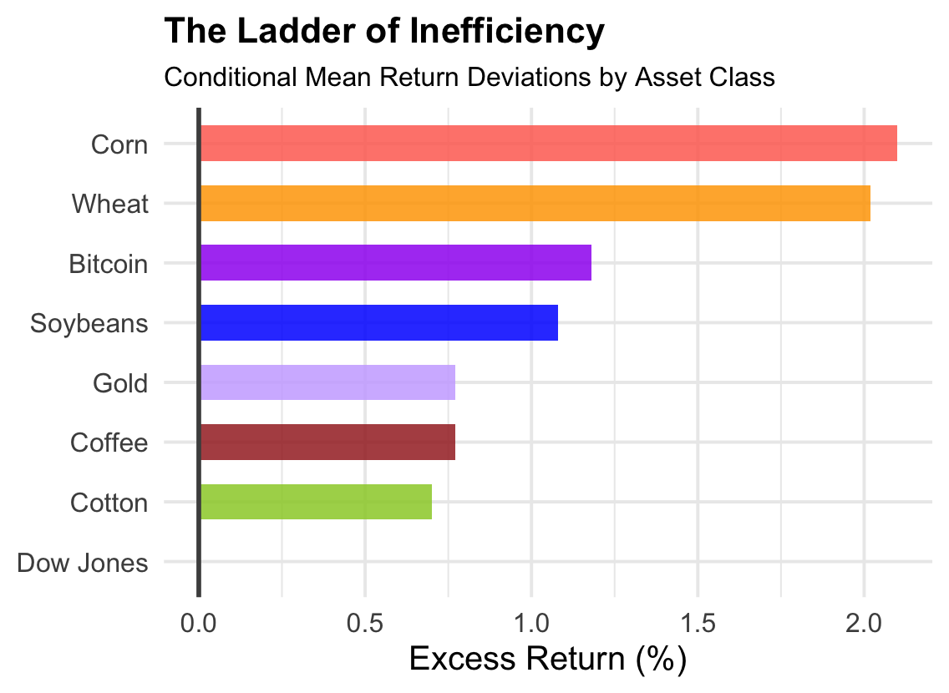
Figure 2. The Ladder of Inefficiency
Bars represent conditional mean return deviations—how far each asset’s returns drift from their unconditional mean under the specific tested condition.

Interpretation
- Agricultural commodities show predictable seasonality tied to planting, harvest, and export cycles.
- Gold and Coffee exhibit momentum persistence, where strong months predict subsequent positive returns.
- Bitcoin maintains median momentum robust to outliers, detected through a non-parametric approach.
Across several markets, excess returns are statistically significant, economically meaningful, and theoretically grounded — contradicting weak-form EMH.

Conclusion
The weak-form EMH does not hold universally. Commodities and digital assets show durable inefficiencies driven by real-world supply, seasonal structure, and investor psychology. These results imply that systematic seasonal and momentum strategies may outperform passive index exposure in specific commodity and crypto markets.
© 2025 — Alexander K. Laudano — Skidmore College — Applied Market Inefficiency Research

