­­Figures

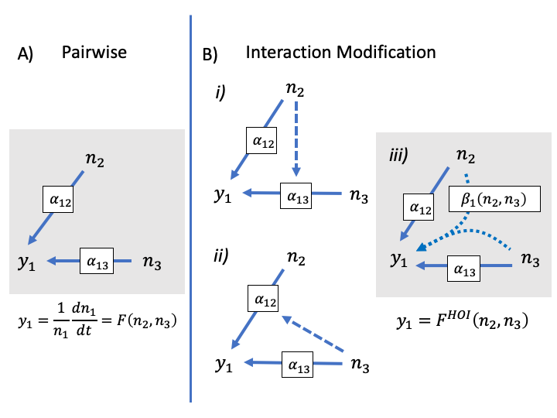

Figure 1. Interaction modifications lead to higher order interactions. In A, a pairwise model is shown without interaction modification. The competitive effect of species two and three on the per capita growth rate of the focal species, *y1*, are shown as separate blue arrows. These effects may be simple per competition coefficients, and , or could be more complicated non-linear functions of density. In B, a model with interaction modification is shown: in *i)* the dashed arrow shows that the effect of three is modified by the density of two; in *ii)* the effect of two is modified by the density of three. In reality, the interaction modifications in *i)* and *ii)* are not separate but result in a single HOI between two and three shown with the curved arrows in *iii*.

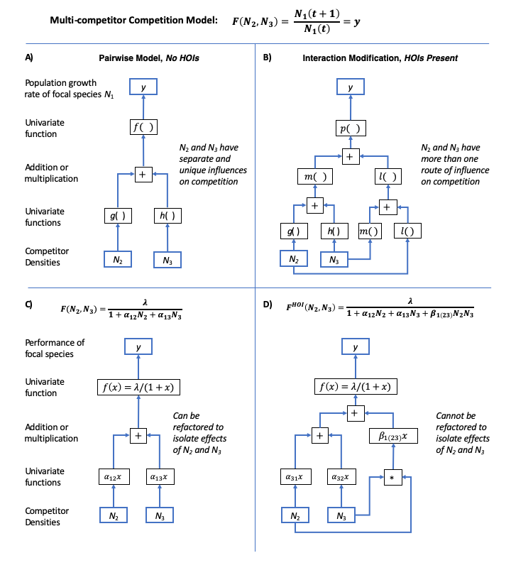

Figure Definition of higher order interactions illustrated by functional dependency diagrams. In each panel, we illustrate how a multi-competitor competition model is broken down into a set of univariate functions connected by addition or subtraction. In A) a model is pairwise and does not have HOIs when there is only one path between competitor species’ density and the focal species’ performance. Following the blue arrows from the bottom of the diagram, the densities of each competitor, *N2* and *N3*, are inputs for functions *g* and *h*. The outputs of these functions are combined by addition and their sum is the input for the function, *f*, which returns *y*, the population growth rate of the focal species. By contrast, B) shows a model with HOIs, defined by the fact that there are multiple paths connecting the competitor species’ densities to the focal species’ performance. When competitor species have more than one effect depending on the density of another competitor, this is an HOI. In C) a specific example of a non-linear, but still pairwise, model is shown. In D) a specific example of a model with HOIs between competitors. The multi-competitor model involves more than one path from the competitor’s densities to the focal species.

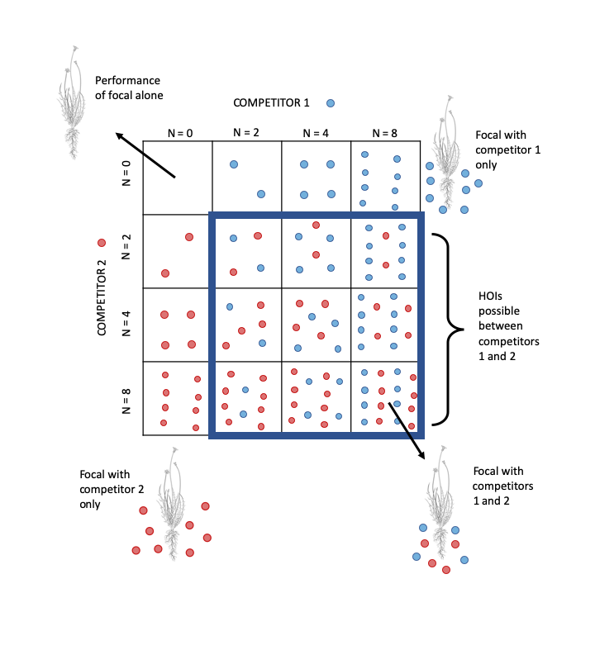

Figure Schematic of orthogonal competition experiment required to detect higher order interactions. Each square represents a separate study plot. Competitor 1, (blue circles) and Competitor 2 (red circles) are grown in a gradient of increasing density alone and together. A single individual of the focal species (line drawing) is grown in each plot allowing the response to competition from each competitor species to be fitted.

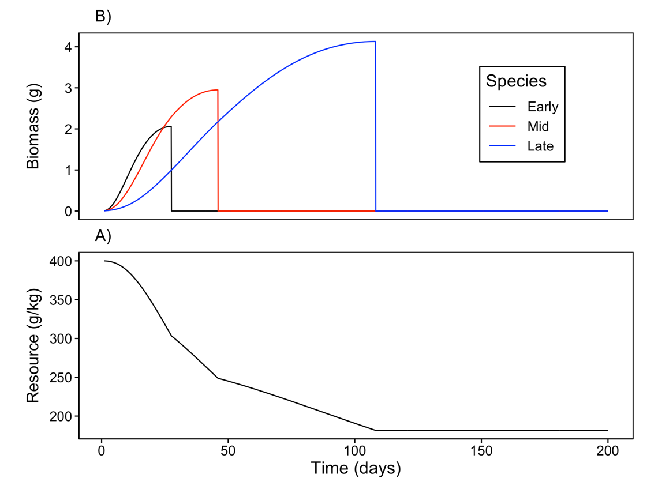

Figure 4. Example time course of A) annual plant growth and B) resource concentration during a single simulated growing season. In this example, each species’ population was initiated with one seed. The early season species (black) grows rapidly when resource availability is high and senesces early. By contrast, the late season species (blue) grows more slowly but grows later into the season as resource availability declines. The growth curve for the mid-season species (red) lies between these extremes.

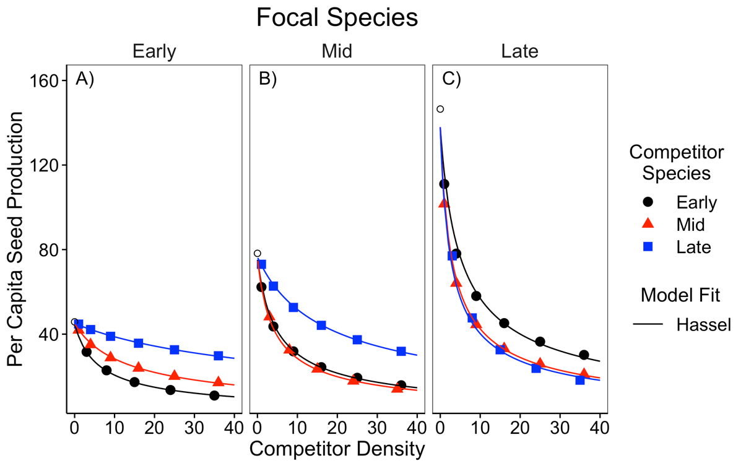

Figure 5. Simulated per capita seed production of the A) early, B) middle and C) late season species in response to a single competitor species at a time. Competitor density is shown on the x-axis. Colors and shapes indicate the identity of the competitor species. Open circles show the per capita seed production of each focal species in the absence of any competitors. The solid line shows the fit of the Hassel model.

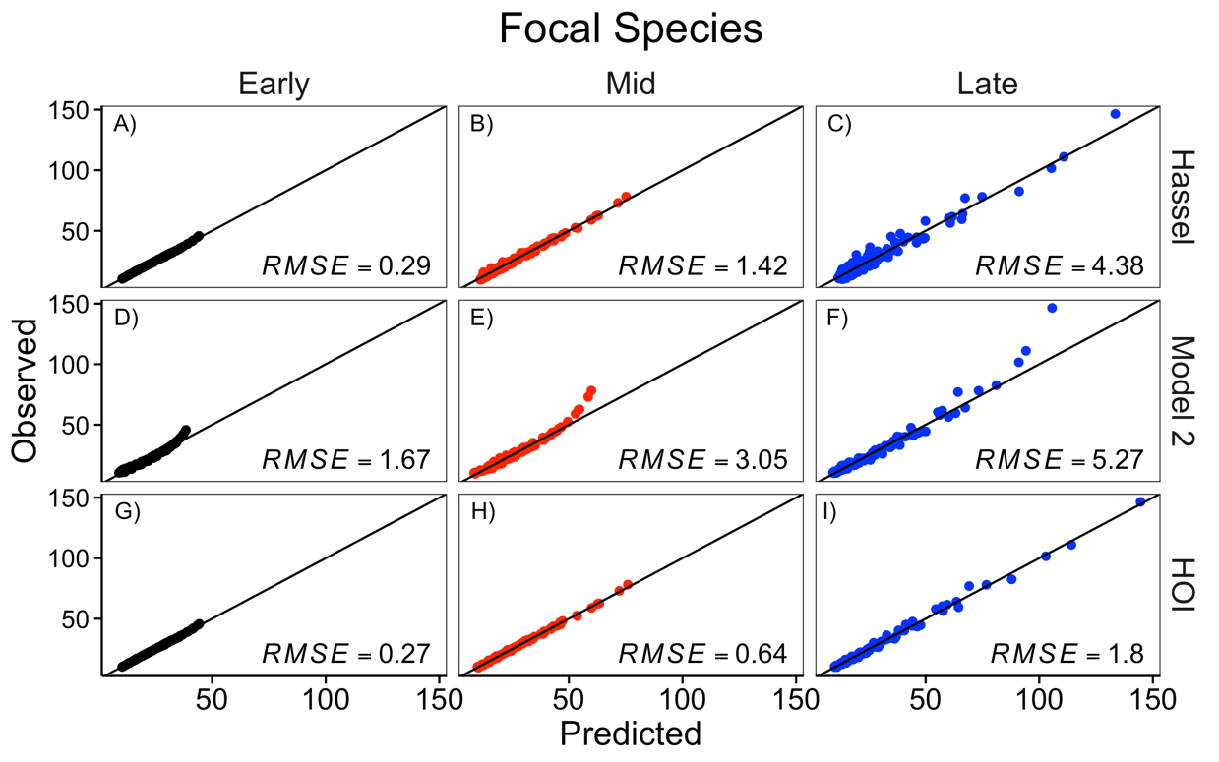

Figure 6. Comparison of the Hassel, multiplicative (model 2), and HOI models fit to each focal species. The y-axis shows the simulated per capita seed production of the focal species. The x-axis shows the per capita seed production predicted by the phenomenological model. The top row, A-C, shows the prediction for the Hassel model; the middle row, D-F, shows the prediction from the multiplicative model; and the bottom row, G-I, shows the prediction from the HOI model. The one-to-one line and root-mean-squared error (RMSE) for each model are shown on each panel.

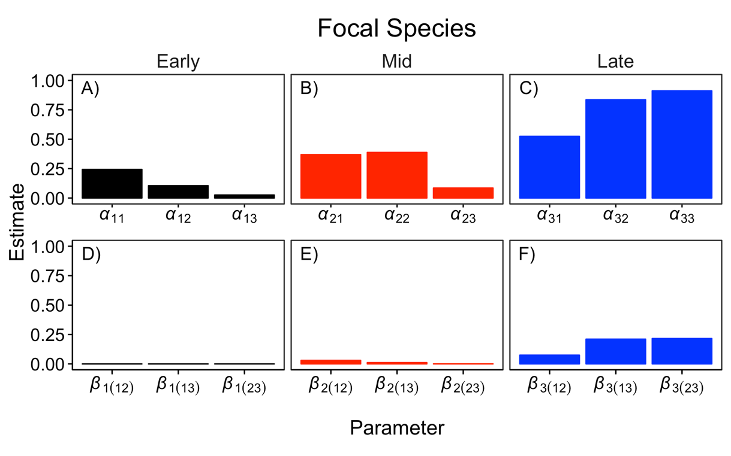

Figure 7. Interaction coefficients for each of focal species from the HOI model. The top row, A-C, shows the pairwise competition coefficients for the focal species and each competitor. The bottom row, D-F, shows the two-species HOI coefficients. Coefficient subscripts indicate which focal species and competitor species are involved, 1 = Early, 2 = Mid, 3 = Late.

# Supporting Information – Additional Tables

Table S 1 Table of parameter values used in the growth simulation experiment in the main text.

|  |  |  |
| --- | --- | --- |
| Parameter | Value | Definition |
| *U* | 200 | Duration of growth simulation (days) |
| *I* | 0 | Resource supply rate (g day-1) |
| *R(0)* | 400 | Initial resource concentration (g kg-1) |
| *d1* | 0.06 | Early competitor root density (g cm-3) |
| *d2* | 0.12 | Mid competitor root density (g cm-3) |
| *d3* | 0.36 | Late competitor root density (g cm-3) |
|  | 0.3 | Early competitor loss and respiration rate (g/g) |
|  | 0.15 | Mid competitor loss and respiration rate (g/g) |
|  | 0.053 | Late competitor loss and respiration rate (g/g) |
| *K* | 350 | Resource half-saturation constant (g kg-1) |
| *Vmax* | 1 | Maximum resource conductance (g d-1cm-2) |
| *p* | 0.5 | Ratio of root to total biomass |
| *nu* | 0.66 | Scaling exponent (unitless) |
| *q* | 0.2 | Biomass assimilation rate (g/g) |
|  | 0.005 | Seed mass (g/seed) |
| *c* | 0.1 | Conversion of final biomass to seed mass (g/g) |

# Supporting Information – Additional figures

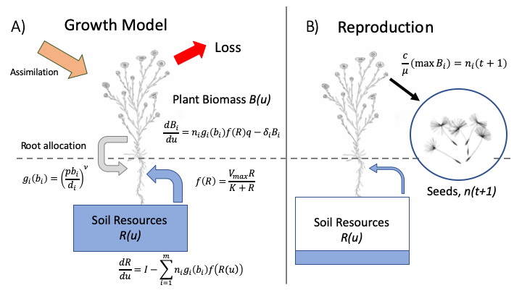

Figure S Diagram schematic of annual plant growth model used in simulation. A) in the model each individual plant start as a seed, grows over the course of a single growing season. Growth is a function of plant biomass, root surface area and soil resource availability. B) Over time the soil resources are depleted and plant growth slows down. Plants reach a maximum size when losses due to respiration and tissue senescence are greater than growth. At this point the plants convert stored resources to seeds. The number of seeds in the next growing season is determined as the total mass of seeds produced per species divided by the weight of a single seed.

# Supporting Information – Additional figures

# 

Figure S 2 Simulated per capita seed production of the A) early, B) mid and C) late season species in response to density of two interspecific competitors. Density of competitor species one is shown on the x-axis and density of competitor species two is shown with colors and shapes. Text in each panel lists the identities of competitor one and two (early, mid or late). Lines show best fit from the phenomenological models fit to the simulations. Residual sum of squared error is shown for each model and focal species.

# Appendix A – The effect of trait differences on higher order interactions

We used an additional simulation experiment to test whether the strength of higher order interactions (HOIs) was associated with the magnitude of functional differences between competitor species. We started with the same parameter values as in the simulation in the main text in which there was a large difference between the species in root density (*di*) and tissue respiration rate (*i*). In four additional simulation scenarios, we gradually decreased the average difference between species in these traits (Table A1). Specifically, we held the traits of the mid-season species constant and decreased the difference in the root density trait, *di*, between the early and late-season species. We assumed a trade-off between root density and tissue respiration rate such that changing root density also changed the tissue respiration rate, *i* (Figure A1). We quantified the average functional difference between species as the standard deviation of root density among all species. In each scenario, we simulated competition and fitted the phenomenological HOI model as in the main text. For each species in each scenario, we quantified the strength of HOIs as the average magnitude of the coefficients divided by the average magnitude of the coefficients. For the mid and late season species, the strength of the HOIs increased with the functional difference between species (Figure A1 B&C). For the early season species, HOIs were weak in all five scenarios (Figure A1 A). These simulations show that the functional differences between competitors drive the HOIs we observed in this system.

Table A 1. Parameter values for five simulations with gradually decreasing the trait difference between the early season and late season species. All other simulation parameters are the same as in Table S1.

|  |  |  |  |  |  |
| --- | --- | --- | --- | --- | --- |
| Functional  Difference | Scenario | Species | Root density *d*  (g cm-3) | Respiration rate *i*  (g g—1d-1) | Standard deviation of *d* |
|  | 1 | Early | 0.066 | 0.300 | 0.1460 |
| Large | Mid | 0.128 | 0.150 |
|  | Late | 0.343 | 0.053 |
|  | 2 | Early | 0.075 | 0.261 | 0.0821 |
|  | Mid | 0.128 | 0.150 |
|  | Late | 0.236 | 0.078 |
|  | 3 | Early | 0.088 | 0.222 | 0.0467 |
|  | Mid | 0.128 | 0.150 |
|  | Late | 0.181 | 0.104 |
|  | 4 | Early | 0.105 | 0.184 | 0.0208 |
|  | Mid | 0.128 | 0.150 |
|  | Late | 0.147 | 0.130 |
|  | 5 | Early | 0.132 | 0.145 | 0.0405 |
| Small | Mid | 0.128 | 0.150 |
|  | Late | 0.124 | 0.155 |

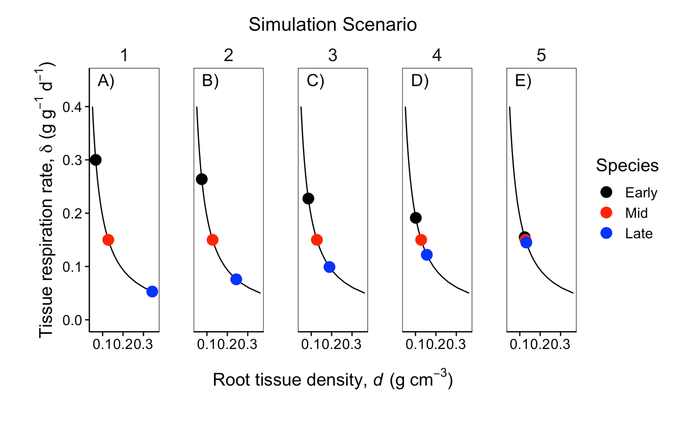

Figure A . Colored points show the value of functional traits, root density and tissue loss rate, for each of the three competitor species in each of the five simulation scenarios (A-E). Across the five scenarios, the differences between the early season and late season species’ root density and respiration rates were gradually decreased. The mid-season species’ traits were held constant. The black line indicates the trade-off between the root density and tissue respiration rate traits.

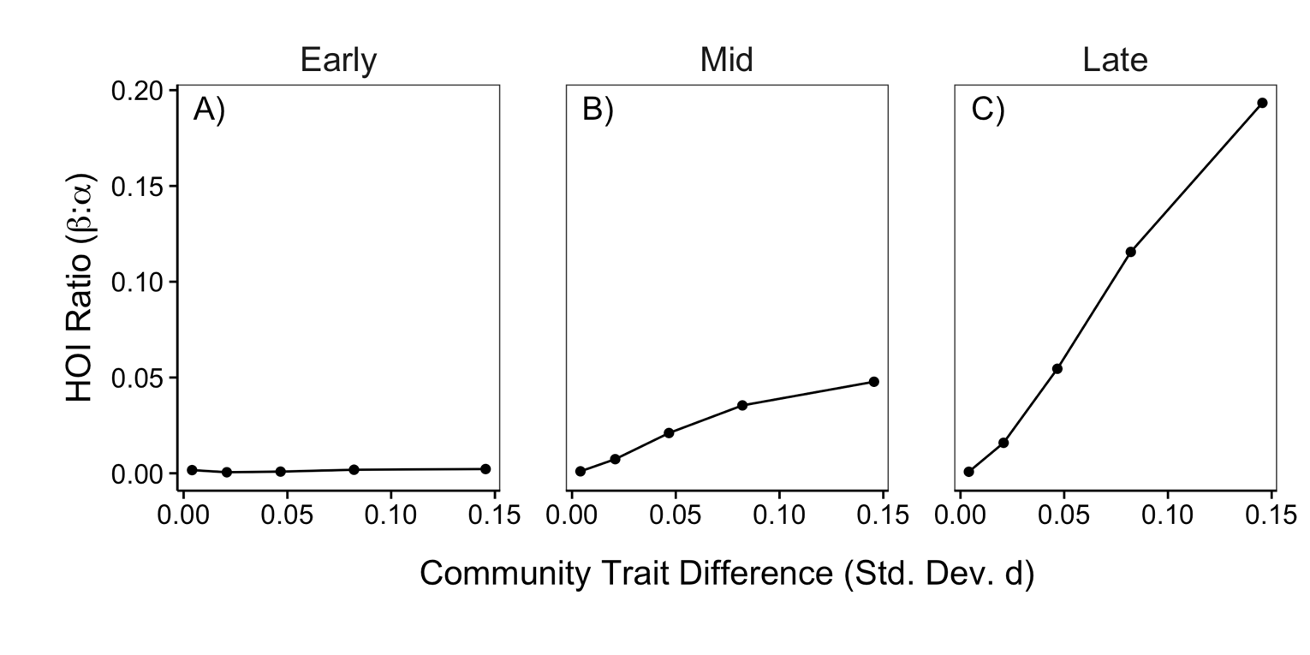

Figure A 2. The strength of HOIs depends on the difference in species functional traits. The y-axis quantifies the strength of HOIs affecting the early (A), mid (B) and late (C) species as the ratio of the of the average magnitude of the coefficients to the average magnitude of the coefficients in the phenomenological HOI model. A larger ratio ratio indicates stronger HOIs compared to pairwise interactions. The x-axis quantifies the community-level trait difference as the standard deviation of the root density trait, *d*.