­­

**Detecting Higher Order Competitive Interactions**

Andrew R. Kleinhesselink1, Jonathan M. Levine2, Nathan J.B. Kraft1

1Department of Ecology and Evolutionary Biology, University of California, Los Angeles 621 Charles E. Young Drive South, Los Angeles, USA

2Institute of Integrative Biology, ETH Zurich, Switzerland

Running Title: Higher Order Interactions

Word Count:

# Abstract

Almost every species on earth interacts with more than one competitor. When species simultaneously interact with two or more competitors, higher order interactions (HOIs) can invalidate the application of classical theories of species competition based on pairwise interactions. HOIs occur when the strength of competition between two species depends on the density of other species in the community. It is therefore critical to understand how often and by what mechanisms HOIs arise in order to extend pairwise ecological theory to multi-species communities. In this paper we discuss the definition of HOIs, the difficulties inherent in detecting HOIs and illustrate potential mechanisms that could lead to HOIs . We do this by simulating resource competition between three annual plant species differing in the phenology of growth. We then fit a discrete time phenomenological competition model to their dynamics in order to detect the presence of HOIs. We find that HOIs emerge most strongly for late season competitors- species that experience a competitive environment strongly modified by earlier growing competitors. We conclude that HOIs are likely to arise as an outcome of mechanistic resource competition played out in discrete time. Clarifying the source of HOIs in simple simulation models may help us better understand the true nature of competition and stability in multi-species communities.

*Key words: competition, coexistence theory, phenology, annual plants*

# Introduction

Almost every species on earth interacts with a diversity of predators, pathogens and competitors. Despite this reality, most classical models in community ecology summarize species interactions assuming that the per capita effect of one species on another is independent of the densities of other species in the system. In particular, models with such fixed per capita competitive effects have been critical to the development of modern coexistence theory (Chesson 2000, Levine et al. 2017), and imply that the dynamics of multi-species species competition can be predicted by understanding competition between all competitive pairs (Grilli et al. 2017a). This concept is central to recent efforts to relate species’ functional traits and phylogenetic relationships to the outcome of their competitive dynamic (Adler et al. 2013, Godoy et al. 2014, Kraft et al. 2015).

The potential for higher order interactions (HOIs) between species challenges the core assumption of many foundational models in ecology (Billick and Case 1994, Mayfield and Stouffer 2017, Levine et al. 2017, Grilli et al. 2017b). The conceptual importance of HOIs is clear: if HOIs are prevalent even a perfect understanding of competition between pairs of species may not be sufficient to describe the dynamics of communities with more than two species (Pomerantz 1981, Abrams 1983, Billick and Case 1994). The presence of HOIs challenges classical definitions of coexistence and the niche that rest on the assumption that intraspecific and interspecific interactions are fixed strength (Levine et al. 2017). In the extreme, HOIs may permit coexistence in communities of three or more species that are unable to coexist as species pairs (Grilli et al. 2017b).

Although there has been a revival in ecologists’ interest in the implications of HOIs for community coexistence the field still lacks a consensus definition of HOIs and robust methods to detect them in empirical data. The difficulty in defining HOIs was apparent early on (Vandermeer 1969, Neill 1974, Case and Bender 1981, Pomerantz 1981). Early discussions defined an HOI only within the context of a standard Lotka-Volterra competition model (Vandermeer 1969). Billick and Case (1994) attempted to define HOIs more generally as the presence of non-additive effects between species, but this definition was itself problematic (Adler and Morris 1994). A recent paper by Mayfield and Stouffer (2017) included non-linear intra- and inter-specific interaction terms in their definition of HOIs, which deviates from the original emphasis on interactions between more than two species. In another recent paper, Grilli et al. (2017b) demonstrate the implications HOIs could have for multispecies coexistence, but their example of HOIs are strictly speaking not interaction modifications at all, but rather more like indirect interaction chains (Levine et al. 2017). The renewed interest in HOIs demands a clearer definition of what these interactions truly are and a worked example showing how HOIs could be detected in the kind of empirical data ecologists actually collect.

In addition, the mechanisms that do and do not generate higher order interactions between competitors are unclear. Ecologists know that higher order interactions emerge organically in mechanistic competition models (Abrams 1983, O’Dwyer 2018), which has two key implications. First, since mechanistic models generate HOIs without the addition of explicit HOI terms, one might argue that the issue of higher order interactions is essentially an artificial construct of phenomenological models. However, the question of whether perfect knowledge of pairwise interactions is sufficient to predict the dynamics of more complex systems is fundamentally phenomenological and thus can only be investigated in the context of phenomenological interactions. Second, if mechanistic models almost unavoidably generate HOIs, this suggests that such interactions should be common in nature (Abrams 1983). This observation leaves the fact that there have been so few rigorous demonstrations of HOIs in natural communities somewhat of a mystery, aside from the logistical challenges of experiments that can test for them. An investigation of the mechanistic basis of HOIs would help ecologists predict when and where HOIs are most likely to emerge—and may help explain why phenomenological models without HOIs have been successfully applied in many communities.

In this paper we discuss the difficulties in defining HOIs, and the pitfalls inherent in detecting HOIs in empirical data. To illustrate our definition and to highlight the mechanism that can generate HOIs we construct a simple mechanistic resource competition model that captures key features of the kind of empirical data that ecologists often collect when studying natural populations. We use the mechanistic model to simulate a virtual field experiment on the effects of competition on individual performance. We then fit phenomenological models to the simulated data in order to assess the presence of HOIs. Our virtual experiment demonstrates that HOIs may indeed be common even in relatively simple mechanistic competition. Importantly, we suggest that systems in which competitors vary in timing of resource uptake are likely to show HOIs, and that HOIs will likely be stronger for species maturing later in the growing season. Our worked example also shows how the strength and even the direction of HOIs are dependent on the structure of the phenomenological model being fit to the data.

## What counts as a higher order interaction?

Competition occurs when individuals consume the same limiting resource, such that increases in consumer densities reduce the availability of resources, which in turn changes the population growth rate of the consumers (Meszéna et al. 2006). Thus, resource competition is an indirect effect of individuals on one another mediated by shared resources. The commonly used phenomenological definition of competition simplifies the representation of the interaction by focusing on the net effect of the indirect interaction without tracking the status of shared resources. At the population-level, phenomenological competition is measured as the reduction in a per-capita population growth rate due to an increase in density of individuals of the same trophic level (Chesson 2000).

Arguably the greatest benefit of modeling competition phenomenologically is that such models can be fitted to empirical data for any pair of species without making assumptions about which resources or environmental factors are limiting to their populations (e.g. (Kraft et al. 2015)). This power, however, comes with complications. Phenomenological models require choosing a functional form for the effects of species density on population performance. As we will show, this choice fundamentally dictates how we define species interactions and the how we could detect higher order interactions (Adler and Morris 1994).

In order to construct a useful definition for HOIs, we start from what we see as the important implication HOIs have for community dynamics: the presence of HOIs means that even with perfect knowledge of how each pair of species compete against one another, an ecologist would nonetheless be unable to predict the dynamics of a community with more than two species. While this may sound mysterious, HOIs can arise from a simple modification of standard competition models: if we assume, as is done in the classical Lotka-Volterra model, that interactions between species to be independent of the broader competitive environment, then there are no HOIs; if on the other hand, we allow interactions between species to depend on the density of other species then this leads to HOIs (see (Billick and Case 1994)). Thus HOIs and interaction modification are often discussed as two sides of the same coin (Adler and Morris 1994).

Nevertheless, recent theoretical and empirical papers have defined HOIs in other ways. For instance, Grilli et al. (2017b) show how HOIs can emerge even without interaction modifications. However, what the authors call HOIs in their model are essentially indirect effects or interaction chains (Levine et al. 2017). These appear to be HOIs on the time scale of the longest lived life stage of in the competing populations because their model does not explicitly track the density of early stage competitors through time.

In a study of annual plant competition, Mayfield and Stouffer (2017) define as HOIs any polynomial terms of species density in their demographic model that improve the statistical fit to the data. Thus, their definition includes interactions between intraspecific and interspecific density and even quadratic terms involving the density of only one species. While including these terms as HOIs simplifies the statistical detection of HOIs these kinds of HOIs have different implications for community dynamics than the definition we emphasize above. For instance, interspecific by intraspecific HOIs are inherent in pairwise competition and are not an emergent property of multispecies communities. And including quadratic density terms within the definition of HOIs is inconsistent with idea that HOIs result from interaction modification: i.e. how can a species modify its own competitive effect? A similar problem was pointed out early on by Pomerantz (1981) who argued that a distinction needed to be made between HOIs and non-linear density dependence.

< I haven’t worked out the transition here to the next paragraph, but we wan to introuduce our own definition at some point>

HOIs have been defined as non-additive effects of separate species on per capita growth rate of a focal species (Billick and Case 1994). This definition is straightforward in cases where competition between pairs of species is fit using the Lotka-Volterra differential equations (Abrams 1983) because this model is essentially additive. However, aside from rapidly reproducing microbes or plankton, ecologists rarely measure populations more than once or twice a year, and such data are fit with difference equations in discrete time, rather than differential equations in continuous time. We argue that in the context of discrete time difference equations, defining HOIs as non-linear per capita density effects, or strictly as non-additive species effects can lead to considerable confusion about what causes HOIs.

Consider that the most widely used discrete time models for density dependent population growth, such as the Hassel and Ricker models imply that per capita competitive effects depend on density (Hassell and Comins 1976). Specifically, in these models per capita competitive effects decline as density increases, as can be seen by looking at how the slope of these functions change with respect to competitor density (Figure 1). That per capita competition should decline with density is necessitated by a simple argument: if it did not, then competition could force a species’ per capita growth rate negative (Figure 1 C) – which is nonsensical in a discrete time model. For the same reason, species effects are not, strictly speaking, additive in such models. Since non-linear density dependence and non-additive species effects are a property of all the commonly used discrete time models, these properties should not be taken as our definition of HOIs.

As pointed out by Billick and Case (1994), non-additivity does not require more than two species. Non-additivity can occur if intra-specific effects are modified by interspecific effects of one other species. However, these kinds of HOIs would still allow one, in theory, to predict population performance in multispecies communities from data on pairwise interactions. We focus our examples on cases where a third species modifies the interaction between two other species throughout the remainder of the paper because this type of interaction modification has generally received the most attention (Adler and Morris 1994, Grilli et al. 2017b). Resolving the mathematical definition of HOIs is a necessary first step for understanding these interactions, but does not clarify the processes generating these interactions in nature. Addressing these processes is the subject of the remainder of this paper.

**Box 1: Defining HOIs ------------------**

A mathematical definition of HOIs starts with a general phenomenological model of species competition in discrete time,

|  |  |  |
| --- | --- | --- |
|  |  | (1) |

where is the density of species at time , is a function that gives the per capita population growth rate as a function of the densities of species , and . A Beverton-Holt model of density dependent competition, for example, is a specific case of this general functional form in which the per capita population growth rate declines in proportion to the inverse of the sum of competitor densities,

|  |  |  |
| --- | --- | --- |
|  |  | (2) |

where is the per capita population growth rate in the absence of all competition and gives the per capita competitive effect of each individual of species *j*.

Despite the fact that the functional relationship between population growth rate and competition is non-linear in the Beverton-Holt model, it is possible to transform population growth by some function, such that the effects of competition are additive on this scale. In this case, we transform population growth rate by dividing by , then taking the inverse and subtracting one,

On this transformed scale we can still predict the overall effects of competition in multi-species community by adding up the separate pairwise competitive interactions and applying the appropriate transformation—competition is additive on the transformed scale and there are no HOI’s.

In contrast, consider the case with a higher order interaction where, . The coefficient captures an HOI between species *j* and *k*. So long as , there are no transformations of the population growth rate that will allow us to assess the effects of species *j* and *k* as a linear combination of their effects. By extension, we also cannot predict the population growth rate of species *i* in a multi-species community from just the pairwise interaction coefficients. From this definition, even a two species community can include non-additivity and HOIs, as might describe the effects of species *j* and on the effect species *i* has on itself (Billick and Case 1994, Mayfield and Stouffer 2017).

[ end box ]

# HOIs arise from unmeasured population states < I cut this >

# HOIs in a mechanistic resource competition model

To illustrate how HOIs might be detected in data on species interactions and to explore the processes that could lead ot HOIs in a discrete time model, we simulate competition among annual plants for a single shared resource over continuous time using a mechanistic resource competition model. We then describe competition in the system using a simple phenomenological competition model. By comparing the cases in which higher order interactions emerge or fail to emerge in this phenomenological description of the system, we can address the processes causing these interactions develop.

Our mechanistic model is inspired by California annual plant communities. In this system, rainfall generally starts in the early winter and gradually declines through the spring while temperature and evaporative demand increase. Plants germinate in the winter and grow until they begin to flower in spring. By summer, most plants have completed flowering and produce seeds and die. In our model, we track a single pool of generic soil resources, most easily conceptualized as water given its timing of availability. Importantly, this pool is not resupplied during the growing season. As spring progresses, plants grow larger and use up the pool of stored soil resources. Because growth is resource dependent in our model, plant growth slows and eventually net growth is negative as resources are depleted. We make the assumption that when net plant growth stops, the optimal behavior of the plants is to stop producing vegetative biomass and start producing seeds (Cohen 1976).

The model is expressed as a set of differential equations,

|  |  |  |
| --- | --- | --- |
|  |  | (3) |

where gives the resource availability at time , and gives the resource supply rate. The final term expresses the loss of resources due to uptake by plants. Plant biomass of species at time is given by , *s* is the number of species in the community and is the resource dependent uptake function for species *i*. We simulate a Mediterranean climate by setting initial resource availability high, , and setting the resource supply rate to zero—resource availability starts out high and is gradually depleted (Figure 3 a).

Growth of each species is simulated with a piecewise differential equation dependent on resource availability,

|  |  |  |
| --- | --- | --- |
|  |  | (4) |

where, is the total biomass of species , is a resource conversion factor, is a per biomass respiration and tissue loss rate, and as in the first equation, is a function giving resource uptake rate. The growth of each species stops when meaning that biomass gained is equal to biomass lost to respiration and maintenance. The optimal behavior of the plant at this point is to stop growing and convert all biomass to seed mass. We impose this behavior on the model by setting growth to zero when resources fall to this point.

Different species are likely to have different rates of resource uptake and growth. In our simulation, we assume a trade-off between rates of resource uptake at high resource availability and rates of resource uptake at low resource availability (Figure 3c). This means that species which grow rapidly early in the season when resource availability is high will stop growing and produce seed earlier (Figure 3b). In contrast, species that grow slower early in the growing season are able to persist later into the season when resource availability is low.

This trade-off between species in early and late season growth rates is produced by giving each species a unique resource uptake function (Miller and Klausmeier 2017),

|  |  |  |
| --- | --- | --- |
|  |  | (5) |

where, is the maximum rate of resource capture and is the half-saturation constant of resource capture. The unique resource uptake curves result in unique growth and phenology for the three species we model here, and term ‘early’, ‘mid’ and ‘late’ (Figure 3). The differences in the timing of growth of species in this model recreates important functional differences between species observed empirically in this system (Godoy and Levine 2013).

So far, we have described a model of growth dynamics in continuous time *u* within a single generation. By contrast, for fitting the phenomenological competition models, we track the total population size of each generation at a discrete annual time . To calculate the total population size of each species in year we take each species’ maximum vegetative biomass during the growing season, multiply that by a conversion factor to get total number of seeds produced. Thus,

|  |  |  |
| --- | --- | --- |
|  |  | (6) |

where is the number of seeds produced at the end of the growing season, and therefore available to start the next years population growth. We assume that there is no seed mortality between years and all seeds germinate.

We simulate these dynamics using the ordinary differential equation solvers package desolve in the statistical program R (R Core Team 2015). Simulation parameters and code to run the simulations are given in the supporting information.

Finally, we used this mechanistic model to simulate plant growth when faced with a range of densities of one or two other competitors, and from these simulated data we fit a phenomenological competition model. In the simulated experiment each of the three species are grown against increasing densities of either one interspecific competitor species or two interspecific competitor species at once. For each simulation, we calculated the per capita reproductive output of the focal species and fit the phenomenological competition models described in the next section to our simulated experimental data.

## Phenomenological annual plant model

We model annual plant competition in terms of the decline in per capita reproductive output with increasing density of competitors at the start of the growing season (). We tested two different phenomenological competition models. The first has been used in a number of empirical studies of annual plant competition (Rees et al. 1996, Freckleton et al. 2000, Kraft et al. 2015),

|  |  |  |
| --- | --- | --- |
|  |  | (7) |

where denotes maximum per capita reproductive output, is the per capita competitive effect of species on and is a species-specific parameter controlling how steep fecundity declines with competition in general.

We also fit a second model in which the effects of each species are modified with a separate exponent where

|  |  |  |
| --- | --- | --- |
|  |  | (8) |

This allows species to have per capita effects that depend on density but the competitive effects of each species are still additive. We fit separate competition models for each of three species using the nls package in R. We calculated for each species as the per capita fecundity in the absence of any competitors and set this as a fixed parameter when fitting the models.

In order to detect HOIs emerging from these simple dynamics and measure their strength we first fit the phenomenological models to cases where each focal species faced increasing densities of one other competitor species at a time- the pairwise case. Once we had shown that phenomenological models fit these pairwise dynamics adequately we used the best fitting model to predict species fecundity in the case where the focal species simultaneously faces two interspecific competitor species. This approach provides a direct and concise test of the assumption of additive species effects in this simulation. If species effects are additive, then our model fit to density gradients of a single competitor species should be able to predict the joint effect of competition from two competitor species together. The average deviation between the fecundity of each species predicted by the additive phenomenological model and the fecundity observed in the simulations is a measure of the effect of the HOIs between the competitors. Importantly, this approach does not require that we specify the functional form of the higher order term- i.e. whether a function that includes an or term best describes the data.

# Evidence for HOIs

For all three species we found that the modified phenomenological competition model with varying exponents on species effects fit the simulated data accurately (, whereas the standard model with one coefficient per recipient of competition did not fit the data as well (Figure 4). When we tested how well the pairwise competition model fits predict species’ response to simultaneous competition from two other species, we found the emergence of HOIs depended on the focal species’ phenology (Figure 5). For the early species, the observed effect of the two other competitors on its growth was close to that predicted by each of their pairwise effects (Figure 6). For the mid and late season species, the predicted fecundity based on pairwise interactions did not match the observed fecundity when the focal species faced the two other competitors at once (Figure 6). Specifically, the additive model underpredicted the strength of competition on the mid-season species (Figure 6 b), and overpredicted the strength of competition on the late species (Figure 6 c). The difference between the predicted and observed effects of competition on the mid and late season species indicate the presence of HOIs: in other words, competitors’ effects change depending on the presence of other competing species.

In sum, our example shows that even in a relatively simple resource competition model, the effects of multi-species competition may not match the additive effects of pairwise species competition. Our method of comparing the effects of competition assuming additivity to the observed effects of multispecies competition is a useful way to determine the presence of HOIs without assuming a specific functional form for the HOIs. This makes it a diagnostic tool, not a way to predict multispecies community dynamics.

**Box 2: The problem of non-constant competition coefficients -----------------**

We found that interspecific competition did not have constant per capita effects on the mid and late season species (Figure 4). In order to fit these effects, we modified each of the interspecific competition terms with an exponent, , in equation 8. This creates a conceptual problem in applying our definition of HOIs in this system (Box 1).

To see why, consider two species, species A and B, with identical resource consumption curves and therefore identical effects on a third competitor, species C. If we use equation 8 to model how the per capita fecundity of species C declines in response to density of A and B separately we would find that the parameters for the two competitors were identical: , and . Our definition of HOIs suggests that if there are no HOIs, the true response of C to the combined effect of A and B together will be proportional to the inverse of the sum of their separate competitive effects:, where and give the densities of A and B respectively. However, since we have assumed that individuals of A and B are identical we know that their true effect on C must in fact be equal to the expression These two expressions are not equal, , for non-zero densities of competitors and where and . This means that our definition of HOIs, non-additivity of competitive effects, is technically only correct when per capita interspecific effects are constant. It also hints that any system that is characterized by non-constant per capita competition, should produce HOIs. [ end box 2]

*What Causes Higher Order Interactions?*

In this model, HOIs emerge because species growth and resource uptake rates are dependent on the current availability of resources in the system (Figure 3 c). This means that as species use resources they not only affect the growth rates of their competitors, but they can also affect the net interaction between their competitors. For instance, the early species has the most rapid growth and resource uptake rate early in the season when resource concentrations are high and it has a strong impact on early season resource availability. This shifts the resource uptake rates of the mid and late season species left along their resource uptake curves. Figure 7a shows how the timeseries of resource uptake rates of the mid and late season species shift earlier in response to the change in resource availability caused by the early season species. Because the mid and late season species resource uptake curves are shaped differently, this reduces the uptake rate of the mid-season species more than the late season species during the period of time when both species are active, that is until the mid-season species stops growing (gray vertical lines Figure 7 a). Taking the time averaged resource uptake rates of each species over this period shows the effect more clearly (Figure 7 b): the average resource uptake rate of the mid-season species declines much more than that of the late season species over in response to the early season species.

This differences in how much the species resource uptake rates change, explains the direction of the HOI effect of the early and mid-season species on the late season species: in the presence of the early season species, the late season species gets a larger share of the resource pool it competes for with the mid-season species, and the joint effect of competition is less than additive (Figure 5 c; Figure 6 b). The same dynamics cause the mid-season species to experience stronger than additive competition from the early and late species together: in the presence of the early season species, the mid-season species gets a smaller share of the resource pool it competes for with the late season species (Figure 5 b; Figure 6 b).

By contrast, the early species is only weakly affected by HOIs (Figure 6). This is partly because it dominates early season resource competition and then senesces before its competitors grow large (Figure 3). In principle, resource uptake by the late season species should reduce the early season species’ average resource uptake rate more than it does the mid-season species, thereby strengthening the effect of competition on the early species. However, the late season species grows much slower early in the season than either of the other species and so it only has minimal impact on the resource availability. Meanwhile, the mid-season species does not significantly change the resource uptake rate of the late season species—the late species’ resource uptake curve is flat over the range of resource availabilities that the early species is active (Figure 3).

The origin of HOIs in this system are consistent with the arguments in favor of HOIs put forward by Abrams (1983). Abrams argued that HOIs should occur when competing species have different non-linear responses to resource availability. In our simulation, the resource uptake and growth rates of the competing species follow a Monod or type II functional response to resource availability (Figure 3c). They also stop competing at different resource availabilities. This means that competition between pairs of species depends upon the level of resources available. Since all species also influence the resource concentration itself, it follows that competition between any pair of species is influenced by the presence of other species in the community—the definition of a HOI.

What makes our example more complicated, but perhaps more realistic, is that unlike in classical resource competition models, resources do not reach an equilibrium during the course of our simulation. Rather they are constantly declining throughout the season (Figure 3 a). Classically, deriving competition coefficients from a mechanistic resource competition model involves solving stable resource equilibria and then calculating the first order sensitivity of the growth rate of each species to the resource availability and the sensitivity of the resource to the consumers (Tilman 1977, Abrams 1983, Meszéna et al. 2006). However, we believe that in many natural systems, such as those involving annual plants, the pace of resource dynamics may be as rapid as the change in consumer biomass. This makes deriving competition coefficients analytically much more difficult. The great advantage of statistically fitting a phenomenological model to observed or simulated effects of competition is that this approach can help us understand pairwise competition even in such complex cases. However, our work here shows that this advantage may come at the cost of ignoring important HOIs in multispecies communities.

# Are HOIs Common in Nature?

One way to view HOIs in this system is to consider it a specific instance of a more general case in which the trait that determines each species’ impact on and sensitivity to resource availability is itself governed by resource availability (Meszéna et al. 2006). In this case, the trait in question is the temporal dynamic of resource uptake by each species, which shifts in response to resource availability and thus the activity of competitors. More generally, we believe a general recipe for HOIs will be systems in which 1) some species can cause large resource fluctuations, 2) the traits of other species that control resource uptake shift in response to resource availability, and 3) the strength of this response varies across species. Among plants, plastic changes in traits such as height, specific leaf area, and phenology, have been shown in response to competition and changes in resource availability e.g. (Aronson et al. 1992, Bennett et al. 2016, Conti et al. 2018). In theory, these traits should also determine each individual’s impact and sensitivity to competition. So, are HOIs inevitable? And if so why are so few documented examples among competing plants (but see Mayfield and Stouffer 2017)?

One hypothesis is while HOIs are common, they are often weak. A key factor in producing HOIs in our simulation is that each species differs in the shape of its resource uptake curve. The weaker the trade-off between resource uptake rates at high versus low resource availability, the weaker the HOIs are in this system (Appendix B). In nature, such strong trade-offs may be rare.

The very large changes in resource availability and plant biomass in our simulation also contribute to the strength of HOIs. Because resource availability fluctuates widely in our simulation it means that species interactions change dramatically over the course of the season. Without the extreme fluctuation in the resource environment, species would have relatively constant competitive effects on one another and no HOIs would emerge. For instance, compare our system to an idealized version of resource competition experienced by competing perennial plants in a temperate climate (Dybzinski and Tilman 2007). Due to their large size, perennial plants can be assumed to quickly draw resources down to a dynamic equilibrium close to the environmental resource supply rate. Thus, even if species have different non-linear responses to resource concentration the fact that resource concentration is relatively fixed eliminates the possibility of strong higher order interactions. Because of their resource dynamics, seasonally forced systems, such as annual plant communities in a Mediterranean climate, may be a good place to look for strong HOIs (Mayfield and Stouffer 2017).

# Conclusion

We have sought to clarify the definition of HOI’s and explain how they could arise from relatively simple competitive dynamics. We illustrate this point with a simple mechanistic model of species competition for a single resource. Separating cases where non-additive competition is due to indirect effects mediated by intermediate population states, and those where competition is fundamentally irreducible to pairwise competition will be an important challenge for future empirical studies of HOIs. Our analysis also reveals a potential difficulty in formulating a truly general way of measuring HOIs—it may be that HOIs are only defined in cases where per capita interspecific competition is constant (Box 2). While we believe that HOIs should be common in nature this does not mean that they will be strong or strong enough to detect statistically in empirical settings. Our work suggests that environments in which resource availability varies strongly throughout the season may be a likely place for HOIs to emerge.

# Acknowledgments

# References

# Figures

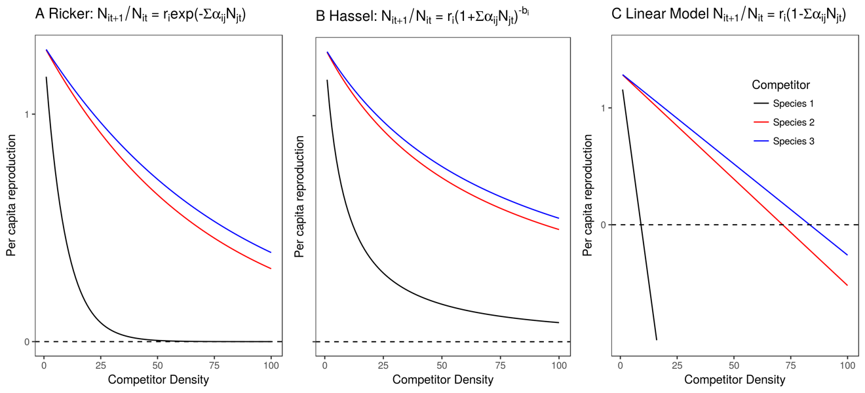

Figure 1 Density dependence of per capita reproduction rate in three different discrete time models, A) Ricker, B) Hassel, and C) Linear.

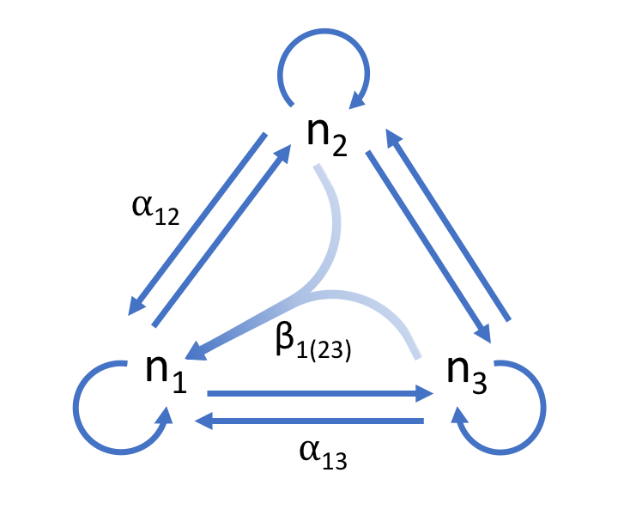

Figure 2. Three species competitive network. Inter- and intraspecific competition between species is depicted with the blue arrows. The effect of species two on one can be described by the per capita effect α12. An HOI, β1(23), is depicted as converging arrows showing that the effects of two and three on species one is non-additive.

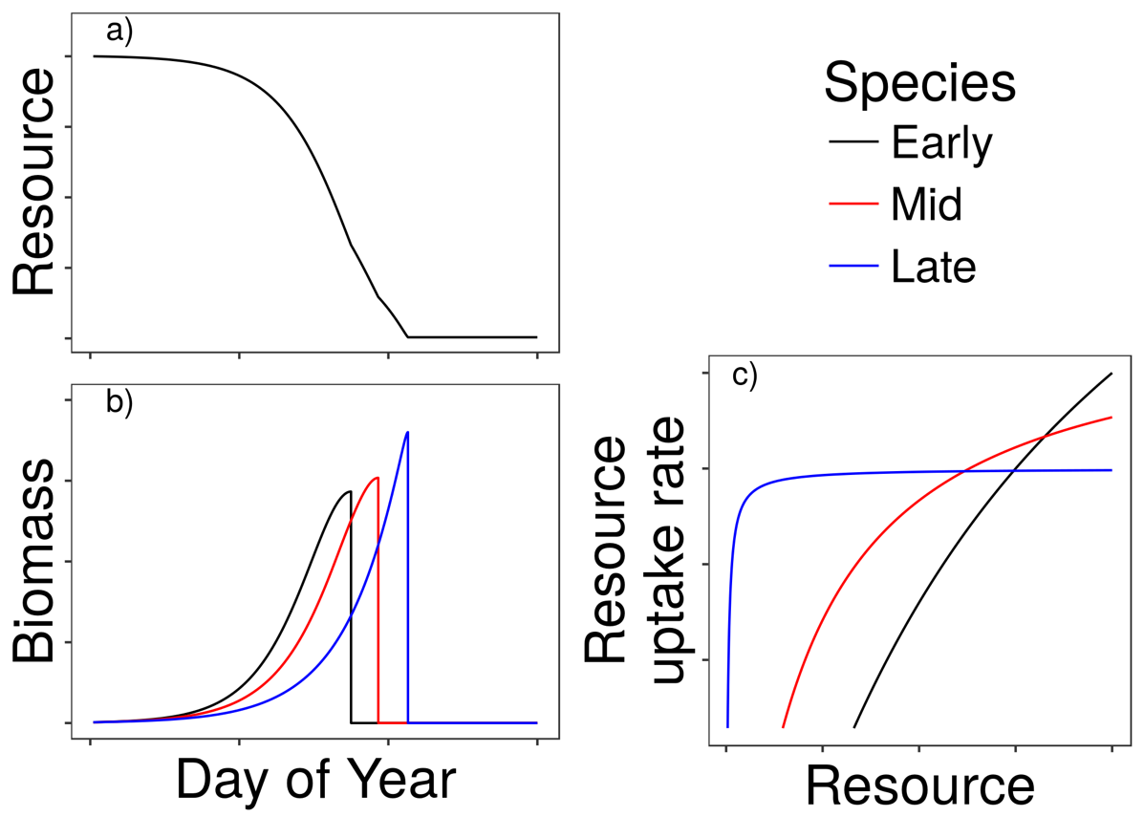

Figure 3. Example time series showing a) the drawdown of the resource during the course of the simulated growing season, b) the growth of each of species shown with colored lines and c) the dependence of resource uptake rates on resource concentration. The early season species grows rapidly when resource availability is high and senesces early. By contrast, the late season species grows slower than species one and two when resource availability is high but it is able to maintain higher rates of resource uptake at lower resource concentrations. This allows it to grow later into the season and senesce last. The middle season species lies between these extremes.

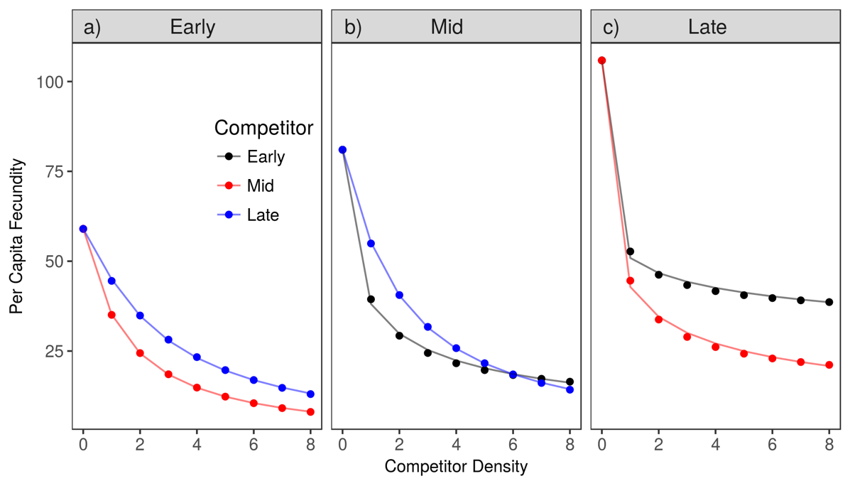

Figure 4. Simulated per capita seed production of the a) early, b) middle and c) late season species in response to increasing inter-specific density on the x-axis. Colors correspond to the identity of the competitor species. The solid line shows best fit line from the model with varying exponents on each competitor’s effect (eq. 8).

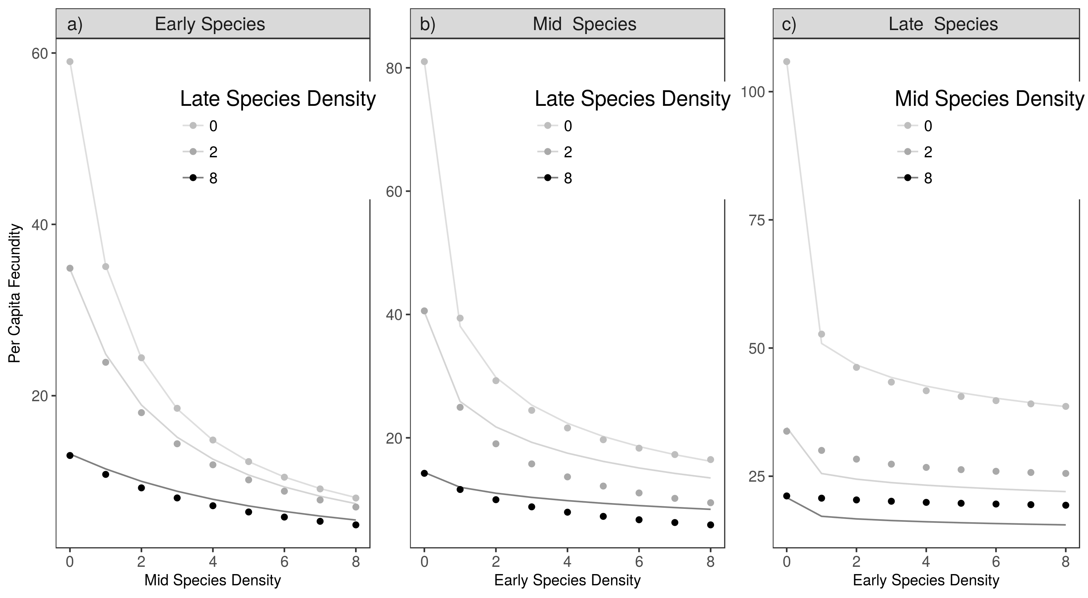

Figure 5. Simulated per capita seed production of the a) early, b) middle and c) late season species in response to increasing competition from two species at once. Increasing densities of one competitor species are shown on the x-axis and three different levels of density from another competitor are shown with the varying shades of gray points. Only the response to interspecific competition is shown. The lines show the predicted per capita fecundity from the competition model with varying exponents (eq. 8). The predictions are generated assuming that single species competitive effects are additive. Deviations between the observed (simulated) fecundity and the predicted fecundity (lines) indicated that competition is non-additive.

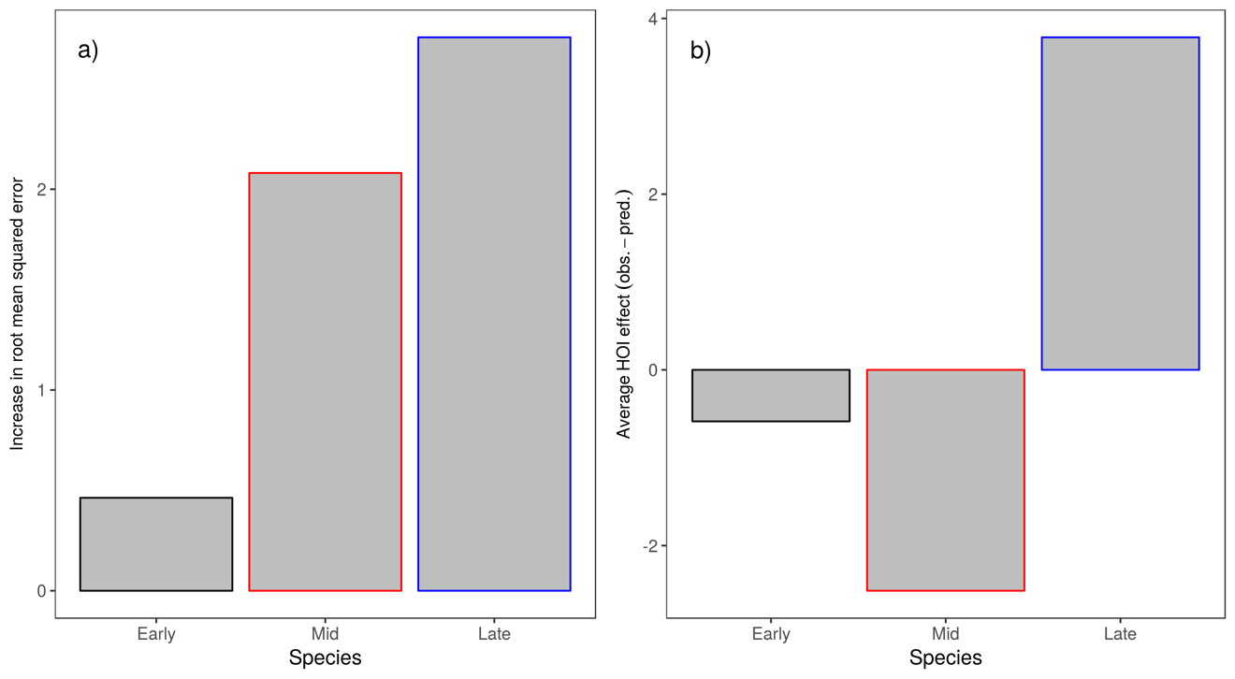

Figure 6. Non-additivity of two-species interspecific competition for each of the focal species. A) The amount of non-additivity is shown as the increase in root mean squared error of the phenomenological model (eq. 8) in multispecies competition compared to single species competition. B) The average strength and direction of the errors are shown, positive values show that competition was less than predicted, a positive effect of the HOI, negative values show where competition was greater than predicted, a negative effect of the HOI.

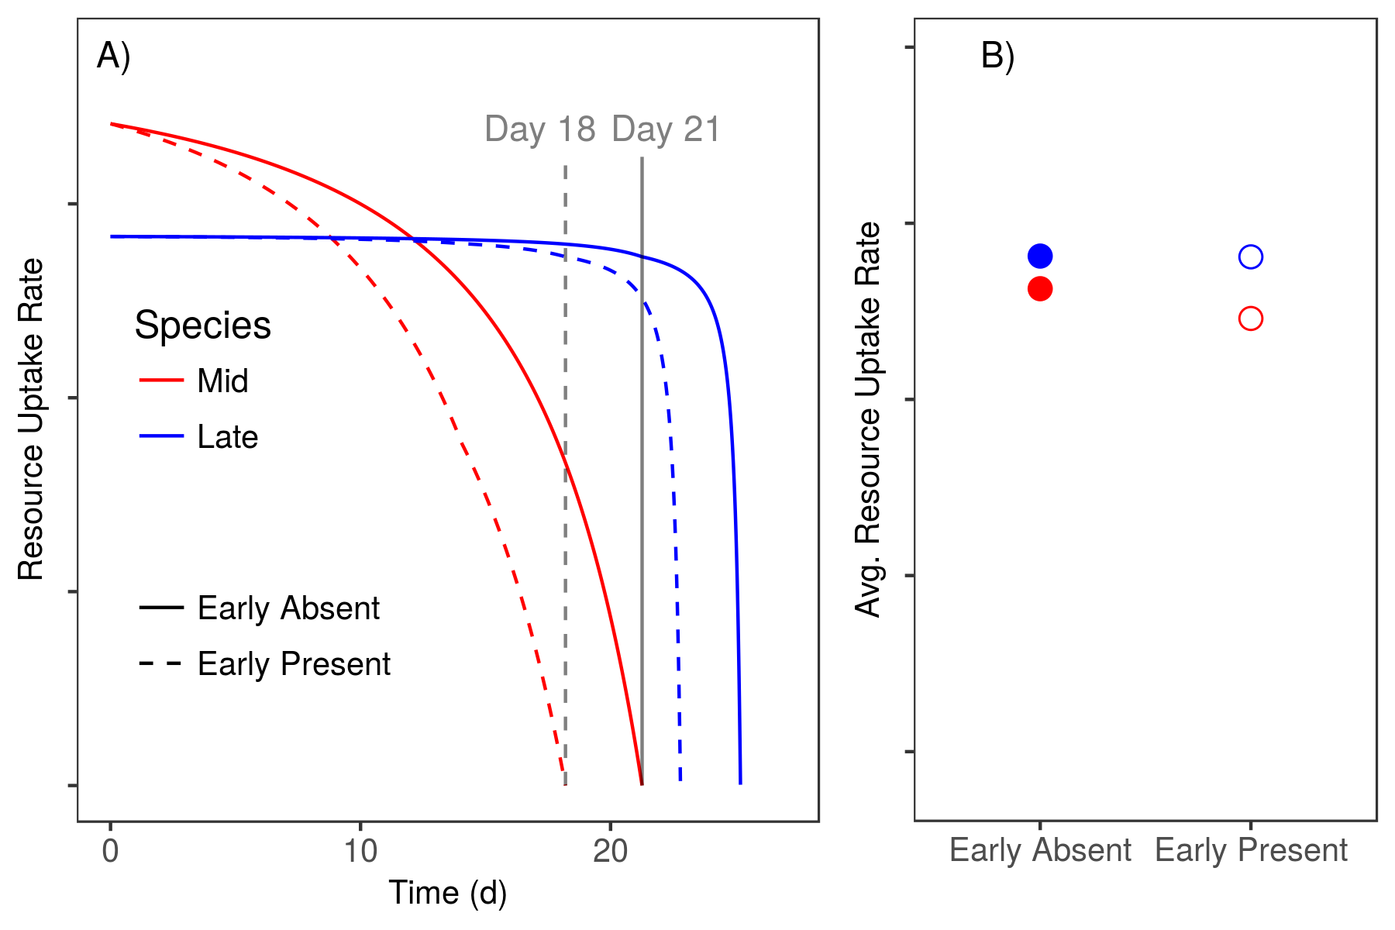

Figure 7. Mechanistic explanation for higher-order interactions. A) The resource uptake rates of the mid and late season species over the course of a growing season, with and without the early species. Gray vertical lines show the date at which the mid-season species stops growing with and without the early species. B) The average resource uptake rates of the mid and late season species in the absence and presence of the early season species.

# Appendix A – Interaction modification leads to non-additive competition:

Assume that competition affecting species one is given by . If we relax the assumption that pairwise competition coefficients are fixed and instead allow for interaction modifications, then competition coefficients may depend on other competitor densities. We can show this by replacing with a linear function of : . Now the competitive effect of on depends on . If we re-write and take into account this interaction modification we arrive at a model that looks equivalent to the one in the main text: .

# Appendix B – The effect of relative non-linearity in resource uptake curves on higher order interactions

In order to test whether stronger higher order interactions were associated with the relative non-linearity of the competitors’ resource uptake curves, we simulated an additional five communities in which we varied the degree of relative non-linearity between species resource uptake curves. We did this by starting with a scenario in which each species was given a resource uptake curve close to the mid-season species in the main text (Figure 3 b). In this first scenario there is very little difference between species in their resource uptake curve. Then we parameterized four additional scenarios, each with an increase in the maximum uptake rate and half-saturation constant of the early season species, and a decrease in the maximum uptake rate and half-saturation constant of the late season species (Table B1; Figure B 1 A). We then simulated competition, fit phenomenological competition models, and compared the predicted effects of competition assuming additivity, to the observed effects of competition as in the main text. Our simulations show that as the relative non-linearity between species is increased, the error between the additive phenomenological model and the simulated observations grows (Figure B 1).

|  |  |  |  |
| --- | --- | --- | --- |
| Scenario | Species | Max Uptake Rate (r) | Half Saturation Constant (K) |
| 1 | Early | 2.92 | 50.88 |
| Mid | 2.60 | 30.00 |
| Late | 2.50 | 23.79 |
| 2 | Early | 3.24 | 73.32 |
| Mid | 2.60 | 30.00 |
| Late | 2.40 | 17.74 |
| 3 | Early | 3.56 | 97.32 |
| Mid | 2.60 | 30.00 |
| Late | 2.30 | 11.84 |
| 4 | Early | 3.88 | 122.88 |
| Mid | 2.60 | 30.00 |
| Late | 2.20 | 6.09 |
| 5 | Early | 4.20 | 150.00 |
| Mid | 2.60 | 30.00 |
| Late | 2.10 | 0.50 |

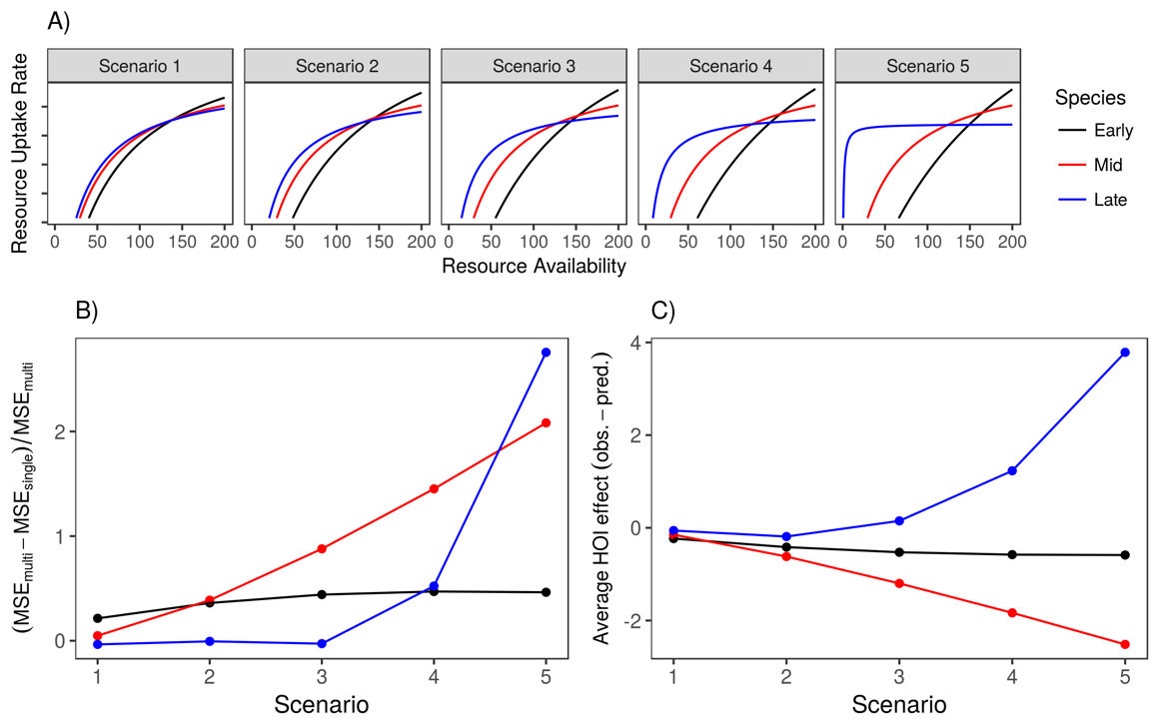

Figure B 1. Increasing the relative non-linearity of species resource uptake curves increases the non-additivity of competition in multispecies communities. A) Shows increasing relative non-linearity between species’ resource uptake curves in five scenarios. B) The amount of non-additivity is shown as the increase in root mean squared error of the phenomenological model in multispecies competition compared to single species competition. C) The average size and direction of the difference between the predicted response to multispecies competition and the observed response. Positive values show that competition was less than predicted, a positive effect of the HOI, negative values show where competition was greater than predicted, a negative effect of the HOI. In B and C the x-axis refers to the different scenarios depicted in A.