­­

**Mechanisms underlying higher order interactions: from quantitative definitions to ecological processes**

Andrew R. Kleinhesselink1, Nathan J.B. Kraft1, Jonathan M. Levine2,

1Department of Ecology and Evolutionary Biology, University of California, Los Angeles 621 Charles E. Young Drive South, Los Angeles, USA

2Institute of Integrative Biology, ETH Zurich, Switzerland

Running Head: *Higher Order Interactions*

**Key words:** *resource competition, interaction modification, phenology, annual plants*

Submission Type: Article

Main Text Word Count: 5,376

Total Word Count: 7741 (including appendix and literature cited)

Total Pages: 38 (including appendix)

Parts: Main text, Supporting Information Figures and Tables, Appendix A, Computer Code (zip file)

# Abstract

When species simultaneously compete with two or more competitors, higher order interactions (HOIs) can invalidate the application of classical theories of species competition and coexistence. In order to extend ecological theory in multi-species communities, it is critical to develop a practical and theoretical sound definition for HOIs that can be applied to empirical data. In this paper we propose a quantitative definition for HOIs that distinguishes an HOI from non-linear density dependence and emphasizes the consequence of HOIs for multi-species competition. In order to illustrate our definition and the challenge of defining HOIs in empirical data we simulate resource competition between three annual plant species differing in their phenology and functional response to resource depletion. We then fit a phenomenological competition model to the outcome of simulated competition and use it to test for the presence of HOIs as we define them. We find the strength of HOIs vary with phenology: species that grow later experience stronger HOIs because their competitive environment is strongly affected by earlier growing species. We conclude that stronger HOIs are likely to occur systems with rapid declines in resource availability and rapid increases in individual size over the course of a single growing season.

# Introduction

Almost all organisms interact with a diversity of predators, pathogens and competitors. Despite this, classical models in community ecology summarize species interactions in a pairwise fashion, assuming that the per capita effect of one species on another is independent of the densities of other species in the system. The implication of this assumption is that we can predict the dynamics of multispecies communities from an accurate model of the interactions between each pair of species (Chesson 2000, Levine et al. 2017). This concept is also central to recent efforts to relate species’ and community functional traits to the outcome of their competitive dynamics (Kraft et al. 2015).

The potential for higher order interactions (HOIs) between species challenges the core assumption of additive pairwise interactions and thus could have profound implications for modeling ecological communities and predicting ecological dynamics (Neill 1974, Mayfield and Stouffer 2017, Levine et al. 2017, Grilli et al. 2017). If HOIs are prevalent and strong, even a perfect understanding of competition between pairs of species may not be sufficient to describe the dynamics of multispecies communities (Neill 1974, Billick and Case 1994, Levine et al. 2017). A specific example of where HOIs can strongly impact our understanding of community dynamics is in the application of the criterion of mutual invasibility for defining coexistence (Levine et al. 2017). In the extreme, HOIs may permit coexistence in communities of three or more species that are unable to invade monocultures of one another (Grilli et al. 2017).

While HOIs could profoundly alter our understanding of multi-species communities research in this area has been slowed by inconsistent definitions of HOIs, statistical difficulties in detecting HOIs in empirical data and few investigations of the processes that give rise to HOIs. In this paper we first review previous discussions of HOIs and define a new quantitative definition of HOIs that can be applied generally to any phenomenological models of species competition. In the second part of the paper, we use a simulation model to illustrate our definition and to investigate the mechanisms that may generate HOIs.

## Higher order interactions result from interspecific interaction modification

A quantitative description of HOIs should align with their important implications for modeling species interactions. We begin by stipulating that our definition is concerned with models of species’ performance (usually per capita population growth rate) as a function of competitor population density. In this context, an HOI means that even if we have a perfect model for how a species’ performance changes in response to increasing density of species one and two alone, we cannot predict how the species’ performance responds to densities of species one and two together. (Two species’ densities are given as an example but this generalizes to any number of species). While this may sound mysterious, HOIs arise from making a simple change to standard competition models: if we assume, as is done in the classical Lotka-Volterra model, that per capita competitive effects (usually denoted with ‘’) are independent of the density of any *other* species in the system, then there are no HOIs; if on the other hand, per capita competition depends on the density of other species then this leads to HOIs (see Billick and Case (1994) for a derivation). Thus HOIs and interaction modification can be discussed as two sides of the same coin (Adler and Morris 1994).

Importantly, according to this description, the interaction between the competitor and the focal species must be modified by a species other than the competitor. This emphasis on multispecies competition matches the predominant understanding of HOIs among ecologists. The first empirical studies of HOIs emphasized HOI's in an interspecific context, and defined an HOI as a non-additive effect of two or more competitor species on one focal species (Hairston et al. 1968, Vandermeer 1969, Neill 1974). Or equivalently, that the “nature of density dependent competition between two species is influenced by additional species” (Morin et al. 1988).

We argue that at their root, HOIs are fundamentally a multispecies phenomenon involving modification of interspecific competition. Nevertheless, it is tempting to associate HOIs with non-linear density dependence. Part of the problem here is the phrase ‘higher order’, which invokes the language of a Taylor series where a higher order term is one that is derived from a 2nd order or higher derivative. In this way, the Lotka-Volterra model can be regarded as a first order approximation of density dependence in a system (Alfred J.Lotka 1925, Neill 1974). Adding higher order terms to a Lotka-Volterra model implies that the strength of per capita competition changes depending on the density of competitors. In recent theoretical and empirical analyses, Letten and Stouffer (2019) and Mayfield and Letten (2017) equate HOIs with these higher order terms . However, defining HOIs this way risks confusing non-linear density dependence with interaction modification as described above (Adler and Morris 1994). This is more than a semantic difference: interaction modification between species produces emergent properties in multispecies communities that cannot be predicted by studying the effects of any single species on any other—non-linear density dependence does not necessarily do the same. This distinction gets to the heart of why we care about HOIs.

## Visualizing multispecies competition

We develop a graphical description of interaction modification and HOIs to match the verbal description above. We start with two functions, *h* and *l*­, which give the population growth rate of species *i* (hereafter referred to as the ‘focal’ species) as a function of the density of competitor species one or two (*n*1 or *n*2),

|  |  |  |
| --- | --- | --- |
|  | = . | (1) |

If we are studying how the focal species responds to two competitor species in isolation these two functions are distinct and we plot them separately (Figures 1a and 1b). These plots represent a traditional pairwise understanding of competition. However, when both competitor species one and two are present together, we require a new multivariate function, *F*, which we can depict as a surface in three dimensions with the per capita growth rate of the focal species on the z-axis (fig. 1c).

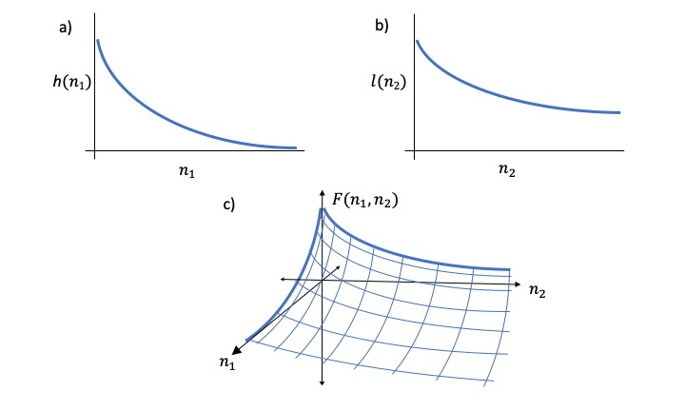

Figure 1 The per capita growth rate as a function of competitor densities.

While we originally described the response of the focal species to competition using separate functions, *h*, *l*, and *F*, these functions are related: the lines in figures 1a and b are slices through the three-dimensional surface in figure 1c. A graphical interpretation of a key assumption of pairwise competition models is that we can recreate the two-dimensional function *F* from the two separate functions, *h* and *l*, that define the perpendicular slices at the edges. Any HOIs between species one and two will produce a surface in figure 1c that cannot be recreated from two perpendicular slices through it. In an abstract way, a pairwise model of *m*-species competition can be compressed into *m*-dimensions, each representing the functional response to a separate competitor. In contrast, an *m*-species competition model with HOIs *cannot* be compressed into *m*-dimensions.

## A quantitative description of higher order interactions

Building on this visual understanding of HOIs we propose a quantitative definition for pairwise competition and higher order interactions. We start by defining the function *F* which gives the population growth rate of the focal species as a function of the density of competitor species one and two:

|  |  |  |
| --- | --- | --- |
|  |  | (2) |

For the pairwise understanding of multispecies competition to be correct, we need to be able to express population growth rate as some function of the two single species functions defining the cases where species one or two is absent. In mathematical terms,

|  |  |  |
| --- | --- | --- |
|  |  | (3) |

where *G* is a new function that combines the univariate competition functions *h* and *l* described in equation 1 and shown in figure 1. If we cannot re-write *F* in this way, then there would appear to be no way to recover the surface in figure 1 c from the single species functions in figures 1a and b. By our definition, the pairwise understanding of species composition is not adequate for the multispecies case. Interaction modification or HOIs are a particular case that causes the pairwise model to fail.

In this model, the interaction between a competitor and the focal species is defined by the sensitivity of the focal species to a change the in the density of the competitor species one, which is given by the partial derivatives: and . The partial derivative in terms of G,

|  |  |  |
| --- | --- | --- |
|  |  | (3) |

At this point we note that our definition of a non-pairwise model, coincides with the criteria for interaction modification developed by Adler and Morris (1994). A possible quantitative test for an interaction modification resulting in an HOI would be to take the partial derivative of the function *Fi* with respect to the density of each competitor, , and assess whether the partial derivative is a function, *Gij*, of any competitor’s density other than *j*.

|  |  |  |  |
| --- | --- | --- | --- |
|  |  | IM / HOI present | (2) |

While this test may appear adequate, Adler and Morris (1994) demonstrated that many standard models of density dependent growth that are not commonly thought to contain HOIs would test positive for HOIs according this test. For instance, a discrete time Hassel model for population growth (Hassell and Comins 1976),

|  |  |  |
| --- | --- | --- |
|  |  | (1) |

where *ri* is the intrinsic population growth rate, are the competition coefficients describing the effect of species *j* on species *i*, and *bi* determines how density dependent effects change with competitor density. The complicated partial derivative,

|  |  |  |
| --- | --- | --- |
|  |  | (1) |

includes the original function, *Fi*, for population growth and by extension the density of all competitors. While we understand this model not to have HOIs, the sensitivity of the model to density of any competitor, *j*, is a function of all competitor’s densities. How can we resolve this problem? A step taken by Adler and Morris (1994) was to make an exception for partial derivatives like the one above that are a function of the per capita population growth rate itself. Thus, they found a way to prevent models like the one above from testing positive for HOIs.

Nevertheless, the reasoning behind the Adler and Morris criteria was somewhat unclear and their specific test was developed to accommodate community models of trophic dynamics whereas we want to focus more strictly on HOIs among competitors.

Old Adler and Morris Section:

Here, we propose a new quantitative definition for HOIs based on an a definition first proposed by Adler and Morris (1994). We believe this definition provides a concise quantitative criteria for testing for HOIs while still retaining the intended meaning of the earlier verbal definitions. The goal of the Adler and Morris definition was to “distinguish simple non-additivity in the statistical sense from higher order interaction and interaction modification (IM) in the biological sense” (Adler and Morris 1994). Thus, they developed a definition of HOIs that could isolate how the density of one competitor species at a time affected the population growth rate of the focal species.

To understand the Adler and Morris definition and our slight revision of it, we start with a general model of density dependent population growth:

|  |  |  |
| --- | --- | --- |
|  |  | (1) |

where the per capita population growth rate of species *i* (the focal species) is a function, *Fi*, of the densities of all other *m* species (the competitors) in the community. Adler and Morris argue that one cannot determine if *Fi* involves HOIs simply by testing whether *Fi* is non-linear, because such nonlinearities are not necessarily the result of one species modifying the effect of another competitor. As a case in point, competition in commonly used models of density dependence, such as the Ricker, Beverton-Holt or Hassel, is non-additive but this is generally not thought of as an HOI (Mayfield and Stouffer 2017). A more specific test for an HOI requires examining the partial derivative of *Fi* with respect to the density of a competitor species *j* (for brevity, we refer to this as the sensitivity of the focal species to the competitor). If this partial derivative can be expressed as a function, *Gi*, which is itself a function of *Fi* and the density of the competitor species *j* and no other species, then the model does not contain HOIs. On the other hand, if the partial derivative involves the density of any other species *k* then there is an HOI. This is expressed mathematically as,

|  |  |  |  |
| --- | --- | --- | --- |
|  |  | HOI absent | (2) |
|  |  | HOI present |

Here we have slightly modified the definition provided by Adler and Morris and we discuss why later on. To contrast this definition with non-linearity, take the Lotka-Volterra model for competition between three species and apply the criteria in (2):

|  |  |  |
| --- | --- | --- |
|  | ). | (3) |

The sensitivity of species *i* to the density of species *j* is given by the partial derivative: This sensitivity is a constant and is not determined by the density of any other species’, so there are no HOIs. Adding a quadratic term, , to the same model,

|  |  |  |
| --- | --- | --- |
|  | ), | (4) |

and taking the partial derivative shows that the sensitivity of species *i* to competitor *j* now depends on the density of competitor *j*. However, according to our definition there is still no HOI because no *additional* competitor species are involved.

In contrast, adding the product of and to eq. (3) results in,

|  |  |  |
| --- | --- | --- |
|  | ). | (4) |

The sensitivity of the focal species to the competitor j is now expressed by the partial derivative . The partial derivative is now a function of an additional species, *k*, which means that the model includes an HOI. Specifically, the HOI is the modification of the effect of *j* on the per capita growth rate of *i* by the density of *k*.

To restate our criteria in one sentence, *a model does not contain an HOI if the sensitivity of the focal species to a change in the density of a competitor can be expressed as a function of the density of the competitor and the current population growth rate of the focal species, and does not involve the densities of any other competitor species*. It may appear that our criteria are more complicated than they need to be. Why is the current population growth rate, *Fi*, included in the definition? A simpler criteria for models without HOIs, would be requiring the sensitivity of the focal species to be a function of competitor species *j’s* density and nothing else. However, allowing the sensitivity to be function of the current per capita population growth rate, *Fi*, is a critical part of the definition. As Adler and Morris explain, *Fi* can be thought of as a proxy for all other limiting resources and interactions. Allowing the partial derivative to be a function of *Fi* means that we are isolating how one competitor species at a time affects the focal species while accounting for all other competitor densities (see Box 1 for a graphical interpretation). A practical consequence of this is that the standard version of discrete time competition models such as Beverton-Holt and Ricker do not test positive for HOIs, despite being non-additive (Adler and Morris 1994). In these models, the sensitivity of per capita growth rate to each additional competitor declines as more competitors are added (Hassell and Comins 1976). This could be interpreted as a kind of HOI, an interaction modification among *individuals within* species. However, the standard versions of these models are widely understood not to contain HOIs (Mayfield and Stouffer 2017) and our criteria are consistent with this (Adler and Morris 1994).

Our test is slightly less restrictive for the presence of HOIs than that of Adler and Morris. We stipulate that the partial derivative in eq. (2) must be a function of another competitor other than *j* for there to be an HOI. This means that an HOI can involve the modification of intraspecific density dependence by interspecific density, or vice versa. Consider a variation on eq. (3) above,

|  |  |  |
| --- | --- | --- |
|  | ), | (4) |

Taking the partial derivative of the growth rate with respect to species *j*, we find, , which shows that the sensitivity of species *i* to the competitor *j* depends on the density of species *i* itself. Our definition says this is an HOI, whereas the original Adler and Morris criteria required models to be sensitive to the density of some competitor other than the focal species. In essence, we treat intraspecific competition no differently than interspecific competition in our models. This matches the definitions for HOIs in earlier papers as well (Billick and Case 1994, Mayfield and Stouffer 2017). This difference in interpretation may be due to the fact that Adler and Morris discussed a larger set of population models including both trophic and competitive dynamics. It is only among trophic models that the sensitivity of the focal species was a function of its own density.

## The phenomenological nature of higher order interactions

The modified Adler and Morris test we propose offers a way to determine whether a model includes higher order interactions, but we can only apply it after we have defined some model of species competition. However, Adler and Morris (1994) do not tell us how to test for HOIs in raw data on species interactions. Our test and that of Adler and Morris are fundamentally a question about what kind of modeling assumptions do we need to make in order to fit a phenomenological model to data on species competition. Competition occurs when individuals consume the same limiting resource, such that increases in population density reduces the availability of resources, which in turn changes the population growth rate of the consumers (Meszéna et al. 2006). A phenomenological model of competition simplifies the representation of this interaction by tracking only the population density of the competitors without tracking fluctuations in the resources (Chesson 2000).

The benefit of modeling competition phenomenologically is that such models can be fitted to empirical data for any pair of species without making assumptions about which resources are limiting to their populations (e.g. Kraft et al. (2015). Nevertheless, HOIs may emerge in phenomenological models precisely because they leave out mechanistic details and do not explicitly model resource (or shared predator) dynamics (Abrams 1983, O’Dwyer 2018, Letten and Stouffer 2019). Given this, one might argue that HOIs are an artifact of incomplete understanding in phenomenological models. Our response, is that any theory of species interactions is inherently phenomenological. Thus, any theory of ecological communities rooted in species interactions must confront the issue of HOIs. Likewise, the question of HOIs can only be investigated in the context of phenomenological, not mechanistic, models of species interactions.

Moreover, if mechanistic models of resource competition frequently generate HOIs (Abrams 1983, O’Dwyer 2018) this begs the question of why there have been few rigorous demonstrations of HOIs among competitors in nature—the logistical challenge of studying multispecies competition notwithstanding. We believe our definition above will help ecologists tackle this important gap in our knowledge. While Adler and Morris, showed how to define HOIs, in their paper they only tested a handful of phenomenological competition models, each of which did not have HOIs. Advances in statistical software since their paper make it easier today fit a wide array of phenomenological models to data (Kraft et al. 2015, Mayfield and Stouffer 2017), some of which may contain HOIs. In the next part of the paper we take off where Adler and Morris (1994) left off and hope to show how an ecologist could test for HOIs in data without pre-supposing any particular functional form for the HOIs as we do in the examples above.

# HOIs in a mechanistic resource competition model

To illustrate how we might detect HOIs in empirical data on species interactions, we simulate competition among annual plants for a single shared resource using a mechanistic resource competition model. We then fit species’ responses to interspecific competition using a range of phenomenological competition model. By considering the cases in which higher order interactions emerge we can also shed some light on the processes that lead to these interactions.

Our mechanistic model is inspired by annual plant communities growing in a Mediterranean climate. In this system, rainfall starts in the early winter and gradually declines through the spring while temperature and potential evapotranspiration increase. Plants germinate in the winter, grow through the spring, and flower, produce seeds and die by the summer (Godoy and Levine 2013). In our model, we track a single pool of generic soil resources, most easily thought of as water given its timing of availability. Importantly, this pool is not resupplied during the growing season and plants eventually use up the pool of stored soil resources. As resources are depleted, plant growth slows and eventually stops. We make the assumption that when net plant growth stops, the plants stop producing vegetative biomass and start producing seeds (Cohen 1976).

The model is expressed as a set of differential equations,

|  |  |  |
| --- | --- | --- |
|  |  | (5) |

where gives the resource availability at time $u$, and $S$ gives the resource supply rate. The final term expresses the loss of resources due to uptake by plants. Plant biomass of species $i$ at time $u$ is given by , *S* is the number of species in the community and $f_{i}$ is the resource dependent uptake function for species *i*. We simulate a Mediterranean climate by setting initial resource availability high, $R\left(t=0\right)≫0$, and setting the resource supply rate $S$ to zero (Figure 2 a).

Growth of each species is simulated with a piecewise differential equation dependent on resource availability,

|  |  |  |
| --- | --- | --- |
|  |  | (6) |

where, is the total biomass of species $i$, $q$ is a resource conversion factor, $m$ is a per biomass respiration and tissue loss rate, and as in the first equation, the function gives the resource uptake rate. The growth of each species stops when meaning that the rate of biomass gain is equal to biomass loss. At this point the plant stops growing and converts all biomass to seed mass. We impose this behavior on the model by setting growth and resource uptake to zero when resources fall to this point.

Different species are likely to have different rates of resource uptake. In our simulation, we assume a trade-off between rates of resource uptake at high resource availability and rates of resource uptake at low resource availability (Figure 2c). This means that species which grow rapidly early in the season when resource availability is high will stop growing and produce seed earlier (Figure 2b). In contrast, species that grow slowly early in the growing season will to persist later into the season when resource availability is low.

This trade-off between species in early and late season growth rates is produced by giving each species a saturating Monod resource uptake function $f_{i}$ (Miller and Klausmeier 2017),

|  |  |  |
| --- | --- | --- |
|  |  | (7) |

where, is the maximum rate of resource capture and $K_{i}$ is the half-saturation constant of resource capture. The trade-off we impose means requires that the species with the highest maximum resource uptake rate has the highest half-saturation constant , and the species with slowest maximum resource uptake rate has the lowest half-saturation constant (Table S1). The resource uptake curves result in species-specific phenology for the three species and so we refer to these as ‘early’, ‘mid’ and ‘late’ (Figure 2). The differences in the timing of growth recreates important functional differences between species observed empirically in annual plant communities (Godoy and Levine 2013).

So far, we have described a model of growth dynamics in continuous time *u* within a single generation and with units of total biomass. In contrast, a phenomenological model of competition that might realistically be parameterized from field data would track the total population density, , as number of individuals of species at time *t*. To convert between the units of the simulation and the units of the phenomenological model, we first assume that all individuals start as seeds at the beginning of a simulation. Thus, we calculate the initial biomass, , at the start of a simulation as, where is the mass of an individual seed and is the number of seeds of species *i*. Second, we assume that population density at year is equal to the number of seeds produced during the course of a simulation, and we assume this is proportional to the biomass at the time of flowering. Thus,

|  |  |  |
| --- | --- | --- |
|  |  | (8) |

where is the number of germinable seeds produced during the growing season, and therefore available to start population growth in year *t+1*, and *c* is a conversion factor that represents the mass of seeds produced for each unit of total plant mass. The maximum of over the course of the growing season is equal to the final biomass of species *i*, or equivalently the biomass at time of flowering. We assume that all species have the same values for and *c* (Table S 1). We simulate these dynamics using the differential equation solvers package desolve in the statistical program R (R Core Team 2015). Code to run the simulations are given in the supporting information.

Finally, we used this mechanistic model to simulate plant growth of each species when faced with a range of densities of one or two other interspecific competitors. In the simulated experiment a single individual of each of the three species are grown in “plots” either with increasing densities (0, 1, 2, …7, 8) of a single interspecific competitor species or in plots with two interspecific competitor species where each competitor species was at a density ranging from 0 to 8 (in an orthogonal design).

## Phenomenological annual plant model

We model annual plant competition in terms of the decline in per capita reproductive output with increasing density of competitors at the start of the growing season ($n_{j,t}$). We tested two different phenomenological competition models. The first has been used in a number of empirical studies of annual plant competition (e.g. Kraft et al. 2015),

|  |  |  |
| --- | --- | --- |
|  |  | (9) |

where denotes maximum per capita reproductive output, $α_{ij}$ is the per capita competitive effect of species $j$ on $i$ and $τ_{i}>0$ is a species-specific parameter controlling how steep fecundity declines with competition in general.

We also fit a second model in which the effects of each species are modified with a separate exponent where

|  |  |  |
| --- | --- | --- |
|  |  | (10) |

This allows species to have per capita effects that are themselves density dependent but the competitive effects of each species are still assumed to be additive. We fit separate competition models for each of three species using the nls package in R. We defined for each species as the per capita fecundity in the absence of any competitors and set this as a constant when fitting the models.

In order to detect HOIs and measure their strength we fit the phenomenological model to cases where each focal species faced increasing densities of only one other competitor species at a time (details in the preceding section). Once we were satisfied that phenomenological models fit these pairwise dynamics adequately, we used the models to predict species’ per capita fecundity in cases where the focal species simultaneously faces two interspecific competitor species. If species effects are additive, then our model fit to density gradients of a single competitor species should be able to predict the joint effect of competition from two competitor species together. However, if there are HOIs then the sum of species effects will not be equal to the observed effect of multiple species. We use the deviation between the per capita fecundity of each species predicted by the additive phenomenological model and the per capita fecundity observed in the simulations as a measure of the effect of HOIs. HOIs are supported when the average deviation in the multispecies case is greater than the deviation in the single species cases. We can quantify this by comparing the root-mean-squared error from two competitor simulations to the root-mean-squared error in single competitor simulations. We can also look at the average deviation to get a sense of the direction of the HOIs. Importantly, this approach does not require that we specify the functional form of the higher order interaction term.

# Evidence for HOIs

For all three species we found that the modified phenomenological competition model with varying exponents (equation 7) fit the simulated data accurately (Figure 3), whereas the standard model (equation 6) only fit the data for the early species (Figure S 1). When we tested how well models fit to single species competition predicted the simultaneous effects of two species’, we found weak HOIs for the early season species and stronger HOIs for the mid and late season species (Figure 4). In other words, for the early species, the observed effect of two species together was close to the sum of the two species’ individual effects (Figure 5). However, assuming additive competitor effects underpredicted the total strength of competition on the mid-season species (Figure 5 b), and overpredicted the strength of competition on the late species (Figure 5 c). This shows that competitors’ effects changed depending on the density of other competing species, and by our definition this is a HOI. Using the first phenomenological model, equation 6, which was less accurate in fitting the fecundity of single species, we also found evidence of HOIs (Figure S 2) but these were different in direction and magnitude than those detected with equation 7, indicating that HOIs are by definition dependent on what form of phenomenological model is fit to single species effects.

Our simulation shows that even in a relatively simple resource competition model the effects of multi-species competition may not be equal to the sum of the individual species effects. Comparing the observed effects of multispecies competition to the sum of the separate species’ effect is a useful way to determine the presence of HOIs without assuming a specific functional form for the HOIs. This makes it a diagnostic tool, not a way to predict multispecies community dynamics.

*What Causes Higher Order Interactions?*

In this model, HOIs emerge because species growth and resource uptake rates are dependent on the current availability of resources in the system (Figure 2 c). This means that as species use resources they not only affect the growth rates of their competitors, but they can also affect the interactions between those competitors. For instance, the early species has the most rapid growth and resource uptake rate early in the season. This shifts the resource uptake rates of the mid and late season species towards the left along their resource uptake curves (Figure 6a). Because the mid and late season species resource uptake curves are shaped differently, this reduces the uptake rate of the mid-season species more than it does the late season species during the period of time when both species are active, that is until the mid-season species stops growing (vertical lines Figure 6 a). Thus the average resource uptake rate of the mid-season species declines more than that of the late season species in response to the presence of the early season species (Figure 6 b).

Differences between species in how much their resource uptake rates change with the presence of the early competitor explain the direction of the HOI effects on the late season species: the presence of the early species, puts the mid-season species at a slight disadvantage relative to the late species; thus the joint effect of the early and mid-season species together is less than their additive effect (Figure 4 c; Figure 5 b). The same dynamics cause the mid-season species to experience stronger than additive competition from the early and late species together: in the presence of the early season species, the mid-season species gets a smaller share of the resource pool it competes for with the late season species (Figure 4 b; Figure 5 b).

By contrast, the early species is only weakly affected by HOIs (Figure 5). In principle, resource uptake by the late season species should reduce the early season species’ average resource uptake rate more than it does the mid-season species, thereby strengthening the effect of competition on the early species. However, this effect is weak because the late season species grows much more slowly early in the season than its competitors and so it has minimal impact on resource availability. Meanwhile, the mid-season species does not significantly change the resource uptake rate of the late season species because the late species’ resource uptake curve is flat over the range of resource availabilities that the early species is active (Figure 2).

The origin of HOIs in this system are therefore consistent with the arguments in favor of HOIs put forward by Abrams (1983). Abrams argued that HOIs should occur when competing species have different non-linear responses to resource availability. In our simulation, the resource uptake and growth rates of the competing species follow a Monod or type II functional response to resource availability (Figure 2c). This means that competition between pairs of species depends upon the level of resources available. Since species also influence the resource concentration itself, it follows that competition between any pair of species is influenced by the presence of other species in the community—the definition of a HOI.

What makes our example more complicated, but perhaps more realistic, is that unlike in classical resource competition models, resources do not reach an equilibrium during the course of our simulation. Rather, they are constantly declining throughout the season (Figure 2 a). Deriving phenomenological competition coefficients from a mechanistic resource competition model often requires first solving for stable resource equilibria and then calculating the first order sensitivity of the growth rate of each species to the resource availability and the sensitivity of the resource to the consumers (Tilman 1977, Meszéna et al. 2006, Letten et al. 2017). However, we believe that in many natural systems, such as those involving annual plants, the pace of resource dynamics may be as rapid as the change in consumer biomass. This makes deriving competition coefficients analytically much more difficult, perhaps impossible (O’Dwyer 2018). The advantage of statistically fitting a phenomenological model to observed or simulated effects of competition is that this approach can help us understand pairwise competition even in such complex cases. However, our work here also shows that this advantage may come at the cost of ignoring important HOIs in multispecies communities.

# Are HOIs Common in Nature?

One way to view HOIs in this system is to consider them instances of a more general case in which the trait that determines each species’ impact on and sensitivity to resource availability is itself governed by resource availability (Meszéna et al. 2006). In this case, the trait in question is the average rate of resource uptake, which shifts in response to resource availability and thus the earlier activity of competitors. More generally, we believe HOIs will be inevitable in systems in which 1) some species can cause large resource fluctuations, 2) the rate of resource uptake by other species shifts in response to resource availability, and 3) the strength of this response varies across species. Among plants, plastic changes in traits such as height, specific leaf area, and phenology, have been shown in response to competition and changes in resource availability (e.g. Aronson et al. 1992, Bennett et al. 2016, Conti et al. 2018). In theory, these traits should also determine each individual’s impact and sensitivity to competition. So, are significant HOIs inevitable? And if so, why are there so few documented examples among competing plants (but see Mayfield and Stouffer 2017)?

One hypothesis is while HOIs are common, they are often weak. A key factor in producing HOIs in our simulation is that each species has a uniquely shaped resource uptake curve. Additional simulations show that the more similar species resource uptake curves are to one another the weaker the HOIs are in this system (Appendix A). In nature, such large differences in the shape of resource uptake curves may be rare.

In addition, the large changes in resource availability and plant biomass in our simulation contribute to the magnitude of HOIs. Because resource availability fluctuates widely from the beginning to the end of the growth period in our simulation, it means that species interactions change dramatically over the course of the season. Without the extreme fluctuation in the resource environment, species would have relatively constant competitive effects on one another and no HOIs would emerge. For instance, compare our system to an idealized version of resource competition experienced by competing perennial plants (Dybzinski and Tilman 2007). Due to their large size, perennial plants can be assumed to quickly draw resources down to a dynamic equilibrium. Thus, even if species have different non-linear responses to resource concentration the fact, that resource concentration is relatively fixed eliminates the possibility of strong higher order interactions. For this reason, seasonally forced systems, such as annual plant communities in Mediterranean climates, may be a good place to look for strong HOIs (Mayfield and Stouffer 2017).

Finally, our analysis that even though we restrict our definition of HOIs to only involve interaction modification between heterospecific and not conspecific individuals (in their total competitive effects), HOIs are virtually guaranteed when species’ individual contributions to change non-linearly with density. Such non-linearity would arise when individuals alter the competitive effects of other individuals within the same species. In our simulated experiment for example, we found that a model with non-linear terms for each competitor species’ effect best fit the simulated data for the mid and late-season species. These species-specific non-linear terms were required to fit the single species data because the densities of each competitor had different non-linear effects (Figure 3).

To see how these non-linear effects of competitor density within species almost guarantee an HOI (between species), consider two species, one and two, that have identical effects on shared resources and therefore identical effects on a third competitor, species three. Our definition of HOIs suggests that if there are no HOIs, the true combined effect of one and two together will be the sum of their separate effects:, where is a function of species density. In the case where individuals of one and two are identical, we know that their true effect on three must in fact be equal to yet if is a non-linear function, . Just because we label the individuals of species one and two as belonging to different species, the sum of their separate effects will not equal their combined effect. This example illustrates why any system in which competition, *C*, depends non-linearly on the density of individual species will likely result in HOIs between species.

# Conclusion

Higher order interactions have profound implications for how we understand multispecies communities. We have sought to clarify the definition of HOI’s and explain how they could arise from simple resource dynamics. We propose that the most robust method to detect HOIs is to compare the observed strength of multispecies competition to the sum of individual species effects. We illustrate our definition of HOIs and our proposed method for detecting HOIs with a simulation of species competition for a single resource. Defining HOIs in this way requires first finding a phenomenological model that accurately describes the focal species’ response to single species competition. While we believe that HOIs should be common in nature this does not mean that they will be strong enough to detect statistically in empirical settings. Our work suggests that environments in which resource availability and competitor size change rapidly during a single growing season may be a likely place for HOIs to emerge.

# Acknowledgments

# References

Abrams, P. A. 1983. Arguments in Favor of Higher Order Interactions. The American Naturalist 121:887–891.

Adler, F. R., and W. F. Morris. 1994. A General Test for Interaction Modification. Ecology 75:1552–1559.

Alfred J.Lotka. 1925. Elements of Physical Biology. Williams and Wilkins Company.

Aronson, J., J. Kigel, A. Shmida, and J. Klein. 1992. Adaptive phenology of desert and Mediterranean populations of annual plants grown with and without water stress. Oecologia 89:17–26.

Bennett, J. A., K. Riibak, R. Tamme, R. J. Lewis, and M. Pärtel. 2016. The reciprocal relationship between competition and intraspecific trait variation. Journal of Ecology 104:1410–1420.

Billick, I., and T. J. Case. 1994. Higher Order Interactions in Ecological Communities: What Are They and How Can They be Detected? Ecology 75:1530–1543.

Chesson, P. 2000. Mechanisms of Maintenance of Species Diversity. Annual Review of Ecology and Systematics 31:343–366.

Cohen, D. 1976. The Optimal Timing of Reproduction. The American Naturalist 110:801–807.

Conti, L., S. Block, M. Parepa, T. Münkemüller, W. Thuiller, A. T. R. Acosta, M. van Kleunen, S. Dullinger, F. Essl, I. Dullinger, D. Moser, G. Klonner, O. Bossdorf, and M. Carboni. 2018. Functional trait differences and trait plasticity mediate biotic resistance to potential plant invaders. Journal of Ecology 106:1607–1620.

Dybzinski, R., and D. Tilman. 2007. Resource Use Patterns Predict Long‐Term Outcomes of Plant Competition for Nutrients and Light. The American Naturalist 170:305–318.

Godoy, O., and J. M. Levine. 2013. Phenology effects on invasion success: insights from coupling field experiments to coexistence theory. Ecology 95:726–736.

Grilli, J., G. Barabás, M. J. Michalska-Smith, and S. Allesina. 2017. Higher-order interactions stabilize dynamics in competitive network models. Nature 548:210–213.

Hairston, N. G., J. D. Allan, R. K. Colwell, D. J. Futuyma, J. Howell, M. D. Lubin, J. Mathias, and J. H. Vandermeer. 1968. The Relationship between Species Diversity and Stability: An Experimental Approach with Protozoa and Bacteria. Ecology 49:1091–1101.

Hassell, M. P., and H. N. Comins. 1976. Discrete time models for two-species competition. Theoretical Population Biology 9:202–221.

Kraft, N. J. B., O. Godoy, and J. M. Levine. 2015. Plant functional traits and the multidimensional nature of species coexistence. Proceedings of the National Academy of Sciences of the United States of America 112:797–802.

Letten, A. D., P.-J. Ke, and T. Fukami. 2017. Linking modern coexistence theory and contemporary niche theory. Ecological Monographs 87:161–177.

Letten, A. D., and D. B. Stouffer. 2019. The mechanistic basis for higher-order interactions and non-additivity in competitive communities. Ecology Letters In Press.

Levine, J. M., J. Bascompte, P. B. Adler, and S. Allesina. 2017. Beyond pairwise mechanisms of species coexistence in complex communities. Nature 546:56–64.

Mayfield, M. M., and D. B. Stouffer. 2017. Higher-order interactions capture unexplained complexity in diverse communities. Nature Ecology & Evolution 1:0062.

Meszéna, G., M. Gyllenberg, L. Pásztor, and J. A. J. Metz. 2006. Competitive exclusion and limiting similarity: A unified theory. Theoretical Population Biology 69:68–87.

Miller, E. T., and C. A. Klausmeier. 2017. Evolutionary stability of coexistence due to the storage effect in a two-season model. Theoretical Ecology 10:91–103.

Morin, P. J., S. P. Lawler, and E. A. Johnson. 1988. Competition Between Aquatic Insects and Vertebrates: Interaction Strength and Higher Order Interactions. Ecology 69:1401–1409.

Neill, W. E. 1974. The Community Matrix and Interdependence of the Competition Coefficients. The American Naturalist 108:399–408.

O’Dwyer, J. P. 2018. Whence Lotka-Volterra?: Conservation laws and integrable systems in ecology. Theoretical Ecology.

R Core Team. 2015. R: A Language and Environment for Statistical Computing. R Foundation for Statistical Computing, Vienna, Austria.

Tilman, D. 1977. Resource Competition between Plankton Algae: An Experimental and Theoretical Approach. Ecology 58:338–348.

Vandermeer, J. H. 1969. The Competitive Structure of Communities: An Experimental Approach with Protozoa. Ecology 50:362–371.

# Figures

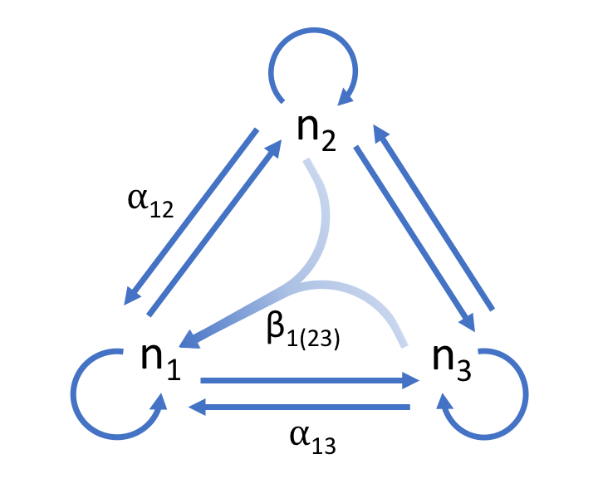

Figure 2. Three species competitive network. Inter- and intraspecific competition between species is depicted with the blue arrows. The effect of species two on one can be described by the per capita effect . An HOI, , is depicted as arrows from species two and three converging on one. The effect of the HOI means that net effect of two and three on species one is non-additive.

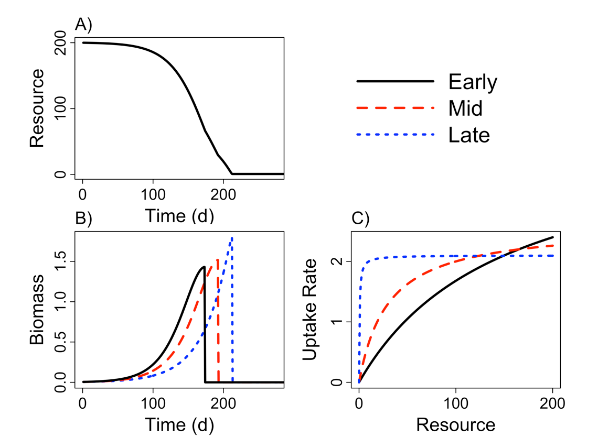

Figure 3. Example time series showing A) the drawdown of the resource during the course of the simulated growing season with starting densities of one individual of each species, B) the growth of each of species shown with colored lines and C) the dependence of resource uptake rates on resource concentration. The early season species grows rapidly when resource availability is high and senesces early. By contrast, the late season species grows slower than species one and two when resource availability is high but it is able to maintain higher rates of resource uptake at lower resource concentrations. This allows it to grow later into the season and senesce last. The mid season species lies between these extremes.

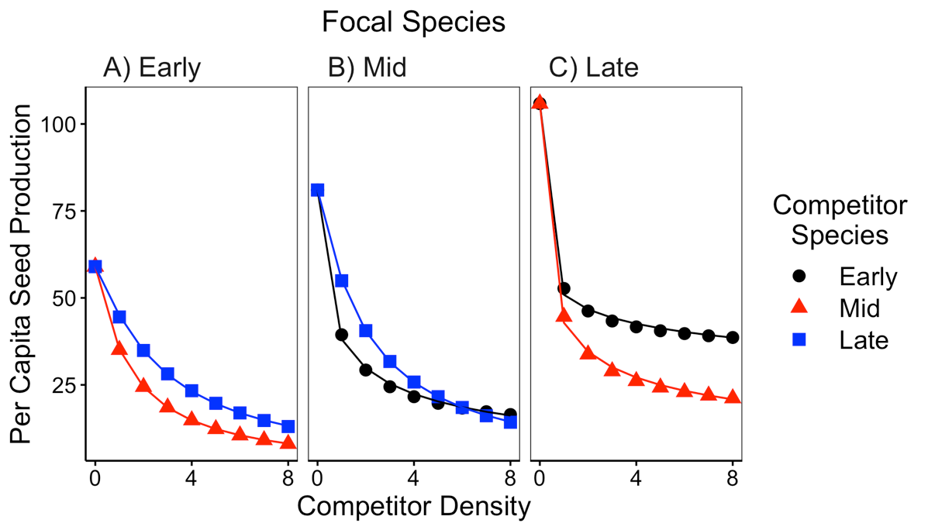

Figure 4. Simulated per capita seed production of the A) early, B) middle and C) late season species in response to increasing inter-specific density on the x-axis. Colors correspond to the identity of the competitor species. The solid line shows the best fit from the model with varying exponents on each competitor’s effect (equation 7).

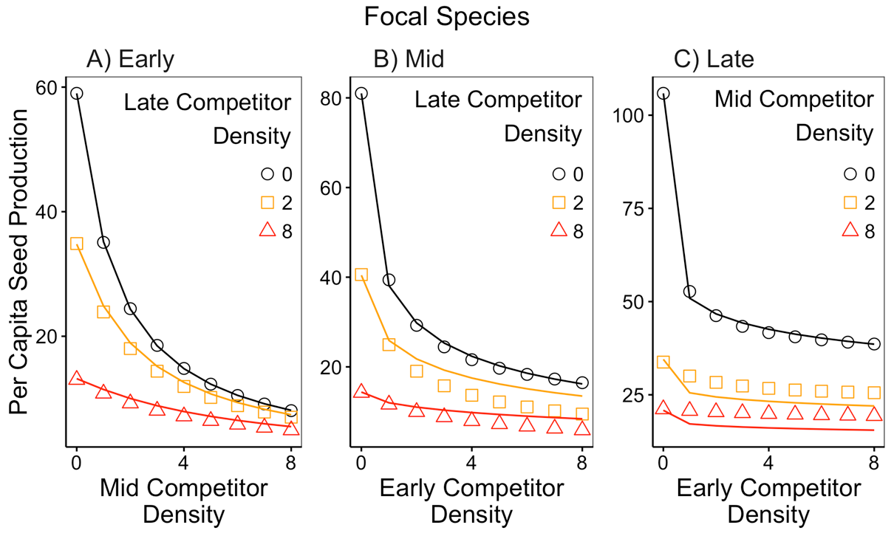

Figure 5. Simulated per capita seed production of the A) early, B) mid and C) late season species in response to increasing simultaneous competition from two species. Increasing densities of one competitor species are shown on the x-axis and increasing density of a second competitor are shown with the varying colors. The lines show the predicted per capita fecundity from the competition model with varying exponents (equation 7). The predicted per capita seed production assumes species’ competitive effects are additive. Deviations between the predictions (lines) and the observations (points) indicate the presence of non-additive species’ effects and therefore higher order interactions.

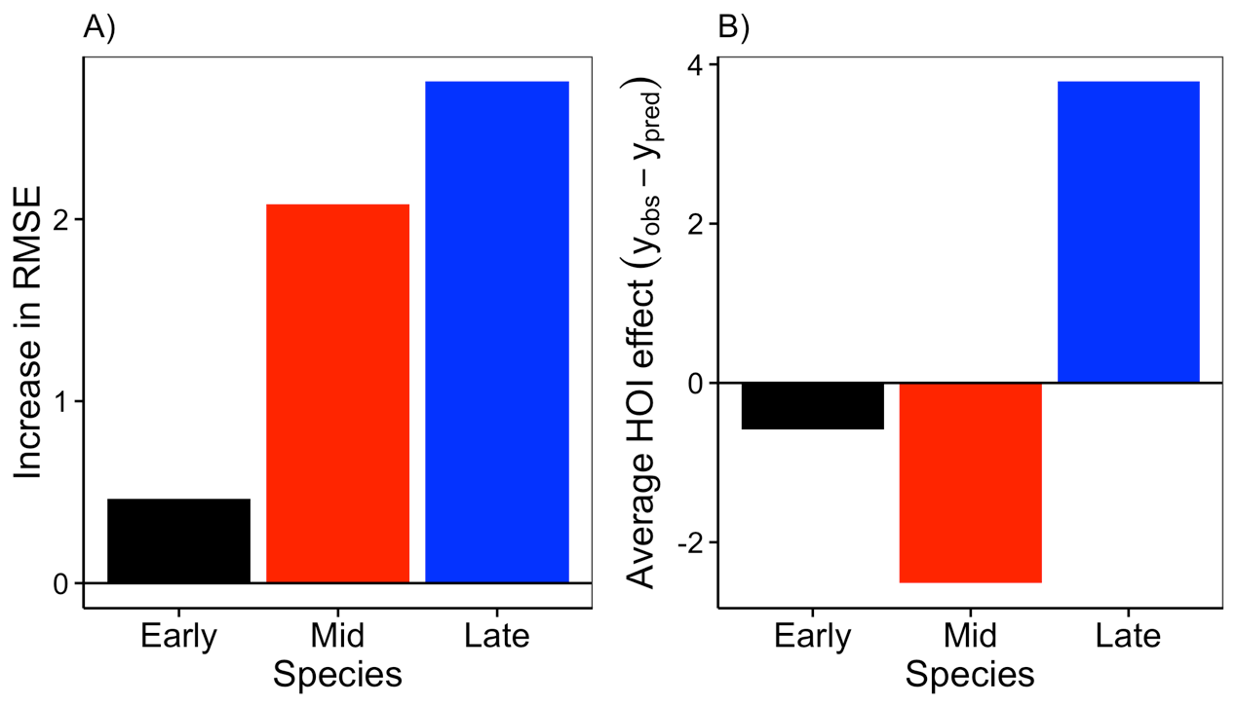

Figure 6. Deviation from additivity of two-species competition for each species in the community. A) The deviation from additive competitor effects is shown as the increase in root mean squared error of the second phenomenological model (equation 7) in multispecies competition compared to single species competition. B) The average deviation from additive competitor effects, positive values show that multispecies competition was weaker than predicted, negative values show where competition was greater than predicted.

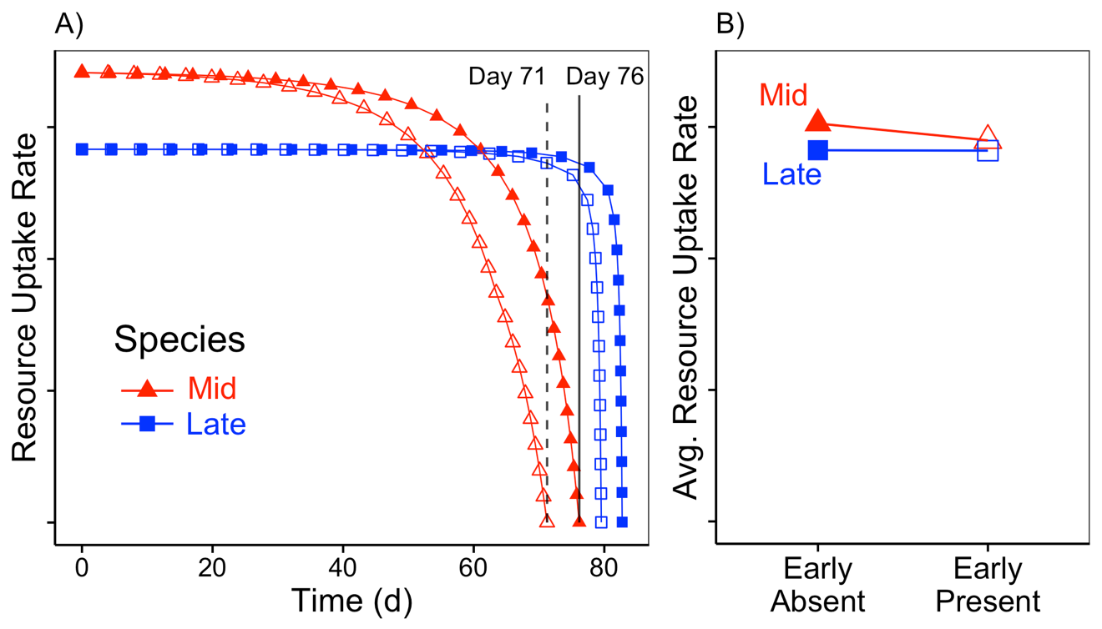

Figure 7. Mechanistic explanation for higher-order interactions. A) The resource uptake rates of the mid and late season species plotted over the course of a growing season, with (open symbols) and without (filled symbols) the early species. Vertical lines show the day at which the mid-season species stops growing with (dashed) and without (solid) the early species. B) The time-averaged resource uptake rates of the mid and late season species in the absence and presence of the early season species.

# Supporting Information – Additional Tables

Table S 1 Table of parameter values used in the growth simulation experiment in the main text.

|  |  |  |
| --- | --- | --- |
| Parameter | Value | Definition |
| *U* | 200 | Duration of growth simulation in days |
| *I* | 0 | Environmental resource supply rate |
| *R(0)* | 200 | Initial resource concentration |
| *r1* | 4.2 | Early competitor maximum resource uptake rate |
| *r2* | 2.6 | Mid competitor maximum resource uptake rate |
| *r3* | 2.1 | Late competitor maximum resource uptake rate |
| *K1* | 150 | Early competitor half-saturation constant |
| *K2* | 30 | Mid competitor half-saturation constant |
| *K3* | 0.5 | Late competitor half-saturation constant |
| *m* | 0.09 | Respiration/Loss rate |
| *q* | 0.07 | Biomass assimilation rate |
|  | 0.005 | Seed mass |
| *c* | 0.1 | Conversion rate of total biomass to seed mass |

# Supporting Information – Additional figures

# 

Figure S 1 Simulated per capita seed production of the A) early, B) middle and C) late season species in response to increasing inter-specific density on the x-axis. Points show the simulated response from the mechanistic model. Solid lines show best fit from the standard Beverton-Holt phenomenological model (equation 6) and the dashed line shows the best fit from the modified model with varying exponents for each species’ effect (equation 7).

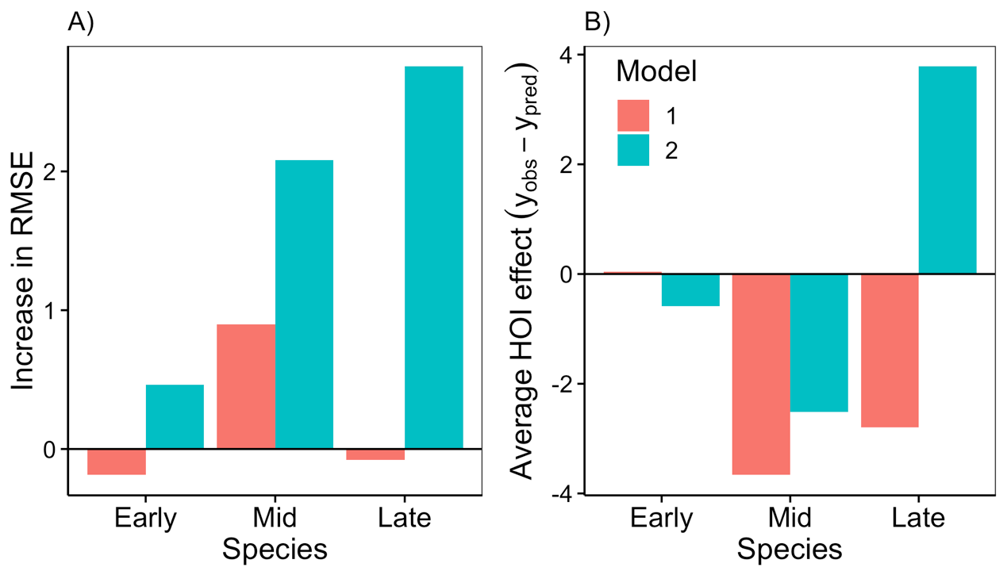

Figure S 2 Deviation from additivity of two-species competition for each species in the community. A) The deviation from additive competitor effects is shown as the increase in root mean squared error of the phenomenological models in multispecies competition compared to single species competition. B) The average deviation from additive competitor effects, positive values show that multispecies competition was weaker than predicted, negative values show where competition was greater than predicted. Deviations from additivity are shown for both phenomenological models—the standard Beverton-Holt model (“model 1”, equation 6) and the model with separate exponents on each competitor (“model 2”, equation 7).

# Appendix A – The effect of relative non-linearity in resource uptake curves on higher order interactions

In order to test whether the strength of higher order interactions was associated with the strength of the trade-off in the competitors’ resource uptake curves, we simulated an additional five communities in which we varied the degree of relative non-linearity between species resource uptake curves. We did this by starting with a scenario in which each species was given a resource uptake curve close to that of the mid-season species in the main text (Figure 2 b). In this first scenario there is very little difference between species in their resource uptake curves (see top of Figure A1). Then we parameterized four additional scenarios by gradually increasing the maximum uptake rate and half-saturation constant of the early season species, and gradually decreasing the maximum uptake rate and half-saturation constant of the late season species (Table A1). We then simulated competition, fit phenomenological competition models, and compared the predicted effects of competition assuming additivity, to the observed effects of competition as in the main text. Our simulations show that as the relative non-linearity between species is increased, the error between the additive phenomenological model and the simulated observations grows (Figure A 1).

Table A 1. Parameter values for five simulations with gradually increasing strength of the trade-off between the early season and late season species resource uptake curves.

|  |  |  |  |  |
| --- | --- | --- | --- | --- |
| Tradeoff | Scenario | Species | Max Uptake Rate (r) | Half Saturation Constant (K) |
|  | 1 | Early | 2.92 | 50.88 |
| Weak | Mid | 2.60 | 30.00 |
|  | Late | 2.50 | 23.79 |
|  | 2 | Early | 3.24 | 73.32 |
|  | Mid | 2.60 | 30.00 |
|  | Late | 2.40 | 17.74 |
|  | 3 | Early | 3.56 | 97.32 |
|  | Mid | 2.60 | 30.00 |
|  | Late | 2.30 | 11.84 |
|  | 4 | Early | 3.88 | 122.88 |
|  | Mid | 2.60 | 30.00 |
|  | Late | 2.20 | 6.09 |
|  | 5 | Early | 4.20 | 150.00 |
| Strong | Mid | 2.60 | 30.00 |
|  | Late | 2.10 | 0.50 |

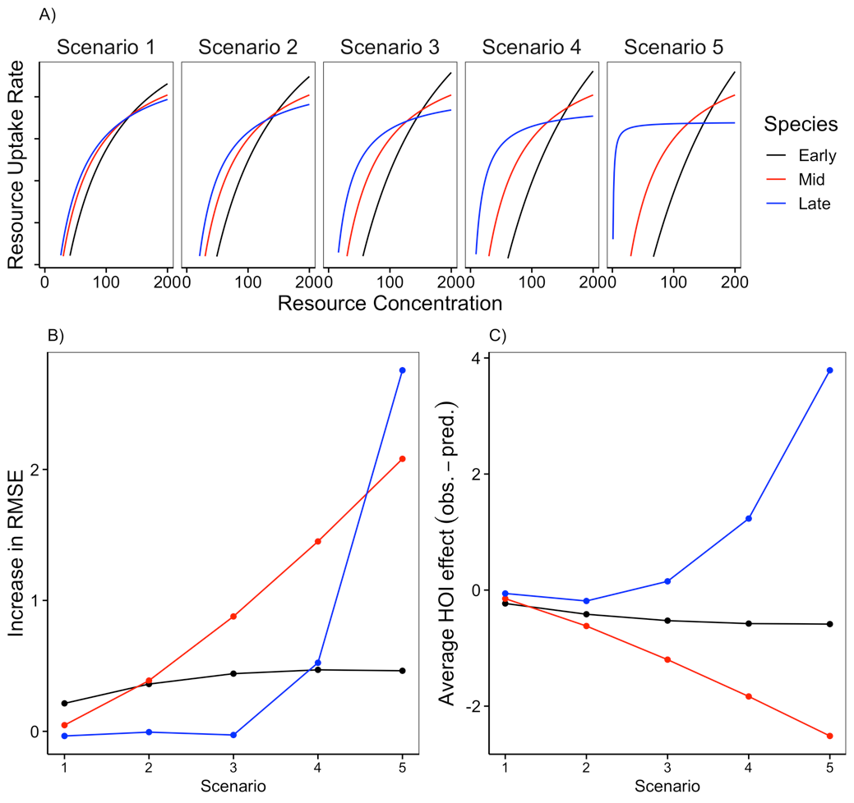

Figure A 1 Increasing the strength of the resource uptake trade-off between the early and late season species increases the magnitude of higher order interactions. A) Shows increasing relative non-linearity between species’ resource uptake curves in five scenarios. B) The deviation from additive competitor effects is shown as the increase in root mean squared error of the phenomenological model (equation 7) in multispecies competition compared to single species competition. C) The average deviation from additive competitor effects, positive values show that multispecies competition was weaker than predicted, negative values show where competition was greater than predicted. In B and C, the x-axis refers to the different scenarios depicted in A.