­­

**Higher Order Interactions in Simple Competition Models**

Andrew R. Kleinhesselink1, Jonathan M. Levine2, Nathan J.B. Kraft1

1Department of Ecology and Evolutionary Biology, University of California, Los Angeles 621 Charles E. Young Drive South, Los Angeles, USA

2Institute of Integrative Biology, ETH Zurich, Switzerland

I think this is a great start. What I think we need are clearer expectations or hypotheses from the outset about what will cause a higher order interaction (which to me is trait change in response to competitors) so that when we present our modeling results they support a hypothesis, and help to refine that hypothesis. Otherwise someone might think that this paper builds a quirky model and finds some HOIs, but does not get at general issues. This is just a matter of framing that we should talk about.

Running Title: Higher Order Interactions

Word Count:

# Abstract

Most communities on earth contain many more than two species, and almost every species interacts with more than one competitor. When species interact with two or more competitors at a time, higher order interactions (HOIs) can invalidate the application of classical theories of species competition based on pairwise interactions. HOIs occur when the strength of competition between two species depends on the density of other species in the community. It is therefore critical to understand how often and by what mechanisms HOIs arise in order to extend pairwise ecological theory to multi-species communities. In this paper we use simple competition models to illustrate potential causes of HOIs and their interpretation in a community context. We quantify the higher order interactions emerging in a system of annual plants differing in their growth phenology and competing for water resource depleted over the growing season. We find that higher order interactions emerge most strongly for late season competitors- species that experience a competitive environment modulated by earlier growing competitors. We use these results to discuss possible pitfalls in detecting HOIs in empirical datasets. We conclude that HOIs are likely to arise when competitive effects arise over time periods in which competition or competitor densities are not constant. Clarifying the source of HOIs in simple analytical and simulation models may help us better understand the true nature of competition and stability in multi-species communities.

*Key words: competition, coexistence theory, phenology, annual plants, ?intransitivity?*

# Introduction

Almost every species on earth interacts with a diversity of predators, pathogens and competitors. And the densities of each of these species are themselves determined by interactions with yet other species in the community. Despite this reality, most classical models in community ecology summarize species interactions assuming that the per capita effect of one species on another is independent of the densities of other species in the system. In particular, models with such fixed per capita competitive effects have been critical to the development of modern coexistence theory (Chesson 2000, Levine et al. 2017), and imply that the dynamics of multi-species species competition can be predicted by understanding competition between all competitive pairs (Grilli et al. 2017a). This idea is also foundational to recent efforts to relate species’ functional traits and phylogenetic relationships to the outcome of their competitive dynamic (Adler et al. 2013, Godoy et al. 2014, Kraft et al. 2015).

The potential for higher order interactions (HOIs) between species challenges the core assumption of many classical models in ecology (Billick and Case 1994, Mayfield and Stouffer 2017, Levine et al. 2017, Grilli et al. 2017b). By definition, HOIs mean that our understanding of competition between pairs of species is not sufficient on its own to describe the interactions of more than two species (Abrams 1983, Billick and Case 1994). For these reasons, predicting community assembly and composition in natural communities with information on all possible pairwise competitive interactions may not be possible (e.g. Kraft et al. 2015). In addition, the presence of HOIs also challenges classical definitions of coexistence and niche differences that rest on a comparison of pairwise intraspecific vs. interspecific limitation (Adler et al. 2007, Levine et al. 2017, Grilli et al. 2017b). In the extreme, HOIs may permit coexistence in multi-species communities impossible in simpler systems (Grilli et al. 2017b).

Although ecologists are beginning to appreciate the implications of higher order interactions for our understanding of how communities assemble, what is generally not understood are the mechanistic processes that generate higher order interactions in the first place. What types of resource competition generate competitive interactions that can and cannot be reasonably approximated by pairwise competition coefficients? Answering this question is particularly important to generate expectations about which systems are likely to show HOIs, and therefore worthy of further examination, and which might be enable to more classical descriptions of pairwise competitive dynamics. More generally, a thorough empirical and theoretical investigation of HOI in natural communities is critical to expanding ecological theory beyond two species models and increasing its relevance in the natural world.

In this paper we attempt to demystify HOIs by 1) clarifying their definition 2) highlighting the challenges in detecting HOIs in empirical systems, and 3) exploring the mechanisms through which HOIs may emerge in nature. We ground our discussion in foundational (but perhaps recently overlooked) research in this area and demonstrate the important role of temporal scale in influencing our perception of HOIs.

## Defining higher order interactions

Before we define higher order interactions (HOIs), we need a suitable definition of competition. From a mechanistic perspective, competition occurs when individuals consume the same limiting resource. Increases in consumer densities change the availability of resources, which in turn changes the growth rate of consumers. Thus, resource competition can be considered an indirect effect of individuals on one another mediated by shared resources. Equivalent models apply to any limiting factor, such as shared mutualists or shared predators (Chesson and Kuang 2008).

The commonly used phenomenological definition of competition simplifies the representation of the interaction by focusing on the indirect effects themselves without tracking the status of shared resources. Phenomenological competition is typically measured as the reduction in a per-capita population growth rate due to an increase in density of individuals of the same trophic level (Chesson 2000). This perspective on competition is powerful because it includes all shared resources and other environmental feedbacks into one effect that can be measured empirically. A phenomenological definition of competition also encompasses direct interactions between individuals of the same trophic level, such as hemiparisitism, intra-guild predation, interference competition and allelopathy (Amarasekare 2002).

The advantage of phenomenological models, however, come with a complication. In particular, the fixed pairwise interaction coefficients on which they are based may fail to characterize species interactions if there are HOIs between species (Billick and Case 1994, Adler and Morris 1994). In the most general sense, a higher order interaction describes the case where the interaction between multiple species could not be predicted with knowledge of how each competes in a pairwise manner. The challenge is developing a precise mathematic definition. Following Billick and Case (1994), we argue that HOIs can be defined as non-additive competitive interactions. In Figure 1, we illustrate additive and non-additive competitive effects between three species. This has both a technical mathematical definition (Box “Defining HOIs” ) as well as an intuitive ecological meaning: when competition between species is additive, then competition between species can be studied separately as a set of pairwise interactions that when summed to predict the population growth rates of the focal species in a community (at least on some transformed scale, see (Adler and Morris 1994)). Importantly, the summing can occur on a transformed (e.g. log or inverse) scale such that even interactions that are multiplicative or nonlinear in their effect in the linear scale may not necessarily generate HOIs.

**Box: Mathematical definition of HOIs ------------------**

A mathematical definition of HOIs starts with a general model for species phenomenological competition in discrete time,

|  |  |  |
| --- | --- | --- |
|  | $$\frac{n_{it+1}}{n_{it}}=f_{i}\left( n_{i}, n_{j}, n_{k}\right),$$ | (1) |

where $n_{i,t}$ is the density of species $i$ at time $t$, $f$ is a function that gives the per capita population growth rate as a function of the densities of species $i$, $j$ and $k$. A Beverton-Holt model of density dependent competition is a more specific case of this general functional form in which the per capita population growth rate declines in proportion to the inverse of the sum of competitor densities,

|  |  |  |
| --- | --- | --- |
|  | $$\frac{n_{it+1}}{n_{it}}={λ_{i}\left(1+ α_{ii}n_{i}+α_{ij}n_{j}+α_{ik}n_{k}\right)}^{-1},$$ | (2) |

where $λ_{i}$ is the per capita population growth rate in the absence of all competition and $α_{ij}$ gives the per capita competitive effect of each individual of species *j*.

Despite the fact that the functional relationship between population growth rate and competition is non-linear in the Beverton-Holt model, it is possible to transform population growth by some function, $f^{'}\left(\frac{n_{it+1}}{n_{it}}\right),$ such that the effects of competition are additive on this scale. In this case, we transform population growth rate by dividing by $λ_{i}$, then taking the inverse and subtracting one,

$$f^{'}\left(\frac{n_{it+1}}{n_{it}}\right)={\left(\frac{\frac{n_{it+1}}{n_{it}}}{λ_{i}}\right)}^{-1}-1=α_{ii}n_{i}+α_{ij}n_{j}+α_{ik}n_{k}.$$

On this transformed scale we can still predict the overall effects of competition in multi-species community by adding up the separate pairwise competitive interactions and applying the appropriate transformation—competition is additive on the transformed scale and there are no HOI’s.

In contrast, consider the case with a higher order interaction where, $f_{i}(n_{i},n_{j},n_{k})=λ_{i}{\left(α_{ii}n_{i}+α_{ij}n_{j}+α_{ik}n_{k}+ β_{i\left(jk\right)}n_{j}n_{k}\right)}^{-1}$. The coefficient $β_{i,(j,k)}$ captures a second order HOI between species *j* and *k*. So long as $β_{i,(j,k)}≠0$, there are no transformations of the population growth rate that will allow us to assess the effects of species *j* and *k* as a linear combination of their effects. By extension, we also cannot predict the population growth rate of species *i* in a multi-species community from just the pairwise interaction coefficients. From this definition, even a two species community can include non-additivity and HOIs, as might describe the effects of species *j* and on the effect species *i* has on itself (Billick and Case 1994, Mayfield and Stouffer 2017). [ end box ]

Defining HOIs as the presence of non-additive competition between species highlights an important consequence of HOIs for the community as a whole. In contrast, other researchers have emphasized interaction modifications rather than HOIs per se (Adler and Morris 1994). Interaction modification is defined by a change in the strength or type of interaction between individuals of two species in the presence of a third species. Billick and Case (Adler et al. 2007) make the point that this definition emphasizes individual level interactions, rather than aggregate population level outcomes. It also requires three or more species, whereas non-additivity can involve only two species. We show that interaction modification will often lead to non-additive effects (Appendix A), and so can be thought of as a specific mechanism generating non-additivity of competition.

The take home messages from Billick and Cases’s (1994) paper are still very much relevant to ecologists working today. HOIs can be defined a variety of ways, and the definition needs to be clear before any attempt to detect them in nature. Billick and Case (1994) focused on the definition of HOIs and wrote less about how HOIs could actually emerge in nature. Why should ecologists ever expect competition between species to be non-additive?

# HOIs arise from unmeasured population states

Theoretical discussions of HOIs have often focused on differential equations where competition operates as a function of continuously changing species densities or individual sizes (Billick and Case 1994). Yet, except for work in laboratory microcosms and studies of plankton, ecologists rarely quantify competition using models that are explicitly continuous in time. Population-level effects of competition are most often measured by observing per-capita population growth rates over some discrete period of time, typically one year. Competitor density and individual performance can also be measured within a single growing season and the effects on population growth rate can be modeled if all demographic rates are measured e.g. (Kraft et al. 2015, Mayfield and Stouffer 2017). Measuring the effects of competition over a discrete time interval opens the possibility for HOIs to emerge as a result of unmeasured states within the population (Adler and Morris 1994).

In a recent theoretical model of forest gap dynamics, Grilli et al. (2017b) provide a concise demonstration of this effect. In their model, tree seedlings of many species all compete to fill forest gaps. Competition for each gap occurs as a sequence of competitive rounds between pairs of individuals within the gap. Even when competition is always between only two individuals at a time, HOIs may still arise in determining the ultimate winner of the gap. This counter-intuitive result occurs because the probability that a species wins the gap depends not only on its direct pairwise interactions, but also on the pairwise interactions between its competitors in all earlier rounds. The key to the emergence of HOIs in this case is the fact that the frequencies of the species are only measured at the start of the process and all the subsequent changes in frequency of the species are unmeasured until the gap is filled. Modeling the outcome of competition over the presumably years long gap filling process without tracking these intermediate states requires HOIs.

A similar issue may arise even in models with a shorter time-step. HOIs may occur whenever models ignore changes in population density or ontological stage over the course of the timestep from *t* to *t + 1.*  As an example, consider three annual plant species competing with one another. Assume that populations of each species are measured in terms of adult density, *ni*, at time *t* and again one year later at time *t +1* (Figure 2). A phenomenological model for population growth and the response to competition can be fitted from just these annual observations (Rees et al. 1996, Freckleton et al. 2000). However, a discrete time model necessarily glosses over the demographic transitions that occur within that time period. In this case, adult plants measured at time *t*, flower and produce seedlings at time *t + u* at some rate determined by a fecundity function *f*. And the seedlings survive and grow to flowering adults by the survival function *p*. Both the survival and the fecundity processes could be influenced by interspecific competition.

For the purposes of our example, assume that fecundity of species two is responsive to the density of species three and the seedling survival of species one is responsive to the density of seedlings of species two. This sequence of interactions means that the effect of species two on species one would be reduced as the density of species three increases (Figure 2). Thus, a phenomenological model for the per capita growth rate of species one that includes only pairwise competition effects on species one might not be adequate. Including an HOI term to account for the indirect effect of species three on species one will improve our model of the population growth rate of species one.

The apparent HOI in this example arises because of the model structure. The phenomenological model does not explicitly track seedling density and does not take into account the differences in competition between seedlings early in the season and between adults later in the season. We have made these competitive effects very different to illustrate this point. In nature, it might be unlikely that competition at the seedling stage and at the adult stage are so different, and this may explain why fitting pairwise phenomenological competition coefficients is often adequate. But this example illustrates the point that any changes in population structure that occur over the time step *t* to *t+1* over which population growth is measured could lead to some kind of HOI emerging. Whether to regard these as true HOIs or as simply as a correction for an incomplete demographic model may not always be clear.

# HOIs in a mechanistic resource competition model

Ecologists have long known that HOI interactions are a function of the fact that phenomenological models often cannot capture the full complexity of multispecies interactions as representable in a mechanistic model. Nonetheless, the fundamental question of whether information about pairwise interactions is sufficient to predict the dynamics of more complex systems is inherently a phenomenological proposition. Thus understanding when such interactions emerge in systems modeled with explicit consumer resource interactions would be useful for obtaining a predictive understanding of forces that generate HOIs. To investigate how HOIs arise, we first simulate competition among annual plants for a single shared resource in a mechanistic resource competition. We then attempt to describe competition in the system using a simple phenomenological competition model. By comparing the cases in which higher order interactions emerge or fail to emerge, we can address the conditions under which these interactions develop.

Our mechanistic model is inspired by California annual plant communities. In this environment, rainfall starts in the winter and gradually declines through the spring while temperature and evaporative demand increase. Plants germinate in the winter and begin to flower in spring. By summer, most plants have completed flowering and produce seeds and die. In our model, we track a single pool of generic soil resources, perhaps water or mobile inorganic nutrients. The resource supply rate spikes in early spring and then stops at some point during the spring. As spring progresses, plants grow larger on the pool of stored soil resources, but eventually the pool of resources is exhausted and plant growth cannot keep up with respiration and maintenance costs. At this point, we assume that plants adopt the optimum allocation strategy and stop producing vegetative biomass and start producing seeds (Cohen 1976).

The model is expressed as a set of differential equations,

|  |  |  |
| --- | --- | --- |
|  | $$\frac{dR}{dt}=S\left(t\right)-\sum_{i=1}^{s}{B_{i}f\left(R(t)\right)},$$ | (3) |

where $R\left(t\right)$ gives the resource availability at time $t$, and $S$ gives the resource supply rate at time $t$. The final term expresses the loss of resources due to uptake by plants. Plant biomass of species $i$ at time $t$ is given by $B_{i}$, *s* is the number of species in the community and $f_{i}$ is the resource dependent uptake function for species *i*. We simulate a Mediterranean climate by setting initial resource availability high, $R\left(t=0\right)≫0$, and setting the resource supply rate $S\left(t\right)$ to zero.

Growth of each species depends on resource availability,

|  |  |  |
| --- | --- | --- |
|  | $$\frac{dB_{i}}{dt}=B_{i}(q_{i}f(R\left(t\right))-m),$$ | (4) |

where, $B_{i}$ is the total biomass of species $i$, $q$ is a resource conversion factor, $m$ is a per biomass respiration and tissue loss rate, and as in the first equation, $f_{i}$ is a function giving resource uptake rate. The growth of each species stops when $q_{i}f_{i}\left(R\right)=m$ meaning that biomass gained is equal to biomass lost to respiration and maintenance. The optimal behavior of the plant at this point is to stop growing and convert all biomass to seed mass. We impose this behavior on the model by setting biomass at time $B_{i}(t=z)$ to zero when $m_{i}$ matches resource uptake and conversion: $q_{i}f_{i}\left(R\left(z\right)\right)=m$.

Different species are likely to have different rates of resource uptake, respiration and tissue loss rates. In our simulations, we assume a trade-off between rates of resource uptake at high resource availability and rates of resource uptake at low resource availability (Figure S1). This means that species which dominate early in the season when resource availability is high will stop growing earlier in the season as resource availability declines (Figure 3). In contrast, species that grow slower early in the growing season are able to persist later into the season when resource availability is low, an empirically justified pattern of growth (Godoy and Levine 2013).

We enforce this trade-off between species by giving each species $i$ a unique resource uptake function $f_{i}$ (Miller and Klausmeier 2017),

|  |  |  |
| --- | --- | --- |
|  | $$f_{i}\left(R\right)=\frac{r_{i}R}{K_{i}+R},$$ | (5) |

where, $r_{i}$ is the maximum rate of resource capture and $K_{i}$ is the half-saturation constant of resource capture (Figure S1). The unique resource uptake curves result in unique growth and phenology for the three species we model here. In our simulations, species one grows fastest early in the season but flowers and senesces earlier, species two flowers a little later, and species three flowers last (Figure 3).

So far, we have described a model of growth dynamics in continuous time *t* within a single generation. By contrast, we track the total population size of each generation at a discrete annual time scale $τ$. To calculate the total population size of each species at time step $τ+1$ we take each species’ maximum vegetative biomass during the growing season, multiply that by a conversion factor $c$ to get a seed mass, and then multiply that by a constant seed per gram ratio, $μ$. Thus,

|  |  |  |
| --- | --- | --- |
|  | $$n_{iτ+1}=μc{\left(\max{B_{i}}\right)}_{τ},$$ | (6) |

where $n_{i,τ+1}$ is the number of seeds produced at the end of the growing season. We assume that there is no seed mortality between years and all seeds germinate.

We simulate these dynamics using the ordinary differential equation solvers package desolve in the statistical program R (R Core Team 2015). Simulation parameters and code to run the simulations are given in the supporting information.

Finally, to assess the conditions under which higher order interactions emerge in phenomenological descriptions of the underlying mechanistic processes, we used our mechanistic model to simulate plant growth in an experiment from which a phenomenological competition experiment could be fit. In the experiment each of the three species were grown against factorial combinations of varying densities of two competitor species (including intraspecific competitors). We also simulated experiments in which each species grew with only one competitor of varying density. For each experiment, we calculated the per capita reproductive output of the focal species and fit the phenomenological competition models described in the next section to our simulated experimental data.

## Phenomenological annual plant model

We model annual plant competition in terms of the decline in per capita reproductive output with increasing density of competitors at the start of the growing season ($n_{j,τ}$). We use a standard functional form for phenomenological competition that has been used in a number of empirical studies of annual plant competition (Rees et al. 1996, Freckleton et al. 2000, Kraft et al. 2015),

|  |  |  |
| --- | --- | --- |
|  | $$\frac{n_{i,τ+1}}{n_{i,τ}}=\frac{λ_{i}}{{\left(1+ \sum_{j=1}^{3}{α_{ij}n_{j,τ}}\right)}^{η_{i}}} ,$$ | (7) |

where $λ_{i}>0$ and denotes maximum per capita reproductive output, $α_{ij}$ is the per capita competitive effect of species $j$ on $i$ and $η_{i}>0$ and is a species-specific parameter controlling how steep fecundity declines with competition in general.

In order to assess the importance of HOIs, we can include various higher order terms within the basic functional form. In the case of three species, this includes three pairwise effects, three quadratic effects and three second order interaction terms,

|  |  |  |
| --- | --- | --- |
|  | $$\frac{n_{i,τ+1}}{n_{i,τ}}=\frac{λ_{i}}{{\left(1+ \sum_{j=1}^{3}{α_{ij}n_{j,τ}}+ \sum_{j=1}^{3}{γ_{ij}n_{j,τ}^{2}}+β_{i(12)}n_{1}n_{2}+β_{i(13)}n_{1}n_{3}+β_{i(23)}n_{2}n_{3} \right)}^{η_{i}}} ,$$ | (8) |

where $γ_{ij}$ is coefficient for the quadratic effects of species $j$, and $β_{i\left(jk\right)}$ is the HOI effect of species $j$ and $k$ acting together on species $i$ (Mayfield and Stouffer 2017). We refer to this competition model as the HOI model. We fit separate competition models for each of three species using the nls package in R. We calculate $λ_{i}$ for each species as the per capita fecundity in the absence of any competitors and set this as a fixed parameter when fitting the models.

# Results of phenomenological model fitting to mechanistic model simulations

For the early species, the purely pairwise interaction model with no HOIs is a good fit for the effects of both inter and intraspecific competition (Figure 4a, Figure S2). For the middle species, we see more of a discrepancy between the pairwise interaction and HOI model fits (Figure 4b, Figure S3). This is especially apparent in the interaction between the densities of species one and species three. The pairwise interaction model tends to under predict the impact of species one and three together on species two. Finally, for the late species, we see an even greater discrepancy between the pairwise interaction and HOI model fits (Figure 4c, Figure S4). In this case, the HOI fit is better than the pairwise interaction model, but is not very accurate (*summary stats needed?*) at high densities of species one and low densities of species two.

For all three species, including HOI and quadratic terms improves model fit (smaller residual squared errors in Table 1). For the early species, the quadratic and HOI terms are small relative to the pairwise effects. For the mid and late species, the HOI terms are of similar magnitude to the pairwise effects, in some cases stronger.

# Discussion

It is clear from the above example that a relatively simple three species resource consumption model may require HOIs in order to be fit by a phenomenological model. The obvious question is how to interpret the additional quadratic and second order HOI terms. On the one hand it should not be surprising that adding additional terms improves model fit. Many functions can be approximated to an arbitrary level of precision by a power series and we begin approximating a power series by summing over polynomial terms of ever increasing order. However, in this case we believe the HOIs can be interpreted as more than simply helping us approximate an unknown non-linear function. In support of this argument, we note that the basic competition model does an adequate job fitting the response of species one to the competitive effects of one and two (Figure 4). It is only for species two and three that we begin to see evidence of important HOIs. This has to do with the temporal nature of competition in this system. While species one is active, species two and three are also always active (Figure 3). Thus, the effects of initial competitor density on species one is relatively simple: increasing densities of competitors will reduce the resources captured by species one in a constant manner regardless of the mix of species.

However, for species two and three the competitive environment is more complex. Take species two competing only against species one. The growing season can be split up into two phases: the first part of the growing season over which species two interacts with species one and itself; and the second part of the growing season where species two only interacts with itself. Working backwards from the time when species two flowers, we might be able to predict its ultimate size and fecundity from its biomass at the time that species one stops growing. That part of the growing season only involves intraspecific competition so it should be relatively simple. But the intraspecific competition experienced by species two over this second part of the growing season depends on its total biomass at start of this second phase of growth. This depends on the inter- and intraspecific competition experienced over the first phase of the growing season.

Keeping this in mind we can rationalize the HOI terms for species two as describing the inter- and intraspecific effects of competitor density on species two during the first phase of the growing season, multiplied by the *intraspecific* effect over the second phase of the growing season. For species two this leads to a strong effect of intraspecific densities squared, and an effect of species one’s density multiplied by species two’s own density (Table 1, Figure S3). Noticeably weak is a quadratic effect on the density of species one, which makes sense given this interpretation.

The competitive dynamics for species three are more complex but follow the same pattern. This late season species goes through three distinct phases of competition, first competing with all three species, then only with two and then finally with only itself. Working backwards from its final biomass and reproductive output, species three’s performance will depend on its size when species two flowers, which will depend on the size of two and three when species one flowers, which will depend on the initial densities of all three species. Because there are effectively three cycles of competitor density and response to consider for species three it is reasonable to expect that adding third order HOI terms resolve some of the lack of fit observed for this species (Figure S4).

This system is characterized by a seasonal pulse of resource availability and the lack of an equilibrium between species biomass and resource concentrations in the environment. In contrast, if resources were supplied continually at some level $S$, then eventually species biomass would increase until resource uptake matched this level of resource supply. This is a classic result from mechanistic resource modeling (Tilman 1977). At this equilibrium, the sensitivity of each species to the densities of each other species can be approximated with a linear phenomenological model (Chesson 2000, Meszéna et al. 2006, Kleinhesselink and Adler 2015). This focus on the equilibrium dynamics, and an avoidance of the complexity inherent in periodically forced non-equilibrium systems may be one reason HOI’s have received little attention.

# Interpreting HOIs: modeling errors, or something more?

Through two hypothetical models of species competition we illustrate how non-additive competition can arise among sets of competing species. In both cases, we model the continuous process of species population growth using a discrete time model. This opens up the possibility of non-additive effects in discrete time. In the first case, the HOIs can be interpreted as the application of an overly simplistic model. There really are no HOIs in the system, it is only that a two-step process of seedling survival and adult fecundity is being approximated using a one-step population model. In contrast, in the mechanistic simulations which we then fit with a phenomenological model, the HOIs cannot be so easily explained. In that case, competition fundamentally modifies each species phenology, causing each species to flower earlier or later by some amount. This change in when a species is active fundamentally modifies its competitive effect and response to the other species and amounts to a kind of interaction modification (Adler and Morris 1994). For example, the early species modifies the effect of the middle species on the late species, in effect changing the per capita effect of the middle on the late species. It is hard to see how any pairwise competition coefficient in a phenomenological model could capture this behavior.

We believe that this mechanistic model creates fundamentally non-additive dynamics that cannot be reduced to pairwise competition. Ultimately, perhaps one of the most important implication of non-additive competition may be in altering the potential for coexistence in multispecies communities (Levine et al. 2017, Grilli et al. 2017b). In our mechanistic simulation, we find that a combination of species one and three interact to suppress species two more than would be expected from additive effects of one and three (Figure 4b). This HOI should reduce the opportunities for three species coexistence all else being equal. In contrast, we see that non-additivity means that species three performs better among two competitors than would be expected from strictly pairwise interactions (Figure 4c). This effect should increase opportunities for multispecies coexistence all else being equal.

<Add a short discussion section on trait changes as mechanisms of HOI’s?>

# Conclusion

We have sought to clarify the definition of HOI’s and explain how they could arise from relatively simple competitive dynamics. We illustrate this point with two hypothetical models of species competition. In the first model, simple pairwise interactions in a two-stage demographic model could lead to HOI’s. In the second, we show that a mechanistic model of a community characterized by an annual resource supply pulse and competition dependent senescence could also lead to HOI’s. Separating cases where non-additive competition is due to indirect effects mediated by intermediate population states, and those where competition is fundamentally irreducible to pairwise competition will be an important challenge for future empirical studies of HOIs.

# Acknowledgments

# References

# Figures

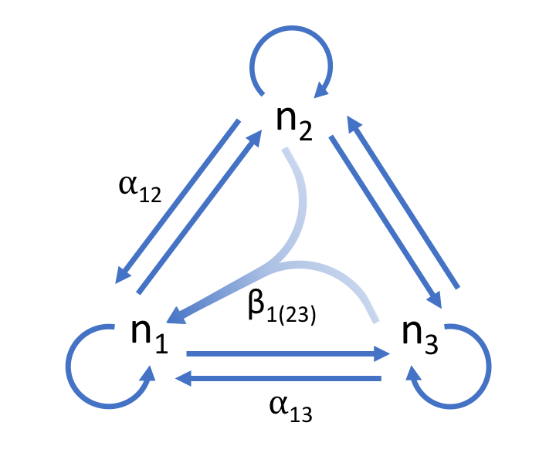

Figure 1. Three species competitive network. Inter- and intraspecific competition between species is depicted with the blue arrows. The effect of species two on one can be described by the per capita effect α12. An HOI, β1(23), is depicted as converging arrows showing that the effects of two and three on species one is non-additive.

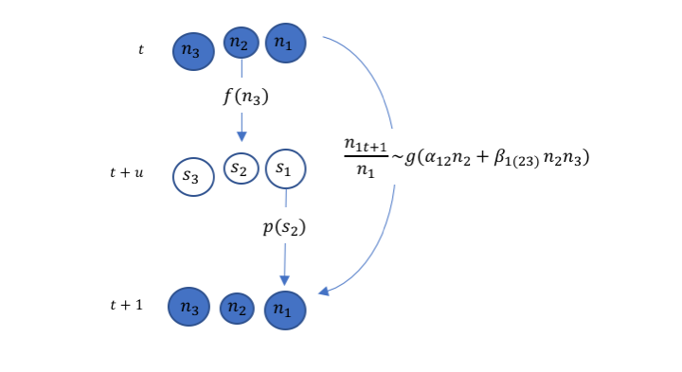

Figure 2. Two stage annual plant model. Plant population density (*ni*) is measured when plants are starting to flower at time *t* and again the next year *t + 1*. Seedling density (*si*) is an unmeasured state at time *t + u*. Adult plants at time *t* produce seedlings via a fecundity function *f* which may depend on competition from other species. Seedlings transition into adult plants via a survival function *p* which may depend on seedling density at time *t + u*. At each transition competition is additive and in this example the fecundity of species two depends on the density of species three, while the survival of seedlings from species one depends on the density of seedlings of species two. In a three species community, a phenomenological model for the population growth rate of species one, given by the function *g,* may be improved with an HOI term to account for the effects of the interaction between species three and two.

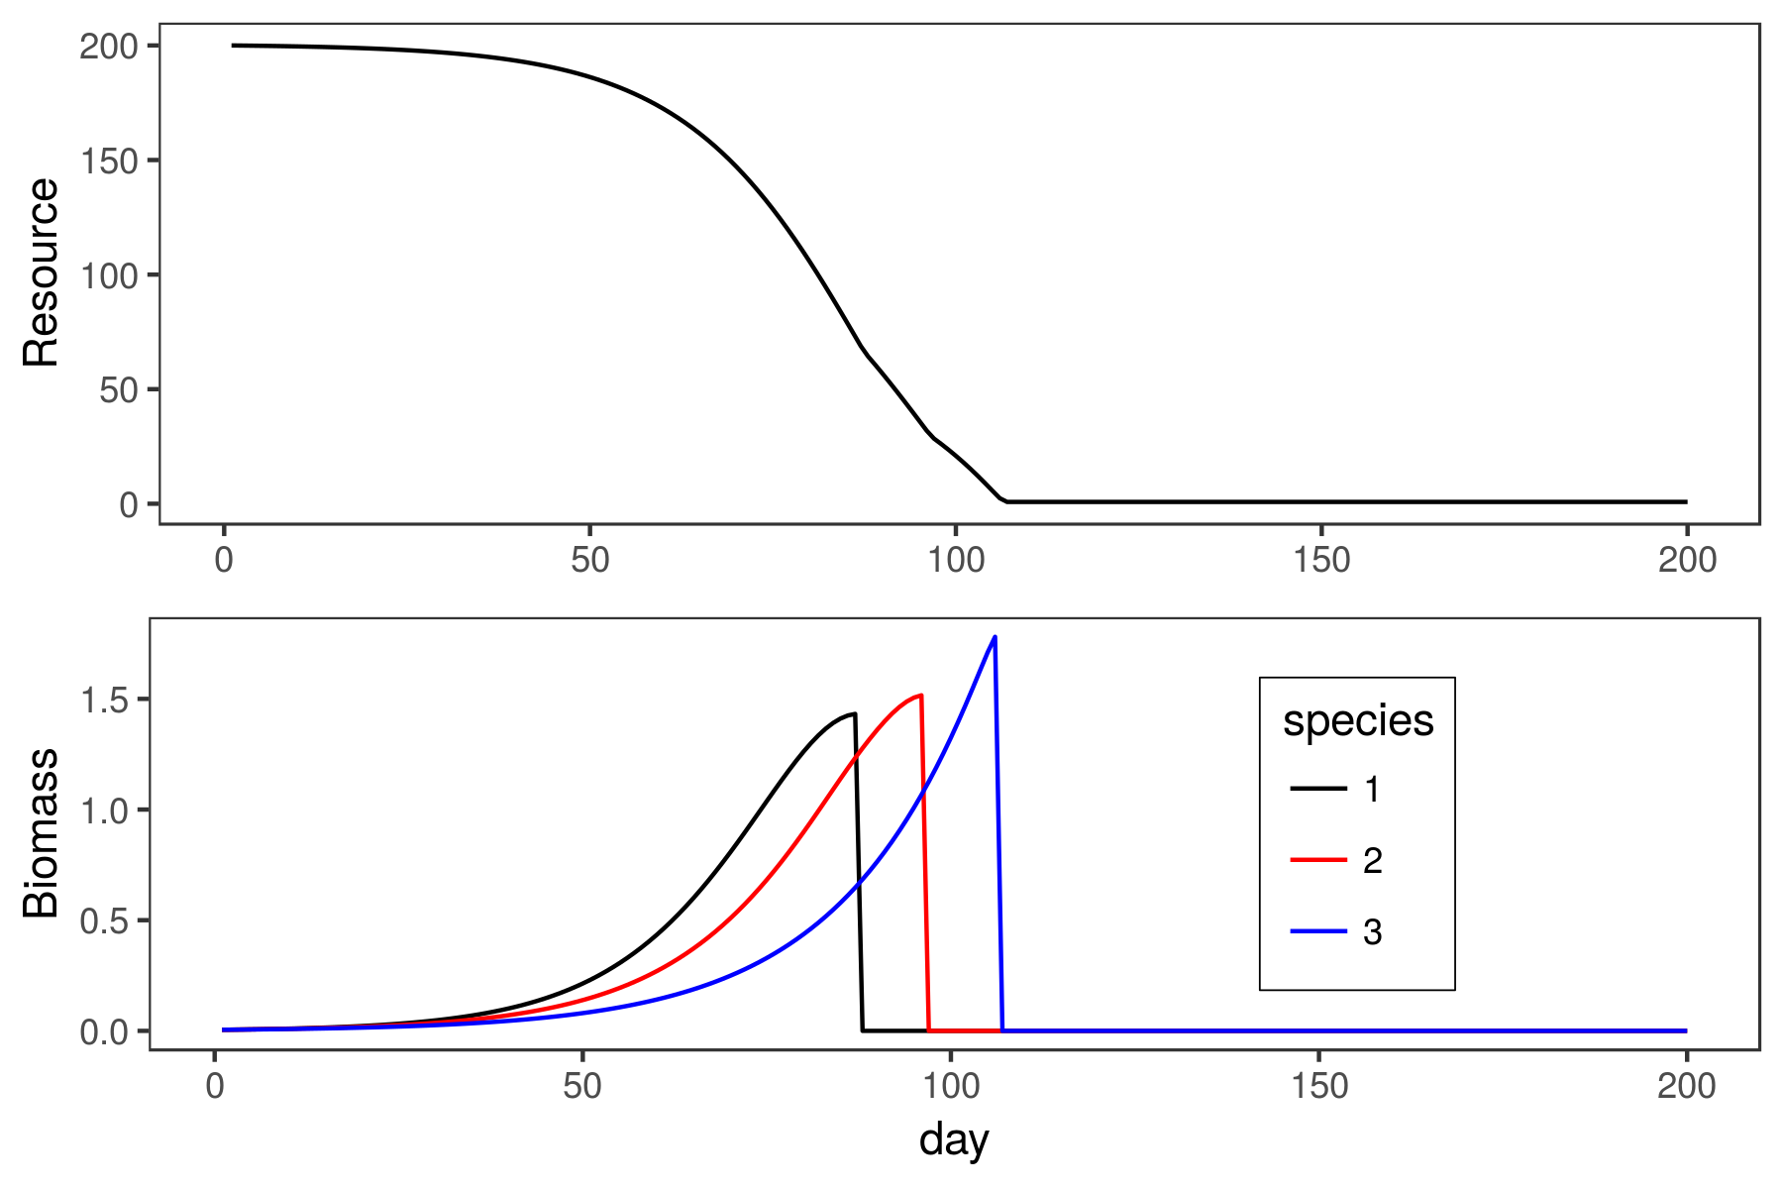

Figure 3. Example time series showing draw down of the resource during the course of the simulation, upper panel, and growth of each of the species, lower panel. Species one grows rapidly early in the season but senesces early as well. Species three grows slowly early in the season but grows for a longer period of time. Species is somewhere between these extremes. Each species reaches its peak biomass at a different time, at which point we assume all vegetative biomass is converted to seed mass, and resource uptake by that species stops.

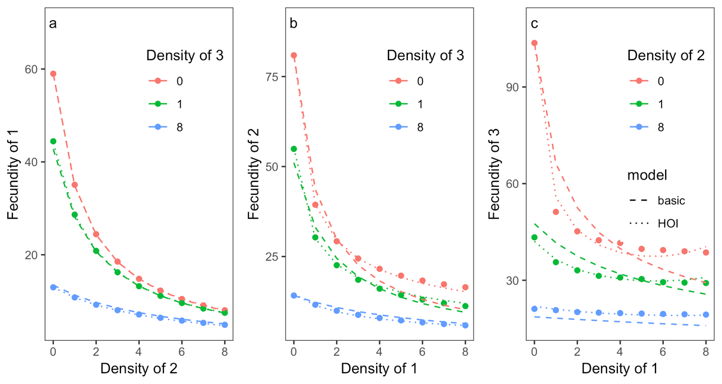

Figure 4. Simulated per capita seed production of species one, two and three (a, b, c) in response to increasing inter-specific competition on the x-axis. Three different levels of density of a second competitor are shown with the colors. The dashed line shows the best fit line from the basic model and the dotted line shows the best fit from the HOI model.

# Tables

Table 1. Fitted model parameters and residual squared error for the basic model and the model containing HOI terms.

|  |  |  |  |  |  |  |  |  |  |  |  |
| --- | --- | --- | --- | --- | --- | --- | --- | --- | --- | --- | --- |
| species | model | $$n_{1}$$ | $$n_{2}$$ | $$n_{3}$$ | $$n_{1}^{2}$$ | $$n_{2}^{2}$$ | $$n_{3}^{2}$$ | $$n_{1}n_{2}$$ | $$n_{1}n_{3}$$ | $$n_{2}n_{3}$$ | error |
| 1 | basic | 0.74 | 0.57 | 0.32 | - | - | - | - | - | - | 0.33 |
| 1 | HOI | 0.83 | 0.58 | 0.28 | -0.02 | 0.00 | 0.01 | -0.01 | 0.00 | 0.01 | 0.08 |
| 2 | basic | 0.84 | 0.98 | 0.58 | - | - | - | - | - | - | 1.19 |
| 2 | HOI | 2.97 | 2.03 | 0.78 | 0.00 | 0.74 | 0.30 | 1.91 | 1.64 | 1.09 | 0.28 |
| 3 | basic | 1.46 | 3.78 | 11.78 | - | - | - | - | - | - | 3.41 |
| 3 | HOI | 3.69 | 7.89 | 1.43 | -0.33 | -0.38 | 2.57 | 0.11 | 5.33 | 8.60 | 0.76 |

# Appendix A – Interaction modification leads to non-additive competition:

Assume that competition affecting species one is given by $C_{1}\left(n_{1},n_{2},n_{3}\right)=\left(α_{1,1}n_{1}+α_{1,2}n_{2}+α_{1,3}n_{3}\right)$. If we relax the assumption that pairwise competition coefficients are fixed and instead allow for interaction modifications, then competition coefficients may depend on other competitor densities. We can show this by replacing $α_{1,2}$ with a linear function of $n_{3}$: $a\left(n_{3}\right)=α_{1,2}+βn_{3}$. Now the competitive effect of $n_{2}$ on $n_{1}$ depends on $n_{3}$. If we re-write taking into account this interaction modification we arrive at a model that looks equivalent to the one in the main text: $C_{1}=\left(α_{1,1}n_{1}+α_{1,2}n_{2}+β_{1,(2,3)}n_{2}n_{3}+α_{1,3}n_{3}\right)$.

# Supporting Information – Figures:

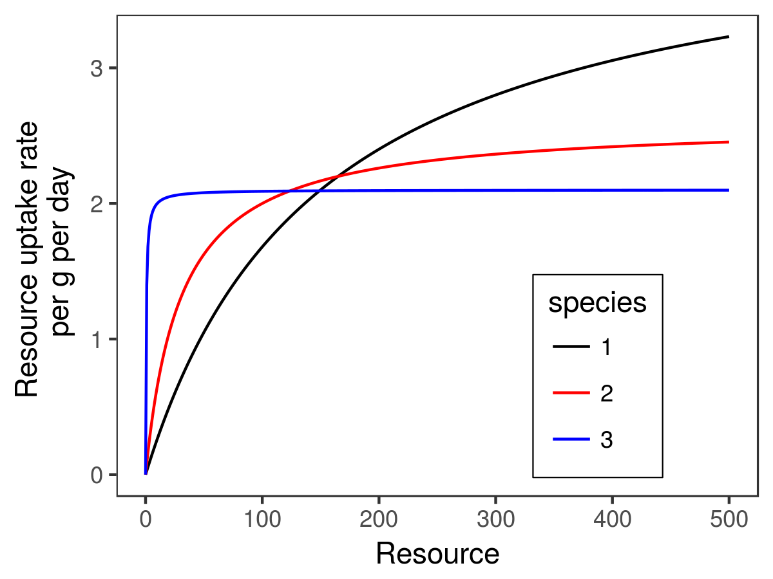

Figure S1. Resource curves for three simulated species. Species one has a resource uptake advantage when resource availability is high whereas species three has a resource uptake advantage when resource availability is low.

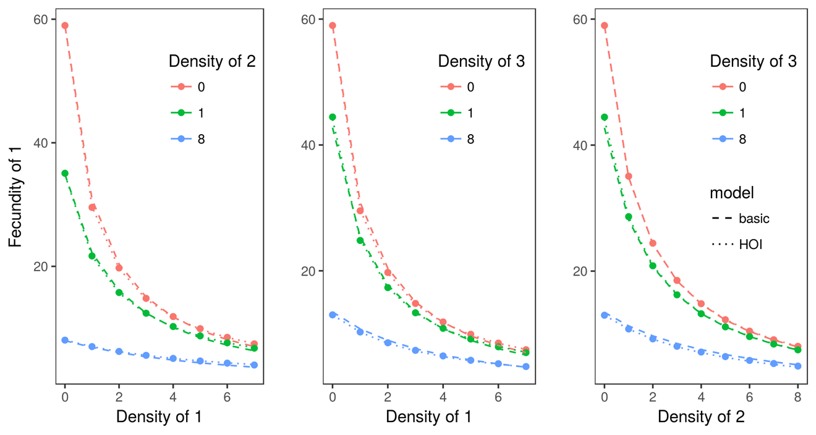

Figure S2. Simulated per capita seed production of species one in response to increasing competitor density on the x-axis. Colored lines show three different levels of density of a second competitor. The dashed line shows the best fit line from the basic model and the dotted line shows the best fit from the HOI model.

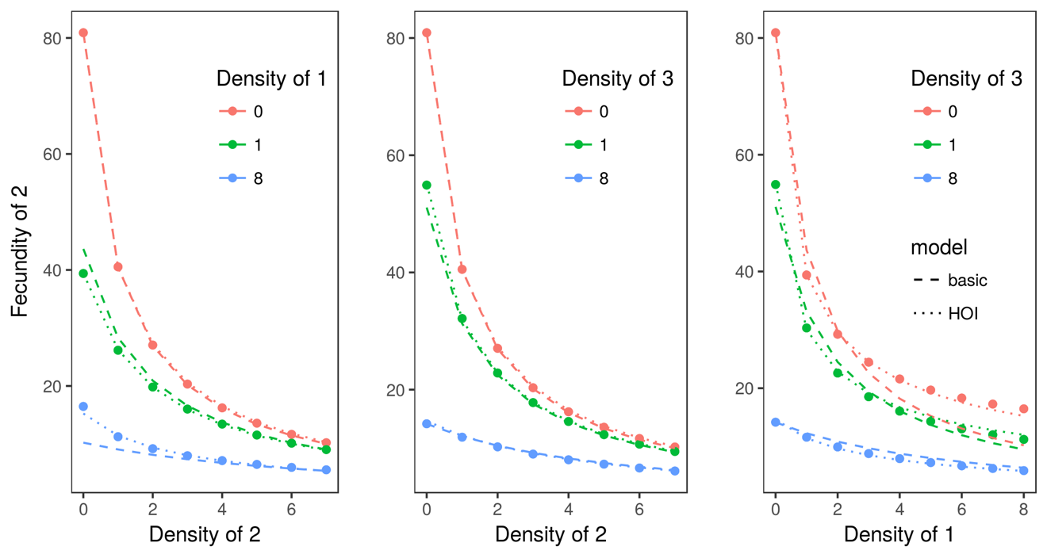

Figure S3. Simulated per capita seed production of species two in response to increasing competitor density on the x-axis. Colored lines show three different levels of density of a second competitor. The dashed line shows the best fit line from the basic model and the dotted line shows the best fit from the HOI model.

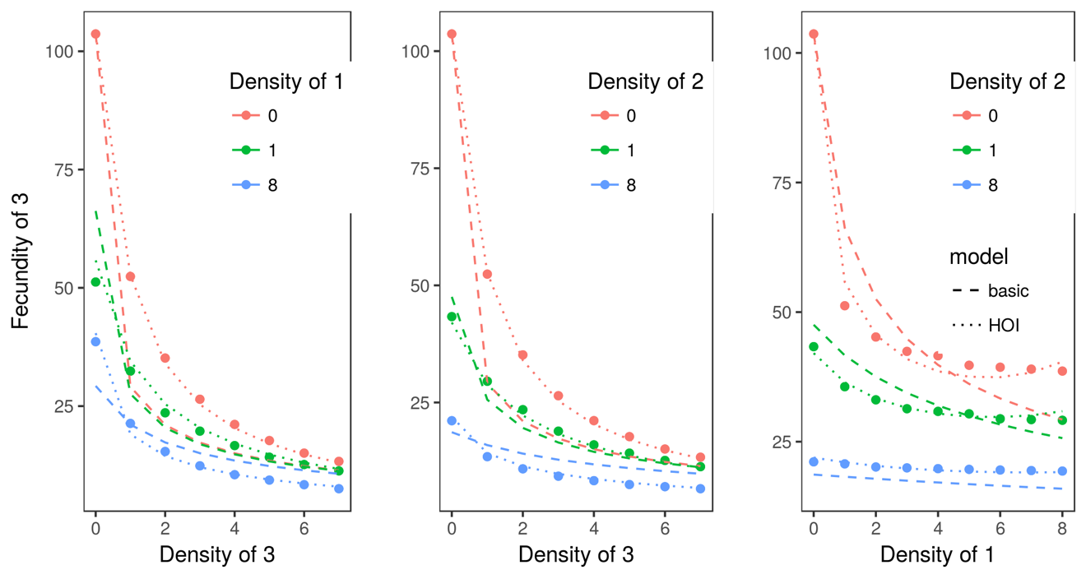

Figure S4. Simulated per capita seed production of species three in response to increasing competitor density on the x-axis. Colored lines show three different levels of density of a second competitor. The dashed line shows the best fit line from the basic model and the dotted line shows the best fit from the HOI model.