­­

**Mechanisms underlying higher order interactions: from quantitative definitions to ecological processes**

Running Head: *Higher Order Interactions*

**Key words:** *resource competition, interaction modification, phenology, annual plants*

Submission Type: Article

Main Text Word Count: 5,376

Total Word Count: 7741 (including appendix and literature cited)

Total Pages: 39 (including appendix)

Parts: Main text, Supporting Information Figures and Tables, Appendix A, Computer Code (zip file)

# Abstract

When species simultaneously compete with two or more competitors, higher order interactions (HOIs) can invalidate the application of classical theories of species competition and coexistence. In order to extend ecological theory to multi-species communities, it is critical to understand how often and by what mechanisms HOIs arise. In this paper we propose a quantitative definition for HOIs that distinguishes them from non-linear density dependence and emphasizes their consequences for multi-species competition. In order to illustrate how HOIs can be detected and to shed light on their mechanistic basis, we simulate resource competition between three annual plant species differing in their phenology and functional response to resource depletion. We then fit a phenomenological competition model to the outcome of simulated competition and use it to test whether competition involving more than one species is equal to the sum of single species effects. We find the strength of HOIs vary with phenology: species that grow later experience stronger HOIs because their competitive environment is strongly affected by earlier growing species. We conclude that stronger HOIs are likely to occur systems with rapid declines in resource availability and rapid increases in individual size over the course of a single growing season.

# Introduction

Almost all organisms interact with a diversity of predators, pathogens and competitors. Despite this, classical models in community ecology summarize species interactions in a pairwise fashion, assuming that the per capita effect of one species on another is independent of the densities of other species in the system. Such models have been critical to the development of modern coexistence theory (Chesson 2000, Levine et al. 2017), and imply that the dynamics of multi-species species competition can be predicted if we have an accurate understanding of the interactions between each pair of species. This concept is also central to recent efforts to relate species’ and community functional traits to the outcome of their competitive dynamics (Kraft et al. 2015).

The potential for higher order interactions (HOIs) between species challenges the core assumption of additive pairwise interactions (Neill 1974, Mayfield and Stouffer 2017, Levine et al. 2017, Grilli et al. 2017). The conceptual importance of HOIs is clear: if HOIs are prevalent, even a perfect understanding of competition between pairs of species may not be sufficient to describe the dynamics of multispecies communities (Neill 1974, Billick and Case 1994, Levine et al. 2017). The presence of HOIs is also a challenge for definitions of species coexistence and the niche that rest on fixed intraspecific and interspecific interaction strengths (Levine et al. 2017). In the extreme, HOIs may permit coexistence in communities of three or more species that are unable to coexist as species pairs (Grilli et al. 2017).

Although there has been a revival in ecologists’ interest in the implications of HOIs for coexistence in communities, the field still lacks a common quantitative definition of HOIs and robust methods to detect them in empirical data. The difficulty in defining HOIs was apparent early on (Vandermeer 1969, Neill 1974, Case and Bender 1981, Pomerantz 1981). Early discussions defined an HOI only within the context of a standard Lotka-Volterra competition model where per capita growth rate declines linearly with competition, and the effects of multiple competitors are summed to the get the aggregate competitive effect (Vandermeer 1969). Billick and Case (1994) attempted to define HOIs more generally as the presence of non-additive effects between species, but this definition was itself viewed as problematic (Adler and Morris 1994) because such non-additivity automatically arises in any model with non-linear density dependence. The lack of an agreed upon definition for HOIs is apparent in a recent paper by Mayfield and Stouffer (2017), which included non-linear intra- and inter-specific interactions as HOIs, a usage deviating from the original emphasis on interaction modification arising between two or more species (see also Letten and Stouffer 2019).

In addition to the challenges of defining HOIs described above, the mechanisms that generate higher order interactions between competing species are unclear. Ecologists know that higher order interactions emerge organically in many mechanistic competition models (Abrams 1983, O’Dwyer 2018). This has two key implications: first, since mechanistic models generate HOIs without the addition of explicit HOI terms, one might argue that HOIs may be an artifact of phenomenological models. However, the question of whether perfect knowledge of pairwise interactions is sufficient to predict the dynamics of more complex systems is fundamentally phenomenological and thus can only be investigated in the context of phenomenological interactions. Second, if mechanistic models of resource competition almost unavoidably generate HOIs (Abrams 1983), the scarcity of rigorous demonstrations of HOIs in nature represents an important gap in our understanding of competition—the logistical challenge of studying multispecies competition notwithstanding. An understanding of the mechanistic basis of HOIs would help ecologists predict when and where HOIs are most likely to emerge—and may help explain why phenomenological models without HOIs have been successfully applied in many communities.

HOIs have the potential to profoundly alter our understanding of the dynamics of multi-species communities, however progress in this area is limited by inconsistent definitions, difficulties in detecting HOIs in empirical data and few investigations of the processes that give rise to HOIs. To illustrate our definition and to investigate the mechanisms that generate HOIs we construct a simple mechanistic resource competition model that captures key features of the kind of empirical data that ecologists often collect when studying natural populations. We use the mechanistic model to simulate a virtual field experiment on the effects of competition on individual performance. We then fit phenomenological models to the simulated data in order to assess the presence of HOIs. Our virtual experiment demonstrates that HOIs may indeed be common even in relatively simple mechanistic models of competition. Importantly, we suggest that systems in which competitors vary in timing of resource uptake are likely to show HOIs, and that HOIs will likely be stronger for species maturing later in the growing season. Our example also shows how the strength and even the direction of HOIs are dependent on the structure of the phenomenological model being fit to the data.

## What counts as a higher order interaction?

Competition occurs when individuals consume the same limiting resource, such that increases in consumer densities reduce the availability of resources, which in turn changes the population growth rate of the consumers (Meszéna et al. 2006). The commonly used phenomenological definition of competition simplifies the representation of the interaction by focusing on the net effect of the indirect interaction without tracking the status of shared resources. At the population-level, phenomenological competition is measured as the reduction in a per-capita population growth rate due to an increase in density of individuals of the same trophic level (Chesson 2000).

The benefit of modeling competition phenomenologically is that such models can be fitted to empirical data for any pair of species without making assumptions about which resources or environmental factors are limiting to their populations (e.g. Kraft et al. 2015). Nevertheless, phenomenological models do require choosing a functional form that can accurately describe the effects of species density on population performance. This choice fundamentally dictates how we define species interactions and how we could detect higher order interactions (Adler and Morris 1994).

A useful definition for HOIs, should start from a recognition of the important implication HOIs have for community dynamics: the presence of HOIs means that even if an ecologist had perfect knowledge of how each pair of species compete against one another phenomenologically, the ecologist would be unable to predict the dynamics of a community with more than two species. While this may sound mysterious, HOIs can arise from a simple modification of standard competition models: if we assume, as is done in the classical Lotka-Volterra model, that per capita interactions between species are independent of density, then there are no HOIs; if on the other hand, interactions between species depend on the density of other species then this leads to HOIs (see Billick and Case 1994 for a derivation). Thus HOIs and interaction modification are often discussed as two sides of the same coin (Adler and Morris 1994).

Nevertheless, recent theoretical and empirical papers have defined HOIs in other ways. For instance, Grilli et al. (2017) show HOIs emerging in a model of forest dynamics even without interaction modifications. However, what the authors call HOIs in their model are essentially indirect effects or interaction chains (sensu Levine et al. 2017). These appear to be HOIs on the time scale of the longest-lived life stage in the competing populations because their model does not explicitly track the density of competitors during early stages of competition. Meanwhile, Mayfield and Stouffer (2017) define as HOIs any polynomial forms of intra or interspecific competitor density in their demographic model that improve the statistical fit of annual plant fecundity to competitor density. This definition includes interactions between intraspecific and interspecific density and even quadratic terms involving the density of a single species. While including these terms as HOIs simplifies their statistical detection, and maps clearly onto what a mathematician thinks of as “higher order” terms, these HOIs have different implications for community dynamics than the definition we emphasize. For instance, including quadratic density terms within the definition of HOIs is inconsistent with HOIs resulting from interaction modification between species. More specifically they imply that a species modifies its own competitive effect.

A similar set of issues was pointed out by Pomerantz (1981) who argued that a distinction needed to be made between HOIs and non-linear density dependence. In the most widely used models for effects of competition, such as the Beverton-Holt, Hassell and Ricker models, per capita growth rate is a nonlinear function of competitor density (Hassell and Comins 1976). In each of these models the effect of each additional competitor on growth declines as more competitors are added. This could be interpreted as a kind of interaction modification among *individuals within* species. Like Pomerantz (1981) however, we advocate restricting higher order interactions to cases where individuals of one species modify the per capita effect of individuals of other species.

*Defining Higher Order Interactions*

To summarize, higher order interactions have profound implications for multispecies communities, foremost among these is that they can make it impossible to predict the dynamics of multispecies communities from models of single species competition. This also implies that the dynamics of the multispecies communities we see around may not be neatly decomposed into separate competitive effects of each species on each other species. These emergent properties at the community level can arise due to interaction modification between competitors. Following from this context, and building on past efforts by Billick and Case (1994) and Adler and Morris (1994), we propose the following general mathematical definition.

We start with a general phenomenological model for species competition in discrete time (though the equivalent definition applies in continuous time):

|  |  |  |
| --- | --- | --- |
|  |  | (1) |

where is the per capita growth rate of species at time , represents that species’ intrinsic per capita population growth rate, and the function gives the competitor-influenced per capita population growth rate as a function of total competition , which is determined by the density of all competitors in the community. While is technically dependent on —it cannot be measured without specifying some function for per capita growth rate—we believe that separating the two is heuristically valuable as a way to differentiate non-linear demographic responses from HOIs. For instance, in the most widely used models for density dependent population growth, is non-linear: in the Ricker model , whereas in the Beverton-Holt or Hassel model Just because per capita growth rate declines nonlinearly with an increasing the density of competitors does not mean that ten individuals of one competitor species, for example, modify the per capita effects of ten individuals of another competitor species.

Our definition of an HOI therefore focuses specifically on how individual species contribute to total competition, *C*: *an HOI occurs whenever cannot be expressed as a sum of individual species effects.* Mathematically this means that for all *S* species in the community, for any function of a single species *j’s* density. HOIs are therefore any additional terms in the summation of that involve functions of more than one species’ density. Following this definition, there are no HOIs in the standard Ricker and Beverton-Holt models because, despite the nonlinear effects of on per capita growth, is a weighted sum of species densities, , where is the competitive effect of each individual of species on species . In fact, one advantage of our definition of HOIs over earlier definitions (e.g. Billick and Case 1994) is that it does not require that each species’ growth depend linearly on density. For example, could be a sum of quadratic functions of each species’ density: (Mayfield and Stouffer 2017). While the effects of density are non-linear in this formulation of , this does not imply HOIs because each species’ contribution to total competition does not depend on the density of any other species. In this case, perfect knowledge of how each competitor individually affects a focal species’ growth perfectly predicts the simultaneous effects of multiple competitor species. Our definition of HOIs includes cases where intraspecific competition is modified by the density of another species (see also, Billick and Case 1994, Mayfield and Stouffer 2017). This means that HOIs as defined here can occur even when only two species interact .

# HOIs in a mechanistic resource competition model

To illustrate how we might detect HOIs in empirical data on species interactions, we simulate competition among annual plants for a single shared resource using a mechanistic resource competition model. We then fit species’ responses to interspecific competition using a simple phenomenological competition model. By considering the cases in which higher order interactions emerge in this phenomenological description of the system, we can address the processes causing these interactions to develop.

Our mechanistic model is inspired by annual plant communities growing in a Mediterranean climate. In this system, rainfall starts in the early winter and gradually declines through the spring while temperature and evaporative demand increase. Plants germinate in the winter, grow through the spring, and flower, produce seeds and die by the summer. In our model, we track a single pool of generic soil resources, most easily thought of as water given its timing of availability. Importantly, this pool is not resupplied during the growing season and plants eventually use up the pool of stored soil resources. As resources are depleted, plant growth slows and eventually stops. We make the assumption that when net plant growth stops, the plants stop producing vegetative biomass and start producing seeds (Cohen 1976).

The model is expressed as a set of differential equations,

|  |  |  |
| --- | --- | --- |
|  |  | (2) |

where gives the resource availability at time , and gives the resource supply rate. The final term expresses the loss of resources due to uptake by plants. Plant biomass of species at time is given by , *S* is the number of species in the community and is the resource dependent uptake function for species *i*. We simulate a Mediterranean climate by setting initial resource availability high, , and setting the resource supply rate to zero (Figure 2 a).

Growth of each species is simulated with a piecewise differential equation dependent on resource availability,

|  |  |  |
| --- | --- | --- |
|  |  | (3) |

where, is the total biomass of species , is a resource conversion factor, is a per biomass respiration and tissue loss rate, and as in the first equation, the function gives the resource uptake rate. The growth of each species stops when meaning that the rate of biomass gain is equal to biomass loss. At this point the plant stops growing and converts all biomass to seed mass. We impose this behavior on the model by setting growth and resource uptake to zero when resources fall to this point.

Different species are likely to have different rates of resource uptake. In our simulation, we assume a trade-off between rates of resource uptake at high resource availability and rates of resource uptake at low resource availability (Figure 2c). This means that species which grow rapidly early in the season when resource availability is high will stop growing and produce seed earlier (Figure 2b). In contrast, species that grow slowly early in the growing season will to persist later into the season when resource availability is low.

This trade-off between species in early and late season growth rates is produced by giving each species a saturating Monod resource uptake function (Miller and Klausmeier 2017),

|  |  |  |
| --- | --- | --- |
|  |  | (4) |

where, is the maximum rate of resource capture and is the half-saturation constant of resource capture. The trade-off we impose means requires that the species with the highest maximum resource uptake rate has the highest half-saturation constant , and the species with slowest maximum resource uptake rate has the lowest half-saturation constant (Table S1). The resource uptake curves result in species-specific phenology for the three species and so we refer to these as ‘early’, ‘mid’ and ‘late’ (Figure 2). The differences in the timing of growth recreates important functional differences between species observed empirically in annual plant communities (Godoy and Levine 2013).

So far, we have described a model of growth dynamics in continuous time *u* within a single generation and with units of total biomass. In contrast, a phenomenological model of competition that might realistically be parameterized from field data would likely track the total population density, , as number of individuals of species at time *t*. To convert between the units of the simulation and the units of the phenomenological model, we first assume that all individuals start as seeds at the beginning of a simulation. Thus, we calculate the initial biomass, , at the start of a simulation as, where is the mass of an individual seed and is the number of seeds of species *i*. Second, we assume that population density at year is equal to the number of seeds produced during the course of a simulation, and we assume this is proportional to the biomass at the time of flowering. Thus,

|  |  |  |
| --- | --- | --- |
|  |  | (5) |

where is the number of germinable seeds produced during the growing season, and therefore available to start population growth in year *t+1*, and *c* is a conversion factor that represents the mass of seeds produced for each unit of total plant mass. The maximum of over the course of the growing season is equal to the final biomass of species *i*, or equivalently the biomass at time of flowering. We assume that all species have the same values for and *c* (Table S 1). We simulate these dynamics using the differential equation solvers package desolve in the statistical program R (R Core Team 2015). Code to run the simulations are given in the supporting information.

Finally, we used this mechanistic model to simulate plant growth of each species when faced with a range of densities of one or two other interspecific competitors. In the simulated experiment a single individual of each of the three species are grown in “plots” either with increasing densities (0, 1, 2, …7, 8) of a single interspecific competitor species or in plots with two interspecific competitor species where each competitor species was at a density ranging from 0 to 8 (in an orthogonal design).

## Phenomenological annual plant model

We model annual plant competition in terms of the decline in per capita reproductive output with increasing density of competitors at the start of the growing season (). We tested two different phenomenological competition models. The first has been used in a number of empirical studies of annual plant competition (e.g. Kraft et al. 2015),

|  |  |  |
| --- | --- | --- |
|  |  | (6) |

where denotes maximum per capita reproductive output, is the per capita competitive effect of species on and is a species-specific parameter controlling how steep fecundity declines with competition in general.

We also fit a second model in which the effects of each species are modified with a separate exponent where

|  |  |  |
| --- | --- | --- |
|  |  | (7) |

This allows species to have per capita effects that are themselves density dependent but the competitive effects of each species are still assumed to be additive. We fit separate competition models for each of three species using the nls package in R. We defined for each species as the per capita fecundity in the absence of any competitors and set this as a constant when fitting the models.

In order to detect HOIs and measure their strength we fit the phenomenological model to cases where each focal species faced increasing densities of only one other competitor species at a time (details in the preceding section). Once we were satisfied that phenomenological models fit these pairwise dynamics adequately, we used the models to predict species’ per capita fecundity in cases where the focal species simultaneously faces two interspecific competitor species. If species effects are additive, then our model fit to density gradients of a single competitor species should be able to predict the joint effect of competition from two competitor species together. However, if there are HOIs then the sum of species effects will not be equal to the observed effect of multiple species. We use the deviation between the per capita fecundity of each species predicted by the additive phenomenological model and the per capita fecundity observed in the simulations as a measure of the effect of HOIs. HOIs are supported when the average deviation in the multispecies case is greater than the deviation in the single species cases. We can quantify this by comparing the root-mean-squared error from two competitor simulations to the root-mean-squared error in single competitor simulations. We can also look at the average deviation to get a sense of the direction of the HOIs. Importantly, this approach does not require that we specify the functional form of the higher order interaction term.

# Evidence for HOIs

For all three species we found that the modified phenomenological competition model with varying exponents (equation 7) fit the simulated data accurately (Figure 3), whereas the standard model (equation 6) only fit the data for the early species (Figure S 1). When we tested how well models fit to single species competition predicted the simultaneous effects of two species’, we found weak HOIs for the early season species and stronger HOIs for the mid and late season species (Figure 4). In other words, for the early species, the observed effect of two species together was close to the sum of the two species’ individual effects (Figure 5). However, assuming additive competitor effects underpredicted the total strength of competition on the mid-season species (Figure 5 b), and overpredicted the strength of competition on the late species (Figure 5 c). This shows that competitors’ effects changed depending on the density of other competing species, and by our definition this is a HOI. Using the first phenomenological model, equation 6, which was less accurate in fitting the fecundity of single species, we also found evidence of HOIs (Figure S 2) but these were different in direction and magnitude than those detected with equation 7, indicating that HOIs are by definition dependent on what form of phenomenological model is fit to single species effects.

Our simulation shows that even in a relatively simple resource competition model the effects of multi-species competition may not be equal to the sum of the individual species effects. Comparing the observed effects of multispecies competition to the sum of the separate species’ effect is a useful way to determine the presence of HOIs without assuming a specific functional form for the HOIs. This makes it a diagnostic tool, not a way to predict multispecies community dynamics.

*What Causes Higher Order Interactions?*

In this model, HOIs emerge because species growth and resource uptake rates are dependent on the current availability of resources in the system (Figure 2 c). This means that as species use resources they not only affect the growth rates of their competitors, but they can also affect the interactions between those competitors. For instance, the early species has the most rapid growth and resource uptake rate early in the season. This shifts the resource uptake rates of the mid and late season species towards the left along their resource uptake curves (Figure 6a). Because the mid and late season species resource uptake curves are shaped differently, this reduces the uptake rate of the mid-season species more than it does the late season species during the period of time when both species are active, that is until the mid-season species stops growing (vertical lines Figure 6 a). Thus the average resource uptake rate of the mid-season species declines more than that of the late season species in response to the presence of the early season species (Figure 6 b).

Differences between species in how much their resource uptake rates change with the presence of the early competitor explain the direction of the HOI effects on the late season species: the presence of the early species, puts the mid-season species at a slight disadvantage relative to the late species; thus the joint effect of the early and mid-season species together is less than their additive effect (Figure 4 c; Figure 5 b). The same dynamics cause the mid-season species to experience stronger than additive competition from the early and late species together: in the presence of the early season species, the mid-season species gets a smaller share of the resource pool it competes for with the late season species (Figure 4 b; Figure 5 b).

By contrast, the early species is only weakly affected by HOIs (Figure 5). In principle, resource uptake by the late season species should reduce the early season species’ average resource uptake rate more than it does the mid-season species, thereby strengthening the effect of competition on the early species. However, this effect is weak because the late season species grows much more slowly early in the season than its competitors and so it has minimal impact on resource availability. Meanwhile, the mid-season species does not significantly change the resource uptake rate of the late season species because the late species’ resource uptake curve is flat over the range of resource availabilities that the early species is active (Figure 2).

The origin of HOIs in this system are therefore consistent with the arguments in favor of HOIs put forward by Abrams (1983). Abrams argued that HOIs should occur when competing species have different non-linear responses to resource availability. In our simulation, the resource uptake and growth rates of the competing species follow a Monod or type II functional response to resource availability (Figure 2c). This means that competition between pairs of species depends upon the level of resources available. Since species also influence the resource concentration itself, it follows that competition between any pair of species is influenced by the presence of other species in the community—the definition of a HOI.

What makes our example more complicated, but perhaps more realistic, is that unlike in classical resource competition models, resources do not reach an equilibrium during the course of our simulation. Rather, they are constantly declining throughout the season (Figure 2 a). Deriving phenomenological competition coefficients from a mechanistic resource competition model often requires first solving for stable resource equilibria and then calculating the first order sensitivity of the growth rate of each species to the resource availability and the sensitivity of the resource to the consumers (Tilman 1977, Meszéna et al. 2006, Letten et al. 2017). However, we believe that in many natural systems, such as those involving annual plants, the pace of resource dynamics may be as rapid as the change in consumer biomass. This makes deriving competition coefficients analytically much more difficult, perhaps impossible (O’Dwyer 2018). The advantage of statistically fitting a phenomenological model to observed or simulated effects of competition is that this approach can help us understand pairwise competition even in such complex cases. However, our work here also shows that this advantage may come at the cost of ignoring important HOIs in multispecies communities.

# Are HOIs Common in Nature?

One way to view HOIs in this system is to consider them instances of a more general case in which the trait that determines each species’ impact on and sensitivity to resource availability is itself governed by resource availability (Meszéna et al. 2006). In this case, the trait in question is the average rate of resource uptake, which shifts in response to resource availability and thus the earlier activity of competitors. More generally, we believe HOIs will be inevitable in systems in which 1) some species can cause large resource fluctuations, 2) the rate of resource uptake by other species shifts in response to resource availability, and 3) the strength of this response varies across species. Among plants, plastic changes in traits such as height, specific leaf area, and phenology, have been shown in response to competition and changes in resource availability (e.g. Aronson et al. 1992, Bennett et al. 2016, Conti et al. 2018). In theory, these traits should also determine each individual’s impact and sensitivity to competition. So, are significant HOIs inevitable? And if so, why are there so few documented examples among competing plants (but see Mayfield and Stouffer 2017)?

One hypothesis is while HOIs are common, they are often weak. A key factor in producing HOIs in our simulation is that each species has a uniquely shaped resource uptake curve. Additional simulations show that the more similar species resource uptake curves are to one another the weaker the HOIs are in this system (Appendix A). In nature, such large differences in the shape of resource uptake curves may be rare.

In addition, the large changes in resource availability and plant biomass in our simulation contribute to the magnitude of HOIs. Because resource availability fluctuates widely from the beginning to the end of the growth period in our simulation, it means that species interactions change dramatically over the course of the season. Without the extreme fluctuation in the resource environment, species would have relatively constant competitive effects on one another and no HOIs would emerge. For instance, compare our system to an idealized version of resource competition experienced by competing perennial plants (Dybzinski and Tilman 2007). Due to their large size, perennial plants can be assumed to quickly draw resources down to a dynamic equilibrium. Thus, even if species have different non-linear responses to resource concentration the fact, that resource concentration is relatively fixed eliminates the possibility of strong higher order interactions. For this reason, seasonally forced systems, such as annual plant communities in Mediterranean climates, may be a good place to look for strong HOIs (Mayfield and Stouffer 2017).

Finally, our analysis that even though we restrict our definition of HOIs to only involve interaction modification between heterospecific and not conspecific individuals (in their total competitive effects), HOIs are virtually guaranteed when species’ individual contributions to change non-linearly with density. Such non-linearity would arise when individuals alter the competitive effects of other individuals within the same species. In our simulated experiment for example, we found that a model with non-linear terms for each competitor species’ effect best fit the simulated data for the mid and late-season species. These species-specific non-linear terms were required to fit the single species data because the densities of each competitor had different non-linear effects (Figure 3).

To see how these non-linear effects of competitor density within species almost guarantee an HOI (between species), consider two species, one and two, that have identical effects on shared resources and therefore identical effects on a third competitor, species three. Our definition of HOIs suggests that if there are no HOIs, the true combined effect of one and two together will be the sum of their separate effects:, where is a function of species density. In the case where individuals of one and two are identical, we know that their true effect on three must in fact be equal to yet if is a non-linear function, . Just because we label the individuals of species one and two as belonging to different species, the sum of their separate effects will not equal their combined effect. This example illustrates why any system in which competition, *C*, depends non-linearly on the density of individual species will likely result in HOIs between species.

# Conclusion

Higher order interactions have profound implications for how we understand multispecies communities. We have sought to clarify the definition of HOI’s and explain how they could arise from simple resource dynamics. We propose that the most robust method to detect HOIs is to compare the observed strength of multispecies competition to the sum of individual species effects. We illustrate our definition of HOIs and our proposed method for detecting HOIs with a simulation of species competition for a single resource. Defining HOIs in this way requires first finding a phenomenological model that accurately describes the focal species’ response to single species competition. While we believe that HOIs should be common in nature this does not mean that they will be strong enough to detect statistically in empirical settings. Our work suggests that environments in which resource availability and competitor size change rapidly during a single growing season may be a likely place for HOIs to emerge.

# Acknowledgments

# References

Abrams, P. A. 1983. Arguments in Favor of Higher Order Interactions. The American Naturalist 121:887–891.

Adler, F. R., and W. F. Morris. 1994. A General Test for Interaction Modification. Ecology 75:1552–1559.

Aronson, J., J. Kigel, A. Shmida, and J. Klein. 1992. Adaptive phenology of desert and Mediterranean populations of annual plants grown with and without water stress. Oecologia 89:17–26.

Bennett, J. A., K. Riibak, R. Tamme, R. J. Lewis, and M. Pärtel. 2016. The reciprocal relationship between competition and intraspecific trait variation. Journal of Ecology 104:1410–1420.

Billick, I., and T. J. Case. 1994. Higher Order Interactions in Ecological Communities: What Are They and How Can They be Detected? Ecology 75:1530–1543.

Case, T. J., and E. A. Bender. 1981. Testing for Higher Order Interactions. The American Naturalist 118:920–929.

Chesson, P. 2000. Mechanisms of Maintenance of Species Diversity. Annual Review of Ecology and Systematics 31:343–366.

Cohen, D. 1976. The Optimal Timing of Reproduction. The American Naturalist 110:801–807.

Conti, L., S. Block, M. Parepa, T. Münkemüller, W. Thuiller, A. T. R. Acosta, M. van Kleunen, S. Dullinger, F. Essl, I. Dullinger, D. Moser, G. Klonner, O. Bossdorf, and M. Carboni. 2018. Functional trait differences and trait plasticity mediate biotic resistance to potential plant invaders. Journal of Ecology 106:1607–1620.

Dybzinski, R., and D. Tilman. 2007. Resource Use Patterns Predict Long‐Term Outcomes of Plant Competition for Nutrients and Light. The American Naturalist 170:305–318.

Godoy, O., and J. M. Levine. 2013. Phenology effects on invasion success: insights from coupling field experiments to coexistence theory. Ecology 95:726–736.

Grilli, J., G. Barabás, M. J. Michalska-Smith, and S. Allesina. 2017. Higher-order interactions stabilize dynamics in competitive network models. Nature 548:210–213.

Hassell, M. P., and H. N. Comins. 1976. Discrete time models for two-species competition. Theoretical Population Biology 9:202–221.

Kraft, N. J. B., O. Godoy, and J. M. Levine. 2015. Plant functional traits and the multidimensional nature of species coexistence. Proceedings of the National Academy of Sciences of the United States of America 112:797–802.

Letten, A. D., P.-J. Ke, and T. Fukami. 2017. Linking modern coexistence theory and contemporary niche theory. Ecological Monographs 87:161–177.

Letten, A. D., and D. B. Stouffer. 2019. The mechanistic basis for higher-order interactions and non-additivity in competitive communities. Ecology Letters In Press.

Levine, J. M., J. Bascompte, P. B. Adler, and S. Allesina. 2017. Beyond pairwise mechanisms of species coexistence in complex communities. Nature 546:56–64.

Mayfield, M. M., and D. B. Stouffer. 2017. Higher-order interactions capture unexplained complexity in diverse communities. Nature Ecology & Evolution 1:0062.

Meszéna, G., M. Gyllenberg, L. Pásztor, and J. A. J. Metz. 2006. Competitive exclusion and limiting similarity: A unified theory. Theoretical Population Biology 69:68–87.

Miller, E. T., and C. A. Klausmeier. 2017. Evolutionary stability of coexistence due to the storage effect in a two-season model. Theoretical Ecology 10:91–103.

Neill, W. E. 1974. The Community Matrix and Interdependence of the Competition Coefficients. The American Naturalist 108:399–408.

O’Dwyer, J. P. 2018. Whence Lotka-Volterra?: Conservation laws and integrable systems in ecology. Theoretical Ecology.

Pomerantz, M. J. 1981. Do “Higher Order Interactions” in Competition Systems Really Exist? The American Naturalist 117:583–591.

R Core Team. 2015. R: A Language and Environment for Statistical Computing. R Foundation for Statistical Computing, Vienna, Austria.

Tilman, D. 1977. Resource Competition between Plankton Algae: An Experimental and Theoretical Approach. Ecology 58:338–348.

Vandermeer, J. H. 1969. The Competitive Structure of Communities: An Experimental Approach with Protozoa. Ecology 50:362–371.

# Figures

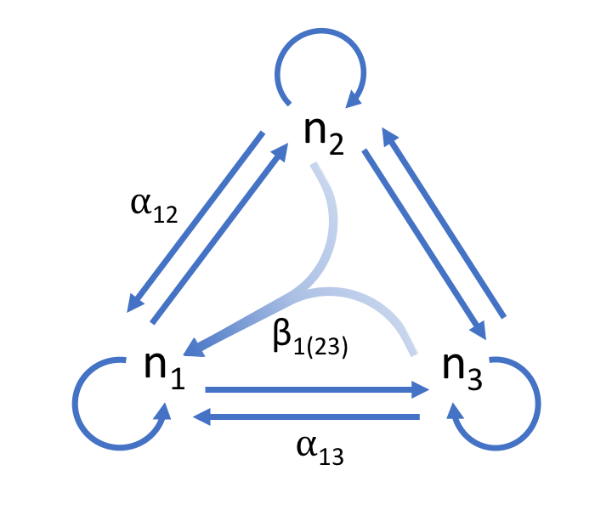

Figure 1. Three species competitive network. Inter- and intraspecific competition between species is depicted with the blue arrows. The effect of species two on one can be described by the per capita effect . An HOI, , is depicted as arrows from species two and three converging on one. The effect of the HOI means that net effect of two and three on species one is non-additive.

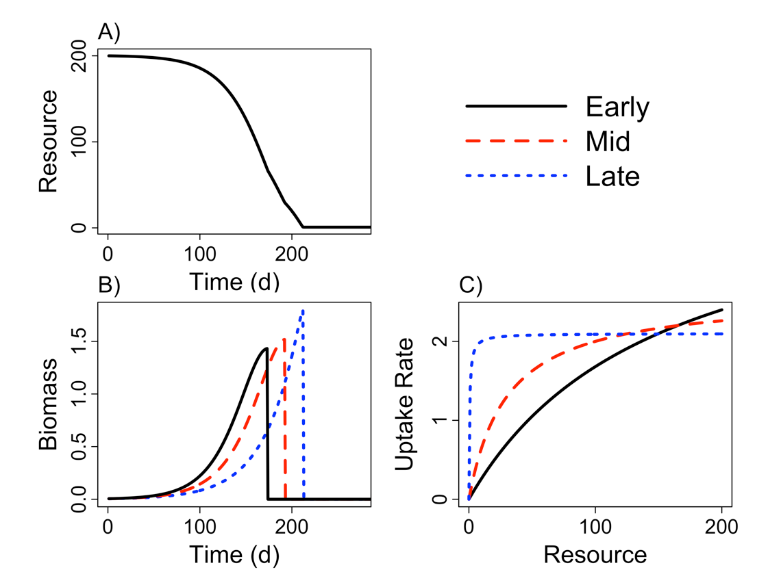

Figure 2. Example time series showing A) the drawdown of the resource during the course of the simulated growing season with starting densities of one individual of each species, B) the growth of each of species shown with colored lines and C) the dependence of resource uptake rates on resource concentration. The early season species grows rapidly when resource availability is high and senesces early. By contrast, the late season species grows slower than species one and two when resource availability is high but it is able to maintain higher rates of resource uptake at lower resource concentrations. This allows it to grow later into the season and senesce last. The mid season species lies between these extremes.

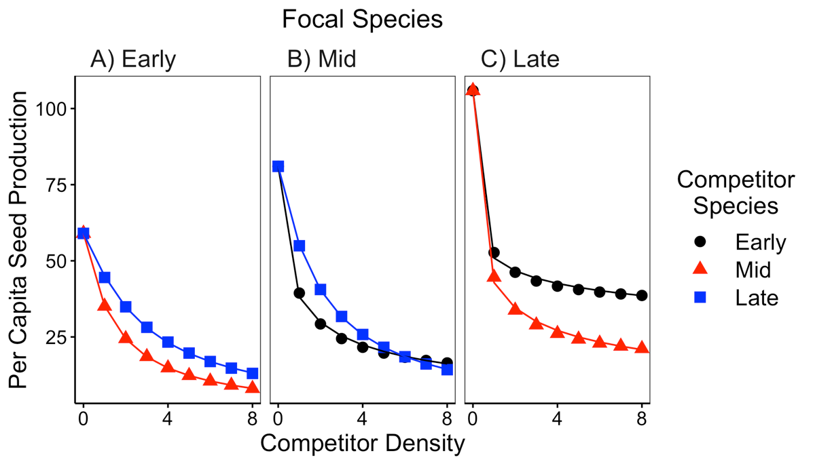

Figure 3. Simulated per capita seed production of the A) early, B) middle and C) late season species in response to increasing inter-specific density on the x-axis. Colors correspond to the identity of the competitor species. The solid line shows the best fit from the model with varying exponents on each competitor’s effect (equation 7).

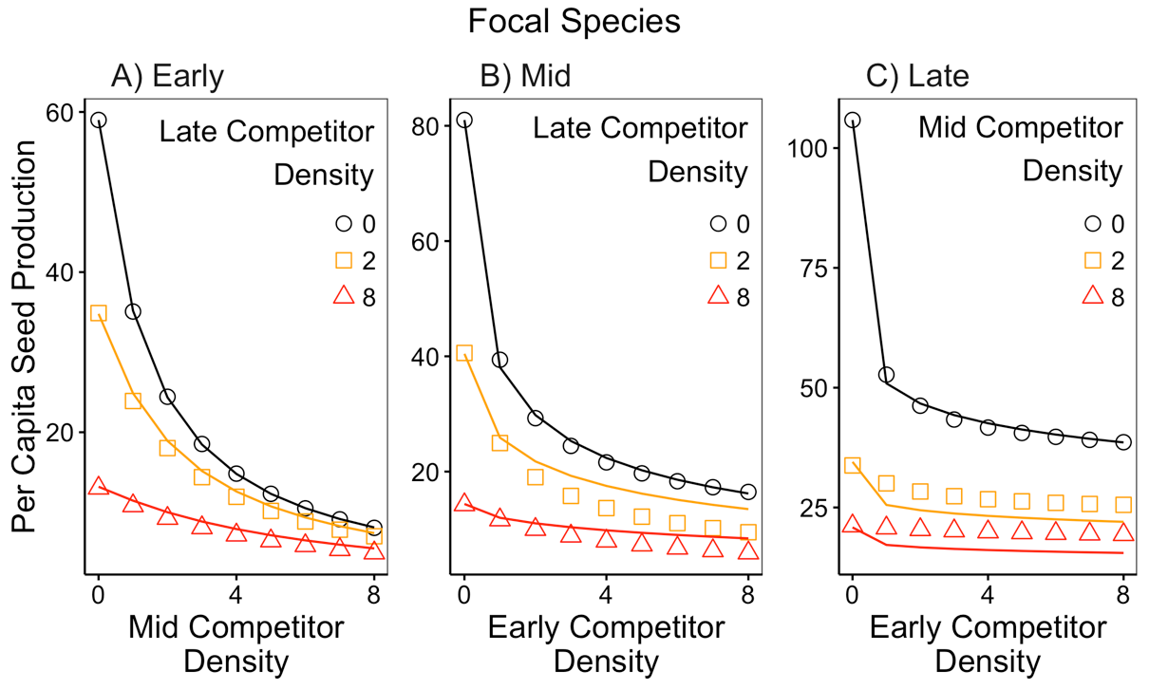

Figure 4. Simulated per capita seed production of the A) early, B) mid and C) late season species in response to increasing simultaneous competition from two species. Increasing densities of one competitor species are shown on the x-axis and increasing density of a second competitor are shown with the varying colors. The lines show the predicted per capita fecundity from the competition model with varying exponents (equation 7). The predicted per capita seed production assumes species’ competitive effects are additive. Deviations between the predictions (lines) and the observations (points) indicate the presence of non-additive species’ effects and therefore higher order interactions.

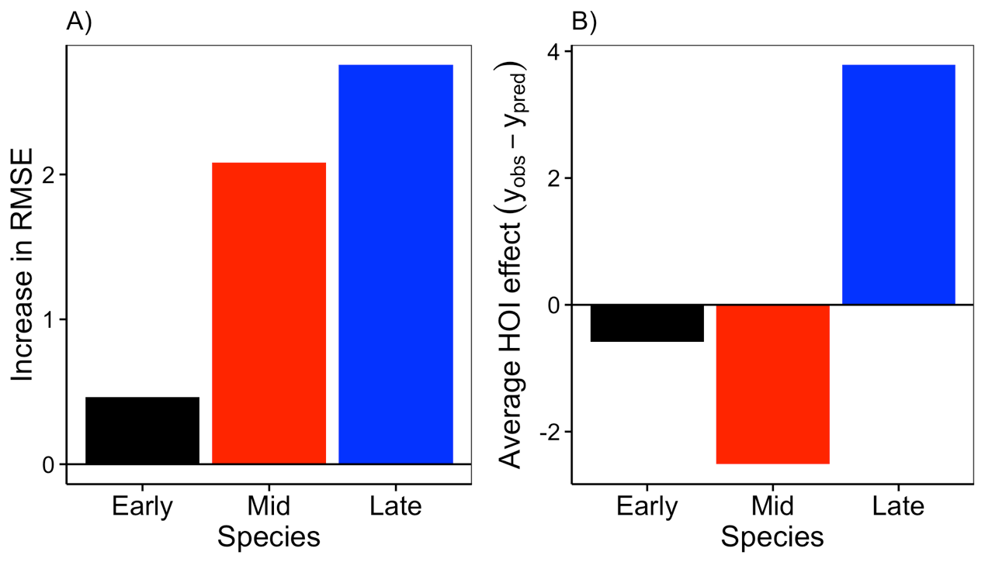

Figure 5. Deviation from additivity of two-species competition for each species in the community. A) The deviation from additive competitor effects is shown as the increase in root mean squared error of the second phenomenological model (equation 7) in multispecies competition compared to single species competition. B) The average deviation from additive competitor effects, positive values show that multispecies competition was weaker than predicted, negative values show where competition was greater than predicted.

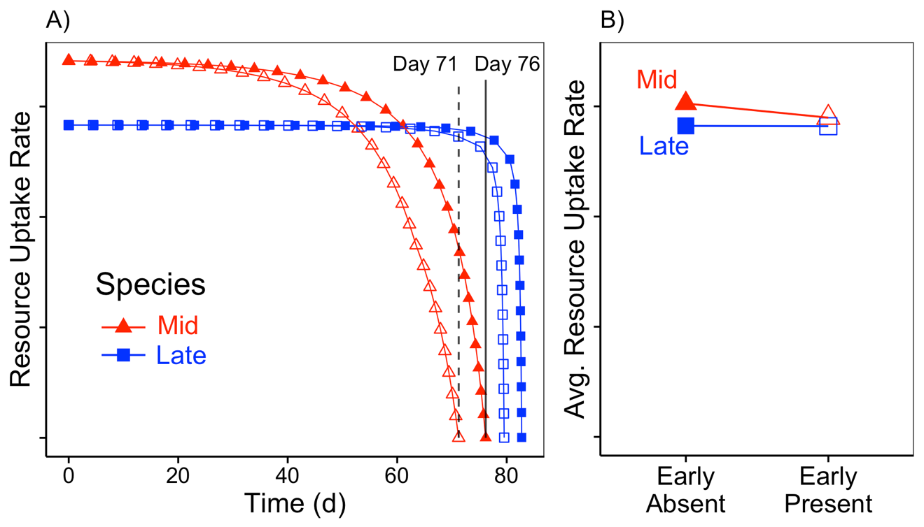

Figure 6. Mechanistic explanation for higher-order interactions. A) The resource uptake rates of the mid and late season species plotted over the course of a growing season, with (open symbols) and without (filled symbols) the early species. Vertical lines show the day at which the mid-season species stops growing with (dashed) and without (solid) the early species. B) The time-averaged resource uptake rates of the mid and late season species in the absence and presence of the early season species.

# Supporting Information – Additional Tables

Table S 1 Table of parameter values used in the growth simulation experiment in the main text.

|  |  |  |
| --- | --- | --- |
| Parameter | Value | Definition |
| *U* | 200 | Duration of growth simulation in days |
| *I* | 0 | Environmental resource supply rate |
| *R(0)* | 200 | Initial resource concentration |
| *r1* | 4.2 | Early competitor maximum resource uptake rate |
| *r2* | 2.6 | Mid competitor maximum resource uptake rate |
| *r3* | 2.1 | Late competitor maximum resource uptake rate |
| *K1* | 150 | Early competitor half-saturation constant |
| *K2* | 30 | Mid competitor half-saturation constant |
| *K3* | 0.5 | Late competitor half-saturation constant |
| *m* | 0.09 | Respiration/Loss rate |
| *q* | 0.07 | Biomass assimilation rate |
|  | 0.005 | Seed mass |
| *c* | 0.1 | Conversion rate of total biomass to seed mass |

# Supporting Information – Additional figures

# 

Figure S 1 Simulated per capita seed production of the A) early, B) middle and C) late season species in response to increasing inter-specific density on the x-axis. Points show the simulated response from the mechanistic model. Solid lines show best fit from the standard Beverton-Holt phenomenological model (equation 6) and the dashed line shows the best fit from the modified model with varying exponents for each species’ effect (equation 7).

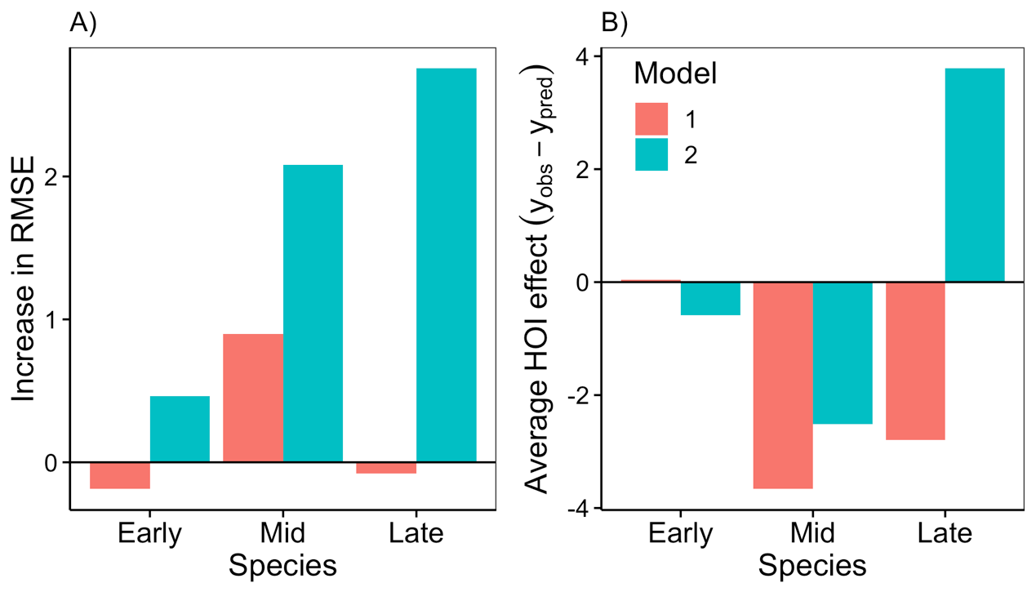

Figure S 2 Deviation from additivity of two-species competition for each species in the community. A) The deviation from additive competitor effects is shown as the increase in root mean squared error of the phenomenological models in multispecies competition compared to single species competition. B) The average deviation from additive competitor effects, positive values show that multispecies competition was weaker than predicted, negative values show where competition was greater than predicted. Deviations from additivity are shown for both phenomenological models—the standard Beverton-Holt model (“model 1”, equation 6) and the model with separate exponents on each competitor (“model 2”, equation 7).

# Appendix A – The effect of relative non-linearity in resource uptake curves on higher order interactions

In order to test whether the strength of higher order interactions was associated with the strength of the trade-off in the competitors’ resource uptake curves, we simulated an additional five communities in which we varied the degree of relative non-linearity between species resource uptake curves. We did this by starting with a scenario in which each species was given a resource uptake curve close to that of the mid-season species in the main text (Figure 2 b). In this first scenario there is very little difference between species in their resource uptake curves (see top of Figure A1). Then we parameterized four additional scenarios by gradually increasing the maximum uptake rate and half-saturation constant of the early season species, and gradually decreasing the maximum uptake rate and half-saturation constant of the late season species (Table A1). We then simulated competition, fit phenomenological competition models, and compared the predicted effects of competition assuming additivity, to the observed effects of competition as in the main text. Our simulations show that as the relative non-linearity between species is increased, the error between the additive phenomenological model and the simulated observations grows (Figure A 1).

Table A 1. Parameter values for five simulations with gradually increasing strength of the trade-off between the early season and late season species resource uptake curves.

|  |  |  |  |  |
| --- | --- | --- | --- | --- |
| Tradeoff | Scenario | Species | Max Uptake Rate (r) | Half Saturation Constant (K) |
|  | 1 | Early | 2.92 | 50.88 |
| Weak | Mid | 2.60 | 30.00 |
|  | Late | 2.50 | 23.79 |
|  | 2 | Early | 3.24 | 73.32 |
|  | Mid | 2.60 | 30.00 |
|  | Late | 2.40 | 17.74 |
|  | 3 | Early | 3.56 | 97.32 |
|  | Mid | 2.60 | 30.00 |
|  | Late | 2.30 | 11.84 |
|  | 4 | Early | 3.88 | 122.88 |
|  | Mid | 2.60 | 30.00 |
|  | Late | 2.20 | 6.09 |
|  | 5 | Early | 4.20 | 150.00 |
| Strong | Mid | 2.60 | 30.00 |
|  | Late | 2.10 | 0.50 |

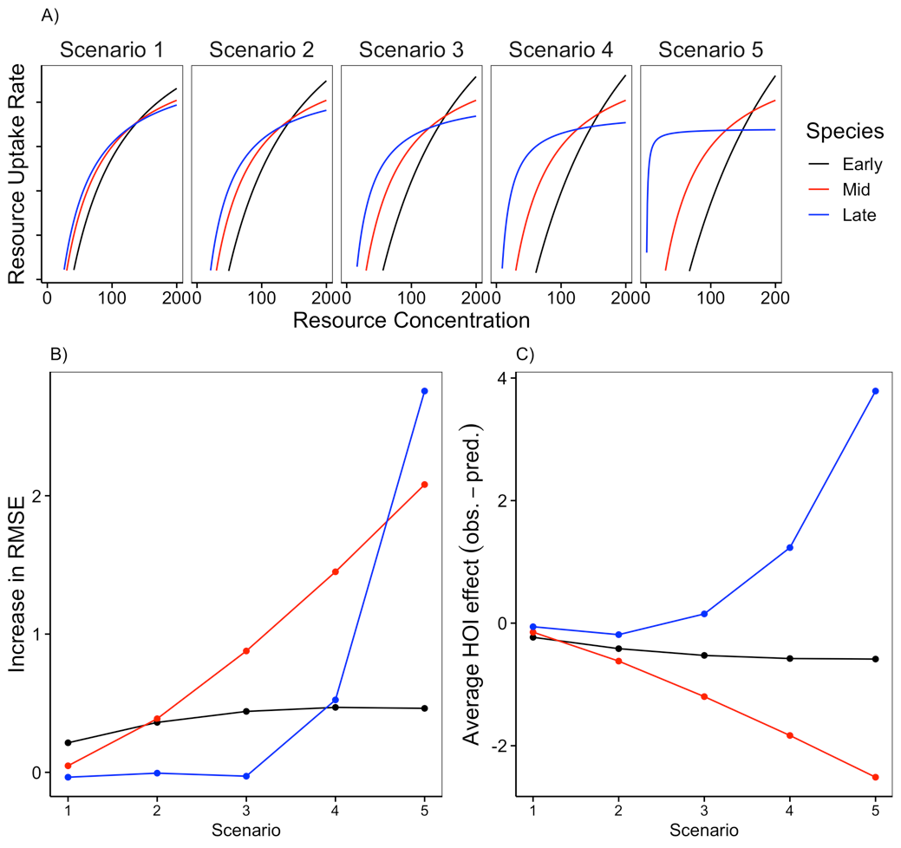

Figure A 1 Increasing the strength of the resource uptake trade-off between the early and late season species increases the magnitude of higher order interactions. A) Shows increasing relative non-linearity between species’ resource uptake curves in five scenarios. B) The deviation from additive competitor effects is shown as the increase in root mean squared error of the phenomenological model (equation 7) in multispecies competition compared to single species competition. C) The average deviation from additive competitor effects, positive values show that multispecies competition was weaker than predicted, negative values show where competition was greater than predicted. In B and C, the x-axis refers to the different scenarios depicted in A.