**Indirect effects of environmental change in resource competition models**

**Andrew R. Kleinhesselink\***

arklein@aggiemail.usu.edu

**Peter B. Adler**

peter.adler@usu.edu

Department of Wildland Resources and the Ecology Center, Utah State University

Logan, UT 84322, USA

*Correspondence author

Keywords: coexistence theory, competition, resource models, indirect effects, global change

Manuscript type: article

**Abstract:**

Anthropogenic environmental change can affect species directly by altering physiological rates or indirectly by changing competitive outcomes. The unknown strength of competition-mediated indirect effects makes it difficult to predict species abundances in the face of ongoing environmental change. Theory developed with phenomenological competition models shows that the strength of indirect effects declines with the strength of stabilizing niche differences, but these models lack a mechanistic link between environmental change and species performance. To extend existing theory, we examined the relationship between coexistence and indirect effects in mechanistic resource competition models. We defined environmental change as a change in resource supply rates and quantified the resulting competition-mediated indirect effects on species abundances. We found that the magnitude of indirect effects decreases in proportion to niche differences. However, indirect effects also depend on differences in how competitors respond to the change in resource supply, an insight hidden in non-mechanistic models. Our analysis demonstrates the value of using niche differences to predict the strength of indirect effects of environmental change and clarifies the types of indirect effects that global change can have on competing species.

**Introduction**

Anthropogenic environmental change affects species directly but also indirectly by altering interactions with predators, pathogens and competitors (Tylianakis et al. 2008). As a result, competition-mediated indirect effects may alter plant and animal community responses to environmental change (Stacey and Fellowes 2002; Jiang and Morin 2004; Brooker 2006; Tylianakis et al. 2008; Adler et al. 2009; Sletvold et al. 2013). In this paper, we define the effects of environmental change at the level of local population density: the direct effect is the sensitivity of a focal species population to some environmental change while holding other species’ abundances and interaction effects constant; the net effect is the sensitivity of the focal population to environmental change allowing for other species’ abundances and interactions to change; and the indirect effect is the difference between the net and direct effects (Adler et al. 2012). More specifically, we can define a competition-mediated indirect effect as the difference between a focal species’ sensitivity to global change when the influence of competitors is held constant (Fig. 1).

Despite the widespread interest in how global change will affect natural communities, only a handful of studies have controlled for both the mechanism of environmental change and the effects of interspecific competition. Experiments in which both the density of competitors and the global change driver are manipulated are ideal for measuring this kind of indirect effect (Jiang and Morin 2004; Adler et al. 2009; Levine et al. 2010; Eskelinen and Harrison 2013), but the effects of competitors and global change can also be investigated with observational data and statistical and mathematical models (Lemoine and Böhning-Gaese 2003; Poloczanska et al. 2008; Adler et al. 2012). Competition mediated-indirect effects range from strong (Eskelinen and Harrison 2013), to relatively weak (Klanderud 2005; Levine et al. 2010) and can vary depending on the underlying driver of change (Liancourt et al. 2012). Variation in the strength of competition-mediated indirect effects that ecologists have observed suggests that this area of research could benefit from improved theory for predicting when and where competition is likely to change the net effect of global change on focal populations.

Adler et al. (2012) linked environmental change and competition-mediated indirect effects with classical coexistence theory. The intuition is straightforward: large niche differences between competing species imply weak competitive interactions and small indirect effects of environmental change, while small niche differences imply strong competition and large indirect effects. Adler et al. (2012) supported this argument by analyzing phenomenological competition modelsin which population growth is limited by per capita interspecific (**CF*, *FC) and intraspecific (**FF*, *CC) competition, where the subscript ‘F’ refers to a focal species, and ‘C’ refers to its competitor. Stable coexistence between competitors requires some form of negative frequency dependence, which causes a species’ growth rate to increase when it is rare, and to decrease when it is common (Chesson 2000). Adler et al. (2012) used the strength of negative frequency dependence as a proxy measure of niche differences. In both the theoretical models and empirical models parameterized with long-term data from a perennial plant community, they found that the magnitude of indirect effects of climate variation decreased with increasing negative frequency dependence in a perennial plant community.

Although Adler et al. (2012) links coexistence theory with indirect effects of environmental change, their phenomenological competition framework lacks an explicit connection between species performance and environmental conditions. For example, in the theoretical models Adler et al. (2012) used, it seems unrealistic and arbitrary that hypothetical environmental change affects a species’ fecundity but has no effects on other model parameters such as competition coefficients. Models that include the mechanism of species competition would provide a more rigorous framework for developing theory about indirect effects and environmental change. In a mechanistic model, a simulated environmental change, such as an increase in resource availability, would simultaneously influence many aspects of performance of both the focal species and its competitor. A second weakness of Adler et al. (2012) is the use of negative frequency dependence as a proxy measure of niche differences. A more precise measure of niche difference in terms of phenomenological competition coefficients is given in Chesson (2013 p. 233):

|  |  |  |
| --- | --- | --- |
|  |  | (1) |

In this definition niche overlap, **, is the geometric mean of interspecific interactions divided by the geometric mean of intraspecific interactions. Stable coexistence is possible only if intraspecific competition is greater than interspecific competition, leading to *ρ* < 1. This expression allows a more direct test of the relationship between niche difference and the strength of indirect effects.

Our goal is to provide a framework for understanding competition-mediated indirect effects that will be useful to ecologists working on empirical studies of global change. Our specific objectives are to link phenomenological definitions of niche overlap to parameters in mechanistic resource competition models and to test the prediction that indirect effects between competitors should be greater when niche overlap is large.

**General Definition of Competition-Mediated Indirect Effects**

As a general example, we start with a Lotka-Volterra model for a focal species whose abundance is given by N_F interacting with a competitor whose abundance is given by N_C:

|  |  |  |
| --- | --- | --- |
|  |  | (2) |

We are interested in the equilibrium abundances of the focal species and competitor which we denote as and . We assume more specifically that these equilibrium abundances can respond to resource availability in the environment which we call S. Therefore we are interested in the derivative as a measure of how sensitive the species are to a change in the environmental variable S. We call this the net effect. By differentiating the equations for species equilibrium abundance with respect to S we arrive at this expression for net effects:

|  |  |  |
| --- | --- | --- |
|  |  | (4) |

The direct effects can be thought of as that component of the above net effects that would appear even if the species were in monoculture. Therefore we can define that direct effect by setting all the terms for species interactions – the and to zero. Thus the direct effects are,

|  |  |  |
| --- | --- | --- |
|  |  | (4) |

The indirect effects are the net effects minus the direct effects,

|  |  |  |
| --- | --- | --- |
|  |  | (4) |
|  |  | (4) |

Note that the indirect effect strength is necessarily proportional to the square of niche overlap in this model—the larger niche overlap the greater indirect effects are as a proportion of net effects. Second note that there are derivatives in the above equation for the K’s and the competition coefficients. Without a mechanistic model of how resource availability affects species we have to remain agnostic about whether these competition coefficients are actually responsive to resources and the environment; hence our investigation of the following mechanistic models.

**Essential Resource Model**

For competing terrestrial and aquatic plants, accounting for shared abiotic resources—soil nutrients, water and sunlight—is perhaps the most straightforward way to model competition (Fig. 2). The main resources for which plants compete are often considered essential resources: some amount of the resource must be present for the plant to grow and cannot be substituted by another (Tilman 1982). For instance, a non-parasitic plant requires some amount of light in order to photosynthesize; substituting light with other resources—water, CO2, P—will not mitigate the need for light.

Our two species essential resource competition model follows Tilman (1977; 1982 p. 38). In this model, per-capita growth of the focal species and competitor are determined by the availability of two resources, *R*1 and *R*2, following a saturating Monod function:

|  |  |  |
| --- | --- | --- |
|  |  | (6) |
|  |  | (7) |

where *r* is the maximum growth rate for each species, *R* is the concentration of each resource, and *m* is a resource loss or mortality rate for each species. The *k* terms determine the concentration of resource one or two for which growth of each species equals half the maximum rate. The larger *k*, the more resource required for a species to achieve a positive growth rate. Resources are supplied in proportion to the difference between an environmental supply point, *S,* and the current resource concentration, *R*. Resources are taken up by each species in proportion to population growth rate and resource loss/mortality rate (Tilman 1982 p. 46):

|  |  |  |
| --- | --- | --- |
|  |  | (8) |
|  |  | (9) |

where *a* is a resource turnover rate and the *q*terms (Tilman uses ‘*c*’) give the amount of each resource required for each unit of biomass growth for each species. Equilibrium abundances, *N*F*\** and *N*C*\**, are reached at resource concentrations *R*1*\** and *R*2*. Each species has a minimum resource requirement required for growth and reproduction to balance mortality and loss—this resource requirement defines the zero-net growth isoclines (ZNGI) for the species (Tilman 1982). Coexistence is possible when the ZNGIs cross—meaning that there is a point where each species is limited by a separate resource (Fig. 3). This equilibrium is only stable when each species consumes more of the resource limiting its own growth than it does of the resource limiting its competitor. For example, in figure 3 the focal species is limited by *R1* and the competitor is limited by *R2*, and a stable equilibrium requires resource consumption and supply rates described by the inequality (from Tilman 1982, p. 77),

|  |  |  |
| --- | --- | --- |
|  |  | (10) |

Because we are interested in indirect effects produced by competition, we make the assumption throughout our analysis that the conditions for coexistence are met.

Assuming the focal species is limited by *R*1 and the competitor by *R*2, we can solve for the equilibrium abundances, *N*F* and *N*C*, by setting the differential equations (8) and (9) to zero and setting the resource concentrations to their equilibrium values, *R*1* and *R*2*:

|  |  |  |
| --- | --- | --- |
|  |  | (11) |
|  |  | (12) |

In Appendix A, we show how Chesson’s measure of niche overlap, **, is related to the parameters of Tilman’s essential resource model. Under the assumption that the focal species is limited by resource one and the competitor by resource two,

|  |  |  |
| --- | --- | --- |
|  |  | (13) |

The termsand correspond to each species’ use of the resource it is most limited by, and thus determine intraspecific competition effects. The terms and correspond to use of the resources most limiting to each species’ competitor, and thus determine interspecific competition effects. As a result, equation (13) parallels the phenomenological expression for niche overlap in equation (1). If the focal species uses a very different ratio of resources from its competitor, *ρ* will be small, while if it uses a similar ratio of resources, *ρ* will approach one. Graphing resource consumption vectors is an intuitive way to assess niche overlap: generally niche overlap is smaller the larger the angle between species’ resource consumption vectors (Petraitis 1989; Fig. 3) and the greater the area of the parallelogram formed with the resource consumption vectors as sides (Barabás et al. 2014).

*Modeling environmental change*

In a mechanistic resource competition model, we can model environmental change as a change in resource supply points (*S*1 and *S*2) to the system (the bottom arrows in figure 2). This is a reasonable choice in the case of direct addition of essential resources such as phosphorous and nitrogen (Jupp and Spence 1977; Vitousek et al. 1997). However, it also makes sense when resource supply changes as an indirect consequence of other types of anthropogenic change. For example, global warming can increase availability of soil nitrogen (Nadelhoffer et al. 1991), as can invasion by nitrogen fixing exotic plants (Vitousek and Walker 1989); climate change can alter water availability (Fensham and Fairfax 2007); forest thinning changes light availability to understory species (Thomas et al. 1999); and aquatic invasive species can drive changes in light availability to submerged aquatic plants (Zhu et al. 2006).

For example, we can explore the net and indirect effects of anthropogenic nitrogen deposition by calculating the rate of change in focal species abundance, *N*F*\**, with respect to nitrogen supply, *S*1, assuming that other limiting resources such as light are not changing (Dybzinski and Tilman 2007). Once we solve for NF in the equations above we can then differentiate the full equation to find the net effect of a change in S1. Note that we assume that the competitor and the focal species can respond to the change in the environment and to each other, achieving a new equilibrium abundance. To find the direct effects we can assume the competitor’s abundance is constant and then solve again for the derivative of the focal species with respect to S1. Finally we can just subtract the latter from the former to arrive at an equation for indirect effects:

|  |  |  |
| --- | --- | --- |
|  |  | (14) |
|  |  | (15) |
|  |  | (16) |
|  |  | (17) |
|  |  | (18) |
|  |  | (19) |

Note in the partial derivatives that each species is only sensitive to the direct effects of one resource—Liebig’s law of the minimum (Tilman 1982). In this example, the focal species is sensitive to nitrogen, *R*1, and the competitor to light, *R*2. Knowing the partial derivatives we can apply the formula for net effects in equation (4),

|  |  |  |
| --- | --- | --- |
|  |  | (20) |
|  |  | (21) |

The right hand side of equation (21) contains the definition of direct effects on the focal species from equation (14) and the definition of niche overlap found in equation (13), so we can re-write equation (21) above as,

|  |  |  |
| --- | --- | --- |
|  |  | (22) |

We can find the indirect effects following equation (5) by subtracting the direct effect on the focal species,

|  |  |  |
| --- | --- | --- |
|  |  | (23) |
|  |  | (24) |

Equation (24) shows that the indirect effects are proportional to the direct effects and a second term determined by niche overlap (Fig. 4). As species become more similar in their resource use, ** approaches one, the second term on the right side of the equation gets larger, and the strength of the indirect effect increases as well.  In this case the indirect effect is positive—that is it amplifies the positive direct effect of the increase in resource supply.

*Changes in the non-limiting resource*

The previous scenario involved a change in the supply of the resource that was most limiting to the focal species. Now consider what would happen if there were a change in the supply of the resource that is limiting to the competitor. In our example, a small change in light availability will not have a direct effect on the focal species (eq. (16)). However, a change in light will have a direct effect on the competitor, which is given by the partial derivative in equation (17). Applying equation (4), we find that the net effect of a change in light supply is:

|  |  |  |
| --- | --- | --- |
|  |  | (26) |

In this case the indirect effects are equal to the net effects—there are no direct effects of the change in light on the focal species at the coexistence equilibrium. We can factor out the definition of niche overlap from the first term on the right hand side of the equation in (26) and rearrange,

|  |  |  |
| --- | --- | --- |
|  |  | (27) |

The sensitivity to the change in light supply (*S*2) is similar to the indirect effects of an increase in nitrogen supply in equation (24)—it includes a term that increases as niche overlap approaches one and a term describing how the focal species is affected by the changing resource. Note that the indirect effect is negative as an increase in light supply (*S*2) benefits the competitor at the expense of the focal species (Fig. 5). The term represents the direct sensitivity of the focal species to a change in light supply (*S*2) in the case that light (*R*2) is limiting. This should not be confused with the partial derivative in (16) which is equal to zero because it is evaluated at the equilibrium where light is not limiting.

**Substitutable Resource Model**

The essential resource model may not be appropriate for modeling many important competitive interactions, including those among animals competing for shared food resources (Rothhaupt 1988). We extended our analysis to a substitutable resource competition model following Tilman (1982, p. 270):

|  |  |  |
| --- | --- | --- |
|  |  | (28) |
|  |  | (29) |

where *R* is the concentration of each resource, *r* is maximum growth rate of each species, *N* is the biomass or population of each species, *D* is a constant mortality rate, *k* is a half-saturation constant for each species' use of resources, ** is a minimal amount of total resource required for growth of each species*,* and *w* is a weighting factor that converts the availability of each resource into its value for each species. Resources are supplied and consumed according to the equations:

|  |  |  |
| --- | --- | --- |
|  |  | (30) |
|  |  | (31) |

where *S* gives the supply rate of each resource and *q* gives the amount of each resource consumed per individual of each species. This model assumes a constant diffusion of resources (i.e. the animal prey or plant food) to the consumers. Using a logistic growth function in equations (30) and (31) may be a better way to model biological resources (but see Rothhaupt 1988). Future investigations of indirect effects could examine complications that arise when resource are supplied using other functions. As in the essential resource model, we will assume that inequality (10) holds: the focal species is limited by *R1*and the competitor is limited by *R2*and the species stably coexist. In Appendix A we show that when these conditions are met niche overlap is defined by the following equation:

|  |  |  |
| --- | --- | --- |
|  |  | (32) |

This definition of niche overlap is more complex than the definition in the essential resource model (eq. (13)). The complexity reflects the fact that niche overlap depends not only on the relative resource consumption rates given by the *q* terms, but also on the relative value of each resource to each species, given by the *w* terms. Barabás et al. (2014) referred to these two aspects of consumer-resource dynamics as the ‘impact niche,’ given by the *q*’s, and the ‘sensitivity niche,’ given by the *w*’s.

We solve for the species equilibrium abundances in Appendix A (eqq. A23 & A24) and then find the partial derivatives (eqq. A26 – A31) needed to apply the general formula for net and indirect effects. We can substitute in the definition for niche overlap in this model from (eq. 32) to arrive at an equation for indirect effects on the focal species,

|  |  |  |
| --- | --- | --- |
|  |  | (33) |
|  |  |  |

This equation shows that the size and direction of indirect effects depend not only on niche overlap, but also on the difference in direct effects given by the first term in parenthesis on the right-hand-side of equation (33) above (see different lines in Fig. 6). By comparison, the essential resource model is a special case of the substitutable resource model where one species is insensitive to the direct effects of a change in resource supply. This is seen by setting direct effects on one or the other species in equation (33) to zero and noting the similarity to equations (24) or (27). At the other extreme, if both species respond equally to the change in the resource (scaled by the ** term, which is the inverse of the effect of the focal species on the competitor), the indirect effects are equal to zero at all values of niche overlap (line labeled *“1”* in figure 6). We confirmed our analytical results with numerical simulations of the essential and the substitutable resource models in the program R (R Core Team, 2013; see Appendix B for R code).

**Discussion**

The uncertain nature of competition-mediated indirect effects limits our ability to make useful predictions about how anthropogenic change will affect populations and communities. Indirect effects may offset or reverse direct effects and appear an unknown time after direct effects have already been observed (Suttle et al. 2007). We hope to reduce some of the mystery surrounding indirect effects by showing how direct and indirect effects arise in simple mechanistic competition models, and how indirect effect strength can be related to the niche differences that stabilize coexistence between competing species. Consistent with previous work based on phenomenological competition models (Adler et al. 2012), we found that indirect effects were closely related to niche differences: species that are very similar in their resource requirements are strongly affected by the competition-mediated indirect effects of a change in resource supply (Figs. 4,5,6). While it is reassuring that our results are consistent with theory developed in non-mechanistic competition models, our analysis goes a step further by using the recently derived definition of niche overlap from (Chesson 2013). Moreover, our use of a mechanistic model that explicitly links environmental change with competition provides novel insights about the strength and direction of indirect effects of environmental change.

Our analysis of an essential resource model shows that a change in resource supply can affect a focal species through two separate pathways: if the resource that is most immediately limiting to the focal species at equilibrium is perturbed, then the focal species is affected by a combination of direct and indirect effects (eq. (24)), and the magnitude of indirect effects increases with the square of niche overlap (Fig. 4). Alternatively, the focal species can be affected by a change in the supply of the resource that is not immediately limiting to it at equilibrium. In this case, the magnitude of the indirect effect increases with both the niche overlap and the focal species’ sensitivity to the changing resource (eq. (27); Fig. 5). Indirect effects have their largest magnitude (either positive or negative in sign depending on which resource is perturbed) when niche overlap is high and when the focal species is highly sensitive to the resource that is changing.

Analysis of a substitutable resource model demonstrated that the two distinct modes of indirect effects described above are extremes at either end of a continuum. Indirect effects are strongest when there is a large difference in competing species’ direct sensitivities to the change in resource supply and when niche overlap is high (Fig. 6). In other words, indirect effects require some change in relative fitness between competitors (defined by the difference in direct effects), and this difference is then amplified by the amount of niche overlap. Equation (33) shows that the effect of the focal species on the competitor also matters: when this effect is strong (i.e. small magnitude of **), it decreases the magnitude of the competitor’s effect on the focal species.

Competition-mediated indirect effects of a change in resource supply can be summarized as the product of two key components: niche overlap, and the difference between species in direct sensitivities to the change in resource supply (eqq. (24), (27) and (33)). In theory, information about direct effects (i.e. direct sensitivities) to changes in resource supply should be relatively easy to acquire by studying how species respond to resource manipulation in monoculture (Tilman and Wedin 1991; Adler et al. 2009; Levine et al. 2010). The short-term response of species to an environmental change might also provide information about direct effects (Suttle et al. 2007). Measuring niche overlap is much more data intensive but is possible with a combination of empirical data and models. Chu and Adler (2015) report niche overlap values for 17 pairs of perennial competitors in five different grassland communities and all niche overlap values fell between 0.07 and 0.4. Even in the absence of information about direct effects, these estimates of niche overlap provide information about the maximum magnitude of indirect effects relative to direct effects. Equation (24) shows that niche overlap needs to be above 0.7 for indirect effect strength to equal direct effect strength; the estimated niche overlap values all fall well below this threshold, meaning that the magnitude of indirect effects would be less than the magnitude of direct effects. While this simple application of our theory implies that indirect effects might be safely ignored in these communities, it ignores a number of complications. First, Chu and Adler’s niche overlap values are based on a phenomenological approach and undoubtedly reflect more coexistence mechanisms than just resource partitioning (Chesson 2000). Second, pair-wise niche overlap values may not be proportional to indirect effects when multiple species are interacting—that is, indirect effects between two species could depend on changes in the abundance of other competitors (Levine 1976). Third, our analysis of competitive interactions does not preclude the possibility of strong indirect effects produced by trophic interactions (Winder and Schindler 2004; Tylianakis et al. 2008; van der Putten et al. 2010; Barton and Ives 2013; Ockendon et al. 2014).

We modeled environmental change as an increase or decrease in the resource supply rate. However, there are other ways to model environmental change. We can categorize changes into three groups depending upon their mechanism. In the first group are changes to the environment that cause the resource supply rates to change (bottom arrows in Fig. 2), but that leave the species traits that control growth and resource use unchanged. In the second group are environmental perturbations that cause underlying rates of growth and mortality to change. For example, higher temperatures might increase mortality or growth rates (Doak and Morris 2010). Changes in growth or mortality rates will affect equilibrium resource concentrations and species equilibrium abundances but not niche overlap in the essential resource model (eqq. (13) & (32)). In the third group are environmental changes that affect the amount of resource demanded for each unit of growth, i.e. the *q* parameters in equations (8) and (9). Increased atmospheric CO2 for instance, can increase plant water use efficiency (Lee et al. 2001; Reich et al. 2001; Ainsworth and Long 2005), and may also reduce light demand (Zotz et al. 2006); while increased temperature may alter nitrogen use efficiency (An et al. 2005) or water use efficiency (Shaw et al. 2000). Similarly, temperature can affect the relative rates at which protists consume different species of bacteria prey, leading to coexistence at some temperatures but competitive exclusion under others (Jiang and Morin 2004). Unlike environmental changes in the first two groups, these kinds of changes affect niche overlap between species and make predicting the outcome of environmental change more difficult. Distinguishing which global change drivers are likely to affect growth and resource use in the three ways outlined here should be a useful first step in categorizing competition-mediated indirect effects.

Our conclusions about the size of indirect effects assume that species can coexist prior to and after anthropogenic change. This assumption is warranted if we are interested in relatively small environmental changes at a short time-scale when colonization and extinction of competitors are unlikely. However, environmental change can rapidly disrupt coexistence in some cases (Jiang and Morin 2004; Stevens et al. 2004; Suttle et al. 2007). In a resource competition model, coexistence requires that the rate of resource supply is greater than the minimum amount required for positive population growth, and also that the ratio of resources supplied falls between the resource use ratios of the focal species and its competitor (see inequality (10) and figure 3). A sufficient increase in the supply of one resource can lead to competitive exclusion (Dybzinski and Tilman 2007). Nevertheless, niche overlap still provides important information: the smaller the niche overlap in terms of resource use ratios then the greater the region of coexistence across a gradient of species performance or resource supply (Barabás et al. 2014). Therefore, changes to resource supply should be less likely to lead to exclusion when niche overlap is small. Moreover, resource partitioning is not the only coexistence mechanism; species-specific responses to spatial heterogeneity, temporal heterogeneity and natural enemies may also contribute to coexistence and further decrease niche overlap (Chesson 2000). Our analysis suggests that management that preserves these mechanisms and keeps niche overlap small could help maintain the diversity of plant and animal communities in the face of anthropogenic changes in resource supply.

**Acknowledgements**

Géza Meszéna, Kris Klausmeier and an anonymous reviewer provided valuable feedback that improved this manuscript. Jim Powel provided help with the analysis. Caroline Farrior and Andrew Tredennick provided comments that greatly improved an earlier draft of the manuscript. Financial support was provided to A.R.K. by Utah State University and an NSF Graduate Research Fellowship. P.B.A. was supported by NSF DEB-1054040.  **Literature Cited**

Adler, P. B., H. J. Dalgleish, and S. P. Ellner. 2012. Forecasting plant community impacts of climate variability and change: when do competitive interactions matter? Journal of Ecology 100:478–487.

Adler, P. B., J. Leiker, and J. M. Levine. 2009. Direct and indirect effects of climate change on a prairie plant community. PLoS ONE 4:e6887.

Ainsworth, E. A., and S. P. Long. 2005. What have we learned from 15 years of free-air CO2 enrichment (FACE)? A meta-analytic review of the responses of photosynthesis, canopy properties and plant production to rising CO2. New Phytologist 165:351–372.

An, Y., S. Wan, X. Zhou, A. A. Subedar, L. L. Wallace, and Y. Luo. 2005. Plant nitrogen concentration, use efficiency, and contents in a tallgrass prairie ecosystem under experimental warming. Global Change Biology 11:1733–1744.

Barabás, G., L. Pásztor, G. Meszéna, and A. Ostling. 2014. Sensitivity analysis of coexistence in ecological communities: theory and application. Ecology Letters 17:1479–1494.

Barton, B. T., and A. R. Ives. 2013. Species interactions and a chain of indirect effects driven by reduced precipitation. Ecology 95:486–494.

Brooker, R. W. 2006. Plant–plant interactions and environmental change. New Phytologist 171:271–284.

Chesson, P. 2000. Mechanisms of maintenance of species diversity. Annual Review of Ecology and Systematics 31:343–366.

Chesson, P. 2013. Species competition and predation. Ecological Systems (pp. 223–256). Springer.

Chiang, A. C. 1984. Fundamental Methods of Mathematical Economics (Third Edition.). McGraw-Hill, New York.

Chu, C., and P. B. Adler. 2015. Large niche differences emerge at the recruitment stage to stabilize grassland coexistence. Ecological Monographs.

Doak, D. F., and W. F. Morris. 2010. Demographic compensation and tipping points in climate-induced range shifts. Nature 467:959–962.

Dybzinski, R., and D. Tilman. 2007. Resource use patterns predict long‐term outcomes of plant competition for nutrients and light. The American Naturalist 170:305–318.

Eskelinen, A., and S. Harrison. 2013. Exotic plant invasions under enhanced rainfall are constrained by soil nutrients and competition. Ecology 95:682–692.

Fensham, R. j., and R. j. Fairfax. 2007. Drought-related tree death of savanna eucalypts: species susceptibility, soil conditions and root architecture. Journal of Vegetation Science 18:71–80.

Higashi, M., and H. Nakajima. 1995. Indirect effects in ecological interaction networks I. The chain rule approach. Mathematical Biosciences 130:99–128.

Jiang, L., and P. J. Morin. 2004. Temperature-dependent interactions explain unexpected responses to environmental warming in communities of competitors. Journal of Animal Ecology 73:569–576.

Jupp, B. P., and D. H. N. Spence. 1977. Limitations on macrophytes in a eutrophic lake, Loch Leven: I. Effects of phytoplankton. Journal of Ecology 65:175–186.

Klanderud, K. 2005. Climate change effects on species interactions in an alpine plant community. Journal of Ecology 93:127–137.

Lee, T. D., M. G. Tjoelker, D. S. Ellsworth, and P. B. Reich. 2001. Leaf gas exchange responses of 13 prairie grassland species to elevated CO2 and increased nitrogen supply. New Phytologist 150:405–418.

Lemoine, N., and K. Böhning-Gaese. 2003. Potential impact of global climate change on species richness of long-distance migrants. Conservation Biology 17:577–586.

Levine, J. M., A. K. McEachern, and C. Cowan. 2010. Do competitors modulate rare plant response to precipitation change? Ecology 91:130–140.

Levine, S. H. 1976. Competitive Interactions in Ecosystems. The American Naturalist 110:903–910.

Liancourt, P., L. A. Spence, D. S. Song, A. Lkhagva, A. Sharkhuu, B. Boldgiv, B. R. Helliker, et al. 2012. Plant response to climate change varies with topography, interactions with neighbors, and ecotype. Ecology 94:444–453.

Nadelhoffer, K. J., A. E. Giblin, G. R. Shaver, and J. A. Laundre. 1991. Effects of temperature and substrate quality on element mineralization in six Arctic soils. Ecology 72:242–253.

Ockendon, N., D. J. Baker, J. A. Carr, E. C. White, R. E. A. Almond, T. Amano, E. Bertram, et al. 2014. Mechanisms underpinning climatic impacts on natural populations: altered species interactions are more important than direct effects. Global Change Biology 20:2221–2229.

Poloczanska, E. S., S. J. Hawkins, A. J. Southward, and M. T. Burrows. 2008. Modeling the response of populations of competing species to climate change. Ecology 89:3138–3149.

Reich, P. B., D. Tilman, J. Craine, D. Ellsworth, M. G. Tjoelker, J. Knops, D. Wedin, et al. 2001. Do species and functional groups differ in acquisition and use of C, N and water under varying atmospheric CO2 and N availability regimes? A field test with 16 grassland species. New Phytologist 150:435–448.

Rothhaupt, K. O. 1988. Mechanistic resource competition theory applied to laboratory experiments with zooplankton. Nature 333:660–662.

Shaw, M. R., M. E. Loik, and J. Harte. 2000. Gas exchange and water relations of two Rocky Mountain shrub species exposed to a climate change manipulation. Plant Ecology 146:195–204.

Sletvold, N., J. P. Dahlgren, D.-I. Øien, A. Moen, and J. Ehrlén. 2013. Climate warming alters effects of management on population viability of threatened species: results from a 30-year experimental study on a rare orchid. Global Change Biology 19:2729–2738.

Stacey, D. A., and M. D. E. Fellowes. 2002. Influence of elevated CO2 on interspecific interactions at higher trophic levels. Global Change Biology 8:668–678.

Stevens, C. J., N. B. Dise, J. O. Mountford, and D. J. Gowing. 2004. Impact of nitrogen deposition on the species richness of grasslands. Science 303:1876–1879.

Suttle, K. B., M. A. Thomsen, and M. E. Power. 2007. Species interactions reverse grassland responses to changing climate. Science 315:640–642.

Thomas, S. C., C. B. Halpern, D. A. Falk, D. A. Liguori, and K. A. Austin. 1999. Plant diversity in managed forests: understory responses to thinning and fertilization. Ecological Applications 9:864–879.

Tilman, D. 1977. Resource Competition between Plankton Algae: An Experimental and Theoretical Approach. Ecology 58:338–348.

Tilman, D. 1982. Resource competition and community structure. Princeton University Press.

Tilman, D., and D. Wedin. 1991. Plant traits and resource reduction for five grasses growing on a nitrogen gradient. Ecology 72:685–700.

Tylianakis, J. M., R. K. Didham, J. Bascompte, and D. A. Wardle. 2008. Global change and species interactions in terrestrial ecosystems. Ecology Letters 11:1351–1363.

van der Putten, W. H., M. Macel, and M. E. Visser. 2010. Predicting species distribution and abundance responses to climate change: why it is essential to include biotic interactions across trophic levels. Philosophical Transactions of the Royal Society B: Biological Sciences 365:2025–2034.

Vitousek, P. M., J. D. Aber, R. W. Howarth, G. E. Likens, P. A. Matson, D. W. Schindler, W. H. Schlesinger, et al. 1997. Human alteration of the global nitrogen cycle: sources and consequences. Ecological Applications 7:737–750.

Vitousek, P. M., and L. R. Walker. 1989. Biological invasion by *Myrica faya* in Hawai’i: plant demography, nitrogen fixation, ecosystem effects. Ecological Monographs 59:247–265.

Winder, M., and D. E. Schindler. 2004. Climate change uncouples trophic interactions in an aquatic ecosystem. Ecology 85:2100–2106.

Zhu, B., D. G. Fitzgerald, C. M. Mayer, L. G. Rudstam, and E. L. Mills. 2006. Alteration of ecosystem function by zebra mussels in Oneida Lake: impacts on submerged macrophytes. Ecosystems 9:1017–1028.

Zotz, G., N. Cueni, and C. Körner. 2006. In situ growth stimulation of a temperate zone liana (*Hedera helix*) in elevated CO2. Functional Ecology 20:763–769.

**Table 1. Symbols used:**

|  |  |
| --- | --- |
| **Variable** | **Definition** |
|  | **direct effect of change in supply of resource *j* on species *i*** |
|  | **indirect effects of change in supply of resource *j* on species *i*** |
|  | **net effect of a change in supply of resource *j* on species *i*** |
| ***a*** | **resource availability constant in the essential resource model** |
| ***D*** | **In the substitutable model, a constant mortality rate.** |
| ***kij*** | **amount of resource *j* where population growth rate of species *i* is half of maximum rate, *r*.** |
| ***m*** | **per capita mortality** |
| ***Ni*** | **population density of species *i*** |
| ***qij*** | **per capita uptake rate of resource *j* by species *i*** |
| ***r*** | **maximum rate of population growth** |
| ***Rj*** | **concentration of resource *j*** |
| ***Sj*** | **supply rate of resource *j*** |
| ***ij*** | **per capita competition effects of species *j* on species *i*** |
| ****** | **the inverse of the effects of the focal species on the competitor** |
| ****** | **niche overlap** |
| ***i*** | **In the substitutable model, the minimum amount of total resource required for growth of each species *i*.** |
| ***ij*** | **In the substitutable model, a weighting factor that converts the availability of each resource *j* into its value for each species *i*.** |

**Figure legends:**

Figure 1: Hypothetical change in focal species abundance (*N*F*) caused by environmental change. When competitive interactions are allowed to change, the focal species abundance increases along with environmental change—“Net effect” solid gray line. When competitive interactions are held constant at the level of *E*0, then the focal species abundance increases only slightly with the environmental change—“Direct effect” dashed black line. The indirect effect is the difference between the slopes of the direct and net effects lines—in this case the indirect effect amplifies the positive direct effect. Inset shows how an environmental driver affects the focal species directly (arrow a) and indirectly by changes in competitive interactions (arrows b and c).

Figure 2: A two species model of competition for two essential resources. Drivers of environmental change can be modeled either as changes in resource supply, changes in the rates of resource uptake, or as changes in rates of plant growth and mortality.

Figure 3: A ZNGI plot for two species competing for two essential resources. The resource consumption vectors for the focal species and competitor are given by the values in parenthesis and shown with the dashed black and gray lines. The niche overlap between species, ** will generally decrease as the angle ** between the resource consumption vectors increases (but see Figure A1 in Appendix).

**Figure 4: Competition-mediated indirect effects on the focal species when there is a change in the supply of the essential resource (*S*1) limiting the focal species. The indirect effects depend on niche overlap and the direct effect of the change in resource supply, . These figures present two different ways of looking at indirect effects: in A niche overlap is on the x-axis with different lines for three different sensitivities to direct effects. In B focal sensitivity to direct effects is on the x-axis with different lines for three different values of niche overlap.**

Figure 5: Competition-mediated indirect effects on the focal species when there is a change in the supply of the essential resource limiting to its competitor (*S*2). The effects depend on niche overlap (**) and the sensitivity of the focal species to the changing resource, . In A niche overlap is shown on the x-axis with different lines for three different values of focal species sensitivity to *S*2. In B the focal species’ direct sensitivity to resource two is on the x-axis and different lines are shown for three different values of niche overlap.

Figure 6: Indirect effects of a change in resource supply in a substitutable resource model. Indirect effects increase with **, but also depend on each species’ direct sensitivity to the change in resource supply. Numbers next to each line give the ratio of focal species’ to competitor species’ sensitivities to direct effects of a change in resource supply. The upper solid line shows the extreme case where the competitor’s direct sensitivity is zero, and the lower solid line the case where the focal species’ direct sensitivity is zero. The indirect effects are positive when the focal species’ sensitivity to the direct effect is greater than the competitor’s, and the indirect effects are negative when the focal species’ sensitivity is less than the competitor’s. All lines are calculated with *  * in equation (33).

**Figures:**

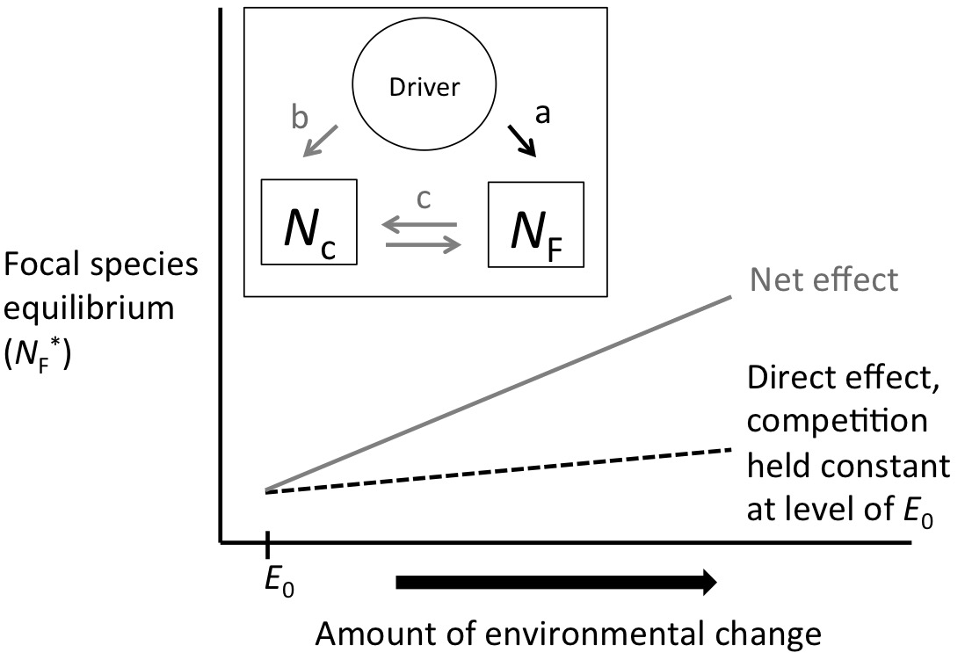

**Figure 1.**

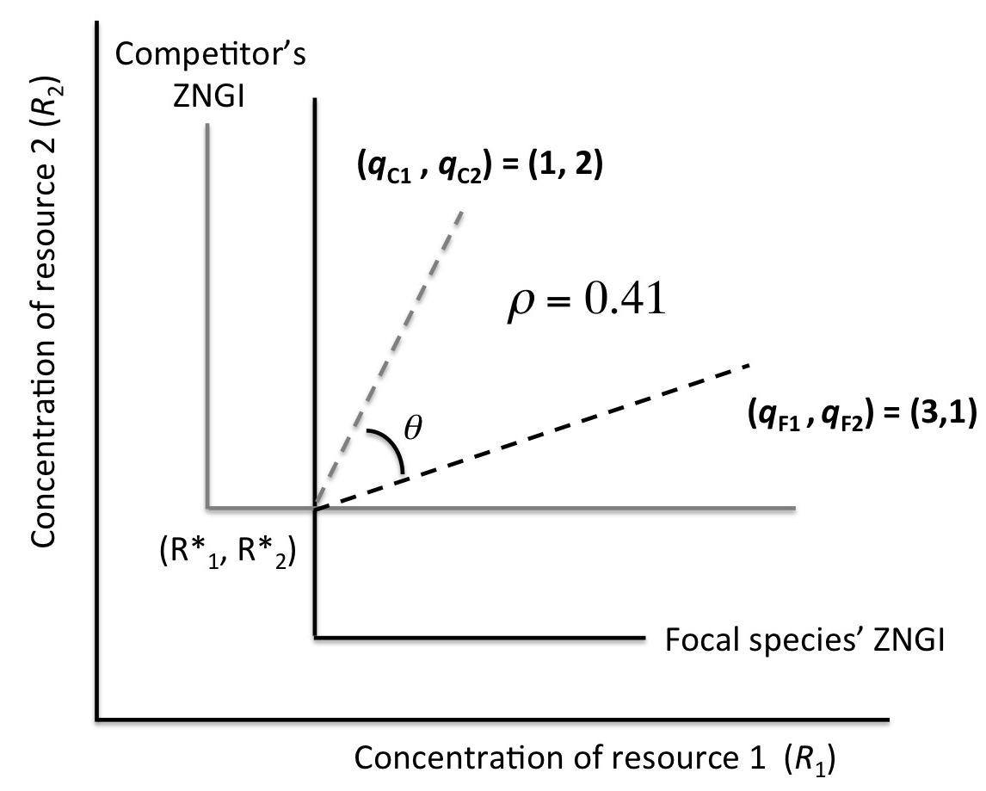

Figure 3.

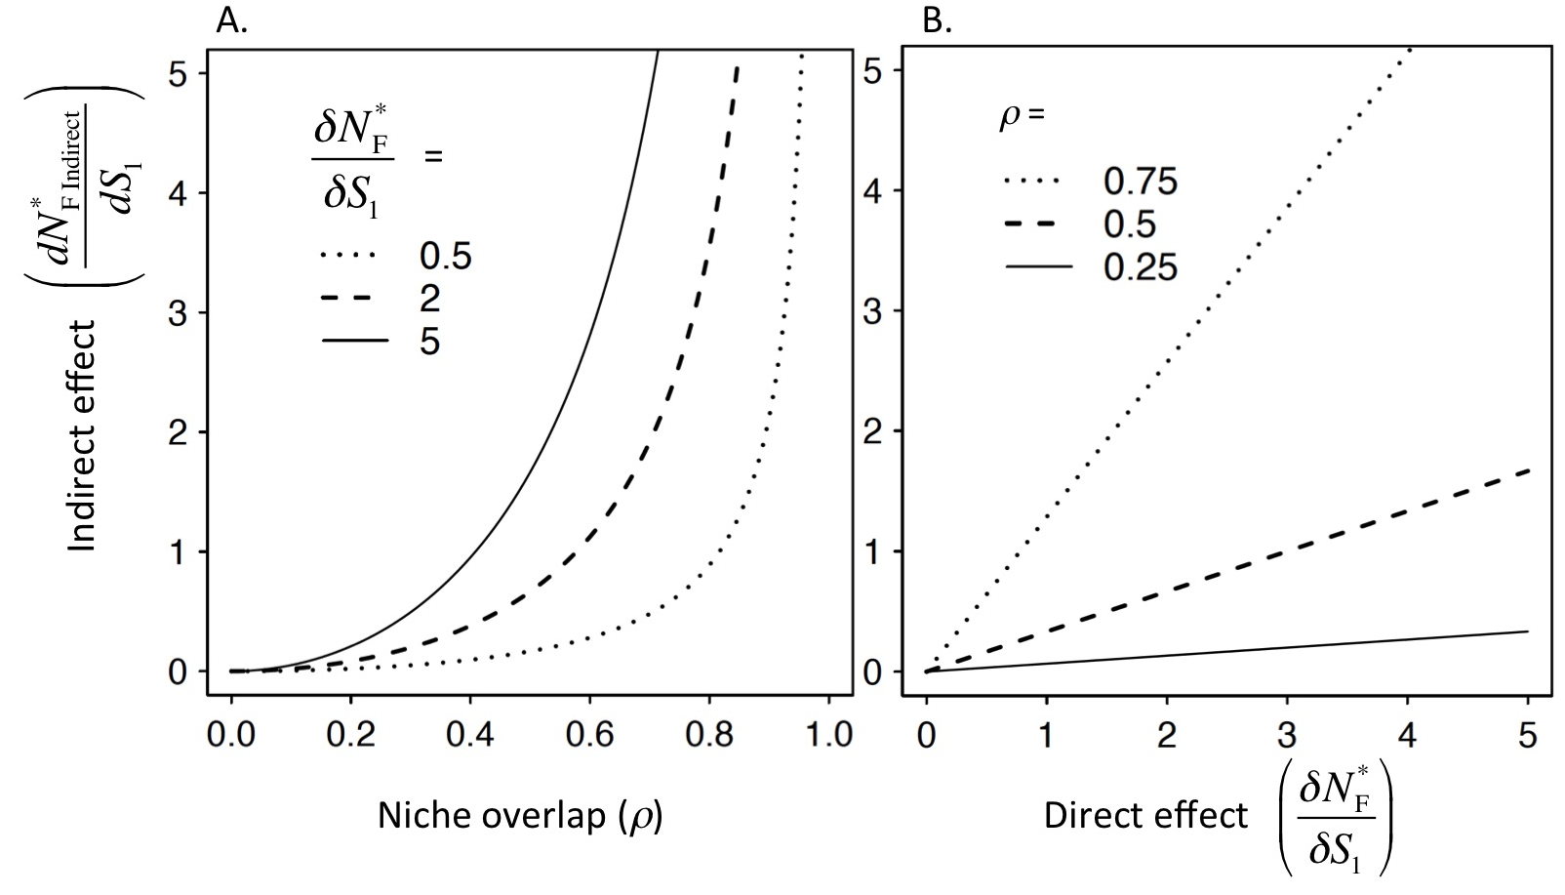

Figure 4.

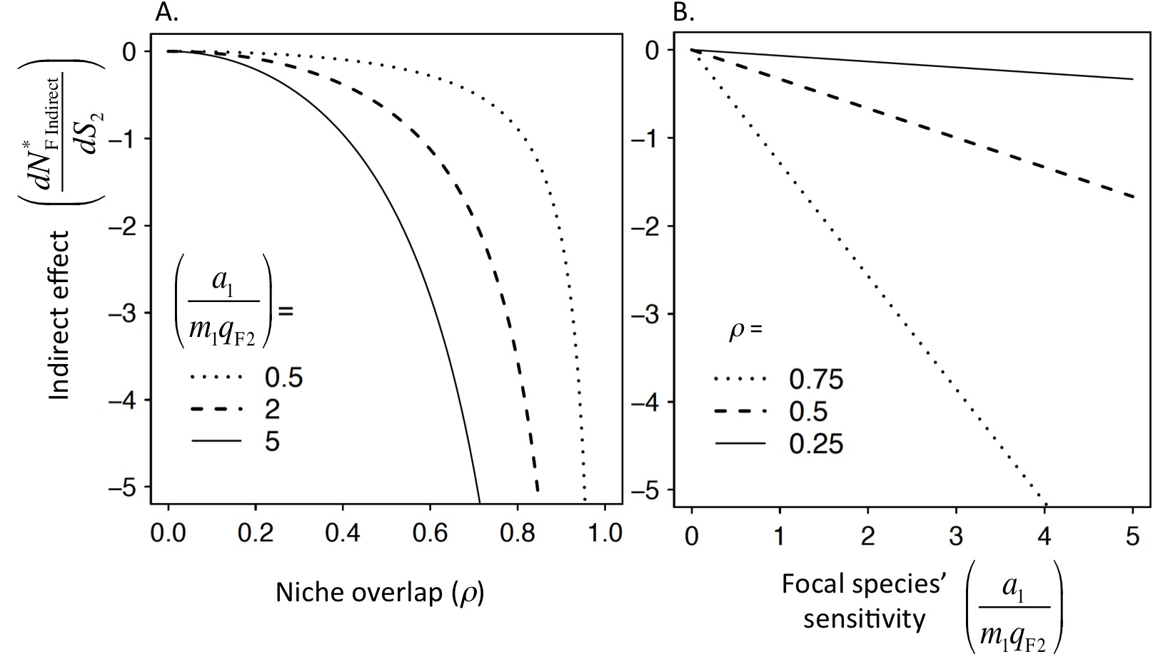

Figure 5.

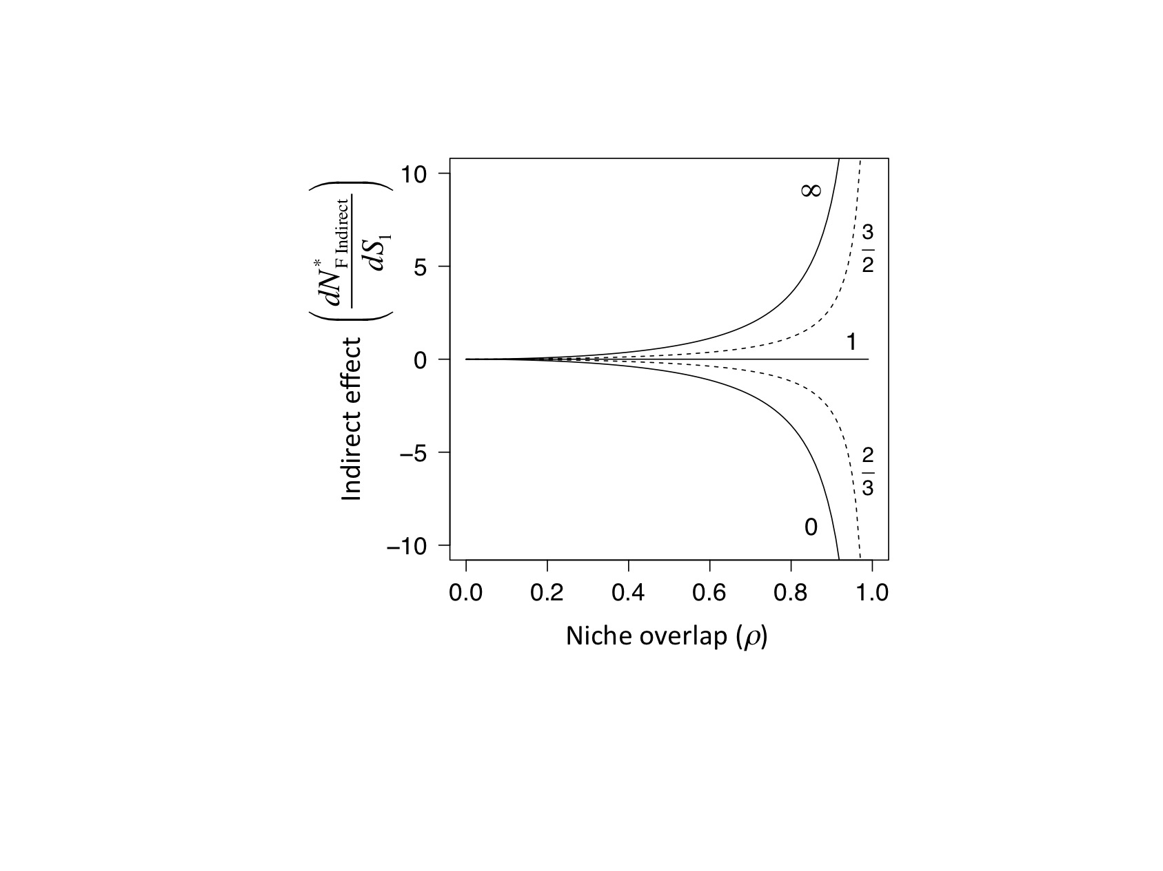

Figure 6.

**Online Appendix A: Mathematical results for “Indirect effects of environmental change in resource competition models”**

1. **Niche overlap in the essential resource model:**

Chesson (2013) defines niche differences and niche overlap,* *, in terms of phenomenological competition coefficients (found in equation 1 in main text) from a two species Lotka-Volterra competition model with intraspecific competition coefficients:

|  |  |  |
| --- | --- | --- |
|  |  | (A1) |
|  |  | (A2) |

Here we use Chesson’s definition to quantify niche overlap in Tilman’s essential resource competition model. To do this, we translate the essential resource model into a Lotka-Volterra competition model following Tilman (1982; pp 190-204). Tilman used a Lotka-Volterra model with a different parameterization than Chesson:

|  |  |  |
| --- | --- | --- |
|  |  | (A3) |
|  |  | (A4) |

Where *K*F and *K*C gives the carrying capacity of each species, **’ gives the per capita effect of the competitor on the focal species and **’ gives the per capita competitive effect of focal species on the competitor (we use alpha prime and beta prime to distinguish these from the competition coefficients in Chesson’s parameterization). If we assume that species coexist at equilibrium and the focal species is limited by resource one and the competitor by resource two, then the following translation between the mechanistic and phenomenological model is possible (see Tilman 1982; pp 190 -204 for more details):

|  |  |  |
| --- | --- | --- |
|  |  | (A5) |
|  |  | (A6) |
|  |  | (A7) |
|  |  | (A8) |

We can substitute the mechanistic definitions of the competition coefficients from eqq. (A5) - (A8) above into Chesson’s definition of niche overlap (Chesson 2013, p. 233),

|  |  |  |
| --- | --- | --- |
|  |  | (A9) |

1. **Comparison between niche overlap and angle between consumption vectors in the essential resource model:**

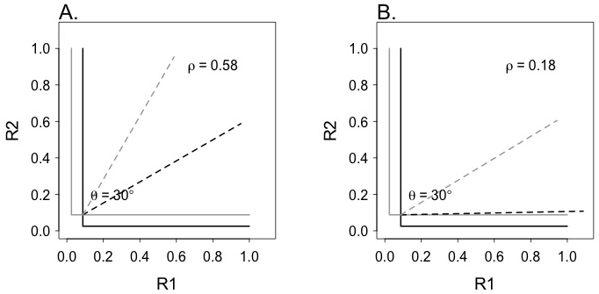

Figure A1: ZNGI plots showing how niche overlap, **, and the angle between resource consumption vectors change in an essential resource model. The x-axis is the concentration of resource one and the y-axis is the concentration of resource two. The solid lines show the ZNGI for two different species. The dashed lines show the consumption vectors for each species. Theta is the angle in degrees between the consumption vectors. In figure 2 in the main text we show how the angle and niche overlap relate. We include the figure above to show that the two are not perfectly equivalent. The angle between resource consumption vectors is the same (** = 30°) in both panels above but niche overlap as given by our measure of ** is larger in the second figure. In A the consumption vectors for the black line is equal to [0.5, 0.866] and for the gray line [0.866, 0.5]. In B. the consumption vector for the black line is [0.980, 0.2] and for the gray line [0.749, 0.663].

1. **Net and indirect effects in the essential resource model:**

We can solve for the equilibrium abundances of the competing species, *N*F* and *N*C*, by setting the differential equations in the main text to zero and setting the resource concentrations to their equilibrium values, *R*1* and *R*2*

|  |  |  |
| --- | --- | --- |
|  |  | (A10) |
|  |  | (A11) |

Equations (A10) and (A11) are equivalent to the functions *f* and *g* that define the effects of resources and competitor on each species’ equilibrium (equations 2 and 3 in the main text). In order to find the partial derivatives needed to apply equation 5 in the main text, we can differentiate the equations (A10) and (A11) above:

|  |  |  |
| --- | --- | --- |
|  |  | (A12) |
|  |  | (A13) |
|  |  | (A14) |
|  |  | (A15) |
|  |  | (A16) |
|  |  | (A17) |

We can substitute these partial derivatives into the equation for the indirect effect of a change in resource supply on the focal species (equation 5 in the main text). Note that all these partial derivatives are evaluated at the coexistence equilibrium (*R*\*1, *R*\*2).

1. **Niche overlap in the substitutable resource model:**

Tilman (1982, pp. 270-272) showed how Lotka-Volterra competition parameters are defined in terms of the substitutable resource model. As in the essential resource model, we can make this conversion and then use the phenomenological competition coefficients to calculate the niche overlap using Chesson’s definition. Given the parameters for the substitutable resource competition model established in equations 27 through 30 in the main text the phenomenological competition coefficients are given by the following equations,

|  |  |  |
| --- | --- | --- |
|  |  | (A18) |
|  |  | (A19) |
|  |  | (A20) |
|  |  | (A21) |

Given the identities above, and assuming that the focal species’ relative consumption rate of resource two is less than the relative consumption rate of resource two by the competitor, then niche overlap for this model is,

|  |  |  |
| --- | --- | --- |
|  |  | (A22) |

1. **Net and indirect effects in the substitutable resource model:**

Equilibrium populations in the substitutable resource model can be found by setting the differential equations (29) and (30) in the main text to zero and solving for the abundances of each species (Tilman 1982. pp. 270 - 272):

|  |  |  |
| --- | --- | --- |
|  |  | (A23) |
|  |  | (A24) |

where *B*F and *B*C are defined by (Tilman 1982, p. 270):

|  |  |  |
| --- | --- | --- |
|  |  | (A25) |
|  |  | (A26) |

Equations (A23) and (A24) are equivalent to the functions *f* and *g* that define the effects of resources and competitor on each species’ equilibrium (equations 2 and 3 in main text). In order find the partial derivatives needed to apply equation 5 in the main text, we differentiate the equations (A23) and (A24) above:

|  |  |  |
| --- | --- | --- |
|  |  | (A27) |
|  |  | (A28) |
|  |  | (A29) |
|  |  | (A30) |
|  |  | (A31) |
|  |  | (A32) |

Note, as in the essential resource model, these partial derivatives are evaluated at the coexistence equilibrium (). We can use these partial derivatives to find the net effects of a change in *S*1 on the focal species following the general formula (eq. 4 in the main text):

|  |  |  |
| --- | --- | --- |
|  |  | (A33) |

In order to clarify the connection to niche overlap, we re-write equation (A33), using the definition of niche overlap (eq. (A21)) for this model,

|  |  |  |
| --- | --- | --- |
|  |  | (A34) |

The indirect effects are the net effects minus the direct effects on the focal species,

|  |  |  |
| --- | --- | --- |
|  |  | (A35) |

which can be rewritten so that it more closely resembles the definition of indirect effects in the essential resource model (see equations 24 and 26 in the main text),

|  |  |  |
| --- | --- | --- |
|  |  | (A36) |

**References:**

Chesson, P. 2013. Species competition and predation. Ecological Systems (pp. 223–256). Springer.

Tilman, D. 1982. Resource competition and community structure. Princeton University Press.