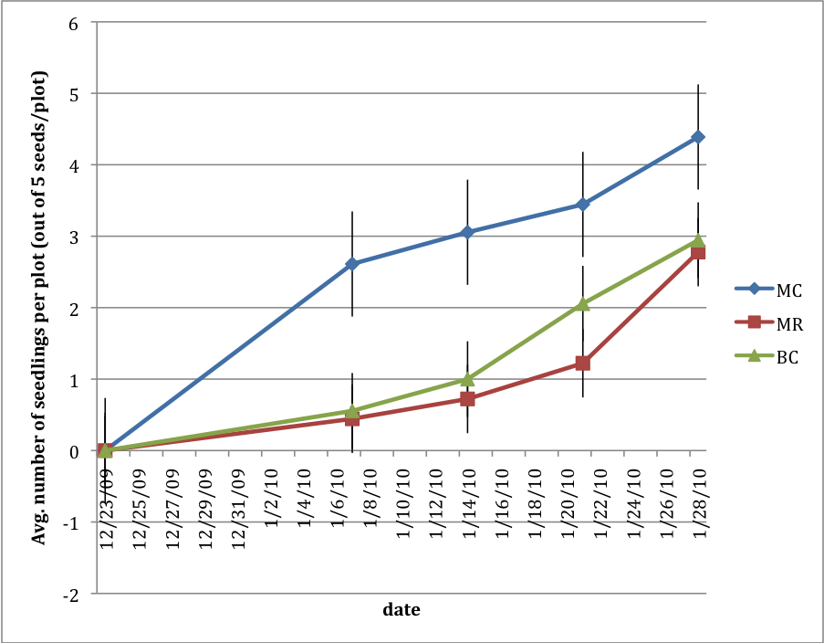
Figure 1 Mean germination per plot in three different moss treatments replicated 18 times across the dune. Each replicate had 5 seeds planted. MC = moss covered plots, MR = Moss removed plots, BC = bare sand plots. Bars show standard error around the mean.

