Contingency Analysis of veg_present By habitat
Mosaic Plot
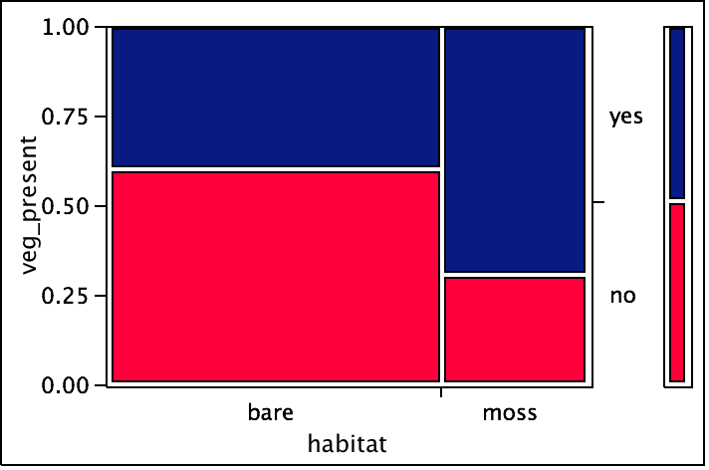

Freq: count

Contingency Table
habitat By veg_present
Count  Total %  Col %  Row % | no | yes
bare | 170  42.18  82.13  60.28 | 112  27.79  57.14  39.72 | 282  69.98
moss | 37  9.18  17.87  30.58 | 84  20.84  42.86  69.42 | 121  30.02
 | 207  51.36 | 196  48.64 | 403

Tests
N | DF | -LogLike | RSquare (U)
403 | 1 | 15.229903 | 0.0546

Test | ChiSquare | Prob>ChiSq
Likelihood Ratio | 30.460 | <.0001
Pearson | 29.907 | <.0001

Fisher's Exact Test | Prob | Alternative Hypothesis
Left | 1.0000 | Prob(veg_present=yes) is greater for habitat=bare than moss
Right | <.0001 | Prob(veg_present=yes) is greater for habitat=moss than bare
2-Tail | <.0001 | Prob(veg_present=yes) is different across habitat

Cochran-Mantel-Haenszel Tests
Stratified by
transect

CMH Test | ChiSquare | DF | Prob>Chisq
Correlation of Scores | 13.8294 | 1 | 0.0002
Row Score by Col Categories | 13.8294 | 1 | 0.0002
Col Score by Row Categories | 13.8294 | 1 | 0.0002
General Assoc. of Categories | 13.8294 | 1 | 0.0002

