Chart
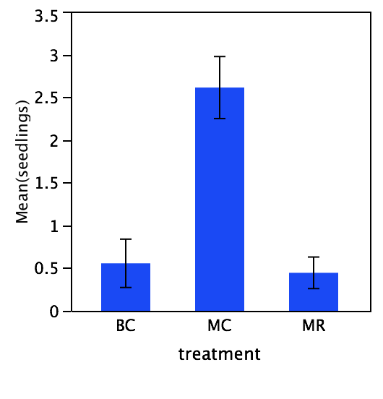

Each error bar is constructed using 1 standard error from the mean.

