Running Head: Native bryophytes, exotic annual grasses and an environmental stress gradient.

**Effects of Native Bryophytes on Exotic Grass Invasion:**

**a Test of the Stress Gradient Hypothesis**

Andrew R. Kleinhesselink1*, & J. Hall Cushman2

1 Department of Ecology and Evolutionary Biology, University of California, Los Angeles, CA 90095 USA

2Department of Natural Resources and Environmental Science, University of Nevada, Reno NV 89557, USA

*Corresponding author: [arklein@g.ucla.edu](https://sites.lifesci.ucla.edu/eeb-kraft/lab-members/arklein@g.ucla.edu)

Running Head: *Effects of Moss on Invasion*

Word count: 5158

Pages: 22

Figures: 3

Parts: Main text, Supporting Information Additional Figures

**Abstract**

Understanding the role native biodiversity plays in controlling exotic species invasion is a critical goal in ecology. The stress gradient hypothesis (SGH) provides a unifying framework for understanding the range effects of natives on invasive species. The SGH predicts that native species will inhibit invasive species in benign habitats but facilitate invasion in more stressful environments. Most studies on exotic plant invasion and the SGH focus only on interactions between vascular plants. However, in many stressful environments, native bryophytes and other non-vascular plants are particularly common. In order to form a more complete picture of the factors influencing exotic plant invasion and to test generality of the SGH, it is critical to measure the effects of native bryophytes on exotic vascular plants across environmental gradients. We used an observational study and a removal experiment to measure the effects of a native moss on two exotic annual grasses along a 200-m stress gradient in a coastal dune in northern California. Our experiment showed the effects of bryophytes to be species-specific: bryophytes facilitated one exotic grass in both low- and high-stress environments. Bryophytes inhibited survival and growth of the other exotic grass at low stress but facilitated survival at high stress. Our findings highlight the importance of bryophytes and biological soil crusts in controlling the process of vascular plant invasion in stressful environments and provide a novel test of the SGH.

**Key-words:** biological soil crusts, dune ecosystems, exotic species, facilitation, stress-gradient hypothesis.

# Introduction

Biological communities throughout the world are increasingly invaded by a wide range of non-native species and it is critical to understand the factors that mediate the success of these taxa in their novel environments (Kennedy et al. 2002). Environmental filtering (Kraft et al. 2014), biotic resistance (Rejmánek 1996) and the stress-gradient hypothesis (Bertness and Callaway 1994) have emerged as complementary explanations for understanding patterns in the success of exotic invasion. The environmental filtering model contrasts physical environmental conditions, such as climate and soil type, that might restrict exotic invasion, with the effects of biotic interactions, such as with competition, predation and mutualism (Kennedy et al. 2002, Kraft et al. 2014). Exotic species are able to invade and thrive when they can pass through abiotic filters and can cope with biotic interactions which are usually assumed to be negative. Despite considerable evidence that competition can limit exotic plant invasion (Levine 2000, Kennedy et al. 2002), there are also growing numbers of examples showing that exotic plants can be facilitated by native species (Badano et al. 2007, Griffith 2010, Cushman et al. 2011, Kleinhesselink et al. 2014). The stress gradient hypothesis (SGH) provides a unifying conceptual framework that seeks to explain the wide range of interactions between exotic and native species (Bruno et al. 2003). Specifically, the SGH predicts that interactions between species will be negative in physically benign or productive environments, while interactions will be positive in stressful environments (Bertness and Callaway 1994). An implication of the SGH is that stress should also predict the effect that native species have on exotics: native taxa may resist invasion in productive habitats, but facilitate invasion in stressful environments (Bruno et al. 2003, Badano et al. 2007).

Studies examining the effects of competition and facilitation on invasive exotic plants have tended to focus on interactions only between vascular plants (Kennedy et al. 2002, Badano et al. 2007). This focus ignores the fact that exotic plants usually interact with a much more diverse array of species during invasion. For example, deserts, coastal dunes, forest understories and arctic environments often have an abundance of non-vascular plants such as bryophytes and lichens (Belnap et al. 2001). In these environments, invading vascular plants are likely to have significant interactions with non-vascular plants (Deines et al. 2007, Langhans et al. 2009). Despite their small stature, non-vascular plants can strongly affect germination conditions for seeds and the availability of nutrients and water resources in the soil (Serpe et al. 2006, Langhans et al. 2009). In some systems, bryophytes and biological soil crusts have been found to play a role in resisting exotic species invasion, especially invasion by exotic annual grasses (Serpe et al. 2006, Morgan 2006, Deines et al. 2007, Hernandez and Sandquist 2011). Studying interactions between native bryophytes and exotic vascular plants would provide a novel test of the SGH and could help expand its generality to all pairs of competitors, not species with similar functional traits and life histories.

While some studies have found that bryophytes can facilitate vascular plant germination, survival and growth (Rayburn et al. 2012), few have examined whether the effects of native bryophytes on exotic species shift from competition to facilitating across environmental gradients as the SGH predicts. In this study, we investigate the effects of native bryophytes on the local distribution of vascular plants across an environmental stress gradient and test whether they affect the germination, survival, growth and reproductive output of two exotic annual grasses. We test two predictions stemming from the SGH: 1) vascular plants will be more positively associated with moss patches in more stressful environments; and 2) native moss patches will inhibit the performance of exotic annual grasses in low stress environments but will facilitate these species in high stress environments.

# Study System

We conducted our study in a coastal dune system at Bodega Head in Sonoma County, California (38 19’ N, 123 3’ W). This area has a Mediterranean climate, receiving most of its precipitation between the fall and early spring (Barbour et al. 1973). The soil at this site is composed almost entirely of fine to coarse sands low in nutrients and organic matter (McNeil and Cushman 2005, Lortie and Cushman 2007, Cushman et al. 2010, Kleinhesselink et al. 2014). The study area is located between two large dune ridges that run in the direction of the prevailing winds. This site spans a gradient in soil conditions and wind speed that creates a large gradient in plant size and species composition which we refer to as a stress gradient. The details of this environmental stress gradient have been previously described by Lortie and Cushman (2007) and Kleinhesselink et al. (2014). These studies have shown that soil nitrate pools, soil water field capacity, average plant size, perennial cover, native plant cover and species richness were highest at the east or “sheltered” end of the trough and decreased towards the west or “exposed” end. Soil coarseness, wind speed, bare ground, annual plant cover and non-native plant cover also followed the gradient and were highest at the exposed end of the gradient and decreased towards the sheltered end. *Bromus diandrus* (Poaceae; hereafter referred to as a *Bromus*) and two species of *Vulpia* (*V. bromoides* and *V. myuros*) are common exotic annual grass species at this site and throughout coastal California. We lumped the two *Vulpia* species into one group in our study because it was difficult to identify them to species in the field.

Bryophytes and lichens constituted an important part of the ground cover at this site. The most abundant bryophyte was *Syntrichia ruralis* (Pottiaceae), which is a large drought-tolerant moss species common in seasonally dry environments across California (Malcolm et al. 2009). Other bryophytes common at this site were *Homalothecium* *arenarium* (Brachytheceae) and *Didymodon vinealis* (Pottiaceae).

# Methods

## Bryophyte patches across the dune stress gradient

We established 23 20-m transects spaced approximately 10 m apart along the 220 m long stress gradient documented by Lortie and Cushman (2007) and Kleinhesselink et al. (2014). Each transect ran perpendicular to the dune gradient. The most southeasterly transect occurred at the sheltered low-stress end, and the most northwesterly transect occurred at the more exposed high-stress end of the gradient. For the remainder of the paper, we refer to position along the gradient in meters away from the more sheltered southeast end of the gradient.

In order to determine cover of native mosses across this study site, and their association with the focal species of annual grass and other vascular plants, we recorded the cover of shrub, bare sand or moss patches on each of the 23 transects described above. To estimate the cover of mosses, we used point-intercept sampling at 25 randomly chosen points along each transect, recording whether points fell on a moss patch, bare sand, or within a shrub. We then recorded the species identity of any vascular plant rooted within 1 cm of the point. For subsequent analyses we only considered those points falling outside of shrubs.

## Effects of Bryophytes on Bromus and Vulpia

We established a field experiment in the winter of 2009/2010 to assess the effect of moss on the germination, survival, growth and reproduction of both exotic grass species. For each species, we established 18 separate blocks centered on large mats (>15 cm in minimum width) of the native moss *Syntrychia ruralis*. Each block was established away from shrubs and other large perennial plants. Nine blocks were located at the low stress end of the gradient and nine were located at the high stress end of the gradient. Each block consisted of three separate 5 x 10 cm patches. Two patches were positioned on on naturally occurring mats of moss. We left one as an un-manipulated patch (“moss covered”), and we removed the moss on the other by pulling the moss off the soil surface (“moss removed”). The third patch in each block was established on naturally moss-free bare sand as a control. Within each patch, we planted five seeds of the either *Vulpia* or *Bromus*. Seeds of both taxa have long awns. To prevent the seeds from blowing out of the patches, we glued them by their awns to a small wire inserted into the sand so that seeds were in contact with the soil surface. Each wire was 10 cm long with seeds spaced 2 cm apart. Seeds of both species were collected from the field site in the fall of 2009. The *Bromus* seeds were planted in late December 2009 and, into separate blocks, the *Vulpia* seeds were planted a few weeks later in January of 2010.

Starting in January 2010, we visited the experimental patches roughly once every two weeks. Because seeds were glued to the wire in each patch, we were able to easily distinguish between plants germinating from the seeds we planted from plants emerging from the natural seed bank. We weeded out all other vascular plants emerging within the experimental patches to eliminate the effect of competition between our focal plants and other vascular plants. In May 2010, the surviving plants produced inflorescences and began to senesce. At this time, we counted the total number of plants and the total number of inflorescences produced in each patch and collected the aboveground biomass from all the plants. Total aboveground biomass from all focal plants surviving in each patch was harvested, dried at 60°C for 48 hr and weighed to the nearest milligram.

## Statistical Analyses

We used chi-square test to determine whether our target grass species and vascular plants as a whole were more frequently rooted within moss patches than expected at random. We also used a logistic regression model to determine whether vascular plants were more associated with moss patches than expected and whether the association between plants and moss changed across the stress gradient. We modeled the probability of a vascular plant occurring at each sampling point as a function of gradient position (meters away from the SE low-stress end of the gradient), moss presence (either moss patch or bare sand) and the interaction between these two factors. When residual deviance was greater than residual degrees of freedom, we used a quasibinomial model as recommended by Crawley (2007). We tested significance of the gradient effect, the micro-habitat effect and their interaction using analysis of deviance with F-tests using the ‘anova’ function in R.

We used logistic regression to model how environmental stress (low-stress or high-stress positions on the gradient) and treatment (moss removed, moss present or bare sand) and their interaction affected the final number of *Bromus* and *Vulpia.*plants in each patch. Because we did not track individual germination and survival, our analysis focuses on the expected probability of one of the five seeds planted in each patch transitioning to an adult plant at the end of the growing season. The model included treatment, stress level and their interaction and the 18 experimental blocks were treated as random effects. We fit the model with the generalized linear mixed effects model in the lme4 package in R (Bates et al. 2015, R Core Team 2015).

In order to determine how our treatments and gradient position affected the growth of surviving *Bromus* and *Vulpia*, we log transformed the average aboveground biomass of the focal plants in each patch and analyzed using a linear mixed model with effects for treatment, stress level and their interaction and including block as random effects.

Finally, we analyzed how the number of inflorescences produced in each patch varied with treatment and position on the stress gradient using generalized linear models with quasipoisson errors. We used the number of surviving plants in each patch as an offset term in the regression so that we effectively modeled the number of inflorescences produced per plant in each patch. We fit these data without the random block effects because models fit with the random effect failed to converge.

We used either likelihood ratio tests or F-tests to evaluate the significance of each of the fixed effects in the models: the interaction effect between moss treatment and gradient position, the moss treatment effect and the stress gradient position effect in that order. When there were significant treatment effects, we tested for significant pairwise differences between treatment means. We adjusted for the multiple comparisons using the Šidák method in the lsmeans package in R (Lenth and Hervé 2015).

# Results

## Vascular plant associations with moss patches across the gradient

Moss cover was low at the low stress (southeastern) end of the gradient and peaked at about 40 percent cover towards the middle of the gradient (Fig. 1). It declined as conditions became more stressful across the last 50 m of the stress gradient. This distribution of abundance was well described by a quadratic function of distance on the stress gradient (F2,20 = 26.5, R2 = 0.70, p < 0.01). In contrast, bare sand was most frequent at the low-stress end of the gradient and the high-stress end of the gradient and least frequent in the middle where moss cover was highest (Fig. 1; F2,20 = 15.9, R2 = 0.58, p < 0.01). We found 31 different species of vascular plants rooted at 189 of the 398 non-shrub sampling points. *Chorizanthe cuspidata* (Polygonaceae), a small annual plant endemic to coastal dunes in California, was the most frequently encountered plant species and occurred at 60 sampling points. Our target annual exotic grass species occurred at 22 sampling points: *Vulpia* at 17 and *Bromus* at five. *Bromus* and *Vulpia* together occurred at 12 of 277 bare sand points and 10 of 121 moss covered points (Chi-squared test, *X*2 = 1.8, df = 1, p = 0.18). Lumping all vascular plants together, we found they were rooted at 104 of 173 points without moss, and 85 of 36 moss covered points, indicating a positive association with moss patches (Chi-squared test, *X*2 = 34.8, df =1, p < 0.01). When we regressed plant occurrence against position on the stress gradient, micro-habitat (moss covered or bare sand), and the interaction between micro-habitat and gradient position, we found a that the overall frequency of vascular plants increased towards the more stressful end of the gradient (F1,396 = 54.3, p < 0.01; Fig. 2) and was greater within moss patches than uncolonized bare sand patches (F1,395 = 17.8, p < 0.01). However, we did not find evidence that the positive association between moss and vascular plants changed across the gradient (stress x micro-habitat interaction; F1,394 = 0.70, p = 0.40). Similarly, exotic and native species analyzed separately both increased in frequency towards the stressful end of the gradient (exotics: F1,396 = 5.0, p = 0.03; natives: F1, 396 = 37.4, p < 0.01) and were both more common within moss patches (exotics: F1,395 = 9.2, p < 0.01; natives: F1,395 = 4.3, p = 0.04), but there was no stress by micro-habitat interaction for either group (exotics: F1,394 = 0.0, p = 0.93; natives: F1,394 = 0.0, p = 0.93).

## Effects of moss on Bromus

The effects of moss on *Bromus* varied with demographic rate and position on the environmental stress gradient. There was a significant treatment x stress interaction on *Bromus* survival (*X*2 = 24.8, df = 2, p < 0.01): in the low-stress environment, moss significantly reduced *Bromus* survival compared to bare sand patches, but this effect disappeared in the high-stress environment (Fig. 3a). *Bromus* survival was also significantly greater in the high-stress moss patches than within the low-stress moss patches. Moss significantly reduced Bromus final biomass ( *X*2 = 7.44, df = 2, p = 0.02; Fig. 3 c). However, there was no significant treatment by stress interaction on *Bromus* final biomass (X2 = 4.27, df = 2, p = 0.12) nor any effect of stress (*X*2 = 1.76, df = 1, p = 0.19). *Bromus* final inflorescence numbers were affected by a treatment x stress gradient interaction (F1,46 = 5.35, p < 0.01): at low stress plants in bare sand produced significantly more inflorescences than plants in either moss patches or in moss-removed patches, whereas at high stress there were no differences (Fig. 3e). Plants in moss-covered and moss-removed patches also produced significantly more inflorescences at high stress than at low stress.

## Effects of moss on Vulpia

Moss significantly increased Vulpia survival (*X*2 = 32.97, df = 2, p < 0.01; Fig. 3b), but this effect did not vary across the stress gradient (*X*2 = 0.58, df = 2, p = 0.75) . There was a trend towards higher *Vulpia* survival in the higher stress environment (*X*2 = 3.59, df = 2, p = 0.06). There was also a trend towards moss Vulpia having greater final biomass in moss covered patches than in uncolonized sand patches or moss removed patches (*X2* = 4.97, df = 2, p = 0.08; Fig. 3 d). But there was no significant treatment x stress interaction on final *Vulpia* biomass (*X2* = 1.18, df = 2, p = 0.55), nor was there any main effect of stress gradient position (*X2* = 0.64, df = 1, p = 0.42). *Vulpia* inflorescence production was not affected by moss (F2,40 = 0.43, p = 0.65), stress gradient position (F1,42 = 0.53, p = 0.47) nor their interaction (F2,38= 0.18, df = 2, p = 0.83; Fig. 3f).

# Discussion

Our study demonstrates that native bryophytes have an important influence on the occurrence, survival, growth and fecundity of invasive, exotic plant taxa in this system. Using a controlled experiment, we found that moss facilitated the establishment of *Bromus* and *Vulpia* at the high stress end of the gradient. Moreover, we found that removing mosses generally decreased the growth and reproductive output of *Bromus* and *Vulpia* plants compared to moss covered patches. We found mixed support for our hypothesis that mosses would generally have a more beneficial effect on the exotic grasses at the more stressful end of the environment gradient. In the high stress plots, mosses had a positive effect on *Bromus* survival while they had a negative effect at low stress. However, the effect of moss on *Vulpia* survival, growth and reproduction did not change greatly with environmental stress.

The occurrence of vascular plants was positively associated with moss in our system but this association did not intensify at the more stressful end of the environmental gradient, as we postulated based on the SGH (Fig. 2). This result held for both native and exotic species alike. Likewise, in our field experiment, we found only limited support for our hypothesis that mosses would have a greater positive influence on plant performance in the more stressful environment. In particular, the effects of moss only varied along the stress gradient for *Bromus* survival (Fig. 3a) and inflorescence production (Fig. 3e). In the low-stress environment, moss clearly reduced *Bromus* germination and survival, whereas in the high stress environment moss facilitated *Bromus* germination and survival (Fig. 3a). This suggests that moss patches are an important microhabitat for *Bromus* success in the more stressful environment. We also observed a gradient by treatment interaction effect on *Bromus* inflorescence production but this was less supportive of our hypothesis (Fig. 3e). In the low stress environment, moss tended to reduce *Bromus* inflorescence production whereas this effect disappeared in the high stress environment (Fig. 3e). In the case of the other exotic grass in this study, *Vulpia*, we found that the effect of moss treatment did not vary with environmental stress (Fig. 3 b, d, f). However, we did find that moss covered patches consistently gave *Vulpia* seeds the highest probability of transitioning into adult plants (Fig. 3 b).

We had expected that the exotic annual grasses in this system would have their performance limited at the more stressful end of the gradient. Instead, we found that *Bromus* and *Vulpia* often performed better at the high stress end of the gradient (Fig. 3). This suggests that the high stress portion of this gradient may not actually be stressful for these annual exotic grasses despite the clear changes in physical properties across this gradient, including higher wind speeds, and coarser and drier soils (Lortie and Cushman 2007 and Kleinhesselink et al. 2014) as well as a strong decrease in shrub cover (Fig. 1). We note also that plant density tends to increase towards the stressful end of the gradient as well (Fig. 2), but this increase in density actually reflects a decrease in plant size and height (Kleinhesselink et al. 2014). This result runs counter to the hypothesis that exotic species could be limited from particularly stressful environments within landscapes because they lack specialized adaptations needed to tolerate the local stresses (Harrison 1999). Instead, our finding supports the idea that stressful environments can sometimes be more easily invaded by exotic plants, perhaps because it offers opportunity to escape competition from larger native competitors (MacDougall et al. 2006). Our study adds an extra component to this hypothesis, by showing that performance at high stress is not merely a balance of environmental effects and competition, but also reflects some facilitation of the exotic species by the native species (Badano et al. 2007)—in this case bryophytes and lichens that make up the biological soil crusts.

We also expected that physically removing moss from treatment patches would undo the effects of mosses and produced effects similar to bare sand. However, for *Bromus* survival and inflorescence production in low stress, and we actually found significant differences between uncolonized sand patches and moss removed patches, while we found no differences between moss patches and moss removed patches (Fig. 3a,e). These differences are notable because they are among the largest treatment effects in our study. This pattern suggests that the environment created by our removal treatment was somehow different from bare sand. We speculate that this effect could be due to some residual influence of moss in these patches. In particular, recent studies have shown that Bryophytes may inhibit germination and root growth of some vascular plants through allelopathy (Michel et al. 2011).

# Conclusion

Native biodiversity plays a critical role in controlling exotic species invasion. We demonstrate that this effect extends to native bryophytes and lichens of biological soil crusts. Moreover, we found the effects of these plants on exotic annual grass establishment depended on environmental context and the vital rate being measured. Our results support the SGH for one exotic grass, but not for the other species. Bryophytes and biological soil crusts may play an important role in vascular plant invasion in stressful environments and their effects should more often be considered in conservation and restoration of native vegetation (Bowker 2007, Chiquoine et al. 2016).

# Acknowledgements

We are grateful for Susan Magnoli’s help in the field. Jackie Sones of the UC Davis Bodega Marine Reserve provided valuable logistical support. We are very grateful for the support and encouragement of the members of the Milo Baker Chapter of the California Native Plant Society. Research support was provided by grants from the California Native Plant Society, Northern California Botanists, Sigma Xi, Sonoma State University and the National Science Foundation (DEB-9981663 to J.H.C.).

# References

Badano, E. I., E. Villarroel, R. O. Bustamante, P. A. Marquet, and L. A. Cavieres. 2007. Ecosystem engineering facilitates invasions by exotic plants in high-Andean ecosystems. Journal of Ecology 95:682–688.

Barbour, M. G., C. RB, D. FR, and G. MT. 1973. Coastal ecology: Bodega Head. University of California Press, Berkeley.

Bates, D., M. Mächler, B. Bolker, and S. Walker. 2015. Fitting Linear Mixed-Effects Models Using lme4. Journal of Statistical Software 67:1–48.

Belnap, J., B. Büdel, and O. L. Lange. 2001. Biological Soil Crusts: Characteristics and Distribution. Pages 3–30 *in* P. D. J. Belnap and P. D. D. h c O. L. Lange, editors. Biological Soil Crusts: Structure, Function, and Management. Springer Berlin Heidelberg.

Bertness, M. D., and R. Callaway. 1994. Positive interactions in communities. Trends in Ecology & Evolution 9:191–193.

Bowker, M. A. 2007. Biological soil crust rehabilitation in theory and practice: An underexploited opportunity. Restoration Ecology 15:13–23.

Bruno, J. F., J. J. Stachowicz, and M. D. Bertness. 2003. Inclusion of facilitation into ecological theory. Trends in Ecology & Evolution 18:119–125.

Chiquoine, L. P., S. R. Abella, and M. A. Bowker. 2016. Rapidly restoring biological soil crusts and ecosystem functions in a severely disturbed desert ecosystem. Ecological Applications 26:1260–1272.

Cushman, J. H., C. J. Lortie, and C. E. Christian. 2011. Native herbivores and plant facilitation mediate the performance and distribution of an invasive exotic grass. Journal of Ecology 99:524–531.

Cushman, J. H., J. C. Waller, and D. R. Hoak. 2010. Shrubs as ecosystem engineers in a coastal dune: influences on plant populations, communities and ecosystems. Journal of Vegetation Science 21:821–831.

Deines, L., R. Rosentreter, D. J. Eldridge, and M. D. Serpe. 2007. Germination and seedling establishment of two annual grasses on lichen-dominated biological soil crusts. Plant and Soil 295:23–35.

Griffith, A. B. 2010. Positive effects of native shrubs on Bromus tectorum demography. Ecology 91:141–154.

Harrison, S. 1999. Native and alien species diversity at the local and regional scales in a grazed California grassland. Oecologia 121:99–106.

Hernandez, R. R., and D. R. Sandquist. 2011. Disturbance of biological soil crust increases emergence of exotic vascular plants in California sage scrub. Plant Ecology 212:1709.

Kennedy, T. A., S. Naeem, K. M. Howe, J. M. H. Knops, D. Tilman, and P. Reich. 2002. Biodiversity as a barrier to ecological invasion. Nature 417:636–638.

Kleinhesselink, A. R., S. M. Magnoli, and J. H. Cushman. 2014. Shrubs as ecosystem engineers across an environmental gradient: effects on species richness and exotic plant invasion. Oecologia 175:1277–1290.

Kraft, N. J. B., P. B. Adler, O. Godoy, E. C. James, S. Fuller, and J. M. Levine. 2014. Community assembly, coexistence and the environmental filtering metaphor. Functional Ecology:n/a-n/a.

Langhans, T. M., C. Storm, and A. Schwabe. 2009. Biological soil crusts and their microenvironment: Impact on emergence, survival and establishment of seedlings. Flora - Morphology, Distribution, Functional Ecology of Plants 204:157–168.

Lenth, R. V., and M. Hervé. 2015. lsmeans: Least-Squares Means.

Levine, J. M. 2000. Species Diversity and Biological Invasions: Relating Local Process to Community Pattern. Science 288:852–854.

Lortie, C. J., and J. H. Cushman. 2007. Effects of a directional abiotic gradient on plant community dynamics and invasion in a coastal dune system. Journal of Ecology 95:468–481.

MacDougall, A. s., J. Boucher, R. Turkington, and G. e. Bradfield. 2006. Patterns of plant invasion along an environmental stress gradient. Journal of Vegetation Science 17:47–56.

McNeil, S. G., and J. H. Cushman. 2005. Indirect effects of deer herbivory on local nitrogen availability in a coastal dune ecosystem. Oikos 110:124–132.

Michel, P., D. J. Burritt, and W. G. Lee. 2011. Bryophytes display allelopathic interactions with tree species in native forest ecosystems. Oikos 120:1272–1280.

Morgan, J. W. 2006. Bryophyte Mats Inhibit Germination of Non-native Species in Burnt Temperate Native Grassland Remnants. Biological Invasions 8:159–168.

R Core Team. 2015. R: A Language and Environment for Statistical Computing. R Foundation for Statistical Computing, Vienna, Austria.

Rayburn, A. P., J. B. Davidson, and H. M. White. 2012. Possible Effects of Moss on Distribution and Performance of a Threatened Endemic Primrose. Western North American Naturalist 72:84–92.

Rejmánek, M. 1996. Species Richness and Resistance to Invasions. Pages 153–172 *in* P. D. G. H. Orians, P. D. R. Dirzo, and P. D. J. H. Cushman, editors. Biodiversity and Ecosystem Processes in Tropical Forests. Springer Berlin Heidelberg.

Serpe, M., J. Orm, T. Barkes, and R. Rosentreter. 2006. Germination and seed water status of four grasses on moss-dominated biological soil crusts from arid lands. Plant Ecology 185:163–178.

# FIGURE LEGENDS

Figure 1. Point intercept cover of moss patches, bare sand and shrubs across the stress gradient. Lines show quadratic regression fitted to points to show pattern across gradient. Positions further to the right on the plot correspond to increasing environmental stress.

Figure 2. Occurrence of vascular plants in moss patches and bare sand across the stress gradient. Y-axis gives probability of a vascular plant rooted within 1 cm of sampling point. Symbol size is scaled to indicate the number of samples within each habitat at each position along the stress gradient—larger symbols indicate larger sample size. Lines and shaded areas show back-transformed means plus or minus standard error from a binomial model. Positions further to the right on the plot correspond to increasing environmental stress.

**Figure 3.** Effect of moss patches, bare sand, and moss removal treatments on the survival growth and fecundity of *Bromus* and *Vulpia* at low and high stress. A and B show the cumulative germination and survival of *Bromus* and *Vulpia* seeds planted in each patch (± S.E.). Y-axis gives the number of live plants at the end of the growing season divided by the number of seeds planted. C and D show the final size of *Bromus* and *Vulpia* plants as log-transformed average mass per plant in g (± S.E.). E and F show the number of inflorescences produced per plant for *Bromus* and *Vulpia* (± S.E.). Average inflorescence production can be less than one per plant because some plants produced no inflorescences.

**Figure 1**

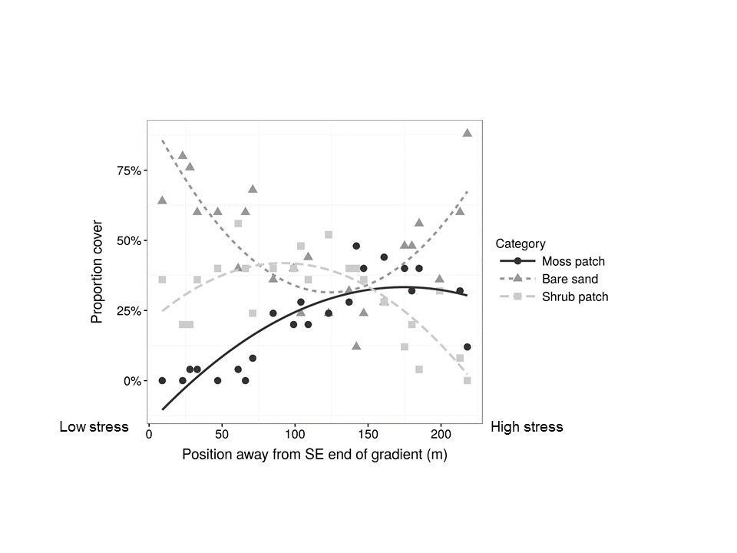

**Figure 2**

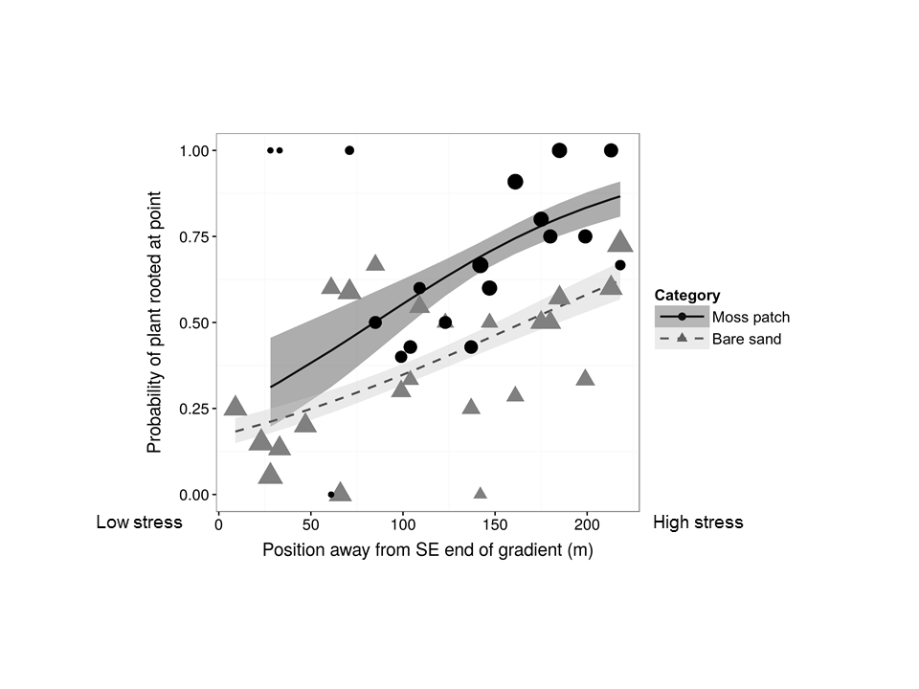

**Figure 3**

