Running Head: *Moss Effects on Exotic Grass*

**Effects of Native Bryophytes on Exotic Grass Invasion Across an Environmental Gradient**

Andrew R. Kleinhesselink1*, & J. Hall Cushman2

1 Department of Ecology and Evolutionary Biology, University of California, Los Angeles, CA 90095 USA

2Department of Natural Resources and Environmental Science, University of Nevada, Reno, NV 89557, USA

*Corresponding author: [arklein@g.ucla.edu](https://sites.lifesci.ucla.edu/eeb-kraft/lab-members/arklein@g.ucla.edu)

**Abstract**

Understanding the role that native biodiversity plays in controlling exotic species invasion is a critical goal in ecology. In terrestrial plant communities, most research has focused on the effects of native vascular plants on invasion by exotic vascular plants. However, in many ecosystems, native bryophytes and other non-vascular plants are common and can affect the establishment, survival and growth of vascular plants. A more complete picture of how native biodiversity affects exotic plant invasion, demands that more studies measure the effects of native bryophytes on exotic vascular plants. Moreover, there is growing realization that the effects of native species on invaders can range from negative to positive and that a complete picture of interactions between native and exotic plants requires measuring interactions in multiple environments. We used both observational and experimental studies to quantify the effects of native moss on two exotic annual grass species along a 200-m environmental gradient in a coastal dune in northern California. We found the effects of bryophytes to be species-specific and to vary with environmental context: bryophytes facilitated one exotic grass species at both ends of the environmental gradient but facilitated survival of another grass in only one environment. Our findings provide an important test of the effects of native bryophytes on exotic vascular plant invasion, and importantly show that these effects can vary dramatically even across local environmental gradients.

**Key-words:** biological soil crusts, coastal dune, exotic species, facilitation, stress-gradient hypothesis.

# Introduction

Biological communities throughout the world are increasingly invaded by a wide range of non-native species and it is critical to understand the factors that mediate the success of these taxa in their novel environments (Kennedy et al. 2002). The environmental filtering model of invasion contrasts physical conditions, such as climate and soil type that might restrict exotic invasion, with the effects of biotic interactions such as competition, predation and mutualism (Kennedy et al. 2002, Kraft et al. 2014). Exotic species are able to invade and thrive when they can pass through abiotic filters and cope with biotic interactions, which are usually assumed to be negative (Rejmánek 1996). Despite considerable evidence that competition can limit exotic plant invasion (Levine 2000, Kennedy et al. 2002), there are also a growing number of examples showing that exotic plants can be facilitated by native species (Badano et al. 2007, Griffith 2010, Cushman et al. 2011, Kleinhesselink et al. 2014). The stress-gradient hypothesis (SGH) provides a unifying conceptual framework that may help explain how environmental context determines whether native species compete with or facilitate exotic invasion (Bruno et al. 2003). The SGH predicts that the effects of native species on invading exotic species will change across environmental gradients; specifically that effects will be less negative and more positive in more stressful environments (Bertness and Callaway 1994, Bruno et al. 2003, Badano et al. 2007).

Studies examining the effects of competition and facilitation on invasive exotic plants have tended to focus on interactions between vascular plants (Kennedy et al. 2002, Badano et al. 2007). However, exotic plants commonly interact with a much more diverse array of species in their novel environments. For example, deserts, coastal dunes, forest understories and arctic environments are often colonized by an abundance of non-vascular plants such as bryophytes and lichens (Belnap et al. 2001). In these environments, invading exotic vascular plants are likely to have significant interactions with native non-vascular plants (Deines et al. 2007, Langhans et al. 2009). Despite their small stature, non-vascular plants can affect germination conditions for seeds and the availability of nutrients and water resources in the soil (Serpe et al. 2006, Langhans et al. 2009). In some systems, bryophytes and biological soil crusts more generally (fungi, lichens, cyanobacteria, bryophytes, and algae) have been found to play a role in resisting exotic species invasion, especially invasion by exotic annual grasses (Serpe et al. 2006, Morgan 2006, Deines et al. 2007, Hernandez and Sandquist 2011). Studying interactions between native bryophytes and exotic vascular plants along environmental gradients would provide a novel test of the idea that these interactions should change depending on environmental context.

While some studies have found that bryophytes can facilitate vascular plant germination, survival and growth (Rayburn et al. 2012), it is unknown how much the effects of native bryophytes on exotic plants can vary across local environmental gradients. In this study, we investigate the effects of native bryophytes on the local distribution of vascular plants across a gradient in environmental conditions and test whether bryophytes affect the germination, survival, growth and reproductive output of two exotic annual grasses. We test these predictions: 1) the association between vascular plants and moss patches will change systematically across an environmental gradient; and 2) the effect of moss on exotic annual grass performance will change depending on position along an environmental gradient.

# Study System

We conducted our study in a coastal dune system at Bodega Head in Sonoma County, California (38 19’ N, 123 3’ W). The area has a Mediterranean climate, receiving most of its precipitation between fall and early spring (Barbour et al. 1973). The soil is composed almost entirely of fine to coarse sands low in nutrients and organic matter (McNeil and Cushman 2005, Lortie and Cushman 2007, Cushman et al. 2010, Kleinhesselink et al. 2014). The current study was conducted between two large dune ridges that run in the direction of the prevailing winds (Supporting Information—Fig. S1). This site spans a 220 m gradient in soil conditions and wind speed that creates a large gradient in plant size and species composition, which we refer to as an environmental gradient. The details of this gradient have been previously described by Lortie and Cushman (2007) and Kleinhesselink et al. (2014). As one moves from the southeast to the northwest along the gradient, soil nitrate pools decrease by over 90%, soil water field capacity decreases by 40%, sand particle size doubles and average surface wind speeds increase by roughly 500% (Lortie and Cushman 2007). These abiotic changes are accompanied by a decrease in average plant height and size: the height of the dominant shrub in this system decreases towards the NW along the gradient and the average aboveground biomass of individual plants declines by a factor of 10 from the SE to the NW end of the gradient. *Bromus diandrus* (Poaceae; hereafter referred to as a *Bromus*) and two species of *Vulpia* (*V. bromoides* and *V. myuros*) are common exotic annual grass species at this site and throughout coastal California. We lumped the two *Vulpia* species into one group in our study because it was difficult to identify them to species in the field. A previous study showed that *Bromus* cover decreased across the environmental gradient, whereas *Vulpia* cover increased (Lortie and Cushman 2007).

Bryophytes and lichens constitute an important part of the ground cover at this site (Danin et al. 1998). The most abundant bryophyte along the environmental gradient was *Syntrichia ruralis* (Pottiaceae), which is a large drought-tolerant moss common in seasonally dry environments across California (Malcolm et al. 2009). Other bryophytes common at this site were *Homalothecium* *arenarium* (Brachytheceae) and *Didymodon vinealis* (Pottiaceae).

# Methods

## Vascular plant association with bryophytes across the gradient

We established 23 20-m transects spaced approximately 10 m apart along the 220 m gradient documented by Lortie and Cushman (2007) and Kleinhesselink et al. (2014). Each transect ran perpendicular to the dune gradient (Fig. S1). The most southeasterly transect occurred at the sheltered end with low wind speed finer textured sand, and the most northwesterly transect occurred at the more exposed end of the gradient with higher wind speeds and coarser textured sand. For the remainder of the paper, we refer to position along the gradient in meters away from the more sheltered southeast end of the gradient and refer to these sides of the gradient as the “SE” and “NW” ends of the gradient.

In order to determine cover of native mosses across this study site, and their association with the focal species of annual grass and other vascular plants, we recorded the cover of shrub, bare sand or moss patches on each of the transects described above. To estimate the cover of mosses, we used point-intercept sampling at 25 randomly chosen points along each transect, recording whether points fell on a moss patch, bare sand, or within a shrub. All moss species were lumped together and recorded as moss. We then recorded the species identity of any vascular plant rooted within 1 cm of the point.

## Effects of Bryophytes on Bromus and Vulpia

We established a field experiment in the winter of 2009/2010 to assess the effect of moss on the germination, survival, growth and reproduction of both exotic grass species. For each species, we established 18 separate blocks centered on large mats (>15 cm in minimum width) of the native moss *Syntrichia ruralis*. Each block was positioned away from shrubs and other large perennial plants. Nine blocks were located on the sheltered SE end of the gradient and nine were located at the more exposed NW end of the gradient. Each block consisted of three separate 5 x 10 cm patches (Fig. S2). Two patches were positioned on naturally occurring mats of moss. We left one as an un-manipulated patch (“moss covered”), and we removed the moss on the other by pulling the moss off the soil surface (“moss removed”). The third patch in each block was established on naturally moss-free bare sand as a control. Within each patch, we planted five seeds of the either *Vulpia* or *Bromus*. We planted only five seeds per patch (roughly spaced 2 cm apart) in order to keep seedling density low and prevent any self-thinning from occurring among the planted individuals. To prevent the seeds from blowing out of the patches and to help re-locate the seeds we glued each seed by its awn to a small wire and inserted the wire into the sand. We then pressed each seed into the sand or the moss surface of the patches. Seeds of both species were collected from the field site in the fall of 2009. The *Bromus* seeds were planted in late December 2009 and the *Vulpia* seeds were planted a few weeks later in January of 2010 in separate blocks.

Starting in January 2010, we visited the experimental patches roughly once every two weeks. Because seeds were glued to wires in each patch, we were able to easily distinguish between plants germinating from the seeds we planted from plants emerging from the natural seed bank. We weeded out all other seedlings within the experimental patches to eliminate the effect of competition between our focal plants and other vascular plants. In May 2010, the surviving plants produced inflorescences and began to senesce. At this time, we counted the total number of surviving plants in each patch, harvested their aboveground biomass and counted the total number of inflorescences. Total aboveground biomass from all focal plants surviving in each patch was dried at 60°C for 48 hr and weighed to the nearest milligram.

## Statistical Analyses

We used logistic regression to determine whether vascular plants were associated with moss patches and whether the association between vascular plants and moss changed across the environmental gradient. For this analysis we only included points falling outside of shrubs. We modeled the probability of a vascular plant occurring at each sampling point as a function of gradient position (meters away from the SE end of the gradient), moss presence (either moss patch or bare sand) and the interaction between these two factors. When residual deviance was greater than residual degrees of freedom, we used a quasibinomial model as recommended by Crawley (2007). We fit separate models for all vascular plant species together, for exotic species, for native species and for the target exotic annual grasses, *Vulpia* and *Bromus,* together. We tested significance of the gradient effect, the micro-habitat effect (moss covered or bare sand) and their interaction by comparing model deviance with F-tests in R (R Core Team 2015).

We used logistic regression to model how position on the environmental gradient (SE vs. NW end of the gradient) and treatment (moss removed, moss present or bare sand) and their interaction affected the final number of surviving *Bromus* and *Vulpia* plants in each experimental patch. Because we did not track individual germination and survival, our analysis focuses on the expected probability of one of the five seeds planted in each patch transitioning to an adult plant at the end of the growing season. The model included treatment, gradient position and their interaction as fixed effects and the 18 experimental blocks as random effects. We fit the model with a generalized linear mixed effects model with a logit link and binomial errors in the lme4 package in R (Bates et al. 2015). We analyzed the log average aboveground biomass of each species using the same model structure but within a linear model with normal errors. Similarly, we analyzed the number of inflorescences produced in each experimental patch using a generalized linear model with a log-link and quasi-poisson errors. We used the number of surviving plants in each patch as an offset term to control for varying number of surviving plants in each patch. We fit the inflorescence data without the random block effects because models fit with the random effect failed to converge.

We compared model deviance with *X*2 or F-tests to evaluate the significance of each of the fixed effects in the models. When we found a significant treatment or treatment x environmental gradient effect, we tested for significant pairwise differences between the three treatment means within levels of gradient position. We adjusted for the multiple comparisons using the Šidák method implemented with the “emmeans” package in R (Lenth and Hervé 2015). R scripts to reproduce the analyses are available on Github (<https://github.com/akleinhesselink/moss_analysis/releases/tag/v2.0>).

# Results

## Vascular plant associations with moss patches across the gradient

Moss cover was low in the more sheltered SE end of the gradient, peaked towards the middle of the gradient and declined across the last 50 m of the gradient (Fig. 1). This pattern of moss cover was well described as a quadratic function of distance on the environmental gradient (F2,20 = 26.7, R2 = 0.70, p < 0.01). We found 31 different species of vascular plants rooted at 189 of the 398 sampling points outside of shrubs. *Chorizanthe cuspidata* (Polygonaceae), a small native annual, was the most frequently encountered species and occurred at 60 sampling points. Lumping all vascular plant species together, we found they were rooted at 104 of 277 points without moss and 85 of 121 moss covered points. The frequency of vascular plants increased towards the NW end of the gradient (F1,396 = 54.3, p < 0.01; Fig. 2) and was greater within moss patches than uncolonized bare sand patches (F1,395 = 17.8, p < 0.01). However, we did not find a gradient position x micro-habitat interaction (F1,394 = 0.70, p = 0.40). Exotic and native species both increased in frequency towards the NW end of the gradient (exotics: F1,396 = 5.0, p = 0.03; natives: F1, 396 = 37.7, p < 0.01; Figs S3 and S4) and were both more frequent within moss patches (exotics: F1,395 = 9.2, p < 0.01; natives: F1,395 = 4.4, p = 0.04), but there was no gradient x micro-habitat interaction for either group (exotics: F1,394 = 0.0, p = 0.93; natives: F1,394 = 0.0, p = 0.93). Our target exotic annual grass species occurred at 22 sampling points: *Vulpia* at 17 and *Bromus* at five. When analyzed together, the frequency of *Bromus* and *Vulpia* did not vary with gradient position (F1,396 = 0.36, p = 0.55), with microhabitat type (F1,395 = 1.99, p = 0.16), nor was there a gradient position x microhabitat interaction (F1,394 = 1.5, p = 0.22; Fig. S5).

## Effects of moss on Bromus

There was a significant treatment x gradient position interaction on *Bromus* survival (*X*2 = 24.8, df = 2, p < 0.01): moss significantly reduced *Bromus* survival compared to bare sand patches at the more sheltered SE end of the gradient, but this effect disappeared in the more exposed NW end of the gradient (Fig. 3a). In contrast, survival in moss covered patches was significantly greater than survival in moss removed patches on the NW end of the gradient but not at the SE end of the gradient. Moss treatment had a significant effect on *Bromus* final biomass (*X*2 = 7.44, df = 2, p = 0.02; Fig. 3c), but this effect was specifically due to biomass being higher in bare sand patches than in patches with moss removed. There was no significant treatment x gradient interaction effect on final *Bromus* biomass (*X*2 = 4.27, df = 2, p = 0.12) nor a main effect of gradient position (*X*2 = 1. 63, df = 1, p = 0.19). *Bromus* inflorescence production was affected by a treatment x gradient interaction (F2,46 = 5.35, p = 0.01): at the SE end of the gradient plants in bare sand produced significantly more inflorescences than plants in either moss patches or in moss-removed patches, whereas at the NW side of the gradient there were no differences between treatments (Fig. 3e).

## Effects of moss on Vulpia

Moss significantly increased *Vulpia* survival (*X*2 = 32.97, df = 2, p < 0.01; Fig. 3b), but this effect did not vary across the gradient (*X*2 = 0.58, df = 2, p = 0.75). There was a trend towards higher *Vulpia* survival at the NW end of the gradient (*X*2 = 3.60, df = 2, p = 0.06). *Vulpia* biomass was not significantly affected by moss cover treatment (*X2* = 4.97, df = 2, p = 0.08; Fig. 3d), gradient position (*X2* = 0.21, df = 1, p = 0.65), nor was there a treatment x gradient interaction (*X2* = 1.18, df = 2, p = 0.55). Similarly, *Vulpia* inflorescence production was not affected by moss (F2,40 = 0.43, p = 0.65), gradient position (F1,42 = 0.53, p = 0.47) nor their interaction (F2,38= 0.18, p = 0.83; Fig. 3f).

# Discussion

Our study demonstrates that native bryophytes have important effects on the occurrence of vascular plants in this system as well as the survival of two exotic annual grasses. However, we found only limited support for our hypothesis that the strength and direction of these effects would change across the environmental gradient. The natural occurrence of vascular plants was significantly greater in moss patches than in bare sand but this positive association did not change significantly across the environmental gradient as we predicted (Fig. 2). This result held for both native and exotic species alike (Fig. S3 and S4). In our field experiment, we found only a few cases where moss had a facilitative effect on exotic grass performance at one end of the environmental gradient but a competitive effect at the other end. In particular, the effects of moss only varied along the environmental gradient for *Bromus* survival (Fig. 3a) and inflorescence production (Fig. 3e). In the more sheltered SE end of the gradient, moss clearly reduced *Bromus* survival, whereas in the more exposed NW end of the environmental gradient moss facilitated *Bromus* survival (Fig. 3a). This suggests that moss patches are an important microhabitat for *Bromus* at the NW end of the gradient. It also demonstrates that moss may play both a facilitative and an inhibitory role in exotic species invasion across the gradient depending on local environmental conditions. We also observed a gradient by treatment interaction effect on *Bromus* inflorescence production but this was less supportive of our hypothesis (Fig. 3e). At the SE end of the environmental gradient, *Bromus* produced fewer inflorescences in both the moss covered and moss removed patches compared to the bare sand patches. However, the differences between any pair of treatment levels disappeared in the more exposed NW end of the gradient (Fig. 3e). The effects of moss on the other exotic grass in this study, *Vulpia*, did not vary along the environmental gradient (Fig. 3b, 3d, 3f). Nevertheless, we did find that moss covered patches consistently gave *Vulpia* seeds the highest probability of germinating and surviving into adult plants (Fig. 3b). This indicates that moss covered patches may be key microhabitats supporting *Vulpia* population growth and invasion in this environment.

Our work shows the potential for native mosses to influence the success of invasive vascular plants in this environment. Mosses and other components of biological soil crusts are often found to have neutral to negative effects on vascular plant germination (Zamfir 2000, Serpe et al. 2006, Jeschke and Kiehl 2008, Drake et al. 2018), while at the same time they can increase the growth and survival of established plants (Pendleton et al. 2003, Langhans et al. 2009, Ferrenberg et al. 2018). Our experiment showed that moss mats had positive effects on the germination and survival of *Vulpia* across the environmental gradient, as well as a positive effect on *Bromus* only at one end of the gradient. We hypothesize that the beneficial effect of moss on seedling germination and survival may be due to the ability of moss to retain moisture and organic matter in the upper soil layers (Sand-Jensen and Hammer 2012). In particular, this effect could be more important on the coarser textured sands and windier conditions at the NW end of the gradient (see Kleinhesselink et al. 2014) and our finding of a positive effect on *Bromus* only at the NW end of the gradient supports this mechanism of influence.

Our experiment showed that the effect of moss on germination and survival depended on the annual grass species involved. The germination and survival of *Vulpia* was facilitated by moss across the gradient, but for *Bromus* facilitation only occurred at the NW end of the gradient and apparently moss competed with *Bromus* at the SW end of the gradient (Fig. 3a). Other studies have also shown that the effects of moss on seedling performance depended greatly on the species of vascular plant (Zamfir 2000, Serpe et al. 2006). Seed size may be an important plant trait that controls how plants respond to bryophyte mats and *Bromus* seeds are over 10 times larger than *Vulpia* seeds (Royal Botanic Gardens, Kew 2019). On the one hand, in deep moss mats, small seeds can be at a disadvantage as they fall deep into the moss where it may be too dark to germinate or emerge (Zamfir 2000). However, large seeds stuck on the surface of a moss mat may not be able to absorb enough water to initiate germination—Serpe et al. (2006) showed that it was not until seeds were incorporated into the moss layer that they began to absorb moisture. One hypothesis to explain the species-specific difference observed in our study involves an interaction between moss mat density and seed size. In the more sheltered end of the gradient, moss patches may be thicker and denser—although we did not measure this. If this is the case, denser moss could have kept the larger *Bromus* seeds on the surface of the moss mat and prevented them from absorbing moisture. On the other hand, the smaller *Vulpia* seeds may have fallen more deeply into the moss layer and had better access to moisture. More detailed observations of the thickness of moss mats across the gradient as well as time courses of seed water status would be needed to test this hypothesis.

We expected that the performance of the annual grasses in patches where moss was removed would be similar to the performance in naturally bare sand patches. However, in the more sheltered end of the environmental gradinet *Bromus* survival and inflorescence production were significantly greater in bare sand patches than in patches where moss was removed, while the difference between moss covered patches and moss removed patches was not significant (Fig. 3a, 3e). The difference between *Bromus* performance in bare sand and moss removed patches at this end of the environmental gradient is notable because it is among the strongest effects in the experiment. This indicates that the environment created by our removal treatment was somehow different from naturally bare sand. We speculate that this effect is either due to depletion of local soil nutrients by the removed moss or due to some residual allelopathic influence of moss in these patches (Michel et al. 2011). Another possibility is the presence of cryptic cyanobacterial or algal crust on what we assumed were naturally bare sand patches. These crusts may have exert a positive effect on *Bromus* but would not necessarily be present in the patches were moss was experimentally removed.

We expected that the exotic annual grasses in this system would have their performance limited at the NW end of the environmental gradient where wind speeds are higher, the sand is coarser and lower in nitrogen content. Instead, we found that *Bromus* and *Vulpia* often performed as well or better at the NW end of the environmental gradient (Fig. 3). While the decrease in plant size and biomass across the gradient are suggestive of a stress gradient, this environmental gradient may not be stressful for these particular exotic species (Lortie and Cushman 2007 and Kleinhesselink et al. 2014). This result runs counter to the hypothesis that exotic species are limited from stressful environments within landscapes because they lack specialized adaptations needed to tolerate the local stresses (Harrison 1999). Instead, our finding supports the idea that stressful environments can sometimes be more easily invaded by exotic plants, perhaps because it offers opportunity to escape competition from larger native competitors (MacDougall et al. 2006).

# Conclusion

Native biodiversity plays a critical role in determining which exotic species can invade and where exotic species can invade. We demonstrate that native bryophytes can also influence the success of exotic vascular plants. Moreover, we found the effects of bryophytes on exotic annual grass establishment depended on environmental context and the vital rate being measured. We find evidence that bryophytes can either compete with or facilitate exotic vascular plants and suggests that the role of native bryophytes should more often be considered in conservation and restoration of native vegetation (Bowker 2007, Chiquoine et al. 2016).

# Acknowledgements

We are grateful to Susan Magnoli for assistance with field research and Tyler Refsland for helpful comments on this manuscript. Jackie Sones of the UC Davis Bodega Marine Reserve provided valuable logistical support. We are very grateful for the support and encouragement of the members of the Milo Baker Chapter of the California Native Plant Society. Research support was provided by grants from the California Native Plant Society, Northern California Botanists, Sigma Xi, Sonoma State University and the National Science Foundation (DEB-9981663 to J.H.C.).

**Author Contributions**

ARK conceived and designed the study, established the experiments, collected and statistically analyzed the data, and wrote the manuscript. JHC conceived and designed the study and wrote the manuscript.

**Data Accessibility**

Data will be uploaded to Dryad prior to publication.

# References

Badano, E. I., E. Villarroel, R. O. Bustamante, P. A. Marquet, and L. A. Cavieres. 2007. Ecosystem engineering facilitates invasions by exotic plants in high-Andean ecosystems. Journal of Ecology 95:682–688.

Barbour, M. G., C. RB, D. FR, and G. MT. 1973. Coastal ecology: Bodega Head. University of California Press, Berkeley.

Bates, D., M. Mächler, B. Bolker, and S. Walker. 2015. Fitting Linear Mixed-Effects Models Using lme4. Journal of Statistical Software 67:1–48.

Belnap, J., B. Büdel, and O. L. Lange. 2001. Biological Soil Crusts: Characteristics and Distribution. Pages 3–30 *in* P. D. J. Belnap and P. D. D. h c O. L. Lange, editors. Biological Soil Crusts: Structure, Function, and Management. Springer Berlin Heidelberg.

Bertness, M. D., and R. Callaway. 1994. Positive interactions in communities. Trends in Ecology & Evolution 9:191–193.

Bowker, M. A. 2007. Biological soil crust rehabilitation in theory and practice: An underexploited opportunity. Restoration Ecology 15:13–23.

Bruno, J. F., J. J. Stachowicz, and M. D. Bertness. 2003. Inclusion of facilitation into ecological theory. Trends in Ecology & Evolution 18:119–125.

Chiquoine, L. P., S. R. Abella, and M. A. Bowker. 2016. Rapidly restoring biological soil crusts and ecosystem functions in a severely disturbed desert ecosystem. Ecological Applications 26:1260–1272.

Cushman, J. H., C. J. Lortie, and C. E. Christian. 2011. Native herbivores and plant facilitation mediate the performance and distribution of an invasive exotic grass. Journal of Ecology 99:524–531.

Cushman, J. H., J. C. Waller, and D. R. Hoak. 2010. Shrubs as ecosystem engineers in a coastal dune: influences on plant populations, communities and ecosystems. Journal of Vegetation Science 21:821–831.

Danin, A., S. Rae, M. Barbour, N. Jurjavcic, P. Connors, and E. Uhlinger. 1998. Early primary succession on dunes at Bodega Head, California. Madroño 45:101–109.

Deines, L., R. Rosentreter, D. J. Eldridge, and M. D. Serpe. 2007. Germination and seedling establishment of two annual grasses on lichen-dominated biological soil crusts. Plant and Soil 295:23–35.

Drake, P., H. Grimshaw-Surette, A. Heim, and J. Lundholm. 2018. Mosses inhibit germination of vascular plants on an extensive green roof. Ecological Engineering 117:111–114.

Ferrenberg, S., A. M. Faist, A. J. Howell, and S. C. Reed. 2018. Biocrusts enhance soil fertility and Bromus tectorum growth, and interact with warming to influence germination. Plant and Soil 429:7790.

Griffith, A. B. 2010. Positive effects of native shrubs on Bromus tectorum demography. Ecology 91:141–154.

Harrison, S. 1999. Native and alien species diversity at the local and regional scales in a grazed California grassland. Oecologia 121:99–106.

Hernandez, R. R., and D. R. Sandquist. 2011. Disturbance of biological soil crust increases emergence of exotic vascular plants in California sage scrub. Plant Ecology 212:1709.

Jeschke, M., and K. Kiehl. 2008. Effects of a dense moss layer on germination and establishment of vascular plants in newly created calcareous grasslands. Flora - Morphology, Distribution, Functional Ecology of Plants 203:557–566.

Kennedy, T. A., S. Naeem, K. M. Howe, J. M. H. Knops, D. Tilman, and P. Reich. 2002. Biodiversity as a barrier to ecological invasion. Nature 417:636–638.

Kleinhesselink, A. R., S. M. Magnoli, and J. H. Cushman. 2014. Shrubs as ecosystem engineers across an environmental gradient: effects on species richness and exotic plant invasion. Oecologia 175:1277–1290.

Kraft, N. J. B., P. B. Adler, O. Godoy, E. C. James, S. Fuller, and J. M. Levine. 2014. Community assembly, coexistence and the environmental filtering metaphor. Functional Ecology:n/a-n/a.

Langhans, T. M., C. Storm, and A. Schwabe. 2009. Biological soil crusts and their microenvironment: Impact on emergence, survival and establishment of seedlings. Flora - Morphology, Distribution, Functional Ecology of Plants 204:157–168.

Lenth, R. V., and M. Hervé. 2015. lsmeans: Least-Squares Means.

Levine, J. M. 2000. Species Diversity and Biological Invasions: Relating Local Process to Community Pattern. Science 288:852–854.

Lortie, C. J., and J. H. Cushman. 2007. Effects of a directional abiotic gradient on plant community dynamics and invasion in a coastal dune system. Journal of Ecology 95:468–481.

MacDougall, A. s., J. Boucher, R. Turkington, and G. e. Bradfield. 2006. Patterns of plant invasion along an environmental stress gradient. Journal of Vegetation Science 17:47–56.

McNeil, S. G., and J. H. Cushman. 2005. Indirect effects of deer herbivory on local nitrogen availability in a coastal dune ecosystem. Oikos 110:124–132.

Michel, P., D. J. Burritt, and W. G. Lee. 2011. Bryophytes display allelopathic interactions with tree species in native forest ecosystems. Oikos 120:1272–1280.

Morgan, J. W. 2006. Bryophyte Mats Inhibit Germination of Non-native Species in Burnt Temperate Native Grassland Remnants. Biological Invasions 8:159–168.

Pendleton, R. L., B. K. Pendleton, G. L. Howard, and S. D. Warren. 2003. Growth and Nutrient Content of Herbaceous Seedlings Associated with Biological Soil Crusts. Arid Land Research and Management 17:271–281.

R Core Team. 2015. R: A Language and Environment for Statistical Computing. R Foundation for Statistical Computing, Vienna, Austria.

Rayburn, A. P., J. B. Davidson, and H. M. White. 2012. Possible Effects of Moss on Distribution and Performance of a Threatened Endemic Primrose. Western North American Naturalist 72:84–92.

Rejmánek, M. 1996. Species Richness and Resistance to Invasions. Pages 153–172 *in* P. D. G. H. Orians, P. D. R. Dirzo, and P. D. J. H. Cushman, editors. Biodiversity and Ecosystem Processes in Tropical Forests. Springer Berlin Heidelberg.

Royal Botanic Gardens, Kew. 2019. Seed Information Database. http://data.kew.org/sid/citing.html.

Sand-Jensen, K., and K. J. Hammer. 2012. Moss cushions facilitate water and nutrient supply for plant species on bare limestone pavements. Oecologia 170:305–312.

Serpe, M., J. Orm, T. Barkes, and R. Rosentreter. 2006. Germination and seed water status of four grasses on moss-dominated biological soil crusts from arid lands. Plant Ecology 185:163–178.

Zamfir, M. 2000. Effects of bryophytes and lichens on seedling emergence of alvar plants: evidence from greenhouse experiments. Oikos 88:603–611.

**FIGURES**

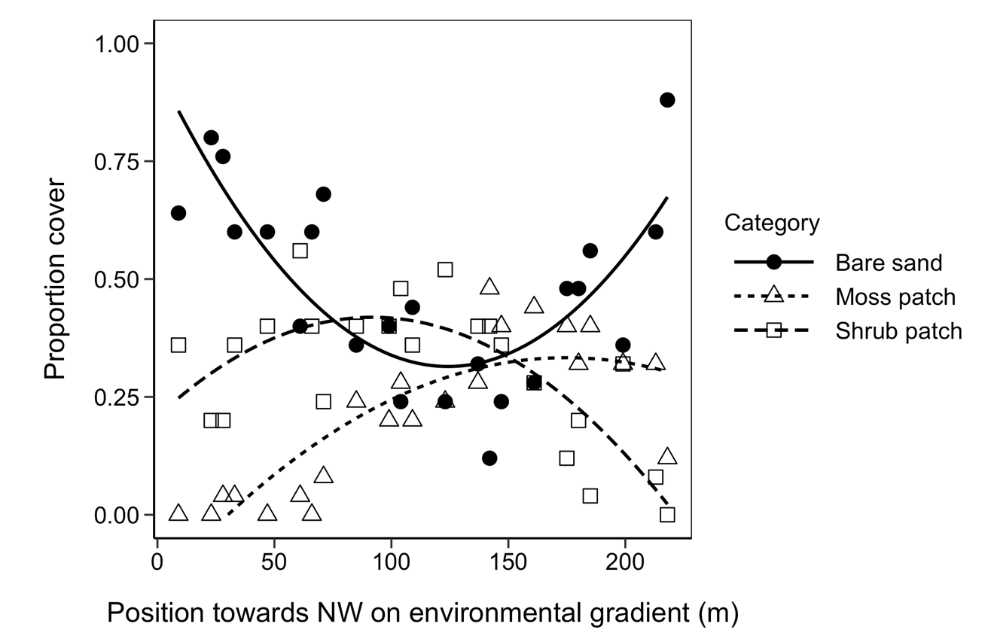**­­**

Figure 1. Point intercept cover of moss patches, bare sand and shrubs across the environmental gradient. Lines show quadratic regression fitted to points. Wind speed and sand particle size increase towards the NW end of the gradient, along with other changes.

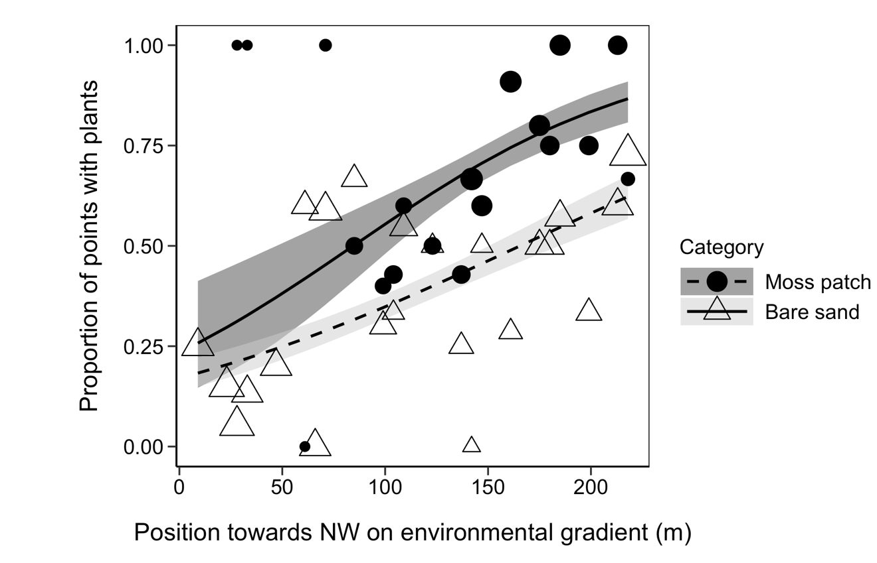

Figure 2. Frequency of all vascular plants rooted in moss patches and bare sand across the environmental gradient. Y-axis gives proportion of vascular plants rooted within 1 cm of sampling point. Symbol size is scaled to indicate the number of samples within each habitat at each position along the gradient—larger symbols indicate larger sample size. Lines and shaded areas show back-transformed means plus or minus standard error from a binomial model.

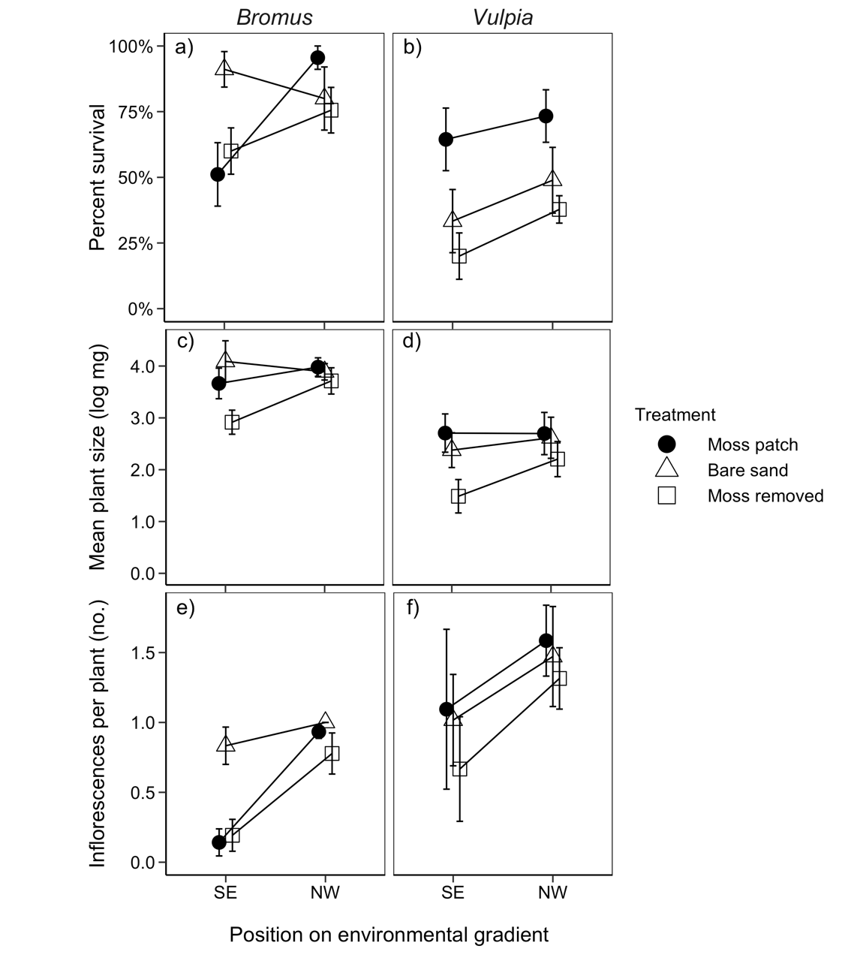

**Figure 3.** Survival, growth and fecundity of *Bromus* and *Vulpia* in patches of moss, bare sand, or where moss was removed at the SE and NW end of the environmental gradient. A and B show the cumulative germination and survival of *Bromus* and *Vulpia* seeds planted in each patch (± S.E.). Y-axis gives the number of live plants at the end of the growing season divided by the number of seeds planted. C and D show the final size of *Bromus* and *Vulpia* plants as log-transformed average mass per plant in mg (± S.E.). E and F show the number of inflorescences produced per plant for *Bromus* and *Vulpia* (± S.E.). Average inflorescence production can be less than one per plant because some plants produced no inflorescences.

**Supporting Information—Additional Figures for “Effects of Native Bryophytes on Exotic Grass Invasion Across an Environmental Gradient”**

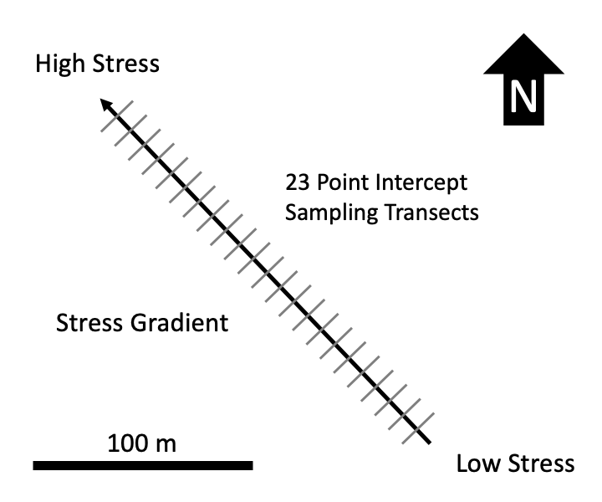

**Figure S 1** – Schematic of environmental gradient and observational study design. 23 20 m long transects were sampled along the length of the roughly 220 m long environmental gradient, running from sheltered SE end (lower wind speed and finer sand) to the more exposed NW end (higher wind speed and coarser sand). Experimental blocks for the moss removal experiment were located on the same gradient.

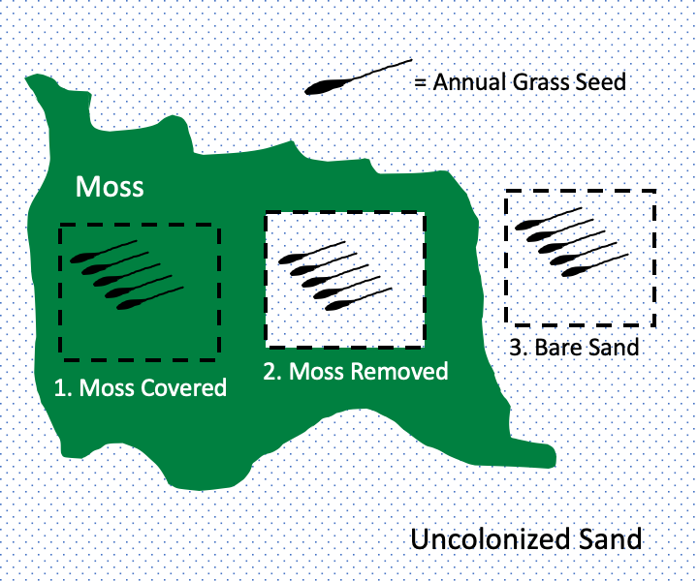

**Figure S 2** – One experimental block in the moss removal experiment. Nine experimental blocks were located at the SE end of the gradient and nine located at the NW end of the gradient (see Fig. S1). Each block was centered on a large moss mat moss and consisted of three experimental patches—a natural moss patch, a patch with moss removed and a bare sand patch outside of moss. Five seeds of exotic annual grasses were planted in each patch. Separate blocks were used for *Vulpia* and *Bromus*.

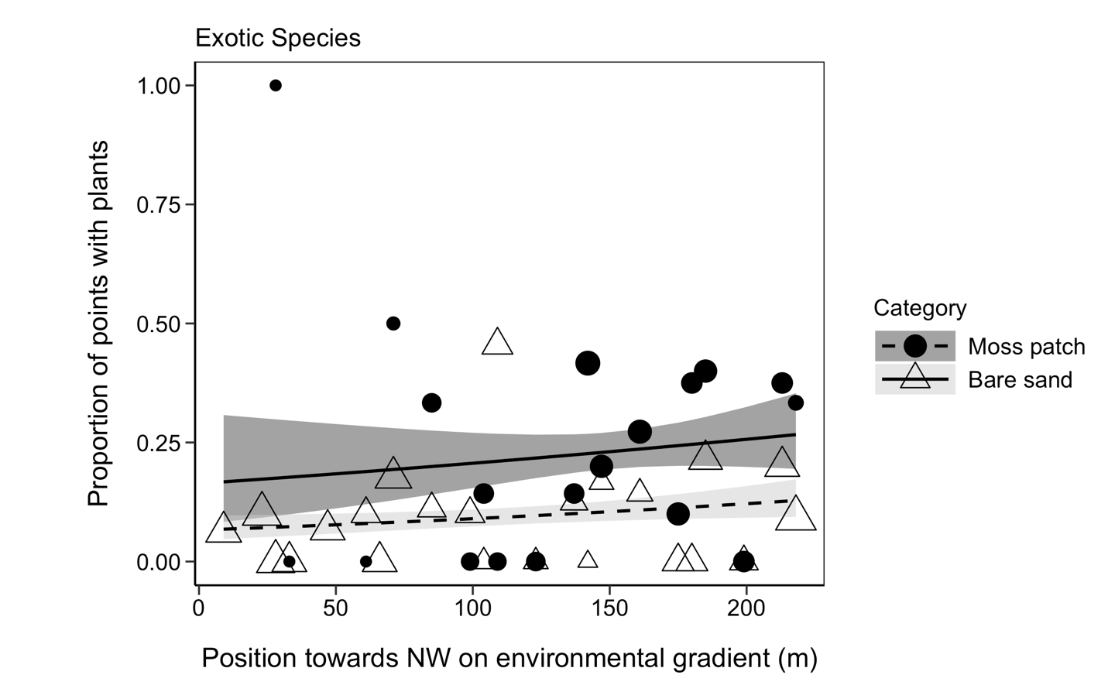

**Figure S 3** – Frequency of exotic vascular plants inside and outside of moss patches across the environmental gradient. Y-axis gives proportion of plants rooted within 1 cm of sampling point. Symbol size is scaled to indicate the number of samples within each habitat at each position along the gradient—larger symbols indicate larger sample size. Lines and shaded areas show back-transformed means plus or minus standard error from a binomial model.

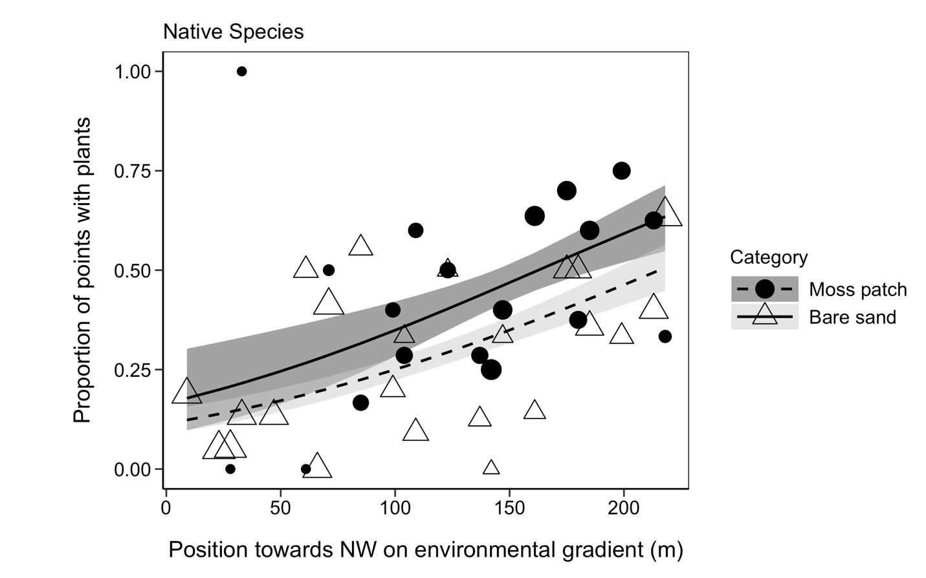

**Figure S 4** – Frequency of native vascular plants inside and outside of moss patches across the environmental gradient. Y-axis shows proportion of plants rooted within 1 cm of sampling point. Symbol size is scaled to indicate the number of samples within each habitat at each position along the gradient—larger symbols indicate larger sample size. Lines and shaded areas show back-transformed means plus or minus standard error from a binomial model.

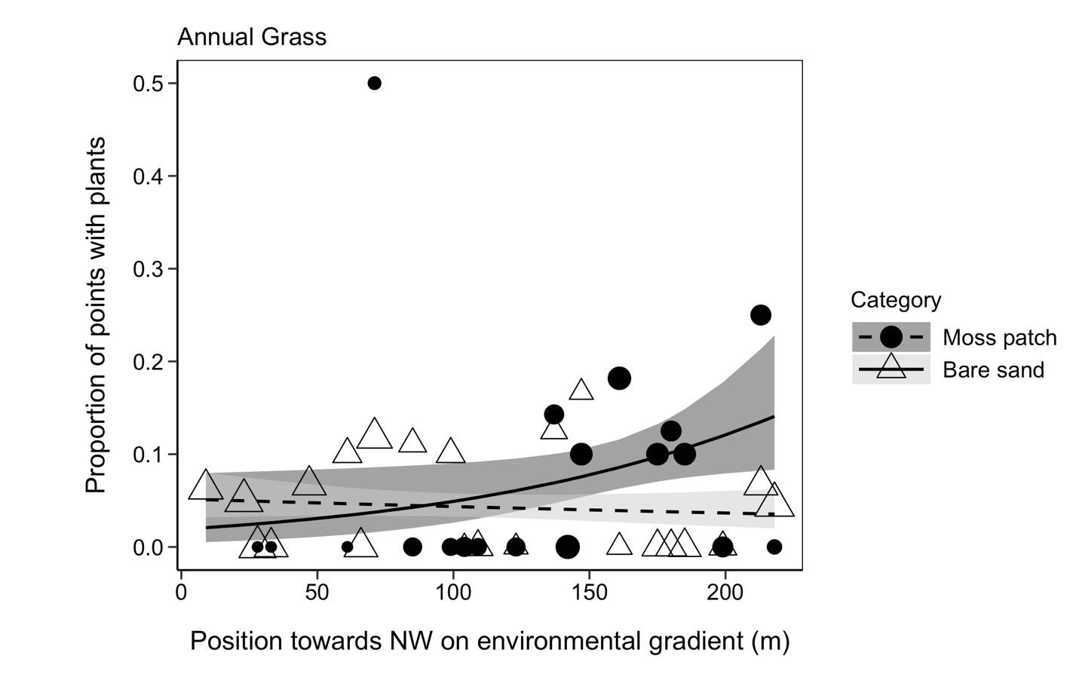

**Figure S 5** – Frequency of exotic annual grasses (both *Bromus* and *Vulpia*) inside and outside of moss patches across the environmental gradient. Y-axis shows proportion of plants rooted within 1 cm of sampling point. Symbol size is scaled to indicate the number of samples within each habitat at each position along the gradient—larger symbols indicate larger sample size. Lines and shaded areas show back-transformed means plus or minus standard error from a binomial model.