Running Head: *Moss Effects on Exotic Grass*

**Effects of Native Bryophytes on Exotic Grass Invasion:**

**a Test of the Stress Gradient Hypothesis**

Andrew R. Kleinhesselink1*, & J. Hall Cushman2

1 Department of Ecology and Evolutionary Biology, University of California, Los Angeles, CA 90095 USA

2Department of Natural Resources and Environmental Science, University of Nevada, Reno, NV 89557, USA

*Corresponding author: [arklein@g.ucla.edu](https://sites.lifesci.ucla.edu/eeb-kraft/lab-members/arklein@g.ucla.edu)

**Abstract**

Understanding the role that native biodiversity plays in controlling exotic species invasion is a critical goal in ecology. The stress gradient hypothesis (SGH) provides a unifying framework for understanding the range of effects that native species have on invasive species. The SGH predicts that native species will compete with and inhibit species invasion in benign habitats but facilitate invasion in more stressful environments. Most previous studies of exotic plant invasion and the SGH have focused only on interactions between vascular plants. However, in many stressful environments, native bryophytes and other non-vascular plants are common. In order to form a more complete picture of the factors influencing exotic plant invasion and to test generality of the SGH, it is critical to measure the effects of native bryophytes on exotic vascular plants across environmental gradients. We used both observational and experimental studies to quantify the effects of native moss on two exotic annual grass species along a 200-m stress gradient in a coastal dune in northern California. We found the effects of bryophytes to be species-specific: bryophytes facilitated one exotic grass in both low- and high-stress environments and inhibited survival and growth of the other exotic grass at low stress but facilitated survival at high stress. Our findings provide a novel test of the SGH and highlight the importance of native bryophytes in controlling vascular plant invasions in stressful environments.

**Key-words:** biological soil crusts, coastal dune, exotic species, facilitation, stress-gradient hypothesis.

# Introduction

Biological communities throughout the world are increasingly invaded by a wide range of non-native species and it is critical to understand the factors that mediate the success of these taxa in their novel environments (Kennedy et al. 2002). Environmental filtering (Kraft et al. 2014) and the stress-gradient hypothesis (Bertness and Callaway 1994) have emerged as complementary frameworks for understanding patterns in the success of exotic invasions. The environmental filtering model contrasts physical conditions, such as climate and soil type that might restrict exotic invasion, with the effects of biotic interactions such as competition, predation and mutualism (Kennedy et al. 2002, Kraft et al. 2014). Exotic species are able to invade and thrive when they can pass through abiotic filters and can cope with biotic interactions, which are usually assumed to be negative (Rejmánek 1996). Despite considerable evidence that competition can limit exotic plant invasion (Levine 2000, Kennedy et al. 2002), there is also a growing number of examples showing that exotic plants can be facilitated by native species (Badano et al. 2007, Griffith 2010, Cushman et al. 2011, Kleinhesselink et al. 2014). The stress-gradient hypothesis (SGH) provides a unifying conceptual framework that seeks to explain the range of interactions arising between exotic and native species (Bruno et al. 2003). The SGH predicts that interactions between species will be negative in physically benign or productive environments and positive in stressful or resource limited environments (Bertness and Callaway 1994). An implication of the SGH is that stress should predict the effect that native species have on exotics: native taxa should resist invasion in productive habitats, but facilitate invasion in stressful environments (Bruno et al. 2003, Badano et al. 2007).

Studies examining the effects of competition and facilitation on invasive exotic plants have tended to focus on interactions between vascular plants (Kennedy et al. 2002, Badano et al. 2007). However, exotic plants commonly interact with a much more diverse array of species in their novel environments. For example, deserts, coastal dunes, forest understories and arctic environments are often colonized by an abundance of non-vascular plants such as bryophytes and lichens (Belnap et al. 2001). In these environments, invading exotic vascular plants are likely to have significant interactions with native non-vascular plants (Deines et al. 2007, Langhans et al. 2009). Despite their small stature, non-vascular plants can strongly affect germination conditions for seeds and the availability of nutrients and water resources in the soil (Serpe et al. 2006, Langhans et al. 2009). In some systems, bryophytes and biological soil crusts more generally (fungi, lichens, cyanobacteria, bryophytes, and algae) have been found to play a role in resisting exotic species invasion, especially invasion by exotic annual grasses (Serpe et al. 2006, Morgan 2006, Deines et al. 2007, Hernandez and Sandquist 2011). Studying interactions between native bryophytes and exotic vascular plants would provide a novel test of the SGH and could help expand the generality of the SGH to all pairs of competitors, not only species with similar functional traits and life histories.

While some studies have found that bryophytes can facilitate vascular plant germination, survival and growth (Rayburn et al. 2012), it is unknown whether the effects of native bryophytes on exotic plant species shift from competition to facilitating across environmental gradients, as the SGH predicts. In this study, we investigate the effects of native bryophytes on the local distribution of vascular plants across an environmental stress gradient and test whether bryophytes affect the germination, survival, growth and reproductive output of two exotic annual grasses. We test two predictions stemming from the SGH: 1) vascular plants will be more positively associated with moss patches in more stressful environments; and 2) moss will inhibit the performance of exotic annual grasses in low-stress environments, but will facilitate these species in high-stress environments.

# Study System

We conducted our study in a coastal dune system at Bodega Head in Sonoma County, California (38 19’ N, 123 3’ W). The area has a Mediterranean climate, receiving most of its precipitation between fall and early spring (Barbour et al. 1973). The soil is composed almost entirely of fine to coarse sands low in nutrients and organic matter (McNeil and Cushman 2005, Lortie and Cushman 2007, Cushman et al. 2010, Kleinhesselink et al. 2014). The current study was conducted between two large dune ridges that run in the direction of the prevailing winds (Supporting Information—Fig. S1). This site spans a gradient in soil conditions and wind speed that creates a large gradient in plant size and species composition, which we refer to as a stress gradient. The details of this environmental gradient have been previously described by Lortie and Cushman (2007) and Kleinhesselink et al. (2014). Soil nitrate pools, soil water field capacity, average plant size, perennial cover, native plant cover and species richness are highest at the east or “sheltered” end of the trough and decreased towards the west or “exposed” end. Soil coarseness, wind speed, bare ground, annual plant cover and non-native plant cover also followed the gradient and were highest at the exposed end of the gradient and decreased towards the sheltered end. *Bromus diandrus* (Poaceae; hereafter referred to as a *Bromus*) and two species of *Vulpia* (*V. bromoides* and *V. myuros*) are common exotic annual grass species at this site and throughout coastal California. We lumped the two *Vulpia* species into one group in our study because it was difficult to identify them to species in the field.

Bryophytes and lichens constitute an important part of the ground cover at this site. The most abundant bryophyte was *Syntrichia ruralis* (Pottiaceae), which is a large drought-tolerant moss common in seasonally dry environments across California (Malcolm et al. 2009). Other bryophytes common at this site were *Homalothecium* *arenarium* (Brachytheceae) and *Didymodon vinealis* (Pottiaceae).

# Methods

## Bryophyte patches across the stress gradient

We established 23 20-m transects spaced approximately 10 m apart along the 220 m long stress gradient documented by Lortie and Cushman (2007) and Kleinhesselink et al. (2014). Each transect ran perpendicular to the dune gradient (Fig. S1). The most southeasterly transect occurred at the sheltered low-stress end, and the most northwesterly transect occurred at the more exposed high-stress end of the gradient. For the remainder of the paper, we refer to position along the gradient in meters away from the more sheltered southeast end of the gradient.

In order to determine cover of native mosses across this study site, and their association with the focal species of annual grass and other vascular plants, we recorded the cover of shrub, bare sand or moss patches on each of the transects described above. To estimate the cover of mosses, we used the point-intercept method and sampled 25 randomly chosen points along each transect, recording whether points fell on a moss patch, bare sand, or within a shrub. All moss species were lumped together and recorded as moss. We then recorded the species identity of any vascular plant rooted within 1 cm of the point. In our analyses we only included sampling points falling outside of shrubs.

## Effects of Bryophytes on Bromus and Vulpia

We established a field experiment in the winter of 2009/2010 to assess the effect of moss on the germination, survival, growth and reproduction of both exotic grass species. For each species, we established 18 separate blocks centered on large mats (>15 cm in minimum width) of the native moss *Syntrychia ruralis*. Each block was positioned away from shrubs and other large perennial plants. Nine blocks were located at the low stress end of the gradient and nine were located at the high stress end of the gradient. Each block consisted of three separate 5 x 10 cm patches (Fig. S2). Two patches were positioned on naturally occurring mats of moss. We left one as an un-manipulated patch (“moss covered”), and we removed the moss on the other by pulling the moss off the soil surface (“moss removed”). The third patch in each block was established on naturally moss-free bare sand as a control. Within each patch, we planted five seeds of the either *Vulpia* or *Bromus*. To prevent the seeds from blowing out of the patches, we glued each seed by its awn to a small wire inserted into the sand so that seeds were just below the soil surface. Planted seeds were spaced 2 cm apart. Seeds of both species were collected from the field site in the fall of 2009. The *Bromus* seeds were planted in late December 2009 and the *Vulpia* seeds were planted a few weeks later in January of 2010 in separate blocks.

Starting in January 2010, we visited the experimental patches roughly once every two weeks. Because seeds were glued to wires in each patch, we were able to easily distinguish between plants germinating from the seeds we planted from plants emerging from the natural seed bank. We weeded out all other vascular plants emerging within the experimental patches to eliminate the effect of competition between our focal plants and other plants. In May 2010, the surviving plants produced inflorescences and began to senesce. At this time, we counted the total number of plants and the total number of inflorescences produced in each patch and collected the aboveground biomass from all the plants. Total aboveground biomass from all focal plants surviving in each patch was harvested, dried at 60°C for 48 hr and weighed to the nearest milligram.

## Statistical Analyses

We used logistic regression to determine whether vascular plants were more associated with moss patches than expected and whether the association between vascular plants and moss changed across the stress gradient. We modeled the probability of a vascular plant occurring at each sampling point as a function of gradient position (meters away from the SE low-stress end of the gradient), moss presence (either moss patch or bare sand) and the interaction between these two factors. When residual deviance was greater than residual degrees of freedom, we used a quasibinomial model as recommended by Crawley (2007). We fit separate models for all vascular plant species together, for exotic species, for native species and for the target exotic annual grasses, *Vulpia* and *Bromus,* together. We tested significance of the gradient effect, the micro-habitat effect (moss covered or bare sand) and their interaction by comparing model deviance with F-tests in R (R Core Team 2015).

We used logistic regression to model how environmental stress (low-stress or high-stress positions on the gradient) and treatment (moss removed, moss present or bare sand) and their interaction affected the final number of surviving *Bromus* and *Vulpia* plants in each experimental patch. Because we did not track individual germination and survival, our analysis focuses on the expected probability of one of the five seeds planted in each patch transitioning to an adult plant at the end of the growing season. The model included treatment, stress level and their interaction as fixed effects and the 18 experimental blocks as random effects. We fit the model with a generalized linear mixed effects model with a logit link and binomial errors in the lme4 package in R (Bates et al. 2015). We analyzed the log average aboveground biomass of each species using the same model structure but within a linear model with normal errors. Similarly, we analyzed the number of inflorescences produced in each experimental patch using a generalized linear model with a log-link and quasipoisson errors. We used the number of surviving plants in each patch as an offset term to control for varying number of surviving plants in each patch. We fit the inflorescence data without the random block effects because models fit with the random effect failed to converge.

We compared model deviance with *X*2 or F-tests to evaluate the significance of each of the fixed effects in the models. When we found a significant treatment or treatment x stress effect, we tested for significant pairwise differences between the three treatment means within stress levels. We adjusted for the multiple comparisons using the Šidák method implemented with the “emmeans” package in R (Lenth and Hervé 2015). R scripts to reproduce the analyses are provided in the supporting information.

# Results

## Vascular plant associations with moss patches across the gradient

Moss cover was low at the low stress (southeastern) end of the gradient and peaked towards the middle of the gradient and declined across the last 50 m of the stress gradient (Fig. 1). This pattern of moss cover was well described as a quadratic function of distance on the stress gradient (F2,20 = 26.7, R2 = 0.70, p < 0.01). We found 31 different species of vascular plants rooted at 189 of the 398 sampling points outside of shrubs. *Chorizanthe cuspidata* (Polygonaceae), a small native annual, was the most frequently encountered species and occurred at 60 sampling points. Lumping all vascular plant species together, we found they were rooted at 104 of 277 points without moss and 85 of 121 moss covered points. The frequency of vascular plants increased towards the more stressful end of the gradient (F1,396 = 54.3, p < 0.01; Fig. 2) and was greater within moss patches than uncolonized bare sand patches (F1,395 = 17.8, p < 0.01). However, we did not find a gradient position x micro-habitat interaction (F1,394 = 0.70, p = 0.40). Exotic and native species both increased in frequency towards the stressful end of the gradient (exotics: F1,396 = 5.0, p = 0.03; natives: F1, 396 = 37.4, p < 0.01; Figs S3 and S4) and were both more frequent within moss patches (exotics: F1,395 = 9.2, p < 0.01; natives: F1,395 = 4.3, p = 0.04), but there was no stress x micro-habitat interaction for either group (exotics: F1,394 = 0.0, p = 0.93; natives: F1,394 = 0.0, p = 0.93). Our target exotic annual grass species occurred at 22 sampling points: *Vulpia* at 17 and *Bromus* at five. When analyzed together, the frequency of *Bromus* and *Vulpia* did not vary with gradient position (F1,396 = 0.36, p = 0.55), with microhabitat type (F1,395 = 1.97, p = 0.16), nor was there a gradient position x microhabitat interaction (F1,394 = 1.5, p = 0.22; Fig. S5).

## Effects of moss on Bromus

The effects of moss on *Bromus* varied with demographic rate and position on the environmental stress gradient. There was a significant treatment x stress interaction on *Bromus* survival (*X*2 = 24.8, df = 2, p < 0.01): moss significantly reduced *Bromus* survival compared to bare sand patches in the low stress environment, but this effect disappeared in the high-stress environment (Fig. 3a). In contrast, survival in moss covered patches was significantly greater than survival in moss removed patches at high stress but not at low stress. Moss treatment had a significant effect on *Bromus* final biomass (*X*2 = 7.44, df = 2, p = 0.02; Fig. 3c), but this effect was specifically due to biomass being higher in bare sand patches than in patches with moss removed. There was no significant treatment x stress interaction effect on final *Bromus* biomass (*X*2 = 4.27, df = 2, p = 0.12) nor a main effect of stress level (*X*2 = 1. 63, df = 1, p = 0.19). *Bromus* inflorescence production was affected by a treatment x stress gradient interaction (F2,46 = 5.35, p = 0.01): at low stress plants in bare sand produced significantly more inflorescences than plants in either moss patches or in moss-removed patches, whereas at high stress there were no differences between treatments (Fig. 3e).

## Effects of moss on Vulpia

Moss significantly increased *Vulpia* survival (*X*2 = 32.97, df = 2, p < 0.01; Fig. 3b), but this effect did not vary across the stress gradient (*X*2 = 0.58, df = 2, p = 0.75). There was a trend towards higher *Vulpia* survival in the higher stress environment (*X*2 = 3.60, df = 2, p = 0.06). *Vulpia* biomass was not significantly affected by moss cover treatment (*X2* = 4.97, df = 2, p = 0.08; Fig. 3d), stress gradient position (*X2* = 0.21, df = 1, p = 0.65), nor was there a treatment x stress interaction (*X2* = 1.18, df = 2, p = 0.55). Similarly, *Vulpia* inflorescence production was not affected by moss (F2,40 = 0.43, p = 0.65), stress gradient position (F1,42 = 0.53, p = 0.47) nor their interaction (F2,38= 0.18, p = 0.83; Fig. 3f).

# Discussion

Our study demonstrates that native bryophytes have important effects on the occurrence of vascular plants in this system as well as the survival of two exotic annual grasses. However, we found only limited support for the stress-gradient hypothesis (SGH). The natural occurrence of vascular plants was significantly greater in moss patches than in bare sand but this positive association did not intensify at the more stressful end of the environmental gradient as we postulated based on the SGH (Fig. 2). This result held for both native and exotic species alike (Fig. S3 and S4). In our field experiment, we found only a few cases where moss had a stronger facilitative effect on exotic grass performance in the more stressful environment. In particular, the effects of moss only varied along the stress gradient for *Bromus* survival (Fig. 3a) and inflorescence production (Fig. 3e). In the low-stress environment, moss clearly reduced *Bromus* survival, whereas in the high stress environment moss facilitated *Bromus* survival (Fig. 3a)—as predicted by the SGH. This suggests that moss patches are an important microhabitat for *Bromus* success in the more stressful environment. We also observed a gradient by treatment interaction effect on *Bromus* inflorescence production but this was less supportive of our hypothesis (Fig. 3e). In the low stress environment, *Bromus* produced fewer inflorescences in both the moss covered and moss removed patches compared to the bare sand patches. However, the differences between any pair of treatment levels disappeared in the high stress environment (Fig. 3e). In the case of the other exotic grass in this study, *Vulpia*, we found that the effect of moss treatment did not vary with environmental stress (Fig. 3b, 3d, 3f). Nevertheless, we did find that moss covered patches consistently gave *Vulpia* seeds the highest probability of germinating and surviving into adult plants (Fig. 3b).

Our work shows the importance of non-vascular terrestrial mosses in structuring the vascular plant community in this environment. Mosses and other components of biological soil crusts are often found to have neutral to negative effects on vascular plant germination, growth and survival (Zamfir 2000, Serpe et al. 2006, Jeschke and Kiehl 2008, Langhans et al. 2009, Drake et al. 2018). In contrast, our experiment showed that moss mats had positive effects on the germination and survival of *Vulpia* across the environmental gradient, as well as a positive effect on *Bromus* at high stress. We hypothesize that the beneficial effect of moss on seedling germination and survival may be due to the ability of moss to retain moisture and organic matter in the upper soil layers (Sand-Jensen and Hammer 2012). In particular, this effect could be more important on the coarser textured sands at the high stress end of the gradient (see Kleinhesselink et al. (2014)) and our finding of a positive effect on *Bromus* only in the high stress environment supports this mechanism of influence.

Our experiment showed that the effect of moss on germination and survival depended on the annual grass species involved. The germination and survival of *Vulpia* was facilitated by moss across the gradient, but for *Bromus* facilitation only occurred at the higher stress end of the gradient and apparently competed with moss in the low-stress environment (Fig. 3a). Other studies have also shown that the effects of moss on seedling performance depended greatly on the species of vascular plant (Zamfir 2000, Serpe et al. 2006). Seed size may be an important plant trait that controls how plants respond to bryophyte mats and *Bromus* seeds are over 10 times larger than *Vulpia* seeds (Royal Botanic Gardens, Kew 2019). On the one hand, in deep moss mats, small seeds can be at a disadvantage as they fall deep into the moss where it may be too dark to germinate or emerge (Zamfir 2000). However, large seeds stuck on the surface of a moss mat may not be able to absorb enough water to initiate germination—Serpe et al. (2006) showed that it was not until seeds were incorporated into the moss layer that they began to absorb moisture. One hypothesis to explain the species-specific difference observed in our study involves an interaction between moss mat density and seed size. At the less stressful end of the gradient, moss colonies may be thicker and denser—although we did not measure this. If this is the case, denser moss colonies could have kept the larger *Bromus* seeds on the surface of the moss mat and prevented them from absorbing moisture. On the other hand, the smaller *Vulpia* seeds may have been able to sink into the moss layer and therefore absorb moisture and germinate. More detailed observations of the thickness of moss mats across the gradient as well as time courses of seed water status and seedling emergence would be needed to test this hypothesis.

We expected that the performance of the annual grasses in patches where moss was removed would be similar to the performance in naturally bare sand patches. However, in the low stress environment *Bromus* survival and inflorescence production were significantly greater in bare sand patches than in patches where moss was removed, while the difference between moss covered patches and moss removed patches was not significant (Fig. 3a, 3e). The difference between *Bromus* performance in moss covered and moss removed patches at low stress is notable because it is among the strongest effects in the experiment. This surprising result suggests that the environment created by our removal treatment was somehow different from bare sand. We speculate that this effect is either due to depletion of local soil nutrients by the removed moss or due to some residual allelopathic influence of moss in these patches. Bryophytes have been shown to produce chemicals in some cases that inhibit the germination and root growth of vascular plants (Michel et al. 2011).

We expected that the exotic annual grasses in this system would have their performance limited at the more stressful end of the gradient. Instead, we found that *Bromus* and *Vulpia* often performed as well or better at the high stress end of the gradient (Fig. 3). This suggests that the high stress portion of this gradient may not actually be stressful for these annual exotic grasses despite its effects on other plants (Lortie and Cushman 2007 and Kleinhesselink et al. 2014). We note also that plant density tends to increase towards the stressful end of the gradient as well (Fig. 2), but this increase in density actually reflects a decrease in plant size and height (Kleinhesselink et al. 2014). This result runs counter to the hypothesis that exotic species could be limited from particularly stressful environments within landscapes because they lack specialized adaptations needed to tolerate the local stresses (Harrison 1999). Instead, our finding supports the idea that stressful environments can sometimes be more easily invaded by exotic plants, perhaps because it offers opportunity to escape competition from larger native competitors (MacDougall et al. 2006). Our study adds an extra component to this hypothesis, by showing that performance at high stress is not merely a balance of environmental effects and competition, but also reflects some facilitation of the exotic species by the native species (Badano et al. 2007)—in this case bryophytes.

# Conclusion

Native biodiversity plays a critical role in controlling exotic species invasion. We demonstrate that this effect extends to native bryophytes and lichens of biological soil crusts. Moreover, we found the effects of these plants on exotic annual grass establishment depended on environmental context and the vital rate being measured. Our results support the SGH for one exotic grass, but not for the other species. Bryophytes and biological soil crusts may play an important role in vascular plant invasion in stressful environments and their effects should more often be considered in conservation and restoration of native vegetation (Bowker 2007, Chiquoine et al. 2016).

# Acknowledgements

We are grateful to Susan Magnoli for assistance with field research and Tyler Refsland for helpful comments on this manuscript. Jackie Sones of the UC Davis Bodega Marine Reserve provided valuable logistical support. We are very grateful for the support and encouragement of the members of the Milo Baker Chapter of the California Native Plant Society. Research support was provided by grants from the California Native Plant Society, Northern California Botanists, Sigma Xi, Sonoma State University and the National Science Foundation (DEB-9981663 to J.H.C.).

**Data Accessibility**

Data will be uploaded to Dryad prior to publication.

# References

Badano, E. I., E. Villarroel, R. O. Bustamante, P. A. Marquet, and L. A. Cavieres. 2007. Ecosystem engineering facilitates invasions by exotic plants in high-Andean ecosystems. Journal of Ecology 95:682–688.

Barbour, M. G., C. RB, D. FR, and G. MT. 1973. Coastal ecology: Bodega Head. University of California Press, Berkeley.

Bates, D., M. Mächler, B. Bolker, and S. Walker. 2015. Fitting Linear Mixed-Effects Models Using lme4. Journal of Statistical Software 67:1–48.

Belnap, J., B. Büdel, and O. L. Lange. 2001. Biological Soil Crusts: Characteristics and Distribution. Pages 3–30 *in* P. D. J. Belnap and P. D. D. h c O. L. Lange, editors. Biological Soil Crusts: Structure, Function, and Management. Springer Berlin Heidelberg.

Bertness, M. D., and R. Callaway. 1994. Positive interactions in communities. Trends in Ecology & Evolution 9:191–193.

Bowker, M. A. 2007. Biological soil crust rehabilitation in theory and practice: An underexploited opportunity. Restoration Ecology 15:13–23.

Bruno, J. F., J. J. Stachowicz, and M. D. Bertness. 2003. Inclusion of facilitation into ecological theory. Trends in Ecology & Evolution 18:119–125.

Chiquoine, L. P., S. R. Abella, and M. A. Bowker. 2016. Rapidly restoring biological soil crusts and ecosystem functions in a severely disturbed desert ecosystem. Ecological Applications 26:1260–1272.

Cushman, J. H., C. J. Lortie, and C. E. Christian. 2011. Native herbivores and plant facilitation mediate the performance and distribution of an invasive exotic grass. Journal of Ecology 99:524–531.

Cushman, J. H., J. C. Waller, and D. R. Hoak. 2010. Shrubs as ecosystem engineers in a coastal dune: influences on plant populations, communities and ecosystems. Journal of Vegetation Science 21:821–831.

Deines, L., R. Rosentreter, D. J. Eldridge, and M. D. Serpe. 2007. Germination and seedling establishment of two annual grasses on lichen-dominated biological soil crusts. Plant and Soil 295:23–35.

Drake, P., H. Grimshaw-Surette, A. Heim, and J. Lundholm. 2018. Mosses inhibit germination of vascular plants on an extensive green roof. Ecological Engineering 117:111–114.

Griffith, A. B. 2010. Positive effects of native shrubs on Bromus tectorum demography. Ecology 91:141–154.

Harrison, S. 1999. Native and alien species diversity at the local and regional scales in a grazed California grassland. Oecologia 121:99–106.

Hernandez, R. R., and D. R. Sandquist. 2011. Disturbance of biological soil crust increases emergence of exotic vascular plants in California sage scrub. Plant Ecology 212:1709.

Jeschke, M., and K. Kiehl. 2008. Effects of a dense moss layer on germination and establishment of vascular plants in newly created calcareous grasslands. Flora - Morphology, Distribution, Functional Ecology of Plants 203:557–566.

Kennedy, T. A., S. Naeem, K. M. Howe, J. M. H. Knops, D. Tilman, and P. Reich. 2002. Biodiversity as a barrier to ecological invasion. Nature 417:636–638.

Kleinhesselink, A. R., S. M. Magnoli, and J. H. Cushman. 2014. Shrubs as ecosystem engineers across an environmental gradient: effects on species richness and exotic plant invasion. Oecologia 175:1277–1290.

Kraft, N. J. B., P. B. Adler, O. Godoy, E. C. James, S. Fuller, and J. M. Levine. 2014. Community assembly, coexistence and the environmental filtering metaphor. Functional Ecology:n/a-n/a.

Langhans, T. M., C. Storm, and A. Schwabe. 2009. Biological soil crusts and their microenvironment: Impact on emergence, survival and establishment of seedlings. Flora - Morphology, Distribution, Functional Ecology of Plants 204:157–168.

Lenth, R. V., and M. Hervé. 2015. lsmeans: Least-Squares Means.

Levine, J. M. 2000. Species Diversity and Biological Invasions: Relating Local Process to Community Pattern. Science 288:852–854.

Lortie, C. J., and J. H. Cushman. 2007. Effects of a directional abiotic gradient on plant community dynamics and invasion in a coastal dune system. Journal of Ecology 95:468–481.

MacDougall, A. s., J. Boucher, R. Turkington, and G. e. Bradfield. 2006. Patterns of plant invasion along an environmental stress gradient. Journal of Vegetation Science 17:47–56.

McNeil, S. G., and J. H. Cushman. 2005. Indirect effects of deer herbivory on local nitrogen availability in a coastal dune ecosystem. Oikos 110:124–132.

Michel, P., D. J. Burritt, and W. G. Lee. 2011. Bryophytes display allelopathic interactions with tree species in native forest ecosystems. Oikos 120:1272–1280.

Morgan, J. W. 2006. Bryophyte Mats Inhibit Germination of Non-native Species in Burnt Temperate Native Grassland Remnants. Biological Invasions 8:159–168.

R Core Team. 2015. R: A Language and Environment for Statistical Computing. R Foundation for Statistical Computing, Vienna, Austria.

Rayburn, A. P., J. B. Davidson, and H. M. White. 2012. Possible Effects of Moss on Distribution and Performance of a Threatened Endemic Primrose. Western North American Naturalist 72:84–92.

Rejmánek, M. 1996. Species Richness and Resistance to Invasions. Pages 153–172 *in* P. D. G. H. Orians, P. D. R. Dirzo, and P. D. J. H. Cushman, editors. Biodiversity and Ecosystem Processes in Tropical Forests. Springer Berlin Heidelberg.

Sand-Jensen, K., and K. J. Hammer. 2012. Moss cushions facilitate water and nutrient supply for plant species on bare limestone pavements. Oecologia 170:305–312.

Royal Botanic Gardens, Kew. 2019. Seed Information Database. http://data.kew.org/sid/citing.html.

Serpe, M., J. Orm, T. Barkes, and R. Rosentreter. 2006. Germination and seed water status of four grasses on moss-dominated biological soil crusts from arid lands. Plant Ecology 185:163–178.

Zamfir, M. 2000. Effects of bryophytes and lichens on seedling emergence of alvar plants: evidence from greenhouse experiments. Oikos 88:603–611.

**FIGURES**

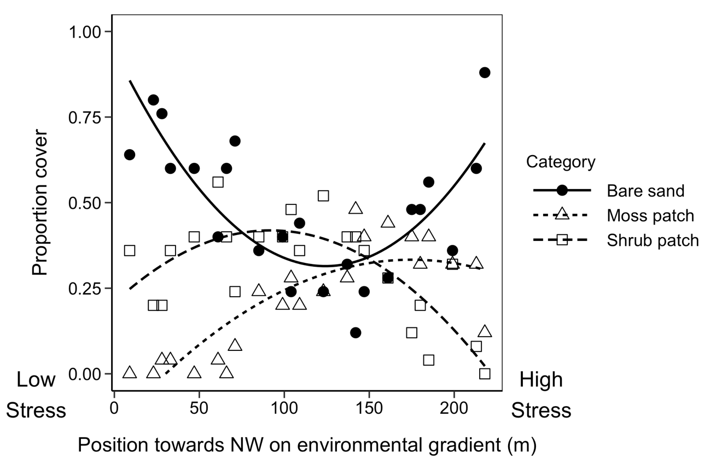**­­**

Figure 1. Point intercept cover of moss patches, bare sand and shrubs across the stress gradient. Lines show quadratic regression fitted to points to show pattern across gradient. Positions further to the right on the plot correspond to increasing environmental stress.

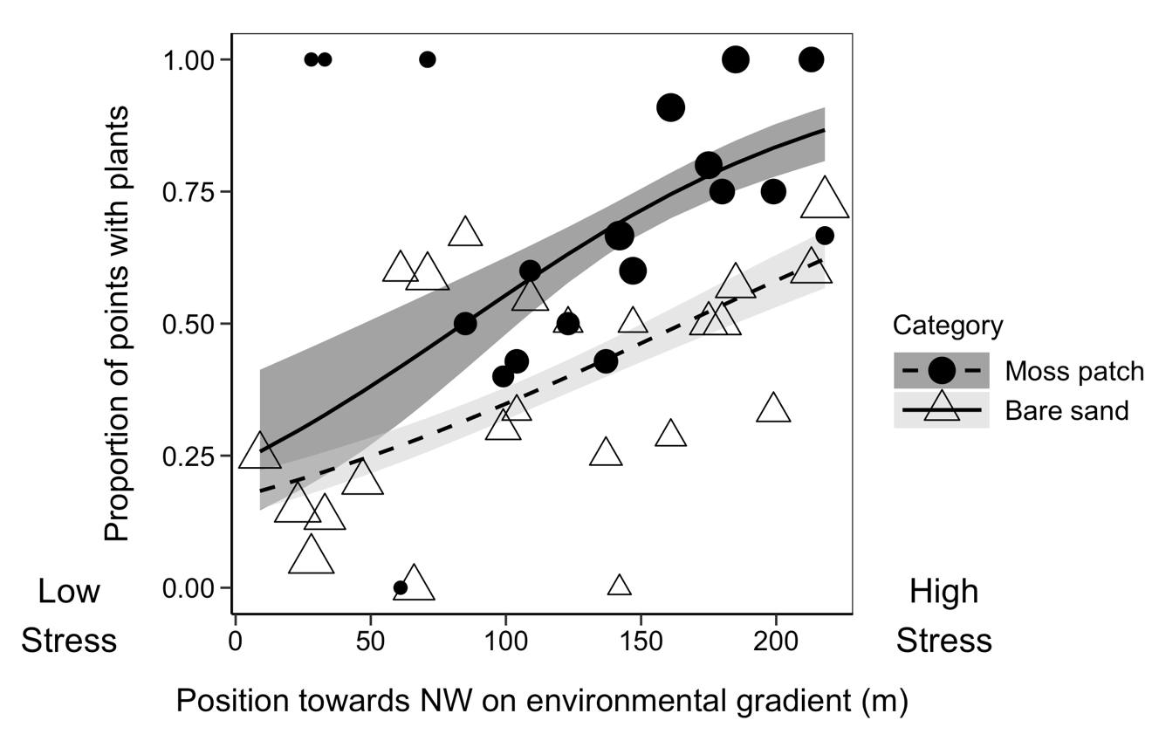

Figure 2. Frequency of all vascular plants rooted in moss patches and bare sand across the environmental stress gradient. Y-axis gives proportion of vascular plants rooted within 1 cm of sampling point. Symbol size is scaled to indicate the number of samples within each habitat at each position along the stress gradient—larger symbols indicate larger sample size. Lines and shaded areas show back-transformed means plus or minus standard error from a binomial model. Positions further to the right on the plot correspond to increasing environmental stress.

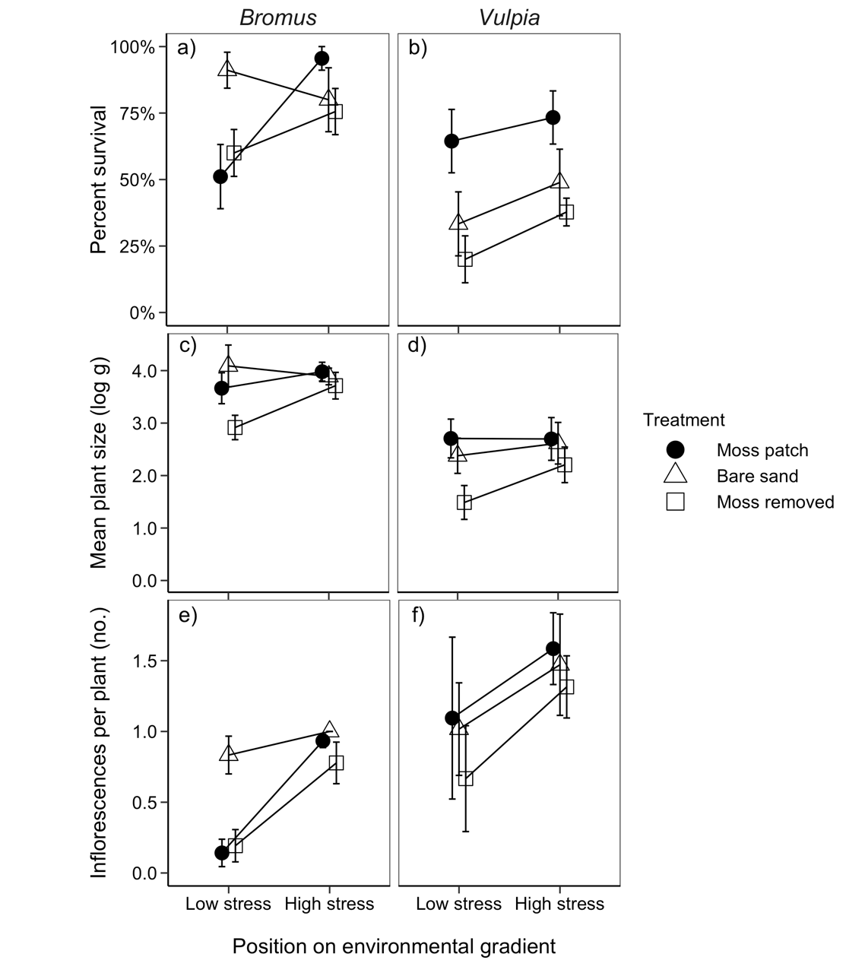

**Figure 3.** Effect of moss patches, bare sand, and moss removal treatments on the survival growth and fecundity of *Bromus* and *Vulpia* at low and high stress. A and B show the cumulative germination and survival of *Bromus* and *Vulpia* seeds planted in each patch (± S.E.). Y-axis gives the number of live plants at the end of the growing season divided by the number of seeds planted. C and D show the final size of *Bromus* and *Vulpia* plants as log-transformed average mass per plant in g (± S.E.). E and F show the number of inflorescences produced per plant for *Bromus* and *Vulpia* (± S.E.). Average inflorescence production can be less than one per plant because some plants produced no inflorescences.

**Supporting Information—Additional Figures for “Effects of Native Bryophytes on Exotic Grass Invasion: A Test of the Stress Gradient Hypothesis”**

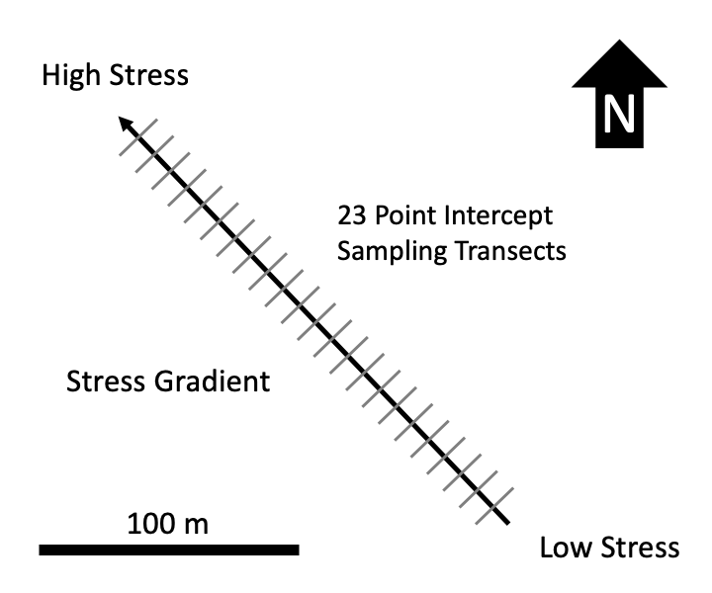

**Figure S 1** – Schematic of environmental stress gradient and observational study design. 23 20 m long transects were sampled along the length of the roughly 220 m long stress gradient, running from low stress in the SE and high stress in the NW. Experimental blocks for the moss removal experiment were located on the same gradient.

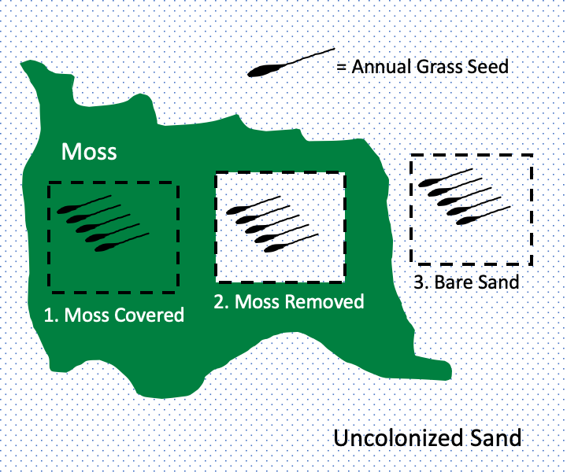

**Figure S 2** – One experimental block in the moss removal experiment. Nine experimental blocks were located at the low stress end of the gradient and nine located at the high stress end of the gradient (see Fig. S1). Each block was centered on a large moss mat moss and consisted of three experimental patches—a natural moss patch, a patch with moss removed and a bare sand patch outside of moss. Five seeds of exotic annual grasses were planted in each patch. Separate blocks were used for the two different species.

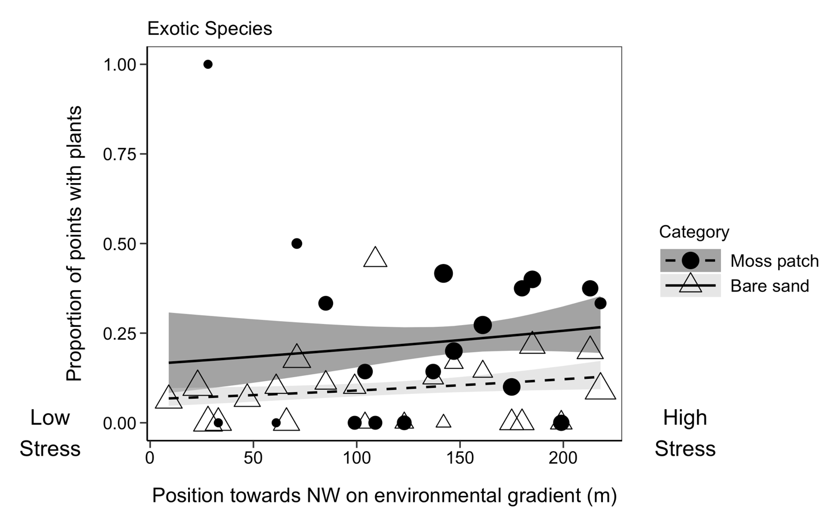

**Figure S 3** – Frequency of exotic vascular plants inside and outside of moss patches across the environmental gradient. Y-axis gives proportion of plants rooted within 1 cm of sampling point. Symbol size is scaled to indicate the number of samples within each habitat at each position along the stress gradient—larger symbols indicate larger sample size. Lines and shaded areas show back-transformed means plus or minus standard error from a binomial model. Positions further to the right on the plot correspond to increasing environmental stress.

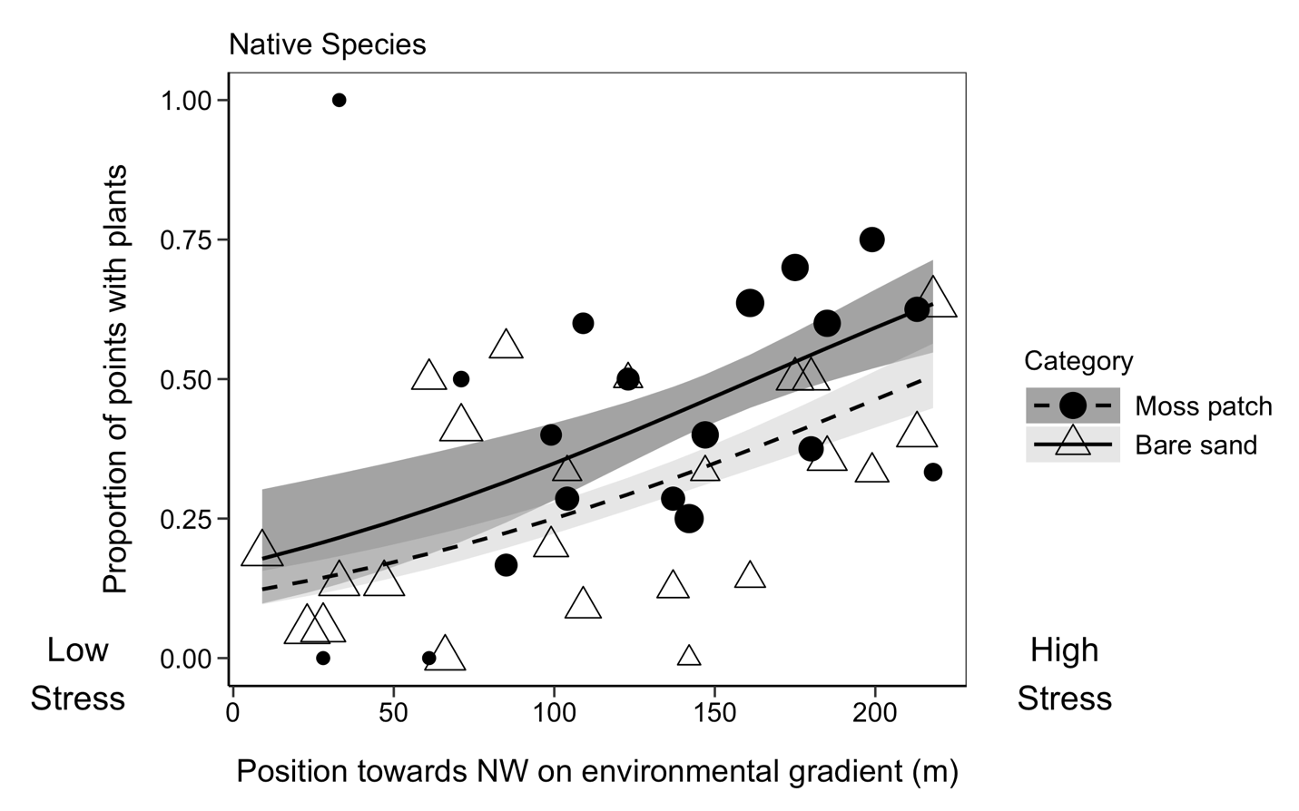

**Figure S 4** – Frequency of native vascular plants inside and outside of moss patches across the environmental gradient. Y-axis shows proportion of plants rooted within 1 cm of sampling point. Symbol size is scaled to indicate the number of samples within each habitat at each position along the stress gradient—larger symbols indicate larger sample size. Lines and shaded areas show back-transformed means plus or minus standard error from a binomial model. Positions further to the right on the plot correspond to increasing environmental stress.

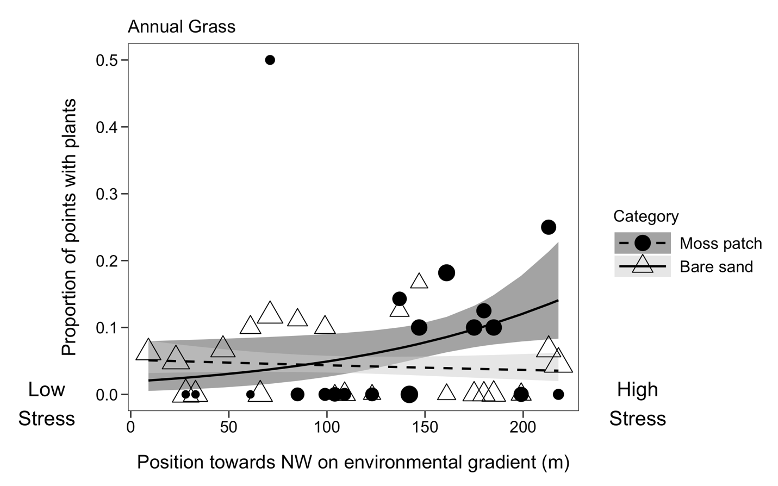

**Figure S 5** – Frequency of exotic annual grasses (both *Bromus* and *Vulpia*) inside and outside of moss patches across the environmental gradient. Y-axis shows proportion of plants rooted within 1 cm of sampling point. Symbol size is scaled to indicate the number of samples within each habitat at each position along the stress gradient—larger symbols indicate larger sample size. Lines and shaded areas show back-transformed means plus or minus standard error from a binomial model. Positions further to the right on the plot correspond to increasing environmental stress.