Running Head: Native bryophytes, exotic annual grasses and an environmental stress gradient.

**Species-Specific Effects of a Native Bryophyte on Exotic Grass Species Across an Environmental Stress Gradient**

**Andrew R. Kleinhesselink1*, & J. Hall Cushman2**

1Ecology and Evolutionary Biology Department, University of California Los Angeles, CA, USA

2Department of Natural Resources and Environmental Science, University of Nevada Reno, Reno NV, USA.

**Abstract**

Competition from native species may reduce the establishment and abundance of invasive exotic species. However, in stressful environments native species may actually facilitate exotic species invasion. Biological soil crusts are particularly common in stressful environments where vascular plant cover is low and we expect that they may be important inhibitors or facilitators of exotic plant invasion in these environments. To test the role of biological soil crusts in exotic plant invasion and whether it changes across environmental gradients, we sampled the association between vascular plants and biological soil crusts across a documented 200-m stress gradient in a coastal dune in northern California. We also used a removal experiment to test the effects of dominant native bryophytes on the germination, growth and reproduction of two exotic annual grasses (*Bromus diandrus* and *Vulpia spp.*). We found that vascular plants were more likely to be rooted within biological soil crusts than expected by chance—but this positive association did not increase across the gradient. Our removal experiment showed the effects of bryophytes to be species-specific: bryophytes facilitated *Vulpia* survival, growth and reproduction at both low and high stress environments; in contrast, bryophytes inhibited *Bromus* survival and growth at low stress but had positive effects at high stress. Our experiment adds to the growing evidence for the importance of bryophytes and other components of biological soil crusts in vascular plant population ecology. We show that even the smallest plants in a community can have a large influence on exotic species invasion.

**Key-words:** biological soil crusts, dune ecosystems, exotic species, facilitation, stress-gradient hypothesis.

# Introduction

Biological communities throughout the world are increasingly invaded by a wide range of non-native species and it is critical to understand the factors that mediate the success of these taxa in their novel environments (Kennedy et al. 2002). Environmental filtering (Kraft et al. 2014), biotic resistance (Rejmánek 1996) and the stress-gradient hypothesis (Bertness and Callaway 1994) have emerged as complementary explanations for understanding patterns in the success of exotic invasion. The environmental filtering model contrasts physical environmental conditions, such as climate and soil type, that might restrict exotic invasion with the effects of biotic interactions, such as with competitors and natural enemies (Kennedy et al. 2002, Kraft et al. 2014). Exotic species are able to invade and thrive when they can pass through abiotic filters and can cope with biotic interactions. Despite much evidence that competition can limit exotic plant invasion (Levine 2000, Kennedy et al. 2002), there are also growing numbers of examples where exotic plants are facilitated by native species (Badano et al. 2007, Griffith 2010, Cushman et al. 2011, Kleinhesselink et al. 2014). The stress-gradient hypothesis predicts that interactions between species will tend to be competitive in more physically benign or productive environments, while interactions will more commonly be positive in stressful environments (Bertness and Callaway 1994). An implication of the SGH is that it should also control how native species interact with exotics: while native taxa may restrict invasion in productive habitats, they may facilitate invasion in stressful environments (Bruno et al. 2003, Badano et al. 2007).

Studies examining the effects of competition and facilitation on exotic plant invasions have tended to focus on the effects of native species with similar functional traits and life-history to the invader (Kennedy et al. 2002, Badano et al. 2007). This focus ignores the fact that exotic plants usually interact with a much more diverse array of species during invasion. For example, deserts, coastal dunes, forest understories and arctic environments often have an abundance of non-vascular plants such as bryophytes and lichens (Belnap et al. 2001). In these environments, invasive vascular plants are likely to have significant interactions with non-vascular plants (Deines et al. 2007, Langhans et al. 2009). Despite their small stature, non-vascular plants can strongly affect the germination conditions for seeds and the availability of nutrients and water resources in the soil (Serpe et al. 2006, Langhans et al. 2009). Bryophytes and biological soil crusts have been found to be an important factor in resisting exotic species invasion, especially invasion by exotic annual grasses (Serpe et al. 2006, Morgan 2006, Deines et al. 2007, Hernandez and Sandquist 2011). Considerable efforts are now being made to protect and restore BSC cover in many environments, in part to lessen susceptibility to exotic invasion (Bowker 2007, Chiquoine Lindsay P. et al. 2016).

In contrast, the SGH predicts that soil crusts may have a positive effect on vascular plant establishment in stressful environments. Indeed, some studies have found that bryophytes can facilitate vascular plant germination, survival and growth (Rayburn et al. 2012). Nonetheless few studies have examined whether native plants shift from competing with to facilitating exotic species invasion across environmental gradients as the SGH predicts (Kleinhesselink et al. 2014), fewer still have looked specifically at whether this occurs with non-vascular plants and soil crusts. In this study, we investigate the effects of soil crusts on the local distribution of vascular plants across an environmental stress gradient and experimentally test whether they affect these species’ germination, survival, growth and reproductive output. We test four hypotheses: 1) vascular plants will be found more frequently growing in soil crust patches; 2) patches of soil crust will directly facilitate the germination and growth of exotic grasses; 3) the effects of soil crusts on germination and growth will become more positive (or less negative) across an environmental stress gradient.

# Study System

We conducted our study in a coastal dune system at Bodega Head in Sonoma County, California (38 19’ N, 123 3’ W). This area has a Mediterranean climate, receiving most of its precipitation between the fall and early spring and northwest winds blow across the site throughout the spring and summer (Barbour et al. 1973). The soil at this site is composed almost entirely of fine to coarse dune sands low in nutrients and organic matter (McNeil and Cushman 2005, Lortie and Cushman 2007, Cushman et al. 2010, Kleinhesselink et al. 2014). The study area is located between two large dune ridges that run in the direction of the prevailing winds. This site spans a gradient in soil conditions and wind speed that creates a large gradient in plant size and species composition which we refer to as a stress gradient. The details of this environmental stress gradient are thoroughly described in previous publications from this site (see Lortie and Cushman 2007; Kleinhesselink et al. 2014). Soil nitrate pools, soil water field capacity, average plant size, perennial cover, native plant cover and species richness are highest at the east or “sheltered” end of the trough and decrease towards the west or “exposed” end. Soil coarseness, wind speed, bare ground, annual plant cover and non-native plant cover also follow the gradient and are highest at the exposed end of the gradient and decrease towards the sheltered end. *Bromus diandrus* (Poaceae; hereafter referred to as a *Bromus*) and two species of *Vulpia* (*Vulpia bromoides* and *Vulpia myuros*) are common exotic annual grass species at this site and throughout coastal California. We treat the two *Vulpia* species as one taxon in our study because we were not always able to identify them to species in the field.

Bryophytes and lichens constitute an important part of the ground cover at this site. The most abundant bryophyte is *Syntrichia ruralis* [Pottiaceae] which is a large drought tolerant moss species common in seasonally dry environments across California (Malcolm et al. 2009). Other bryophytes common at this site are *Homalothecium* *arenarium* [Brachytheceae] and *Didymodon vinealis* [Pottiaceae].

# Methods

## Bryophyte patches across the dune stress gradient

We established 23 20-m transects spaced approximately 10 m apart along the 220 m long stress gradient documented by Lortie and Cushman (2007) and Kleinhesselink et al. (2014). Each transect ran perpendicular to the dune gradient. The most southeasterly transect occurred at the sheltered low stress end, and the most northwesterly transect occurred at the more exposed high stress end of the gradient. For the remainder of the paper, we refer to position along the gradient in meters away from the more sheltered southeast end of the gradient.

In order to determine cover of bryophytes across this study site and their association with the focal species of annual grass and other vascular plants we recorded bryophyte cover at 25 points randomly spaced on each of the 23 transects described above. At each point we recorded the species identity of any vascular plant rooted within 1 cm of the point.

## Bryophyte effects on Bromus and Vulpia

We established a field experiment in winter 2009/2010 to directly observe the effects of bryophyte cover on the germination, survival, growth and reproduction of both grass species. For each species we established 18 separate study blocks centered on large moss patches, almost exclusively composed of *Syntrychia ruralis*, greater than 15 cm across. Each block was established away from shrubs and other large perennial plants. Nine blocks were located at the ‘low stress’ end of the gradient and nine were located at the ‘high stress’ end of the gradient. Each block consisted of three separate patches 10 cm long and 5 cm wide. Two patches were located within a natural mat of moss. We left one of these un-manipulated, but carefully removed the moss from the other. The third patch was located next to the natural moss patch but on naturally bare sand. Within each patch we planted five seeds of the either *Vulpia* or *Bromus*. Both *Vulpia* and *Bromus* seeds have long awns on their seeds. To prevent the seeds from blowing out of the plots we glued each seed by its awn to a small piece plastic coated wire. The ends of the wire were then inserted into the sand surface and the seeds themselves lightly pressed into the sand. Each wire was 10 cm long and we glued the seeds roughly 2cm apart. Seeds of both species were collected from the field site in the fall of 2009. The *Bromus* seeds were planted in late December 2009 and the *Vulpia* seeds were planted a few weeks later in January of 2010 in separate blocks. We recorded the number of emerged plants roughly once every two weeks in each study patch starting in January 2010. Because seeds were glued to the wire in each patch we were able to easily distinguish between plants germinating from the seeds we planted and plants emerging from the natural seed bank. We weeded out all other plants emerging within the experimental patches. In May 2010, the surviving plants produced inflorescences and began to senesce. We counted the total number of plants and number of inflorescences produced in each patch and collected the aboveground biomass from all the plants. Cumulative aboveground biomass from each patch was dried at 60°C for 48 hours and weighed to the nearest milligram.

## Statistical Analyses

Each of the point-intercept sampling points along each of the 23 transect was categorized as either shrub, bare sand or moss patch, and for analysis we considered only points falling outside of shrub canopies. We used simple chi-square tests to determine whether our target grass species and vascular plants as a whole were more frequently rooted within moss patches than expected at random. We then used binomial logistic regression models to determine whether vascular plants were more associated with moss patches than expected and whether the association between plants and moss changed across the stress gradient. We modeled the probability of a vascular plant occurring at each sampling point as a function of gradient position (m away from the SE low stress end of the gradient), micro-habitat (either moss patch or bare sand) and the interaction between these two factors. We implemented the logistic regression using the ‘glm’ command in the statistical program R (R Core Team 2013). When residual deviance was greater than residual degrees of freedom, we used a quasibinomial model as recommended by Crawley (2007). We tested significance of the gradient effect, the micro-habitat effect and their interaction using analysis of deviance with F-tests using the ‘anova’ function in R.

We used a logistic binomial regression to model how environmental stress (low stress or high stress positions on the gradient) and experimental treatment (moss removed, moss patch, or bare sand) and their interaction affected the germination and survival of *Bromus* and *Vulpia*. Because we did not track individuals, our analysis focuses on the expected probability of one of the five seeds planted in each patch transitioning to an adult plant at the end of the growing season, rather than separate germination and survival rates. Treatment and stress level were set as fixed effects and the 18 experimental blocks as random grouping factors in the analysis. We fit the model with a logit link using a generalized linear mixed effects model in the lme4 package in R (Bates et al. 2015, R Core Team 2015).

We also analyzed how experimental treatments and gradient position affected the final aboveground biomass of the surviving *Bromus* and *Vulpia*. We divided the total aboveground biomass of the surviving plants in each experimental patch by the number of surviving plants to determine average individual aboveground biomass. We then log-transformed this value and analyzed it as for survival above but using a linear mixed model with normal errors.

Finally, we analyzed how the number of inflorescences produced in each patch varied with experimental treatment and position on the stress gradient using generalized linear models with quasipoisson errors. We used the number of surviving plants in each patch as an offset term in the regression so that we effectively modeled the number of inflorescences produced per plant in each patch. We fit these data using without the random block effects because models fit with the random effect failed to converge.

We used either likelihood ratio tests or F-tests to test for the significance of each of the fixed effects in the models: the interaction effect between moss treatment and gradient position, the moss treatment effect and the stress gradient position effect in that order. When there were significant treatment effects we tested for significant pairwise differences between treatments means. We adjusted for the multiple comparisons using the Šidák method in the lsmeans package in R (Lenth and HervÃ© 2015).

# Results

## Vascular plant association with moss patches across the gradient

Moss cover was low at the low stress (southeastern) end of the gradient and peaked at about 40 percent cover towards the middle of the gradient (Fig. 1). Moss cover declined as conditions became more stressful across the last 50 m of the stress gradient (Fig 1). This distribution of abundance was well described by a quadratic function of distance on the stress gradient (F2,20 = 26.5, R2 = 0.70). In contrast, bare sand was most frequent at the low stress of the gradient and the high stress end of the gradient and least frequent in the middle where moss cover was highest (Fig. 1; F2,20 = 15.9, R2 = 0.58). We found 31 different species of vascular plants rooted at 189 of the 398 non-shrub covered sampling points. *Chorizanthe cuspidata* (Polygonaceae) a small annual plant endemic to coastal dunes in California was the most frequently encountered plant species and occurred at 60 sampling points. Our target annual exotic grass species occurred at 22 sampling points: *Vulpia* at 17 and *Bromus* at five. *Bromus* and *Vulpia* together occurred at 12 of 277 bare sand points and 10 of 121 moss covered points—indicating a slight positive association with moss but this was not significant (Chi-squared test, *X*2 = 1.8, df = 1, p = 0.18). Lumping all vascular plants together, we found vascular plants rooted at 104 out of 173 bare sand points, and 85 out of 36 moss covered points, indicating a positive association with moss patches (Chi-squared test, *X*2 = 34.8, df =1, p < 0.01). When we regressed plant occurrence against position on the stress gradient, micro-habitat (moss covered or bare sand), and the interaction between micro-habitat and gradient position, we found a that the overall frequency of vascular plants increased towards the more stressful end of the gradient (F1,396 = 54.3, p < 0.01; Fig 2) and was greater within moss patches than bare sand (F1,395 = 17.8, p < 0.01). However, we did not find evidence that the positive association between moss and vascular plants changed across the gradient (stress x micro-habitat interaction; F1,394 = 0.70, p = 0.40). Similarly, exotic and native species analyzed separately both increased in frequency towards the stressful end of the gradient (exotics: F1,396 = 5.0, p = 0.03; natives: F1, 396 = 37.4, p < 0.01) and were both more common within moss patches (exotics: F1,395 = 9.2, p < 0.01; natives: F1,395 = 4.3, p = 0.04), but there was no stress by micro-habitat interaction for either group (exotics: F1,394 = 0.0, p = 0.93; natives: F1,394 = 0.0, p = 0.93).

## Effects of moss on Bromus

In the experiment, the effects of moss on *Bromus* varied with demographic rate and position on the environmental stress gradient. There was a significant treatment by stress interaction on *Bromus* survival (*X*2 = 24.8, df = 2, p < 0.01): in the low stress environment, *Bromus* had significantly greater success in bare sand patches over both moss-covered patches and patches where moss cover was removed, whereas in the high stress environment there were no significant differences between treatments (fig 3 a). Survival was also significantly greater in the high stress moss patches than within the low stress moss patches. There was no significant treatment by stress interaction effect on *Bromus* final biomass (X2 = 4.27, df = 2, p = 0.12) nor any effect of stress (*X*2 = 1.76, df = 1, p = 0.19), but biomass was significantly affected by moss treatment ( *X*2 = 7.44, df = 2, p = 0.02) with plants grown in the moss removed plots showing significantly lower final biomass than plants grown in bare sand (fig 3 c). *Bromus* final inflorescence numbers were affected by a treatment by stress gradient interaction (F1,46 = 5.35, p < 0.01): at low stress plants in bare sand produced significantly more inflorescences than plants in either moss patches or in moss removed patches, whereas at high stress there were no differences between treatment levels (fig 3 e). Plants in moss covered and moss removed patches also produced significantly more inflorescences at high stress than at low stress.

## Effects of moss on Vulpia

*Vulpia* survival was not affected by a treatment by stress interaction (*X*2 = 0.58, df = 2, p = 0.75), but there was a significant effect of moss treatment (*X*2 = 32.97, df = 2, p < 0.01): plants within moss patches had significantly greater survival than plants in bare sand or in moss removed patches (fig 3 b). There was a trend towards higher *Vulpia* survival in the higher stress environment (*X*2 = 3.59, df = 2, p = 0.06). There was no significant treatment by stress interaction effect on final *Vulpia* biomass (*X2* = 1.18, df = 2, p = 0.55), nor was there any main effect of stress gradient position (*X2* = 0.64, df = 1, p = 0.42), but there was a trend towards a moss treatment effect (*X2* = 4.97, df = 2, p = 0.08; fig 3 d). *Vulpia* inflorescence production was not affected by moss treatment (F2,40 = 0.43, p = 0.65), stress gradient position (F1,42 = 0.53, p = 0.47) nor their interaction (F2,38= 0.18, df = 2, p = 0.83; fig 3 f).

# Discussion

Our study demonstrates that native mosses can have an important influence on the occurrence, survival, growth and flower production of vascular plants and especially invasive annual grasses in this system. We found mixed support for our hypothesis that mosses would generally have a more beneficial effect on plants in the more stressful environment.

Vascular plant occurrence was positively associated with moss in this system but this association was not stronger at the more stressful end of the environmental gradient as we hypothesized (Figure 2). This result held for both native and exotic species alike. Likewise, in our moss removal experiment we found only limited support for our hypothesis that mosses would have a more positive influence on plant performance in the more stressful environment: in particular, we only observed significant interactions effects between stress gradient position and moss treatment for *Bromus* survival (Figure 3a) and *Bromus* inflorescence production (Figure 3e). In the low stress environment, *Bromus* seeds had the poorest chances of becoming adult plants when planted in moss patches, whereas in the high stress environment *Bromus* had the highest chance of becoming adult plants when planted in moss (Figure 3a). This suggests that moss patches are an important microhabitat for *Bromus* success in the more stressful environment. We also observed a gradient by treatment interaction effect on *Bromus* inflorescence production but this was less supportive of our hypothesis (Figure 3e). In the low stress environment, *Bromus* showed highest inflorescence production when planted in bare sand whereas this effect disappeared in the high stress environment (Figure 3e). In the case of the other exotic grass in this study, *Vulpia*, we found that the effect of moss treatment did not vary with environmental stress (Figure 3 b, d, f). However, we did find that moss covered patches consistently gave *Vulpia* seeds the highest probability of transitioning into adult plants (Figure 3 b). And there was a trend towards *Vulpia* plants in moss patches being larger than in other treatments (Figure 3 d).

We had expected that the exotic annual grasses in this system would have their performance limited at the more stressful end of the gradient. Instead, we found that *Bromus* and *Vulpia* sometimes performed better at the high stress end of the gradient (Figure 3). This suggests that despite the clear changes in physical properties across this gradient, including higher wind speeds, and coarser and drier soils (Lortie and Cushman 2007 and Kleinhesselink et al. 2014) and a strong decrease in shrub cover (Figure 1), that the high stress portion of this gradient may not actually be stressful for these annual exotic grasses. We note also that plant density tends to increase towards the stressful end of the gradient as well (Figure 2), but this increase in density actually reflects a decrease in plant size and height (Kleinhesselink et al. 2014). This result runs counter to the hypothesis that exotic species could be limited from particularly stressful environments within landscapes because they lack specialized adaptations needed to tolerate the local stresses (Harrison 1999). Instead, our finding supports the idea that stressful environments can sometimes be more easily invaded by exotic plants, perhaps because it offers opportunity to escape competition from more dominant competitors (MacDougall et al. 2006). Our study adds an extra component to this hypothesis, by showing that performance at high stress is not merely a balance of environmental effects and competition, but also reflects some facilitation of the exotic species by the native species (Badano et al. 2007)—in this case bryophytes and lichens that make up the biological soil crusts.

We also expected that physically removing moss from treatment patches would undo the effects of mosses and produced effects similar to bare sand. However, for *Bromus* survival and inflorescence production in low stress, and we actually found significant differences between bare sand patches and moss removed patches, while we found no differences between moss patches and moss removed patches (Figure 3a,e). These differences are especially notable because they are among the largest treatment effects in our study. This pattern suggests that the environment created by our removal treatment was somehow different from bare sand. We speculate that this effect could be due to some residual influence of moss in these patches. In particular, recent studies have shown that Bryophytes may inhibit germination and root growth of some vascular plants through allelopathy (Michel et al. 2011).

Our results from an experimental study over a local stress gradient, demonstrate that the stress gradient hypothesis is not predictive of the direction of species interactions in all cases or for all stages in a plant’s life cycle. Our results, however, do suggest that increased bryophyte cover could lead to greater *Vulpia* and *Bromus* invasion in more stressful areas of this dune. In contrast, in less stressful areas, our results indicate that bryophyte cover may reduce *Bromus* performance. Taken at face value, this is a challenge for applying the results of this study to manage species invasion in this system: mosses may be detrimental to the goal of reducing species invasion in some parts of the environment but not others (Bowker 2007).

# Conclusion:

Native biodiversity plays a critical role in controlling exotic species invasion. We demonstrate that this effect extends to native bryophytes and lichens of biological soil crusts. Moreover, we found the effects of these plants on exotic annual grass establishment depended on environmental context and the vital rate being measured. Our results support the SGH for one exotic grass, but not for the other species. Bryophytes and biological soil crusts may play an important role in either facilitating or limiting vascular plant invasion in stressful environments and their effects on vascular plants should more often be considered in conservation and restoration of native vegetation (Chiquoine Lindsay P. et al. 2016).

# Acknowledgements

We are grateful for Susan Magnoli’s help in the field. Jackie Sones of the UC Davis Bodega Marine Reserve provided valuable logistical support. We are very grateful for the support and encouragement of the members of the Milo Baker Chapter of the California Native Plant Society. Research support was provided by grants from the California Native Plant Society, Northern California Botanists, Sigma Xi, Sonoma State University and the National Science Foundation (DEB-9981663 to J.H.C.).

# References

Badano, E. I., E. Villarroel, R. O. Bustamante, P. A. Marquet, and L. A. Cavieres. 2007. Ecosystem engineering facilitates invasions by exotic plants in high-Andean ecosystems. Journal of Ecology 95:682–688.

Barbour, M. G., C. RB, D. FR, and G. MT. 1973. Coastal ecology: Bodega Head. University of California Press, Berkeley.

Bates, D., M. Mächler, B. Bolker, and S. Walker. 2015. Fitting Linear Mixed-Effects Models Using lme4. Journal of Statistical Software 67:1–48.

Belnap, J., B. Büdel, and O. L. Lange. 2001. Biological Soil Crusts: Characteristics and Distribution. Pages 3–30 *in* P. D. J. Belnap and P. D. D. h c O. L. Lange, editors. Biological Soil Crusts: Structure, Function, and Management. Springer Berlin Heidelberg.

Bertness, M. D., and R. Callaway. 1994. Positive interactions in communities. Trends in Ecology & Evolution 9:191–193.

Bowker, M. A. 2007. Biological soil crust rehabilitation in theory and practice: An underexploited opportunity. Restoration Ecology 15:13–23.

Bruno, J. F., J. J. Stachowicz, and M. D. Bertness. 2003. Inclusion of facilitation into ecological theory. Trends in Ecology & Evolution 18:119–125.

Chiquoine Lindsay P., Abella Scott R., and Bowker Matthew A. 2016. Rapidly restoring biological soil crusts and ecosystem functions in a severely disturbed desert ecosystem. Ecological Applications 26:1260–1272.

Cushman, J. H., C. J. Lortie, and C. E. Christian. 2011. Native herbivores and plant facilitation mediate the performance and distribution of an invasive exotic grass. Journal of Ecology 99:524–531.

Cushman, J. H., J. C. Waller, and D. R. Hoak. 2010. Shrubs as ecosystem engineers in a coastal dune: influences on plant populations, communities and ecosystems. Journal of Vegetation Science 21:821–831.

Deines, L., R. Rosentreter, D. J. Eldridge, and M. D. Serpe. 2007. Germination and seedling establishment of two annual grasses on lichen-dominated biological soil crusts. Plant and Soil 295:23–35.

Griffith, A. B. 2010. Positive effects of native shrubs on Bromus tectorum demography. Ecology 91:141–154.

Harrison, S. 1999. Native and alien species diversity at the local and regional scales in a grazed California grassland. Oecologia 121:99–106.

Hernandez, R. R., and D. R. Sandquist. 2011. Disturbance of biological soil crust increases emergence of exotic vascular plants in California sage scrub. Plant Ecology 212:1709.

Kennedy, T. A., S. Naeem, K. M. Howe, J. M. H. Knops, D. Tilman, and P. Reich. 2002. Biodiversity as a barrier to ecological invasion. Nature 417:636–638.

Kleinhesselink, A. R., S. M. Magnoli, and J. H. Cushman. 2014. Shrubs as ecosystem engineers across an environmental gradient: effects on species richness and exotic plant invasion. Oecologia 175:1277–1290.

Kraft, N. J. B., P. B. Adler, O. Godoy, E. C. James, S. Fuller, and J. M. Levine. 2014. Community assembly, coexistence and the environmental filtering metaphor. Functional Ecology:n/a-n/a.

Langhans, T. M., C. Storm, and A. Schwabe. 2009. Biological soil crusts and their microenvironment: Impact on emergence, survival and establishment of seedlings. Flora - Morphology, Distribution, Functional Ecology of Plants 204:157–168.

Lenth, R. V., and M. HervÃ©. 2015. lsmeans: Least-Squares Means.

Levine, J. M. 2000. Species Diversity and Biological Invasions: Relating Local Process to Community Pattern. Science 288:852–854.

Lortie, C. J., and J. H. Cushman. 2007. Effects of a directional abiotic gradient on plant community dynamics and invasion in a coastal dune system. Journal of Ecology 95:468–481.

MacDougall, A. s., J. Boucher, R. Turkington, and G. e. Bradfield. 2006. Patterns of plant invasion along an environmental stress gradient. Journal of Vegetation Science 17:47–56.

McNeil, S. G., and J. H. Cushman. 2005. Indirect effects of deer herbivory on local nitrogen availability in a coastal dune ecosystem. Oikos 110:124–132.

Michel, P., D. J. Burritt, and W. G. Lee. 2011. Bryophytes display allelopathic interactions with tree species in native forest ecosystems. Oikos 120:1272–1280.

Morgan, J. W. 2006. Bryophyte Mats Inhibit Germination of Non-native Species in Burnt Temperate Native Grassland Remnants. Biological Invasions 8:159–168.

R Core Team. 2015. R: A Language and Environment for Statistical Computing. R Foundation for Statistical Computing, Vienna, Austria.

Rayburn, A. P., J. B. Davidson, and H. M. White. 2012. Possible Effects of Moss on Distribution and Performance of a Threatened Endemic Primrose. Western North American Naturalist 72:84–92.

Rejmánek, M. 1996. Species Richness and Resistance to Invasions. Pages 153–172 *in* P. D. G. H. Orians, P. D. R. Dirzo, and P. D. J. H. Cushman, editors. Biodiversity and Ecosystem Processes in Tropical Forests. Springer Berlin Heidelberg.

Serpe, M., J. Orm, T. Barkes, and R. Rosentreter. 2006. Germination and seed water status of four grasses on moss-dominated biological soil crusts from arid lands. Plant Ecology 185:163–178.

# FIGURE LEGENDS

Figure 1. Point intercept cover of moss patches, bare sand and shrubs across the stress gradient. Lines show quadratic regression fitted to points to show pattern across gradient. Positions further to the right on the plot correspond to increasing environmental stress.

Figure 2. Occurrence of vascular plants in moss patches and bare sand across the stress gradient. Y-axis gives probability of a vascular plant rooted within 1 cm of sampling point. Symbol size is scaled to indicate the number of samples within each habitat at each position along the stress gradient—larger symbols indicate larger sample size. Lines and shaded areas show back-transformed means ± standard error from a binomial model. Positions further to the right on the plot correspond to increasing environmental stress.

Figure 3. Effect of moss patches, bare sand, and moss removal treatments on the survival growth and fecundity of *Bromus* and *Vulpia* at low and high stress. Upper row (panels a and b) show the cumulative germination and survival of *Bromus* and *Vulpia* seeds planted in each patch (± S.E.). Y-axis gives the number of live plants at the end of the growing season divided by the number of seeds planted. Middle row (panels c and d) shows the final size of *Bromus* and *Vulpia* plants as log-transformed average mass per plant in g (± S.E.). Bottom row (panels e and f) shows the number of inflorescences produced per plant for *Bromus* and *Vulpia* (± S.E.). Average inflorescence production can be less than one per plant because some plants produced no inflorescences.

# FIGURES

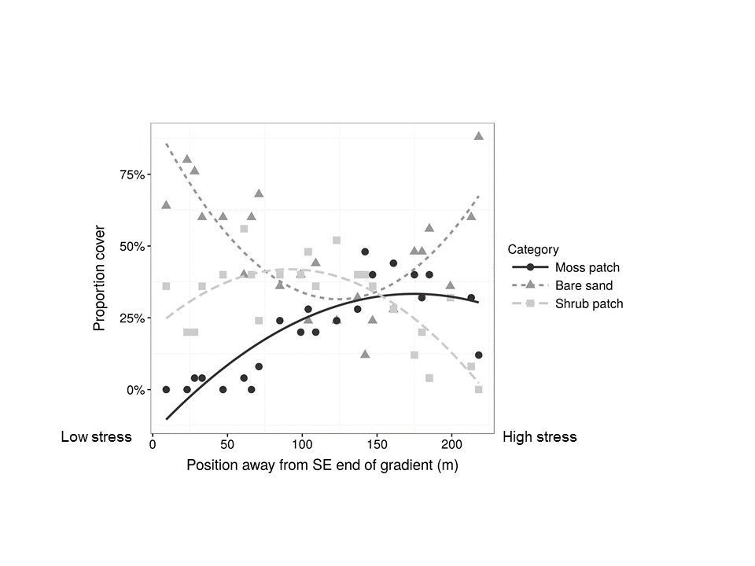

Figure 1.

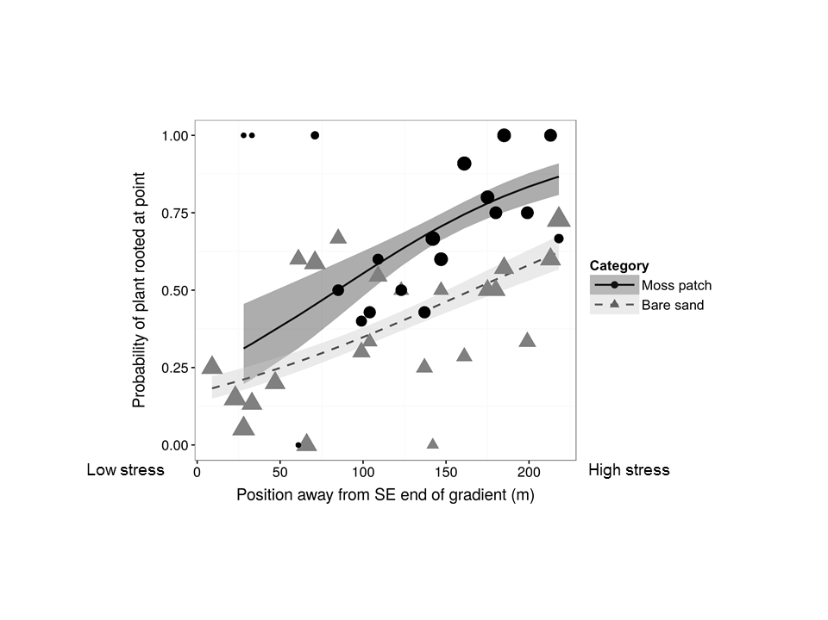

Figure 2.

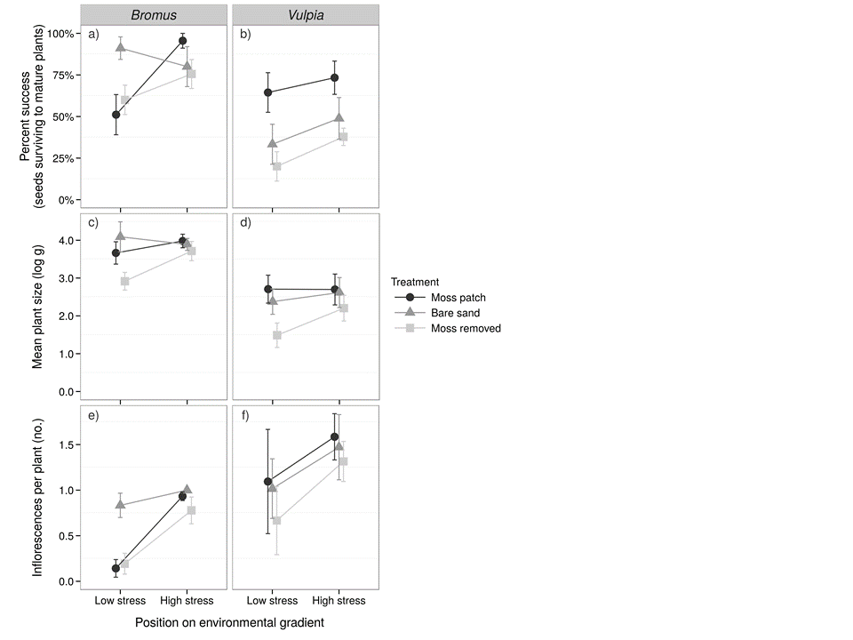

Figure 3.