**Target Journal: Journal of Applied Ecology**

**Title:** Mitigating rangeland ecosystem service tradeoffs in riparian areas by managing grazing duration and timing

**Paper Type:** Research article

**Authors:** Kristin B. Hulvey a,b,c, Cassie Mellon d, Andrew R. Kleinhesselinke

a Working Lands Conservation, Logan, UT, 84341, U.S.A.

b Department of Wildland Resources, Utah State University, Logan, UT, 84322, U.S.A

c The Ecology Center, Utah State University, Logan, UT, 84322, U.S.A.

d Bureau of Land Management, West Valley City, UT, 84119, U.S.A.

e Department of Ecology and Evolutionary Biology, UCLA, Los Angeles, CA, 90095, U.S.A.

**\***Corresponding author: Kristin B. Hulvey, Working Lands Conservation, 1460 E 1220 N, Logan, UT, 84322, kris@workinglandsconservation.org

**Abstract**

1. Finding solutions to ecosystem service tradeoffs is a key management goal in locations where stakeholders value different, and potentially conflicting, services. However, studies are not often designed to examine how different management actions address ecosystem service tradeoffs, and therefore do not provide options that can mitigate conflict.

2. In semi-arid rangelands, we examined the potential for managers to mitigate tradeoffs between livestock production and water quality. To move away from solutions that offer cattle removal as a singular management strategy, we examined how cattle presence, plus two elements of rotational grazing - the length of time cattle spend on rangeland (i.e., duration), and the season grazed (i.e., timing), affected stream *E. coli* concentrations. We also modeled how grazing duration and timing affected the ability to meet regulatory benchmarks for water quality throughout a grazing season.

3. Grazing duration controlled the length of time *E. coli* concentrations were high in streams. In short- and medium-duration systems, *E. coli* concentrations were high for shorter periods of time than in long-duration systems, resulting in fewer violations of national and state water quality standards.

4. Stream *E. coli* concentrations showed a consistent seasonal pattern, starting with lower concentrations in spring, peaking in summer, and declining towards fall. As a result, grazing during the spring or fall, rather than summer, reduced the number of days that E. coli levels exceeded water quality standards.

5. Our results suggest that reducing the duration of grazing period and shifting its timing may be effective strategies to mitigate water quality impacts without entirely removing cattle from rangeland streams.

6. Synthesis and applications. In this study, mitigating tradeoffs between cattle grazing and stream water quality required knowledge of how different management options affected *E. coli* levels in streams throughout the grazing season. We found that managing both grazing duration and timing could limit ecosystem service conflicts. Ultimately, incorporating gradients of timing and duration into grazing studies will support the development of management options able to balance livestock grazing with water quality in rangelands.

**Keywords:** ecosystem service, *Escherichia coli*, rangeland management, riparian, semi-arid rangeland, rotational grazing, tradeoff, water quality

**Introduction**

Ecosystem managers increasingly seek to balance the production of multiple ecosystem services across landscapes in order to address the values and needs of various stakeholder groups (Bennett, Peterson & Gordon 2009; Guerry *et al.* 2015; Yahdjian, Sala & Havstad 2015). This is a departure from historical ecosystem management, which often focused on producing high-levels of single services – such as crop or livestock production, at the expense of services not directly tied to human profit, such as water provision or species habitat quality (Millennium Ecosystem Assessment 2005; Bennett & Balvanera 2007). Managing for multiple services, however, is challenging (Rodriguez *et al.* 2006; Raudsepp-Hearne, Peterson & Bennett 2010). In particular, tradeoffs between services can arise when management actions that maximize one service disrupt ecological processes that support another (Bennett, Peterson & Gordon 2009).

One approach to obtain a balanced supply of multiple services across landscapes is to map ecosystem service production using observational datasets or biophysical landscape features, and then segregate land use according to production potential (Goldstein *et al.* 2012; Zheng *et al.* 2016). Rather than mitigate tradeoffs that arise from management, this approach subdivides the landscape into areas that maximize single ecosystem services. The Nature Conservancy and the Natural Capital Project have used ecosystem service mapping to designate reserve boundaries, choose target locations for carbon sequestration investment, and guide development plans (Chan *et al.* 2006; Nelson *et al.* 2009; Arkema *et al.* 2015). Similarly, US federal agencies such as the Bureau of Land Management (BLM) employ special planning designations for specific uses such as recreation areas, wilderness areas, or areas of critical environmental concern to ensure land will be managed for particular purposes (US Department of the Interior 2019).

An alternative approach to provide multiple ecosystem services in a landscape is to modify current management so that actions focused on production of one ecosystem service do not diminish the provision of other target services (Bennett, Peterson & Gordon 2009). Altering management rather than segregating landscapes may be desirable when target ecosystem services are generated in the same location on landscapes, i.e., ecosystem service hotspots (Turner, Donato & Romme 2013) and when these key locations are limited. Discovering management solutions requires an understanding of how a range of possible actions influence ecosystem functioning and the resulting service provision (Bennett, Peterson & Gordon 2009; Cardinale *et al.* 2012).

An example of multi-use landscapes where ecosystem service tradeoffs commonly occur are rangelands (Bestelmeyer & Briske 2012). These areas are estimated to comprise 40-50% of the earth’s ice-free land surface (Sala *et al.* 2017). A major use of the worlds rangelands is to support human livelihoods via livestock production (Yahdjian, Sala & Havstad 2015; York, Brunson & Hulvey 2019). However, as the global population continues to grow, people increasingly expect rangelands to supply additional ecosystem goods and services such as sustained water supplies, habitat for wildlife, and carbon sequestration (Bennett & Balvanera 2007; Havstad *et al.* 2007; Ferranto *et al.* 2011; Huntsinger & Oviedo 2014; Sala *et al.* 2017).

Clean water for recreation, drinking, and wildlife habitat has long been recognized as both a priority in rangeland management (Havstad *et al.* 2007; Utah Department of Environmental Quality 2018b) and an ecosystem service that faces negative tradeoffs with livestock production (Belsky, Matzke & Uselman 1999; George *et al.* 2011; Pogue *et al.* 2018). This is particularly true in semi-arid rangelands where the riparian areas that influence water quality are both limited in scope and heavily used by livestock (Kauffman & Krueger 1984; Bailey & Brown 2011; Swanson, Wyman & Evans 2015). Ecosystem service tradeoffs arise from livestock disturbance such as direct deposition of wastes into streams (George *et al.* 2011) and resuspension of nutrients and fecal bacteria accumulated in stream sediment (Stephenson & Rychert 1982). Grazing or trampling of stream-side vegetation can further reduce water quality by decreasing the buffering capacity of this vegetation (Tate *et al.* 2006; Pogue *et al.* 2018).

A common way to address such tradeoffs, particularly on public lands, is to remove cattle from riparian areas either by reducing herd size or removing cattle completely (Banner, Baldwin & Leydsman McGinty 2009; Briske *et al.* 2011). While these solutions can improve range condition and water quality (Briske *et al.* 2011), they do not successfully mitigate the ecosystem service conflict for all stakeholders. Rather, reduced cattle numbers and resulting declines in livestock earnings can have negative effects on ranching livelihoods (Boies 2017).

A different solution is to consider how grazing practices can mitigate tradeoffs. One such practice is rotational grazing, which allows managers to control livestock disturbance through controlling the length of time cattle spend on rangeland (i.e. duration), and the period within a season when grazing occurs (i.e. timing) (Mosley *et al.* 1997; Swanson, Wyman & Evans 2015). Managing duration and timing has the potential to reduce livestock disruption of ecosystem processes that contribute to water quality, such as growth and recovery of stream-side plants (Belsky, Matzke & Uselman 1999; Swanson, Wyman & Evans 2015). Controlling these factors can also mitigate direct effects of cattle disturbance in riparian areas such as fecal deposition into water or instream trampling (Belsky, Matzke & Uselman 1999).

Despite rotation’s potential to mitigate ecosystem service tradeoffs, grazing studies are not often designed to examine rotation’s effects on ecosystems. For example, studies rarely include gradients of grazing duration (e.g., short, medium, long grazing periods) or timing (early season, late season) that would allow researchers to link livestock disturbance to changes in ecosystem processes and services (Briske *et al.* 2008; Briske *et al.* 2011). In addition, few studies examine how duration and timing contribute to the generation of non-livestock-based ecosystem services such as water quality (Briske *et al.* 2011; Bestelmeyer & Briske 2012; Fuhlendorf *et al.* 2012).

To address this gap, we examined how two elements of rotational grazing – i.e.: grazing duration and timing – affect water quality in semi-arid rangelands. We targeted *Escherichia coli* (*E. coli*), a common fecal bacteria, as our water quality metric because it is often used as an indicator for pathogenic bacteria that can negatively affect human health in waterbodies and is a common management focus on rangelands (Belsky, Matzke & Uselman 1999; EPA 2012; Utah Department of Environmental Quality 2018a). We examine the livestock disturbance-water quality relationship via gradients of grazing duration and timing rather than via simplistic comparisons of water quality in areas where cattle are present versus absent. Because of this, we highlight management solutions that are not commonly advocated in the grazing literature. In particular, our results provide an example of how grazing duration and timing can be used as tools to manage water quality in rangeland streams and to mitigate this ecosystem service tradeoff.

**Methods**

This study included twelve rangeland streams located across over 40,000 ha of public and private rangelands in Rich County, northeastern Utah (41° 24’ N; 111° 13’ W) sampled from 2016-2018. The area is semi-arid sagebrush-steppe at an elevation of ~1915m. Riparian areas are located in shrub-dominated rangelands consisting of Wyoming big sagebush (Artemisia tridentata ssp. wyomingensis), low rabbitbrush (*Chrysothamnus viscidiflorus*), plus native and non-native grasses and forbs. Riparian corridors contain distinct vegetation, including Nebraska sedge (*Carex nebrascensis*), Sandberg’s bluegrass (Poa secunda), and rush (juncus spp.). Annual precipitation is 25 - 35 cm and temperatures vary between -9°C in winter to 17.3°C in summer (U.S. Climate Data 2020).

Grazing treatments included: **continuous-turnout** (long-duration, no rotation), **deferred-rotation** (medium-duration, with rotation), and **time-controlled rotation** (short-duration, frequent rotation). The first two of these are common in this Utah region, the third is used less often. Long durations ranged from 82-138 days, medium durations from 31-81 days, and short durations from 1-30 days. Timing for continuous-turnout spanned most of the grazing season (mid-May through mid- September). For deferred-rotation, grazing began across a range of timings including mid-May, mid-June, early July, and mid-July. For time-controlled rotation, grazing timing ranged anywhere from spring through fall. All sites were grazed with beef cattle cow-calf pairs. Stocking densities were 0.75 - 1.78 pairs · ha-1 in time-controlled areas, 0.11 – 0.38 in deferred-rotation, and 0.03 - 0.09 pairs· ha-1 in continuous-turnout areas. These equated to stocking rates of 0.033 – 0.104, 0.002 – 0.007, and 0.0002 – 0.001 pairs · ha-1 · day-1 respectively.

Streams span seven pastures on public grazing allotments managed by the Bureau of Land Management (BLM) and two pastures on a private ranch. All streams are small wadable tributaries in the Bear Watershed chosen based on their perennial designation and their location in areas managed via one of the three targeted grazing systems.

*E. coli* regulatory benchmarks in Utah are set by the Utah Division of Water Quality (DWQ) and vary by a stream’s beneficial use classification (Utah Department of Environmental Quality 2018a). All streams included in this study are classified as infrequent primary contact recreation (2b), which for single-sample based monitoring methods have a water quality benchmark of 668 Most Probable Number (MPN) of *E. coli* colony forming units ·100 ml-1. To meet Utah DWQ regulations, no more than 10% of samples collected throughout the recreation season (May 1 - Sept 30) can exceed this benchmark (Utah Department of Environmental Quality 2018a).

We also include US Environmental Protection Agency (EPA) *E. coli* benchmarks in our analysis. The EPA does not regulate water pollution from non-point sources such as livestock grazing, but does recommend thresholds that pollutants should remain below for health reasons (US EPA 2018). These benchmarks include 320 and 410 colony forming units (cfu) 100 · ml-1 for single water grab samples (EPA 2012).

Data collection

We measured stream *E. coli* levels over three years in rangelands employing our target grazing treatments (**Table S1**). We sampled every two to three weeks from May through October/early November, a timeframe that encompasses the grazing and recreation season in this area of Utah. By sampling twice per month, we were able to capture fluctuating *E. coli* levels as cattle moved in and out of pastures.

We collected water grab samples according to Utah DWQ’s Standard Operating Procedures for collection and handling of *E. coli* samples (Utah Department of Environmental Quality 2014a; Utah Department of Environmental Quality 2014b). At each site, we collected 100 mL grab samples from flowing stream channels in sterile jars, which we stored on ice. We analyzed samples within eight hours of collection using the Idexx *E. coli* Quanti-Tray 2000 System (Westborook, MA), adding pre-packaged Colilert reagent to jars, sealing reagent mixture into analysis trays, and incubating samples at 35ºC for 18 - 28 hours. *E. coli* concentrations were identified as most probable number (MPN) of colony forming units per 100 ml via florescence under a UV light. The Quanti-Tray System can detect *E. coli* concentrations up to a maximum concentration of 2419.6 MPN without dilution. We did not dilute samples because this value is above all regulatory benchmark values. MPN values gained via the Idexx Quanti-tray 2000 method are considered interchangeable with the EPA’s ‘colony forming units’ (cfu) values generated via standard filter methods (Kinzelman et al. 2005).

Statistical analyses

We used general additive mixed-effects models (GAMMs) to analyze the effects of grazing rotation treatment and cattle presence on *E. coli* levels in streams over three grazing seasons (**Table S1**). Plotting the timeseries of *E. coli* levels in each stream showed a strong effect of cattle presence and also a marked seasonal pattern of *E.* *coli* levels increasing in summer and decreasing towards fall (**Fig. 1**). In each model, we accounted for this seasonal variation and the autocorrelated nature of the *E. coli* measurements by adding a smoother term fit to day-of-year (Zuur et al. 2009). Our most complex model (model “1”) included cattle presence and rotation scheme (time-controlled, deferred-rotation, continuous-turnout) as fixed effects and treatment specific smoother functions for day of year (**Table 1**). We compared this to simpler models without fixed effects for cattle and or rotation treatment and without treatment specific smoothing terms. To match the hierarchical nature of the study design, we included random intercepts for each stream, pasture, and year combination and for each stream. We fit GAMM models using the ‘gamm4’ package in R (version 3.4.1; R Development Core Team 2017). We log10 transformed *E. coli* concentration prior to analyses. Our analytical method could only measure *E. coli* levels up to a maximum concentration of 2419.6 MPN. This likely causes our model to underestimate true *E. coli* levels near or above this threshold.

We compared candidate models with different fixed effects and smoothing terms based on Akaike Information Criteria (AIC) and choose the model with the lowest AIC value for further analysis. We considered models with AIC scores within four points as equivalent in fit (Burnham and Anderson 2004). We used *F*-tests to evaluate the strength of fixed effects in the selected model and used the Kenward-Rogers method to approximate the denominator degrees of freedom (Halekoh & Højsgaard 2014).

To visualize the effects in our top model, we generated predictions from this model for generic grazing schedules representative of each of the three rotation schemes. In each representative grazing season, cattle were turned out on day of year 150. In the continuous-turnout treatment, cattle were taken off on day of year 270 (duration = 120 days), in the deferred-rotation treatment cattle were taken off on day of year 200 (duration = 50 days) and in the time-controlled rotation treatment cattle were taken off on day of year 170 (duration = 20 days). The model predictions for these representative grazing scenarios allowed us to compare seasonal changes in *E. coli* across the three grazing treatments while accounting for the influence of other factors. In addition, we used 10000 Monte Carlo simulations to generate daily *E. coli* predictions from the top model for a representative grazing seasons in each rotation treatment. From these simulated data, we then found the median and 95% confidence intervals for number of days per year that *E. coli* levels exceeded EPA and Utah DWQ benchmarks for stream water quality.

**Results**

Across all streams and years, *E. coli* levels were higher when cattle were present and showed a consistent seasonal pattern, starting low in spring, peaking in summer, and declining towards fall (**Fig. 1**). Model comparison revealed that including both grazing treatment and cattle presence/absence effects was supported by AIC (**Table 1**). The most complex model (model “1”) with separate smoother functions for each of the three treatment levels had the lowest AIC score. However, a simpler model—hereafter referred to as “***model 2***”—with one smoothing function applied to all grazing treatments used fewer degrees of freedom and had a nearly identical AIC score (**Table 1**). We selected this more parsimonious model for subsequent analyses and predictions (**Table S2**).

The top model (model 2) showed that stream *E. coli* levels were significantly elevated when cattle were present in the pasture (*F*1,327.0 = 49.6, *p* << 0.001, Kenward-Rogers approximation). We found a much weaker but still significant effect of grazing treatment (*F*2,9.5 = 4.3, *p* < 0.05, Kenward-Rogers approximation). Raw *E. coli* concentrations further varied according to day-of-year during the grazing season as captured by the smoothing term in the model.

conduct pairwise comparisons ofthe three these s, and used the delta method to **(Fig. 3).** We judgedthat wereidBy this criteria, t

*E. coli* exceedances of regulatory thresholds based on grazing duration and timing

Over the course of the study, 50% of daily *E. coli* measurements in the continuous-turnout treatment exceeded the Utah Division of Water Quality benchmark of 668 MPN. This contrasted with 22% of days for the deferred-rotation and only 14% of days for the time-controlled rotation (**Fig. 4**). The daily predictions generated from the top GAM showed a similar pattern among grazing treatments, but in each case the predicted proportion of days was lower than the observed proportion of days exceeding the Utah benchmark. Nevertheless 95% confidence intervals around the predictions included the observed values for each treatment (**Fig. 4**).

Because of the seasonal effect on daily *E. coli* concentrations, the number of days that *E. coli* exceeds thresholds depends somewhat on the start of the grazing period. For example, in our representative scenario shown in Fig 2, grazing starts on day 150, however, if this is pushed later in the year the number of days exceeding the thresholds will increase. We explored the impact of changing the grazing schedule and present a range of values for number of days exceeding each threshold for each treatment in a **R shiny app** posted online **(**<https://beautiful.shinyapps.io/Grazing-Windows/>).

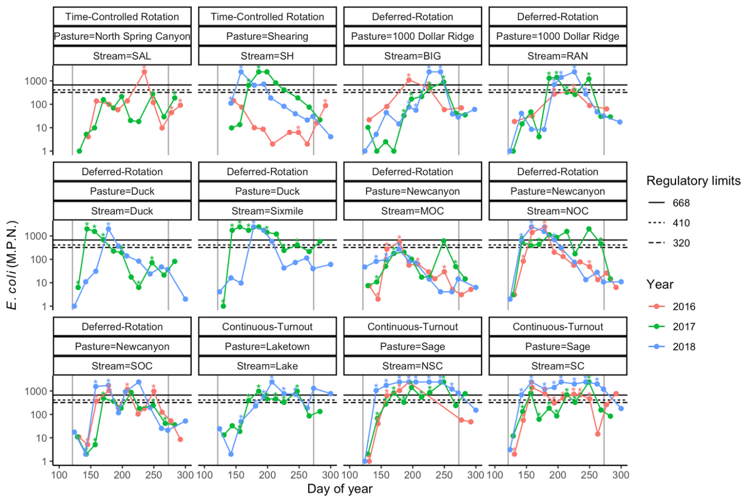

**Figure 1.**  Seasonal variation in E. coli levels in each of the 12 streams across three separate years of measurement. E. coli concentrations are shown on the y-axis (log10 scale) with day of year on the x-axis. Each panel shows data for a separate grazing treatment (“time-controlled rotation”, “deferred-rotation”, and “continuous-turnout”), pasture, and stream. Dates when cattle were present are indicated with an asterisk (*) above that point. Vertical gray lines indicate the beginning and end of the recreational water quality season. Note that our analytical method could only reliably measure E. coli up to 2419.6 MPN.

**Table 1.** Description of fixed effects in six candidate models fitted to stream E. coli data. Additive smoothing terms “s” were included as a function of day of year (DOY). Separate smoothing terms were fit for each of the treatments in models “1” and “3”. All models included the same random effects structure. We choose model “2” for subsequent analyses and predictions.

**Model Fixed effects DF logLink AIC Random effects**

1 ~ treatment + cattle + s(DOY, by=treatment) 13 -339.2 704.5 ~(1 | year:stream:pasture) + (1 | stream)

2 **~ treatment + cattle + s(DOY) 9 -343.7 705.3 same**

4 ~ cattle + s(DOY) 7 -473.7 709.4 same

5 ~ treatment + s(DOY) 8 -367.2 750.3 same

Null ~ treatment + s(DOY), by=treatment) 12 -368.3 760.7 same

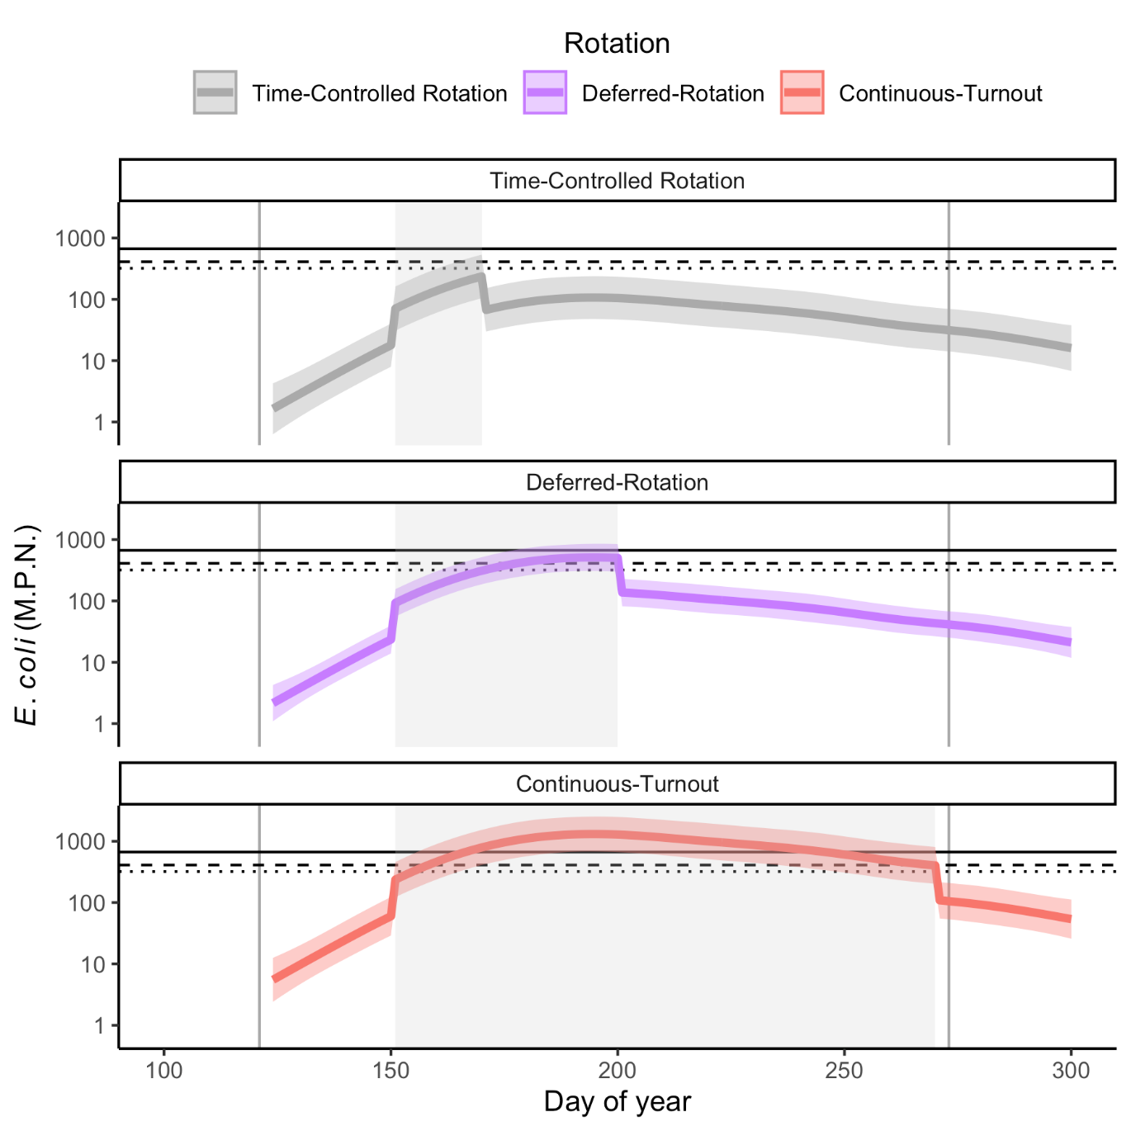

**Figure 2.** Predicted *E. coli* levels by day of year for representative grazing schedules in the “time-controlled rotation”, “deferred-rotation”, and “continuous-turnout” treatments. Solid colored lines show predicted mean E. coli concentrations with shaded areas showing one standard error around the mean. Gray regions in each plot shows the period during which cattle are present in each scenario. Gray vertical lines indicate the start and end of the recreational water quality season. Solid, dashed, and dotted horizontal lines show regulatory limits for *E. coli* as in Fig. 1.

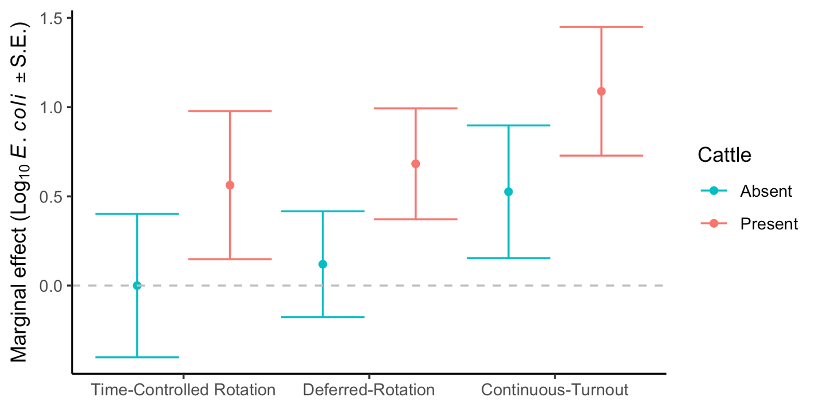

**Figure 3*.*** Marginal effects of grazing treatment and cattle presence on stream *E. coli* levels. Time-controlled rotation with cattle absent is set as the reference level, with treatment effects being differences from that reference level. Treatment effects and standard errors were calculated from the top GAM (model ‘2’) using the delta method.

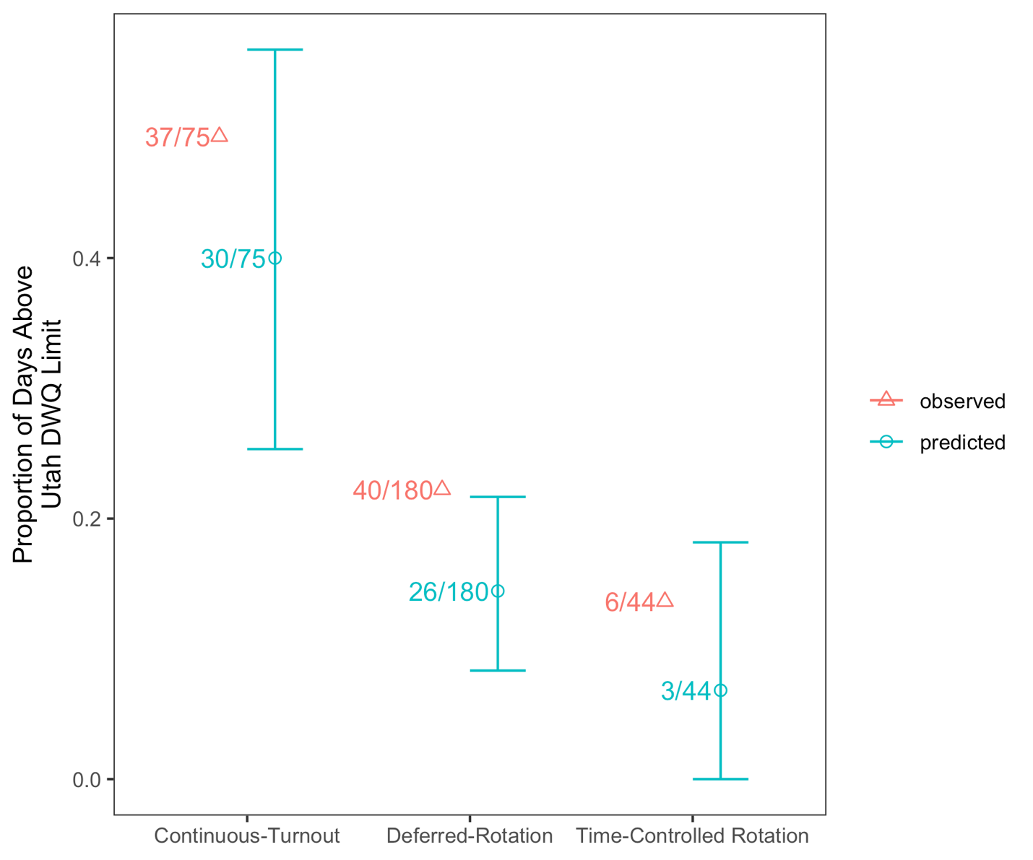

**Figure 4.** Observed and predicted number of daily *E. coli* measurements exceeding Utah Division of Water Quality benchmark of 668 MPN *E. coli*. Number of days exceeding the threshold are given as a proportion of all days sampled during the recreation season (May 1- Sept 30) and number values give the number of days exceeding over number of days measured. 95% confidence intervals are estimated from 10000 Monte Carlo simulations generated from the top GAM (model “2”).

**Discussion**

Mitigating ecosystem service tradeoffs requires knowledge of how different management options affect target ecosystem services. Currently rangeland managers debate whether practices such as rotational grazing provide measurable benefits for livestock and conservation outcomes (Briske *et al.* 2008; Teague *et al.* 2013; Roche *et al.* 2015; Lagendijk *et al.* 2017). Our results suggest that grazing rotation can provide cleaner water in rangelands, but to be most helpful for mitigating ecosystem service tradeoffs, management strategies need to move beyond broadly defined grazing systems that conflate different rotational management practices (Briske *et al.* 2011). For example, we found that our grazing treatments of continuous-turnout, deferred-rotation, and time-controlled rotation, only partially explained differences in *E. coli* levels in rangeland streams. Rather, in the semi-arid rangeland where we conducted our study, water quality reflected variation in two basic elements of grazing rotation – duration and timing.

Grazing duration controlled the length of time *E. coli* levels were elevated in streams, while having little or no effect on total *E. coli* concentration. For example, *E. coli* concentrations in short- and medium-duration systems were often similar to those in long-duration systems, but lasted for shorter periods of time - about 15-20% of the recreation season compared to 50% of the season, respectively. In all cases, *E. coil* levels dropped quickly once cattle were removed from pastures. While this result is consistent with studies that find cattle presence negatively affects water quality (Tiedemann *et al.* 1987; Derlet *et al.* 2012; Myers & Whited 2012; Roche *et al.* 2013), our findings additionally highlight that grazing duration can be used as a tool to manage how long *E. coli* levels are elevated.

The timing of cattle grazing served as a second tool to manage rangeland stream water quality by affecting overall *E. coli* concentrations. Daily *E. coli* levels followed a consistent seasonal pattern across all grazing treatments, starting with lower concentrations in spring, peaking in summer, and declining in the fall. Because of this, grazing occurring in early spring (May) led to lower *E. coli* levels than grazing during mid-summer (July). Differences between summer and fall *E coli* concentrations were not as pronounced, but in general, *E. coli* levels in grazed pastures were lower in fall than summer. We found very few grazing studies that causally linked the timing of grazing to water quality. These found that water quality due to overland runoff was poorest when grazing and the deposition of waste occurred within two weeks of rain events (Wagner *et al.* 2012). More commonly, studies binned timing and duration together to compare overall outcomes of rotational grazing to continuous-turnout grazing (Briske *et al.* 2011). These studies largely do not differentiate between grazing during seasonal timeframes and the cumulative effects of grazing duration or intensity. In contrast, our study provides evidence that the season cattle are grazed can affect water quality.

**Using grazing duration and timing to manage ecosystem service tradeoffs**

Many studies identify cattle number (e.g., densities or stocking rates) as the main driver of rangeland health. For example, in a review of the rangeland literature Briske et al (2011) found increased stocking rates generally reduced rangeland plant production and per head livestock production, and proposed that high stocking rates reduced water quantity, quality, and riparian function compared with low stocking rates (Briske *et al.* 2011). Our results, however, suggest that grazing timing and duration were more important than cattle number for managing water quality at our sites. In fact, stocking rates in the time-controlled grazing treatment were much higher (0.75 - 1.78 pairs · ha-1) than in continuous turnout treatments (0.03 - 0.09 pairs· ha-1). Despite this difference, the number of days per year that *E. coli* exceeded regulatory thresholds was higher in the continuous-turnout treatment than in the time-controlled (**Fig. 4**). An explanation for this result is that regardless of stocking rate or rotation treatment, *E. coli* levels were highest on the days cattle were present in the system (**Fig. 1**). As such, reducing the number of days that cattle were present, or moving those days to the spring or fall, appears to be a highly effective means to reduce the impact on water quality.

Our study suggests that managing grazing duration and timing may be effective strategies for meeting federal and state water quality benchmarks. For example, the streams examined in our study fall under Utah regulations that allow for exceedances of *E. coli* benchmarks for no more than 10% of collected samples (Utah Department of Environmental Quality 2018a). When taken across an entire 153 day recreation season, this equals 16 sample-days. Many past grazing water quality studies do not provide information of how to meet such regulatory benchmarks because they do not track how different types of grazing management affect *E. coli*, do not track how *E. coli* fluctuates through the season in reference to regulatory guidelines, or only compare *E. coli* levels when cattle are present versus absent (Derlet *et al.* 2012; Myers & Whited 2012). In contrast, by accounting for grazing duration and timing in association with water quality benchmarks across an entire grazing season, we found fewer water quality violations occurred when grazing periods were short, and when grazing occurred early or late in the season.

**Cattle disturbance and ecosystem functioning**

Because cattle disturbance can alter ecosystem structure and processes (Derner *et al.* 2009; Swanson, Wyman & Evans 2015; Pogue *et al.* 2018), understanding how grazing duration and timing individually affect water quality may highlight management opportunities to balance livestock grazing and cleaner water in rangelands. We found water quality declined when cattle were present but resolved within days of cattle being removed from pastures. The rapid response of water quality to cattle presence suggests direct, transient effects of cattle disturbance, and could be explained by waste deposition in streams and re-suspension of *E. coli* from stream sediment via hoof action (Stephenson & Rychert 1982; Smith *et al.* 2008; George *et al.* 2011).

It is also possible that cattle grazing and trampling in the riparian indirectly affects *E. coli* levels by reducing cover and presence of stream-side vegetation or increasing soil compaction. For example, past studies found *E. coli* and fecal bacteria concentrations were higher when streambanks had less vegetation to intercept overland runoff (Tate *et al.* 2006; George *et al.* 2011). While cattle presence may reduce herbaceous vegetation along streambanks, it typically takes months or years for vegetation to recover from disturbance, however we saw rapid reductions in *E. coli* only one or two weeks after cattle were removed from stream areas. This suggests waste deposition and hoof action were likely the main drivers of increased *E. coli* levels. Despite the stronger effects of cattle presence, we found a significant effect of grazing treatment on daily water quality that could not be explained by cattle presence alone (**Table 1; Fig. 3**). Future studies that examine whether longer-term recovery of streambank vegetation and soils reduce *E. coli* levels may indicate a cumulative negative effect of cattle disturbance on vegetation across years (Swanson, Wyman & Evans 2015) and thus point to additional management opportunities; for example, allowing streamside vegetation to rest for entire seasons or multiple seasons between grazing.

In our study, the time of the year that cattle disturbance occurred also contributed to grazing’s effects on water quality. The significant effect of the smoothing terms in our top GAMM show that there is strong seasonal variation in *E. coli* concentrations that are somewhat independent of grazing treatment. Past studies have found *E. coli* and fecal bacteria concentrations can increase cumulatively due to reductions of stream-flows in the summer (Roche *et al.* 2013; Xu *et al.* 2019), or can undergo short escalations due to rain events that flush bacteria into streams or resuspend bacteria from stream sediments (Pachepsky & Shelton 2011; Cha *et al.* 2016). These processes, however, do not explain the hump-shaped pattern in *E. coli* concentration that we observed between May and October. Alternatively, a growing number of studies examining climate effects on water quality have found *E. coli* levels in streams and other waterbodies are correlated with ambient air temperature (Whitman & Nevers 2008; Xu *et al.* 2019). Maximum bacterial concentrations often occur during the warmest part of the year (Cha *et al.* 2016), potentially driven by the ability of *E. coli* to reproduce rapidly in warmer waters (e.g., 20ºC) (Guber *et al.* 2015). Our study shows that having cattle present during the warmest part of the year when levels of *E. coli* are at their peak, increases the chance of surpassing regulatory water quality benchmarks.

**Implications for management**

Our results suggest that grazing duration and timing can be used as tools to balance livestock production with rangeland water quality goals. We know of no other rangeland studies that include gradients of grazing duration and timing to generate management options. Rather, many studies only focus on cattle presence/absence or bin multiple types of rotation (i.e. different durations and timings) into a single ‘rotational grazing’ treatment (Briske *et al.* 2008; Briske *et al.* 2011). Such approaches prevent managers and researchers from understanding how cattle grazing in general, and more specifically the individual elements of rotational grazing – duration and timing -- might alter ecosystem processes and alleviate ecosystem service tradeoffs. Rangeland riparian areas not only provide clean water, but also support a suite of additional services including water storage (Kauffman, Thorpe & Brookshire 2004), habitat for fish and other wildlife (Bouwes *et al.* 2016), and recreational opportunities (Yahdjian, Sala & Havstad 2015). Incorporating gradients of timing and duration into experimental designs and management practices will allow managers to develop grazing options more likely to balance conservation objectives with livestock grazing in arid rangelands.

**Authors’ contributions**

KH conceived the ideas and led the writing of the manuscript; KH and CM designed methodology and collected data; AK analyzed data and interpreted it with KH. All authors contributed critically to drafts and gave final approval for publication.

**Acknowledgements**

This work was supported by the Utah Agricultural Experiment Station, Utah State University; by the USDA National Institute of Food and Agriculture under award number XXXX-XXXXX-XXXXX through the Western Sustainable Agriculture Research and Education program under project number SW19-905; and by the USDA National Institute of Food and Agriculture through Foundational Program grant number 12690446/project accession number UTA-grazES2019.

**Data accessibility**

Data available from the Utah Ambient Water Quality Monitoring System (AWQMS) Portal with requested permission: <https://awqms.utah.gov>

**References**

Arkema, K.K., Verutes, G.M., Wood, S.A., Clarke-Samuels, C., Rosado, S., Canto, M., Rosenthal, A., Ruckelshaus, M., Guannel, G. & Toft, J. (2015) Embedding ecosystem services in coastal planning leads to better outcomes for people and nature. *Proceedings of the National Academy of Sciences,* **112,** 7390-7395.

Bailey, D.W. & Brown, J.R. (2011) Rotational grazing systems and livestock grazing behavior in shrub-dominated semi-arid and arid rangelands. *Rangeland Ecology & Management,* **64,** 1-9.

Banner, R.E., Baldwin, B.D. & Leydsman McGinty, E.I. (2009) Rangeland Resources of Utah. pp. 188.Utah State University Cooperative Extension Service, State of Utah Governor's Public Lands Policy Coordination Office, Logan, Utah.

Belsky, A.J., Matzke, A. & Uselman, S. (1999) Survey of livestock influences on stream and riparian ecosystems in the western United States. *Journal of Soil and water Conservation,* **54,** 419-431.

Bennett, E.M. & Balvanera, P. (2007) The future of production systems in a globalized world. *Frontiers in Ecology and the Environment,* **5,** 191-198.

Bennett, E.M., Peterson, G.D. & Gordon, L.J. (2009) Understanding relationships among multiple ecosystem services. *Ecology Letters,* **12,** 1394-1404.

Bestelmeyer, B.T. & Briske, D.D. (2012) Grand challenges for resilience-based management of rangelands. *Rangeland Ecology & Management,* **64,** 654-663.

Boies, R. (2017) Confessions of a collaborator: Shoesole and Stewardship Alliance of Northeast Elko County, Nevada. *Human-Wildlife Interactions,* **11,** 327-338.

Bouwes, N., Weber, N., Jordan, C.E., Saunders, W.C., Tattam, I.A., Volk, C., Wheaton, J.M. & Pollock, M.M. (2016) Ecosystem experiment reveals benefits of natural and simulated beaver dams to a threatened population of steelhead (Oncorhynchus mykiss). *Scientific Reports,* **6,** 28581.

Briske, D.D., Derner, J.D., Brown, J.R., Fuhlendorf, S.D., Teague, W.R., Havstad, K.M., Gillen, R.L., Ash, A.J. & Willms, W.D. (2008) Rotational grazing on rangelands: reconciliation of perception and experimental evidence. *Rangeland Ecology & Management,* **61,** 3-17.

Briske, D.D., Derner, J.D., Milchunas, D.G. & Tate, K.W. (2011) An evidence-based assessment of prescribed grazing practices. *Conservation Benefits of Rangeland Practices: Assessment, Recommendations, and Knowledge Gaps* (ed. D.D. Briske), pp. 22-74.Allen Press, Lawrence, KS.

Cardinale, B., Duffy, E., Gonzalez, A., Hooper, D.U., Perrings, C., Venail, P., Narwani, A., Mace, G.M., Tilman, D., Wardle, D.A., Kinzig, A.P., Daily, G.C., Loreau, M., Grace, J.B., Larigauderie, A., Srivastava, D.S. & Naeem, S. (2012) Biodiversity loss and its impact on humanity. *Nature,* **486,** 59-67.

Cha, Y., Park, M.-H., Lee, S.-H., Kim, J.H. & Cho, K.H. (2016) Modeling spatiotemporal bacterial variability with meteorological and watershed land-use characteristics. *water research,* **100,** 306-315.

Chan, K.M., Shaw, M.R., Cameron, D.R., Underwood, E.C. & Daily, G.C. (2006) Conservation planning for ecosystem services. *PLoS Biology,* **4,** e379.

Derlet, R.W., Richards, J.R., Tanaka, L.L., Hayden, C., Ger, K.A. & Goldman, C.R. (2012) Impact of summer cattle grazing on the Sierra Nevada watershed: aquatic algae and bacteria. *Journal of Environmental and Public Health,* **2012**.

Derner, J.D., Lauenroth, W.K., Stapp, P. & Augustine, D.J. (2009) Livestock as ecosystem enginers for grassland bird habitat in the Western plains of North America. *Rangeland Ecology & Management,* **62,** 111-118.

EPA (2012) Recreational water quality criteria

Ferranto, S., Huntsinger, L., Getz, C., Nakamura, G., Stewart, W., Drill, S., Valachovic, Y., DeLasaux, M. & Kelly, M. (2011) Forest and rangeland owners value land for natural amenities and as financial investment. *California Agriculture,* **65,** 184-191.

Fuhlendorf, S.D., Engel, D.M., Elmore, R.D., Limb, R.F. & Bidwell, T.G. (2012) Conservation of pattern and process: Developing an alternative paradigm of rangeland management. *Rangeland Ecology & Management,* **65,** 579-589.

George, M.R., Jackson, R.D., Boyd, C.S. & Tate, K.W. (2011) A scientific assessment of the effectiveness of riparian management practices. *Conservation Benefits of Rangeland Practices: Assessment, Recommendations, and Knowledge Gaps* (ed. D.D. Briske), pp. 213-252.Allen Press, Lawrence, KS.

Goldstein, J.H., Caldarone, G., Duarte, T.K., Ennaanay, D., Hannahs, N., Mendoza, G., Polasky, S., Wolny, S. & Daily, G.C. (2012) Integrating ecosystem-service tradeoffs into land-use decisions. *Proceedings of the National Academy of Science,* **109,** 7565-7570.

Guber, A.K., Fry, J., Ives, R.L. & Rose, J.B. (2015) Escherichia coli survival in, and release from, white-tailed deer feces. *Applied and Environmental Microbiology,* **81,** 1168-1176.

Guerry, A.D., Polasky, S., Lubchenco, J., Chaplin-Kramer, R., Daily, G.C., Griffin, R., Ruckelshaus, M., Bateman, I.J., Duraiappah, A. & Elmqvist, T. (2015) Natural capital and ecosystem services informing decisions: From promise to practice. *Proceedings of the National Academy of Sciences,* **112,** 7348-7355.

Halekoh, U. & Højsgaard, S. (2014) A Kenward‐Roger approximation and parametric bootstrap methods for tests in linear mixed models – the R package PBKRTEST. *Journal of Statistical Software,* **59,** 1-30.

Havstad, K.M., Peters, D.P.C., Skaggs, R., Brown, J., Bestelmeyer, B., Fredrickson, E., Herrick, J. & Wright, J. (2007) Ecological services to and from rangelands of the United States. *Ecological Economics,* **64,** 261-268.

Huntsinger, L. & Oviedo, J.L. (2014) Ecosystem services are social-ecological services in a traditional pastoral system: the case of California's Mediterranean rangelands. *Ecology and Society,* **19,** 8-19.

Kauffman, J.B. & Krueger, W.C. (1984) Livestock impacts on riparian ecosystems and streamside management implications - a review. *Journal Of Range Management,* **37,** 430-438.

Kauffman, J.B., Thorpe, A.S. & Brookshire, E.J. (2004) Livestock exclusion and belowground ecosystem responses in riparian meadows of eastern Oregon. *Ecological Applications,* **14,** 1671-1679.

Lagendijk, D.D.G., Howison, R.A., Esselink, P., Ubels, R. & Smit, C. (2017) Rotation grazing as a conservation management tool: Vegetation changes after six years of application in a salt marsh ecosystem. *Agriculture Ecosystems & Environment,* **246,** 361-366.

Millennium Ecosystem Assessment (2005) Ecosystems and Human Well-being: Biodiversity Synthesis.World Resources Institute, Washington, D.C.

Mosley, J.C., Cook, P.S., Griffis, A.J. & O’Laughlin, J. (1997) Guidelines for managing cattle grazing in riparian areas to protect water quality: Review of research and best management practices policy. (ed. W.a.R.P.A.G. Idaho Forest).Report, Moscow, ID.

Myers, L. & Whited, B. (2012) The impact of cattle grazing in high elevation Sierra Nevada mountain meadows over widely variable annual climatic conditions. *Journal of Environmental Protection,* **3,** 823.

Nelson, E., Mendoza, G., Regetz, J., Polasky, S., Tallis, H., Cameron, D.R., Chan, K.M.A., Daily, G.C., Goldstein, J., Kareiva, P.M., Lonsdorf, E., Naidoo, R., Ricketts, T.H. & Shaw, M.R. (2009) Modeling multiple ecosystem services, biodiversity conservation, commodity production, and tradeoffs at landscape scales. *Frontiers in Ecology and the Environment,* **7,** 4-11.

Pachepsky, Y. & Shelton, D. (2011) Escherichia coli and fecal coliforms in freshwater and estuarine sediments. *Critical reviews in environmental science and technology,* **41,** 1067-1110.

Pogue, S.J., Krobel, R., Janzen, H.H., Beauchemin, K.A., Legesse, G., de Souza, D.M., Iravani, M., Selin, C., Byrne, J. & McAllister, T.A. (2018) Beef production and ecosystem services in Canada's prairie provinces: A review. *Agricultural Systems,* **166,** 152-172.

R Development Core Team (2017) R: A Language and Environment for Statistical Computing.R Foundation for Statistical Computing, Vienna, Austria.

Raudsepp-Hearne, C., Peterson, G.D. & Bennett, E.M. (2010) Ecosystem service bundles for analyzing tradeoffs in diverse landscapes. *Proceedings of the National Academy of Sciences,* **107,** 5242-5247.

Roche, L.M., Cutts, B.B., Derner, J.D., Lubell, M.N. & Tate, K.W. (2015) On-ranch grazing strategies: context for the rotational grazing dilemma. *Rangeland Ecology & Management,* **68,** 248-256.

Roche, L.M., Kromschroeder, L., Atwill, E.R., Dahlgren, R.A. & Tate, K.W. (2013) Water quality conditions associated with cattle grazing and recreation on national forest lands. *PloS One,* **8,** e68127.

Rodriguez, J.P., T. Douglas Beard, J., Bennett, E.M., Cummings, G.S., Cork, S.J., Agard, J., Dobson, A.P. & Peterson, G.D. (2006) Trade-offs across space, time and ecosystem services. *Ecology and Society,* **11,** 28.

Sala, O.E., Yahdjian, L., Havstad, K.M. & Aguiar, M.R. (2017) Rangeland Ecosystem Services: Nature’s Supply and Humans’ Demand. *Rangeland Systems* (ed. D.D. Briske).Springer, Cham.

Smith, J., Edwards, J., Hilger, H. & Steck, T.R. (2008) Sediment can be a reservoir for coliform bacteria released into streams. *The Journal of general and applied microbiology,* **54,** 173-179.

Stephenson, G. & Rychert, R. (1982) Bottom sediment: a reservoir of Escherichia coli in rangeland streams. *Journal Of Range Management***,** 119-123.

Swanson, S.R., Wyman, S. & Evans, C. (2015) Practical grazing management to meet riparian objectives. *Journal of Rangeland Applications,* **2,** 1-28.

Tate, K.W., Atwill, E.R., Bartolome, J.W. & Nader, G. (2006) Significant Escherichia coli attenuation by vegetative buffers on annual grasslands. *Journal of environmental quality,* **35,** 795-805.

Teague, R., Provenza, F., Kreuter, U. & Barnes, M. (2013) Multi-paddock grazing on rangelands: Why the perceptual dichotomy between research results and rancher experience? *Journal of Environmental Management,* **128,** 699-717.

Tiedemann, A., Higgins, D., Quigley, T., Sanderson, H. & Marx, D. (1987) Responses of fecal coliform in streamwater to four grazing strategies. *Journal Of Range Management***,** 322-329.

Turner, M.G., Donato, D.C. & Romme, W.H. (2013) Consequences of spatial heterogeneity for ecosystem services in changing forest landscapes: priorities for future research. *Landscape Ecology,* **28,** 1081-1097.

U.S. Climate Data (2020).

US Department of the Interior (2019) Special Planning Designations. [*https://www.blm.gov/programs/planning-and-nepa/planning-101/special-planning-designations*](https://www.blm.gov/programs/planning-and-nepa/planning-101/special-planning-designations).

US EPA (2018) Introduction to the Clean Water Act.

Utah Department of Environmental Quality (2014a) Standard operating procedure for collection and handling of *Escherichia coli* (*E. coli*) samples.

Utah Department of Environmental Quality (2014b) Standard operating procedure for *Escherichia coli* (*E. coli*) and total coliform quantification using the IDEXX Quanti-tray/2000 system.

Utah Department of Environmental Quality (2018a) Rule R317-2. Standards of Quality for Waters of the State.

Utah Department of Environmental Quality (2018b) Water Quality Standards and Technical Services.

Wagner, K., Redmon, L., Gentry, T. & Harmel, R. (2012) Assessment of cattle grazing effects on E. coli runoff. *Transactions of the ASABE,* **55,** 2111-2122.

Whitman, R.L. & Nevers, M.B. (2008) Summer *E. coli* patterns and responses along 23 Chicago beaches. *Environmental science & technology,* **42,** 9217-9224.

Xu, K., Valeo, C., He, J. & Xu, Z. (2019) Climate and land use influences on bacteria levels in stormwater. *Water,* **11,** 2451.

Yahdjian, L., Sala, O.E. & Havstad, K.M. (2015) Rangeland ecosystem services: shifting focus from supply to reconcililng supply and demand. *Fronteers in Ecology and the Environment,* **13,** 44-51.

York, E.C., Brunson, M.W. & Hulvey, K.B. (2019) Influence of Ecosystem Services on Management Decisions by Public Land Ranchers in the Intermountain West, United States. *Rangeland Ecology & Management,* **72,** 721-728.

Zheng, H., Li, Y., Robinson, B.E., Liu, G., Ma, D., Wang, F., Lu, F., Ouyang, Z. & Daily, G., C. (2016) Using ecosystem service trade-offs to informwater conservation policies and management pracitces. *Fronteers in Ecology and the Environment,* **14,** 527-532.

**Supporting information:**

**Statistical Tables:**

**Table S1.** Summary of *E. coli* sampling across 12 streams and three years.

**Year Treatment # of # of n per Days with**

**N Streams Pastures stream cattle**

2016 Time-controlled rotation 30 2 2 10 – 20 15 - 21

Deferred-rotation 48 5 2 6 – 12 50 - 67

Continuous-turnout 19 2 1 7 – 12 129

2017 Time-controlled rotation 23 2 2 11 – 12 23 - 30

Deferred-rotation 84 7 3 12 47 - 68

Continuous-turnout 36 3 2 12 104 - 129

2018 Time-controlled rotation 10 1 1 10 17

Deferred-rotation 77 7 3 11 31 - 63

Continuous-turnout 33 3 2 11 97 - 138

**Table S2.** Coefficient summary of selected GAMM fit to *E. coli* data. Summary displayed below corresponds to model “2” in Table 2 in the main text. Model fitted with the GAMM4 package in the R. Linear mixed model fit by REML [‘lmerMod’] and REML criterion at convergence: 700.7.

**Scaled residuals: Min 1Q Median 3Q Max**

-2.8247 -0.5827 0.031 0.6356 2.677

**Random effects: Groups Name Variance SD**

Year:stream:pasture (intercept) 0.05932 0.24356

Stream (intercept) 0.01337 0.11561

Xr s(DOY) 0.0048 006928

Residual 0.37038 0.60859

***Number of Observations: 350, groups: year:stream:pasture, 32, 12: Xr, 8***

**Fixed effects: Estimate SD t value**

(Intercept) 2.0627 0.13815 14.931

Deferred -0.40629 0.15394 -2.639

TimeControlled -0.52601 0.20826 -2.526

CattlePresent 0.56277 0.07915 7.11

DOY 0.5579 0.12021 4.641

**Correlation of Fixed Effects: (lnt) Deferred TimeControlled CattlePresent**

Deferred -0.824

TimeControlled -0.632 0.534

CattlePresent -0.385 0.155 0.174

DOY -0.072 0.031 0.01 0.209