Running Head: Precipitation variability and perennial plant life history

**Precipitation variability does not predict the life history of perennial plants**

**Andrew R. Kleinhesselink**

Department of Wildland Resources, Utah State University, Logan UT 84322

Contact: arklein@aggiemail.usu.edu

**Abstract**

Global climate change is likely to affect both the mean and variance of environmental conditions experienced by organisms. Population ecologists have focused primarily on examining how changes in mean climate could affect the trajectory of populations, however, recent empirical and theoretical work show that changes in climate variability could have large effects as well. I used a matrix transition models for population of 82 perennial plants across 20 plant species, to perform deterministic and stochastic elasticity analyses. I analyzed the elasticity of each population to a change in mean vital rates and a change in variance in vital rates. I tested the hypotheses that 1) patterns of elasticity to variance will be related to climate variance and 2) that plant longevity will buffer populations against negative effects of variability. Across the species there appeared to be no relationship between elasticity to variance and precipitation variability. Moreover, I found no relationship between precipitation variability and longevity. Consistent with earlier research, I did however find a weak relationship between longevity and elasticity to variance. These results suggest that other sources of annual variability besides precipitation may be more important for the evolution of perennial plant life histories.

**Keywords** Life history, stochastic population analysis, elasticity, climate variability, perennial plants

**Introduction**

The effects of global climate change have been detected across many taxa and in numerous ecosystems (Parmesan and Yohe 2003). Most of the responses represent responses to a change in climate mean, generally an increase in temperature. However, climate change will likely also constitute widespread changes in climate variability as well. In particular many regional climates are expected to suffer more severe droughts and less frequent but more extreme rainfall (Easterling et al. 2000). Both changes in mean precipitation and temperature and increased variability in precipitation are likely to have impacts on plant populations, as plant survival, growth and fecundity often show strong relationships to annual precipitation (Hsu et al. 2012, Dalgleish et al. 2010).

Simple population models show that increased variance in vital rates generally leads to a reduction in long-term population growth rates (Lewonton and Cohen 1969). This is due to the non-linear averaging effect (i.e. Jensen’s Inequality) (Drake 2005). This has raised concern that increased variation in climate and in particular precipitation will negatively affect populations (Menges 2000). Recent studies have demonstrated, however, that the negative effect of variability on population growth rates can be buffered by life history adaptations—including increased longevity (Morris et al. 2008). In an analysis of x populations of plants and animals Morris et al. 2008 showed that long-lived organisms generally show less elasticity to variance than short-lived organisms. This raises the possibility that life history evolution should favor strategies, such as longevity, in variable environments to buffer populations against variability.

Among plant populations, variability in precipitation has been hypothesized to be one of the greatest sources of environmental variation (Hsu et al. 2012). If this is true we might expect that plants from environments with highly variable precipitation to evolve strategies, including longevity, to buffer them from the negative effects of variance. This hypothesis would be supported by evidence that 1) plants from climates with high variability of precipitation showed less elasticity to variance in vital rates than plants from climates with more constant precipitation; and 2) plants from climates with high variance of precipitation showed life history adaptations such as increased longevity that could buffer them against the negative effects of variability. In order to test these hypotheses with empirical data, I conducted stochastic elasticity analyses for a large dataset of perennial plant populations around the Northern Hemisphere and compared patterns of elasticity and longevity to patterns of precipitation variability.

**Datasets**

Population data for 20 plant species in 82 populations were obtained from Ellis et al. 2012. All plants were perennial, mostly non-woody species. All but one showed iteroperous reproduction (Table 1). Annual size-based transition matrices were constructed for each population from field observations (see methods in Ellis et al. 2012). Populations had from 2 to x annual transition matrices (Table 1).

Data on variability in precipitation was obtained from a recent analysis of rangeland degradation and climate variability (von Wehrden et al. 2012). This study compiled meteorological data from 18 669 climatic stations in the Global Historical Climate Network Dataset and calculated a coefficient of variation (CV) for annual precipitation for each. They then interpolated between climate stations to produce a complete coverage map of precipitation CV for all terrestrial areas (see methods in von Wehrden et al. 2012). I used the “raster” library in R to upload the spatial raster file containing precipitation CV values. I then used the ‘extract’ function in the “sp” library to obtain precipitation CV at each latitude and longitude of the populations in Ellis et al. 2012.

**Demographic Analysis**

For each population I performed both a deterministic and stochastic analysis of long-term rate of increase, lambda (λ), and elasticities of λ to matrix elements. In the deterministic analysis I averaged the transition matrices across all years a population was observed to calculate a mean transition matrix for each population. I then used eigenanalysis implemented in R to calculate the population’s deterministic λ. I also calculated life-expectancy (LE2) of individuals in life-stage two as a measure of longevity. LE2 was calculated as the second column sum of the fundamental matrix.

I used numerical simulation to investigate the stochastic dynamics of each population. For each population I performed a random selection of the observed set of annual transition matrices over 25 000 time steps. As transition matrices were draws at random for each time step, this represents an Independent and Identically Distributed (IID) environment. Stochastic lambda (λs) was calculated by averaging the population growth rates observed across the entire simulation. I then performed prospective perturbation analysis on each population, specifically focusing on elasticity of λs to increases in the means and variances of transition matrix elements (Morris et al. 2008). The elasticity to changes in the mean is calculated as the average, across all time steps, of the elasticity to the mean matrix given the simulated yearly eigenvalues and rates of population growth. Whereas the elasticity to the variance is calculated by finding the difference between the simulated transition matrix at each time step and the average transition matrix and calculating the average elasticity to this difference (Haridas and Tuljapukar 2005). This results in two elasticity matrices representing elasticities to increases in variance of matrix elements and a separate matrix representing elasticities to increased means of matrix elements. These elasticity matrices sum to one and represent the entire stochastic elasticity of the population.

**Results**

The studied plant populations varied greatly in deterministic analysis. Deterministic λ the populations varied from a minimum of 0.73 for a population of *Dicerandera frutescens* to a maximum of 2.1 for a population of *Arabis fecunda*, with a median of nearly exactly 1 (0.998). Deterministic life-expectancy estimates for stage two individuals varied from 1.61 y for a population of *Eryngium cuneifolium* to 2013 y (!) for a population of *Silene acaulis.* The median life-expectancy across all populations was 4.69 y. Out of the 82 population 11 had negative life-expectancy estimates which which were discarded from further analysis.

Stochastic analysis produced a range of λs estimates from 0.70 to 1.63 with a median of 0.98. The proportion of the overall elasticity of λs due to variance of matrix elements (that is the elasticity to variance divided by the sum of the absoluate values of all elasticities following Morris et al. 2012) was generally quite small and ranged from 0.00004 to 0.32, with a median of 0.025 (Appendix -- A1). The sum of elasticities to variance in survival, growth and retrogression elements was always negative and ranged from -0.49 to -0.00001 (Appendix – A2). In contrast, the sum of elasticities to variance in fecundity was occasionally positive with a maximum of 0.02 for a population of *Astragalus scaphoides.* Most elasticities to variance in fecundity were negative however with a median of -0.0002 (Appendix – A3).

Over the 82 populations CV of precipitation varied from 14.73 % to 24.76% with a median of 17.96%. There was no indication of a relationship between the CV of precipitation and the proportion of elasticity due to variance (Fig 2—upper), or elasticity due to variance in survival and fecundity (Fig 2—middle and bottom). Nor was log life-expectancy related to precipitation CV (Fig 3). There was a weak correlation between log life-expectancy and the proportion of elasticity due to variance – in general elasticity to variance decreased with log of life-expectancy (Fig 3).

**Discussion**

I found no support for the hypothesis that variance in precipitation would be associated with lower elasticity to variance in vital rates for 82 population of perennial plants (Fig 2). Moreover there was no evidence among these populations that plant longevity was associated with CV of precipitation as expected if longevity was selected for in conditions of high variability of precipitation. This analysis suggests that CV of precipitation is probably not an overriding force in perennial plant evolution. Some caution must be taken in interpreting these results however. First it should be noted that I am using an interpolated value of CV of precipitation not locally collected values at the populations studied. CV of precipitation could be different locally. Second, of course, the plant populations analyzed here do not represent true independent samples of plant evolutionary strategy at these locations. Rather they were selected to be studied for subjective reasons by the researchers that contributed to this dataset. These plants are likely not perfect representatives of plants in their respective climate regimes. Third, the study populations, while distributed widely, are heavily biased to North American temperate ecosystems. The range of precipitation variability across these sites is does not capture the global range in precipitation CV and in fact is biased towards the low end of variability. von Wehrden et al. 2012 found CV of precipitations ranging from less then 14% to over 42% in many deserts. It is possible that the inclusion of a wider geographic scope and plants adapted to more variable environments would show more of a pattern.

As was reported by Morris et al. 2008, I found that longevity was associated with decreased elasticity to variance (fig 4). The correlation coefficient I report, is fairly weak however compared to the relationship found in Morris et al. 2008 and lends less support to the notion that plant longevity is critical to buffering populations from variance at least in these populations. This could be because in Morris et al. 2008 the sampled populations included a greater range of longevities from a number of annual species to plants with longevities of hundreds of years. The dataset analyzed here represents a narrower range of perennial plant life histories. There may have also been some methodological problems with my estimation of plant life-span as I found a few populations with unrealistically long life-expectancies (2000 + y) and some with negative life-expectancies.

**References**

Dalgleish, H.J., Koons, D.N., Hooten, M.B., Moffet, C.A., and Adler, P.B. (2010). Climate influences the demography of three dominant sagebrush steppe plants. Ecology *92*, 75–85.

Drake, J.M. (2005). Population effects of increased climate variation. Proc. R. Soc. B *272*, 1823–1827.

Easterling, D.R., Meehl, G.A., Parmesan, C., Changnon, S.A., Karl, T.R., and Mearns, L.O. (2000). Climate Extremes: Observations, Modeling, and Impacts. Science *289*, 2068–2074.

Ellis, M.M., Williams, J.L., Lesica, P., Bell, T.J., Bierzychudek, P., Bowles, M., Crone, E.E., Doak, D.F., Ehrlén, J., and Ellis-Adam, A. (2012). Matrix population models from 20 studies of perennial plant populations. Ecology *93*, 951–951.

Hsu, J.S., Powell, J., and Adler, P.B. (2012). Sensitivity of mean annual primary production to precipitation. Glob. Change Biol. *18*, 2246–2255.

Lewontin, R.C., and Cohen, D. (1969). On Population Growth in a Randomly Varying Environment. PNAS *62*, 1056–1060.

Menges, E.S. (2000). Population viability analyses in plants: challenges and opportunities. Trends in Ecology & Evolution *15*, 51–56.

Morris, W.F., Pfister, C.A., Tuljapurkar, S., Haridas, C.V., Boggs, C.L., Boyce, M.S., Bruna, E.M., Church, D.R., Coulson, T., Doak, D.F., et al. (2008). Longevity can buffer plant and animal populations against changing climatic variability. Ecology *89*, 19–25.

Orzack, S.H., and Tuljapurkar, S. (1989). Population Dynamics in Variable Environments. VII. The Demography and Evolution of Iteroparity. The American Naturalist *133*, 901–923.

Parmesan, C., and Yohe, G. (2003). A globally coherent fingerprint of climate change impacts across natural systems. Nature *421*, 37–42.

Von Wehrden, H., Hanspach, J., Kaczensky, P., Fischer, J., and Wesche, K. (2011). Global assessment of the non-equilibrium concept in rangelands. Ecological Applications *22*, 393–399.

**TABLES and FIGURE**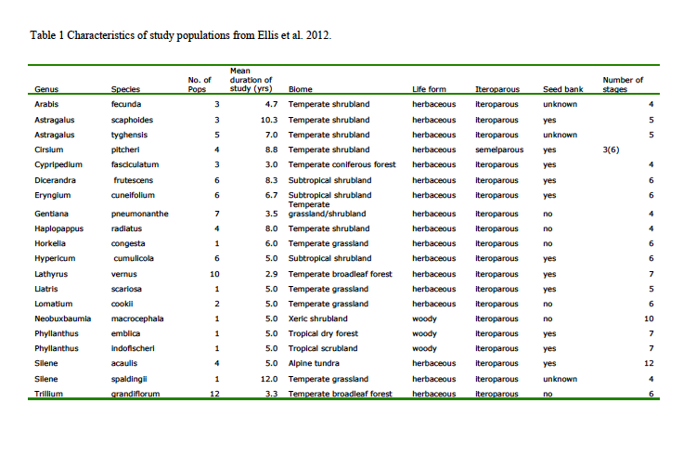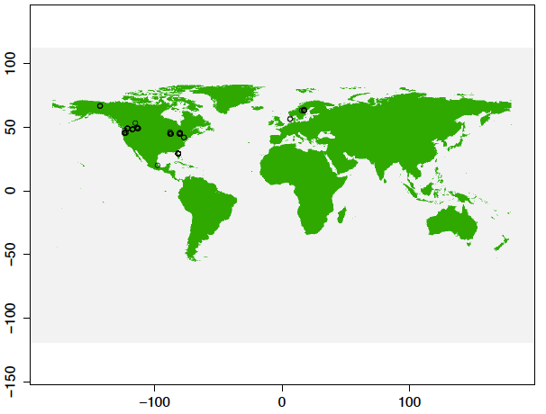

Figure 1 – Map of study populations from Ellis et al. 2012

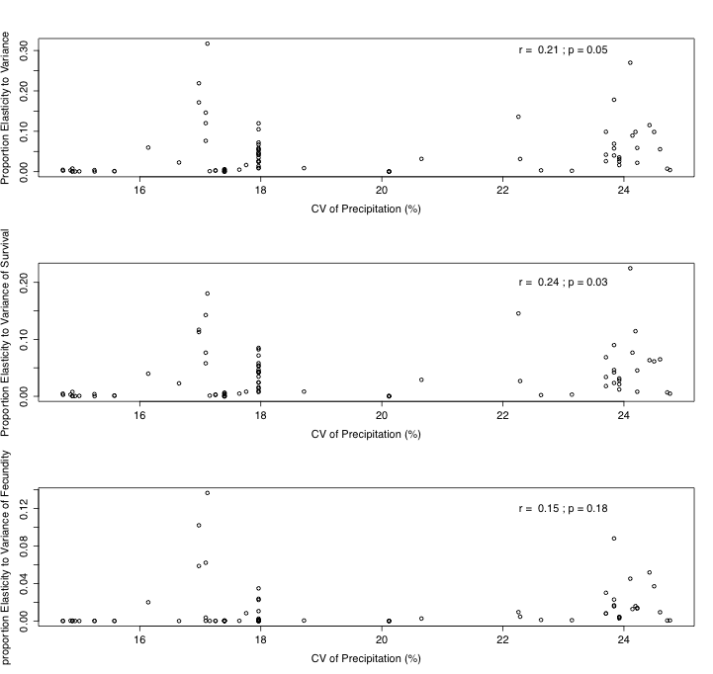

Figure 2 – Relationship between proportion of elasticity to variance to the coefficient of variation of precipitation (CV precip.) at the study site. The elasticity to variance in all vital rates is given in the (top), elasticity to variance in survival (middle) and elasticity to variance in fecundity (bottom). Elasticities are given as absolute values. Pearson’s correlation coefficient and statistical significance given in the upper right corner.

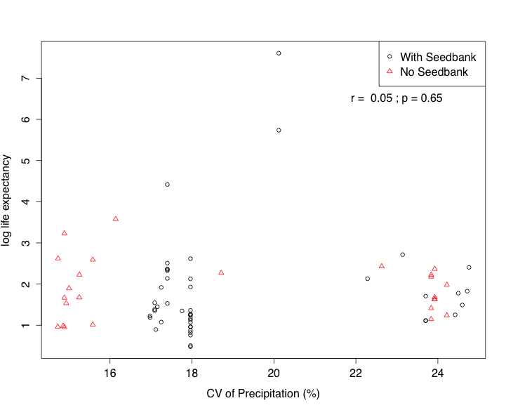

Figure 3 – Log life expectancy as a function of coefficient of variation of precipitation (CV) at the study site. Plants with a seedbank are shown as black circles, plants without seedbanks are red triangles. Pearson’s correlation coefficient and statistical significance given in the upper right corner. 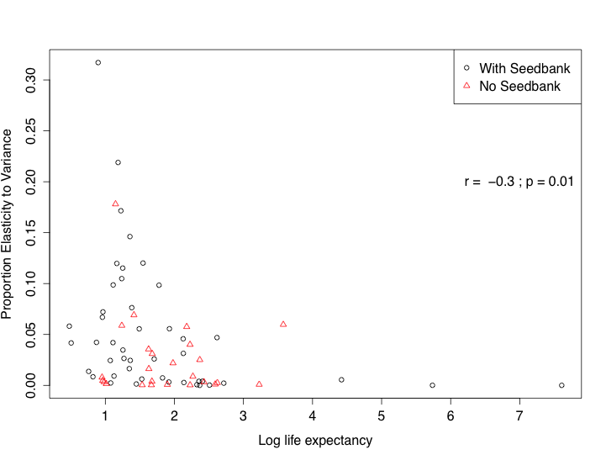

Figure 4 – Proportion of elasticity to variance plotted in relation to coefficient of variation of precipitation (CV) at each study site. Plants with a seedbank are shown as black circles, plants without seedbanks are red triangles. Pearson’s correlation coefficient and statistical significance given in the upper right corner.

APPENDIX

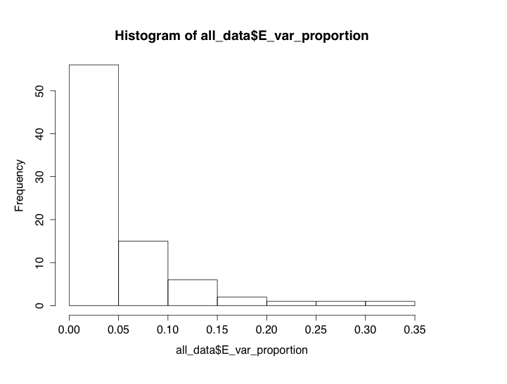

Fig A1 – Histogram of the proportion of elasticity due to variance of matrix elements.

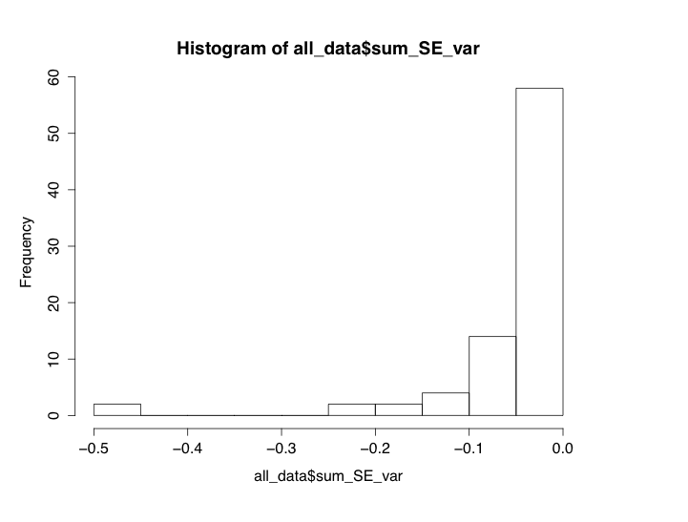

Fig A2—Histogram of elasticity to variation in survival elements.

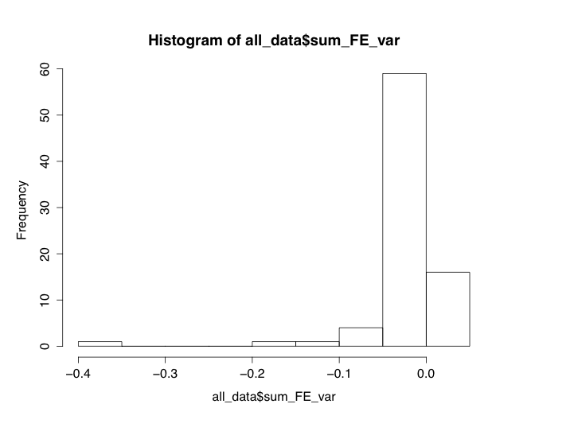

Fig A3—Histogram of elasticity to variance in fecundity elements.