Word Template Creator

Andrew Kleinhesselink

12/19/2018

# Title

## Title Two

### Title Three

This is an R Markdown document. Markdown is a simple formatting syntax for authoring HTML, PDF, and MS Word documents. For more details on using R Markdown see <http://rmarkdown.rstudio.com>.

When you click the **Knit** button a document will be generated that includes both content as well as the output of any embedded R code chunks within the document. You can embed an R code chunk like this:

summary(cars)

## speed dist   
## Min. : 4.0 Min. : 2.00   
## 1st Qu.:12.0 1st Qu.: 26.00   
## Median :15.0 Median : 36.00   
## Mean :15.4 Mean : 42.98   
## 3rd Qu.:19.0 3rd Qu.: 56.00   
## Max. :25.0 Max. :120.00

## 

## Include table

|  |  |
| --- | --- |
| speed | dist |
| Min. : 4.0 | Min. : 2.00 |
| 1st Qu.:12.0 | 1st Qu.: 26.00 |
| Median :15.0 | Median : 36.00 |
| Mean :15.4 | Mean : 42.98 |
| 3rd Qu.:19.0 | 3rd Qu.: 56.00 |
| Max. :25.0 | Max. :120.00 |

## Including Plots

You can also embed plots, for example:

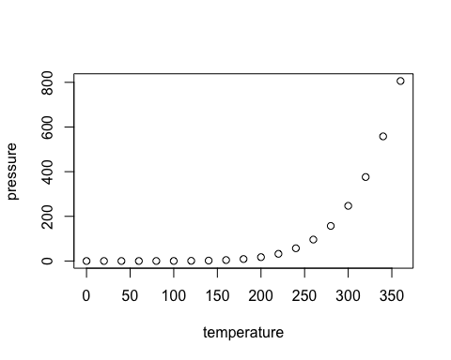

Note that the echo = FALSE parameter was added to the code chunk to prevent printing of the R code that generated the plot.