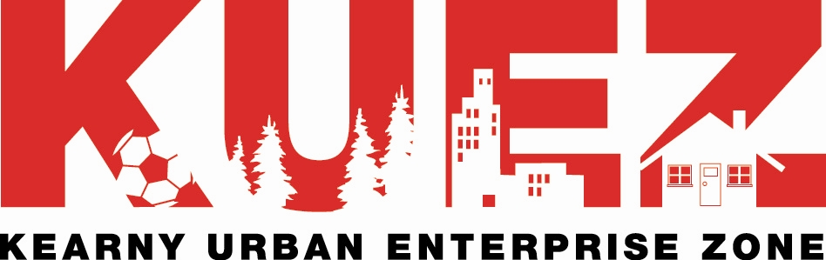
410 Kearny Avenue Kearny New Jersey 07032-2604
201.955.7985 fax 201.955.6187
Email: jfreiser@kearnynj.org
http://www.kearnynj.org/uez/index.asp

Dear Business Owner/ Company Officer:

As a new or established business, whether you are in the process of opening a business, you are an integral part of Kearny's business community. The Kearny Urban Enterprise Zone invites your business become eligible for a number of great incentives to help you save money and be more competitive.

The KUEZ - WHY?  Major Incentives Designed to Result in Bottom-Line Savings
- Sales and Use Tax Exemptions on Specific Purchases, Rentals, Leases for your Business Location
- 7.5% Savings when you purchase predetermined taxable tangible personal property & services
- New Employee Tax Credits
- Investment Tax Credits
- Unemployment Insurance Based Awards (Rebates)
- Reduced Sales Tax Collection for Retailers
- 3.5% savings for your customers on most NJ State taxable items, without any impact on your profit margins
- Preferred Financing, Training, Utilities, and Regulatory Assistance

The KUEZ - WHO?  Any Business Located Within Kearny's Designated UEZ and your Business is One

- Corporations
- Sole Proprietorships
- Partnerships
- Limited Partnerships
- Limited Liability Corporations
- ANY BUSINESS CLASSIFICATION

The KUEZ - HOW? Invest a Small Amount of Time

- Complete a Certification Application
- List Full & Part Time Employees presently on payroll
- Complete REG-1 Form to ensure State Registration: http://www.state.nj.us/treasury/revenue/busregcert.htm
- Complete a UZ-1 Form to apply for collection of the reduced sales tax
- NO FEES, NO CHARGES, JUST A BIT OF TIME

The KUEZ - WHEN? Anytime, NOW, It's Never too Late

- Whenever you want to take advantage of the KUEZ
- Whenever a lease or property deed is signed
- ANYTIME YOUR BUSINESS DECIDES TO OBTAIN AN ADDED DEGREE OF SUPERIORITY

The KUEZ - YOU!  Helping Your Community Through an Informal Partnership

- Generate New Employment (1 New Full-Time, and in some cases 1 Part-Time job, ONLY one, is required Within 2 Years)
- Revitalize the Town through Capital Investments (Program incentives can help your businesses grow)
- Assist in the Town's Economic Development and growth opportunities
- Reinforce Kearny's economic stability
- HELP US ALL HELP OURSELVES BY INCREASING KEARNY'S BUSINESS BASE AND VITALITY

The decision is yours. The program costs nothing, and the savings, no matter how small they may seem, will add up to help your business. Tax exemptions for every business, and consumer savings for retailers, can make a difference. There is nothing to lose; it's a win-win for you and the town you chose to do business in.

For more information, or Certification Application Documents, please contact the KUEZ Office.

Very truly yours,

Joel Freiser, Municipal Department Head - KUEZ

