Content

File Selection 2

Comparison 5

Configuration 8

Additional information 9

## File Selection

There are two ways to add files for the comparison:

1. “Root-Search”: You can set a custom root directory using the “Set directory..” button. All of its subdirectories will be searched.

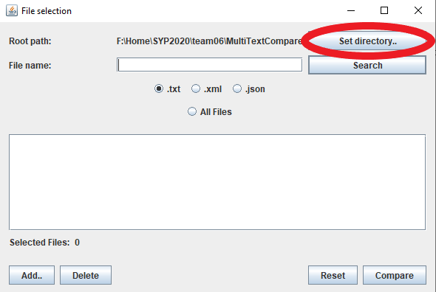

Next, you need to type in a filename to search for. Capitalization does not matter here.

It is possible to use *wildcard characters*:  
“?” replaces a single character

“*” replaces any number of characters

Additionally, you need to choose a file type:

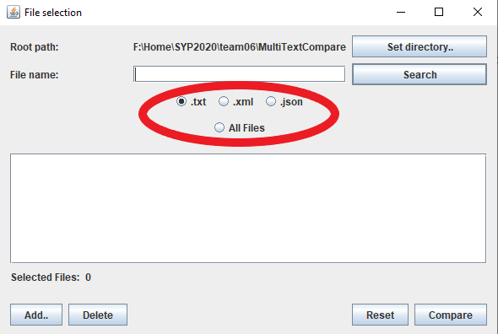

If you do not want to specify one of the three currently supported file types, you can choose the “All Files” option and type in a file name **with its extension** or use a wildcard for the extension (e.g.:“config.*”).

To initiate the search, click the “Search” button next to the “File name” field.

**Examples:**

Searching for: “config?”

Selected Type: .txt

Will find: configA.txt, config7.txt, configx.txt

Will NOT find: configAA.txt, config.txt, configA.xml, configA.abc

Searching for: “FileExampleName.abc”

Selected Type: All Files

Will find: Every file named *exactly*“fileexamplename.abc”

Will NOT find: Any other files

Searching for: “*”

Selected Type: .xml

Will find: ALL .xml files in the directory

Will NOT find: Any other file types

**Important**: To use the .xml or .json specific parameters, the associated file type has to be selected.

1. Manual addition: If you wish to add specific files manually, you can do so by clicking the “Add..” button in the bottom left corner. This can of course be combined with the root-search function.

**Note**: You are only able to add files of the selected file type.

**Deletion**

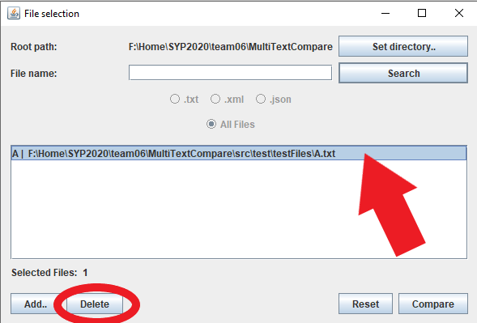

You can choose to delete certain files from the selection. Just click on the file, and then click on the “Delete” button.

By holding *Ctrl*, you can select multiple files at once.

By holding *Shift*, you can select multiple files in one segment.

If you want to completely reset the file selection, click the “Reset” button in the bottom right.

## Comparison

After selecting your files, click the “Compare” button to start the comparison. Depending on the chosen files, this might take a moment. While waiting, you can view your chosen files double-clicking them in the file selection list. This will open the unchanged file in a separate window.

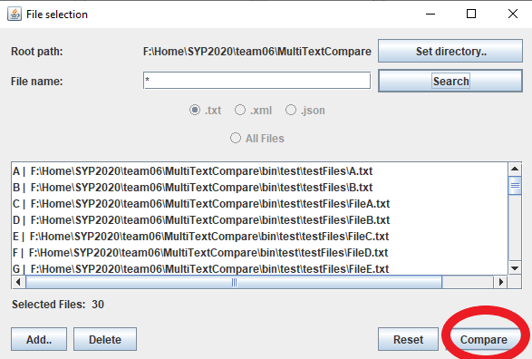

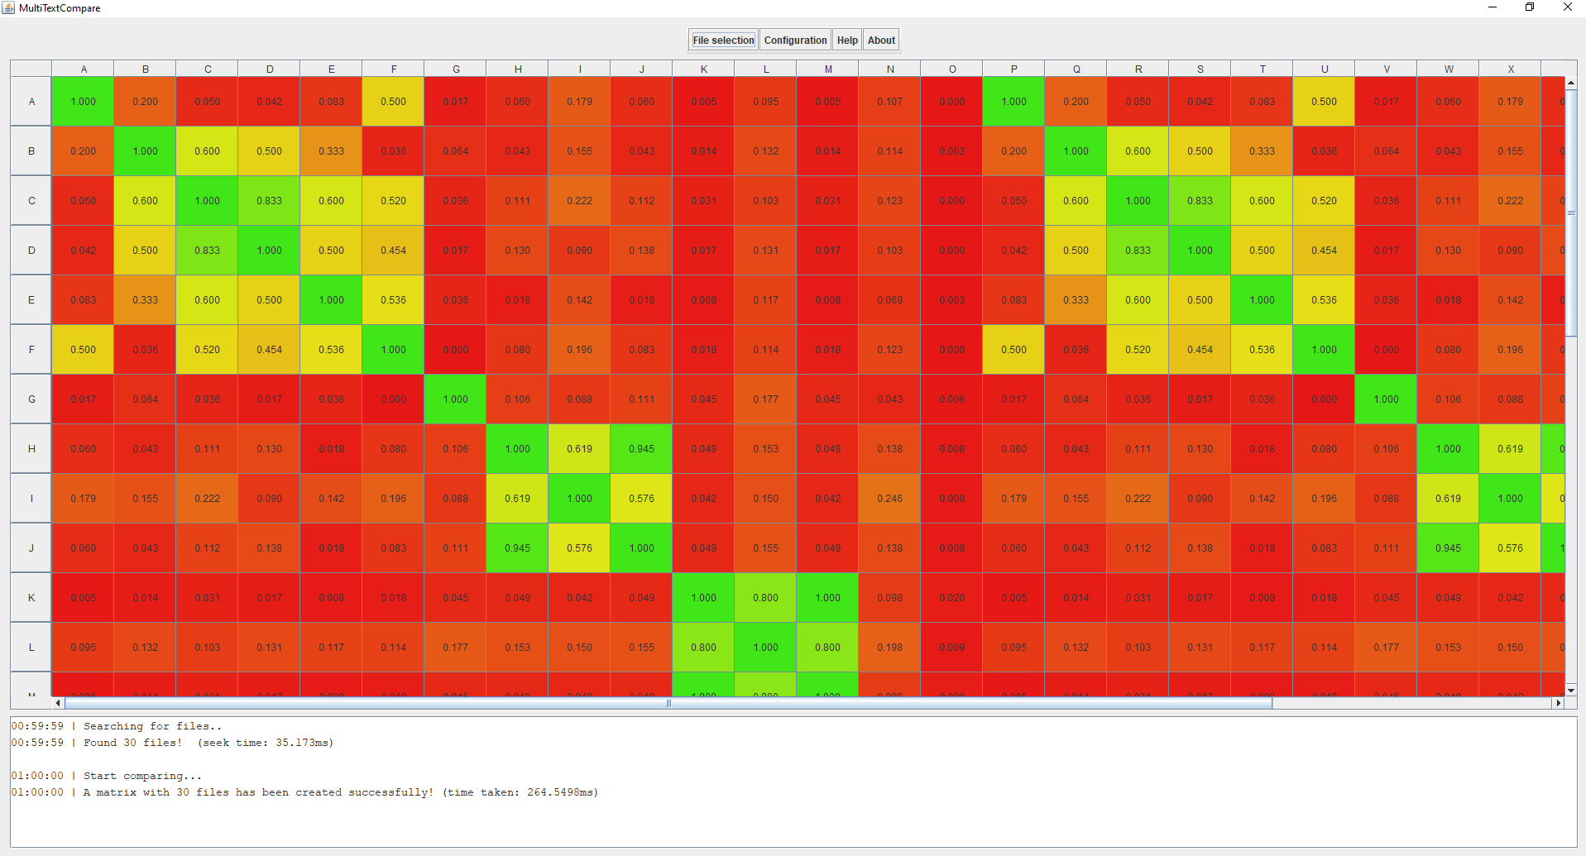

After clicking “Compare” in the file selection menu, you will see a matrix. If you want to see which files are mapped to which letters in the row and column headers, you can either check in the file selection list, or hover your mouse over the column headers.

The values of similarity are displayed here, and they colored accordingly.

**Comparing two files**

If you click a cell within the matrix, a new window will open with a side-by-side diff of the file within the row and column:

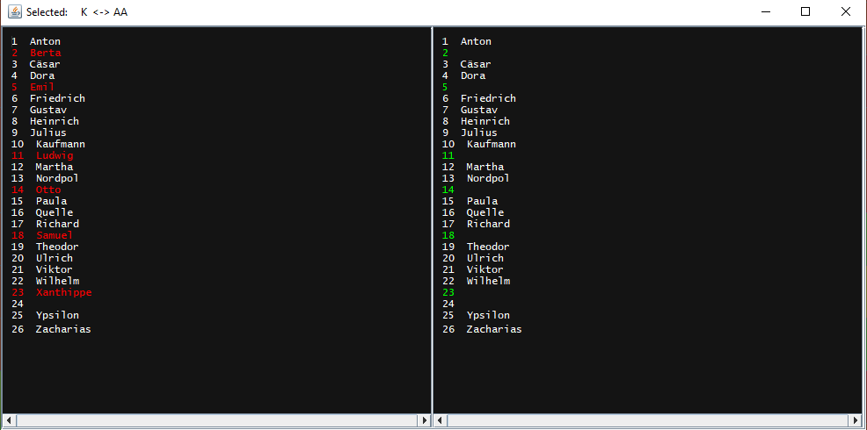

**Comparing three files**

If you click three column headers, you can open a side-by-side comparison of all three files. This also works by clicking a column header first, and then selecting a cell which compares two other files.

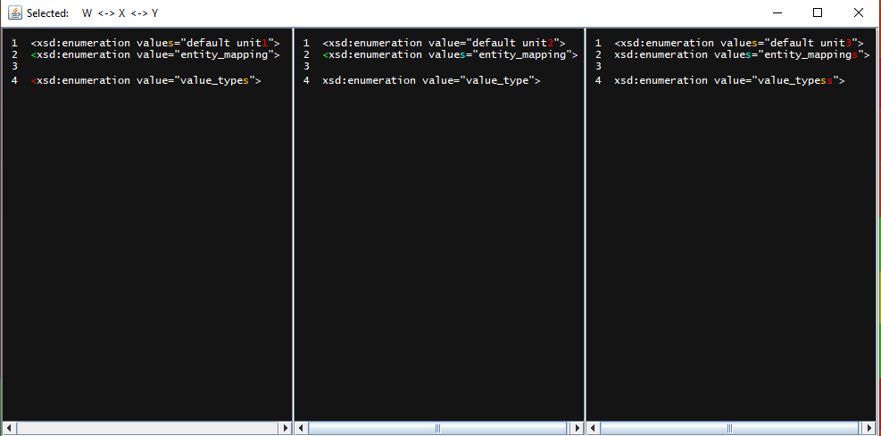

**Note**: Each of these panels is individually scrollable on the horizonal axis and synced on the vertical axis. Also, line wrap is disabled, so all lines are synchronized.

**Coloring**

To show the differences, the characters are highlighted in up to five colors:

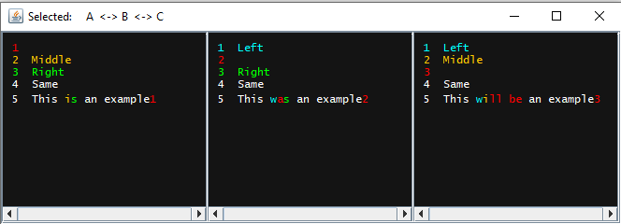

**Blue**: Difference to the left file

**Orange**: Difference to the middle file

**Green**: Difference to the right file

**Red**: Difference to both other files

**White**: No difference

## Configuration

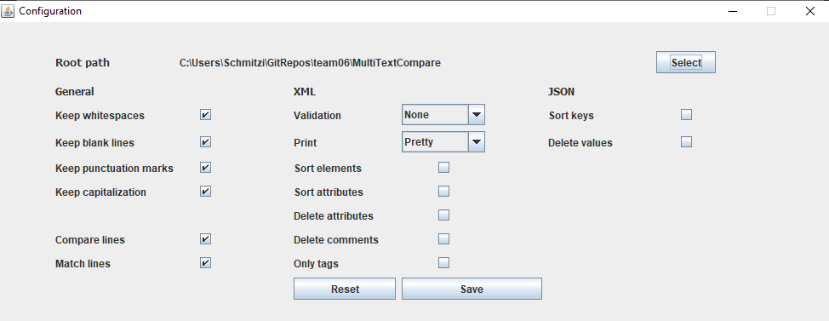

At the top, you can already select the root path for the file selection afterwards. Below are different parameters which will affect how the files will be compared.

**General:**

* **Keep**…: If these boxes are ticked, the comparison will take the respective parameter into consideration.
* **Compare lines**: If this box is ticked, the comparison value will be calculated on a line-to-line basis, as opposed to comparing the whole set of characters.
* **Match lines**: This box affects how the side-by-side comparisons are visualized. If ticked, it will show identical lines on the same line number, even if they were in different places originally.

**XML:**

* **Validation:** 
  + **None: T**he parser will not do any validation to the given files.
  + **Internal XSD:** The parser will validate the XML-file against any internally referenced XSD File.
  + **DTD**: If this box is ticked, the parser will validate the XML-file against any internally referenced DTD.
* **Print:**
  + **Pretty:** Normalizes tabulators and spaces as well as whitespaces on the comparison shown.
  + **Raw:** Will take the original whitespaces/tabulators/spaces etc. as found in the reference file.
  + **Compact:** Will make a compact one line out of the given XML-file.
* **Sort elements:** XML-Elements will be sorted alphabetically before the comparison is made.
* **Sort attributes:** XML-Attributes within Elements will be sorted alphabetically before the comparison is made.
* **Delete attributes:** XML-Attributes within Elements will be deleted before the comparison is made.
* **Delete comments:** XML-Comments within the XML-file will be deleted before the comparison is made.
* **Only tags:** Strips Attributes, Comments and Content from the XML-file. Only the Element Tags remain.  
  Since those Elements do no longer contain content, they are converted into the short notation.

**JSON:**

* **Sort keys:** JSON Key Value Pairs will be sorted in alphabetical order before the comparison is made.
* **Delete values:** JSON Key Value Pairs will be stripped of their Value, JSON Arrays will be emptied.

Clicking the “Reset” Button will simply remove all ticks. After you are done with the configuration, click the “Save” Button. The configuration will also be saved for the next time you start the application.

**Important**: If you change the settings while a matrix has already been generated, the changed will not apply for the current matrix. You need to generate a new matrix for the changes to be applied.

# Additional information

**Logging**

A log with timestamps is located in the main window, right beneath the matrix:

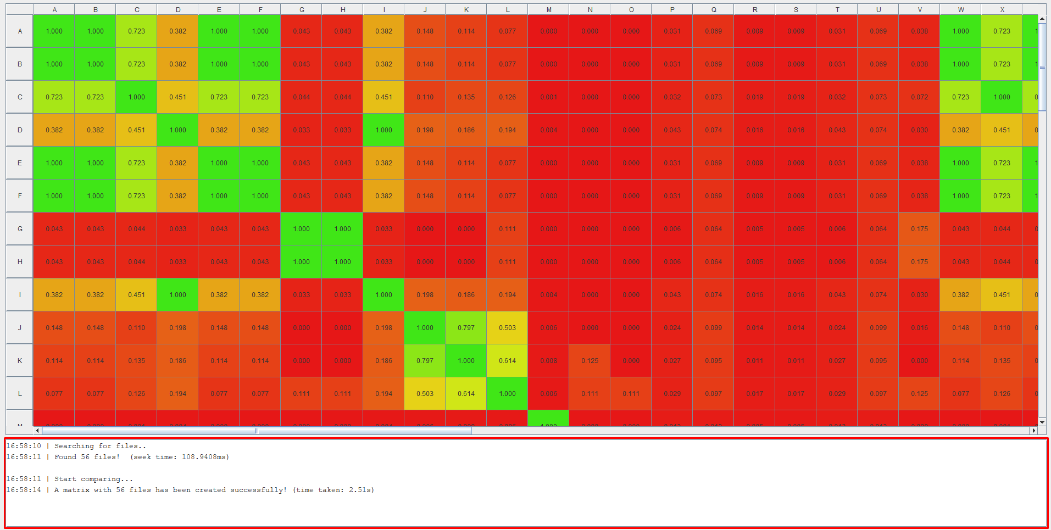

Here you will find feedback based on your interactions with the application. For example, you can see computation times for the comparison and root-search features as well as current information on the files you select for the side-by-side comparison.

**Important**: If you started a .xml or .json comparison, the list will display a list of errors that occurred while parsing.