User Manual

MultiTextCompare

Content

General 2

File Selection 3

Comparison 6

Configuration 9

Additional information 11

## General

Once the application is opened, you will see the main screen. It hosts a large area for the similarity matrix and a log for displaying information. Additionally, there is a menu found at the top of the screen with four tabs.

The file tab will allow you to open the file selection panel for the files you want to compare. Within the same tab, there is also the possibility to save or load past matrices to continue working on past sessions.

The configuration tab allows you to open the settings menu in addition to a save/load functionality for your custom configurations. Should there be no custom configuration, there will be a default config loaded into the application. Configurations can be edited via the Settings menu.

Within the log tab, you can set your desired log level, display the current log file and clear the log entirely. Note that there will be a new log file for each day to keep everything organized.

Finally, the help tab allows you to open this file, the about page and the developer documentation.

Many of these functions can be also accessed via the quick access tab. To know what each button does you can hover over them to get a tooltip with the corresponding functionality.

**Note:** Some of the screenshots may feature an alternate look for the panels. These were not updated, since the actual layout was not changed and they still work identically.

## File Selection

There are two ways to add files for the comparison:

1. “Root-Search”: You can set a custom root directory using the “Set directory..” button. All of its subdirectories will be searched.

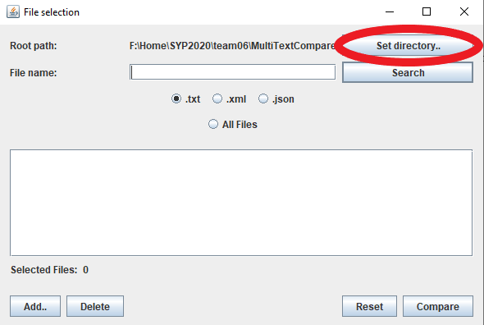

Next, you need to type in a filename to search for. Capitalization does not matter here.

It is possible to use *wildcard characters*:  
“?” replaces a single character

“*” replaces any number of characters

Additionally, you need to choose a file type:

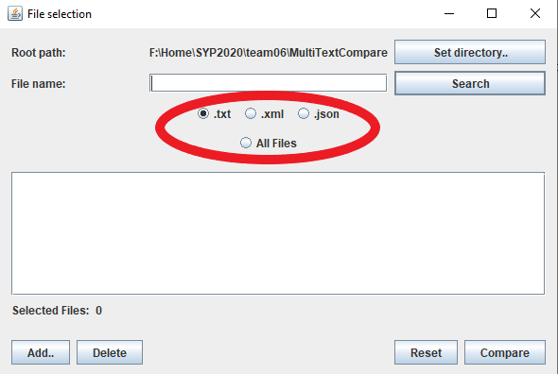

If you do not want to specify one of the three currently supported file types, you can choose the “All Files” option and type in a file name **with its extension** or use a wildcard for the extension (e.g.:“config.*”).

To initiate the search, click the “Search” button next to the “File name” field.

**Examples:**

Searching for: “config?”

Selected Type: .txt

Will find: configA.txt, config7.txt, configx.txt

Will NOT find: configAA.txt, config.txt, configA.xml, configA.abc

Searching for: “FileExampleName.abc”

Selected Type: All Files

Will find: Every file named *exactly*“fileexamplename.abc”

Will NOT find: Any other files

Searching for: “*”

Selected Type: .xml

Will find: ALL .xml files in the directory

Will NOT find: Any other file types

**Important**: To use the .xml or .json specific parameters, the associated file type has to be selected.

1. Manual addition: If you wish to add specific files manually, you can do so by clicking the “Add..” button in the bottom left corner. This can of course be combined with the root-search function.

**Note**: You are only able to add files of the selected file type.

**Deletion**

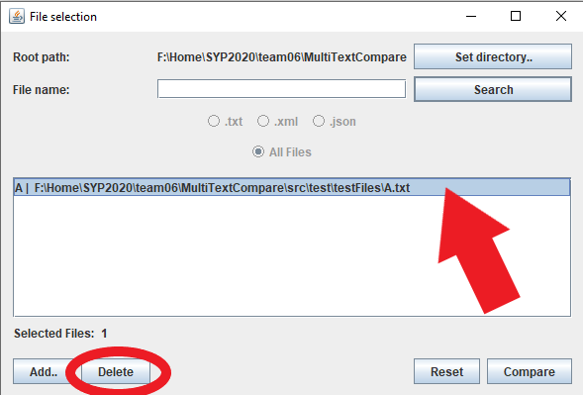

You can choose to delete certain files from the selection. Just click on the file, and then click on the “Delete” button.

By holding *Ctrl*, you can select multiple files at once.

By holding *Shift*, you can select multiple files in one segment.

If you want to completely reset the file selection, click the “Reset” button in the bottom right.

## Comparison

After selecting your files, click the “Compare” button to start the comparison. Depending on the chosen files, this might take a moment. While waiting, you can view your chosen files double-clicking them in the file selection list. This will open the unchanged file in a separate window.

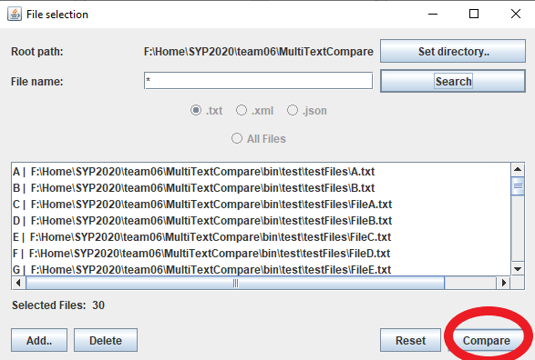

After clicking “Compare” in the file selection menu, you will see a matrix. If you want to see which files are mapped to which letters in the row and column headers, you can either check in the file selection list, or hover your mouse over the column headers.

The values of similarity are displayed here, and they colored accordingly. Additionally, you can zoom in and out of the matrix by holding *Ctrl* and scrolling with the mouse wheel. Alternatively, the plus and minus buttons in the quick access bar can be used. Holding *Shift* while scrolling, will use the horizontal scrollbar instead of the vertical one.

**Comparing two files**

If you double-click a cell within the matrix, a new window will open with a side-by-side diff of the files within the row and column:

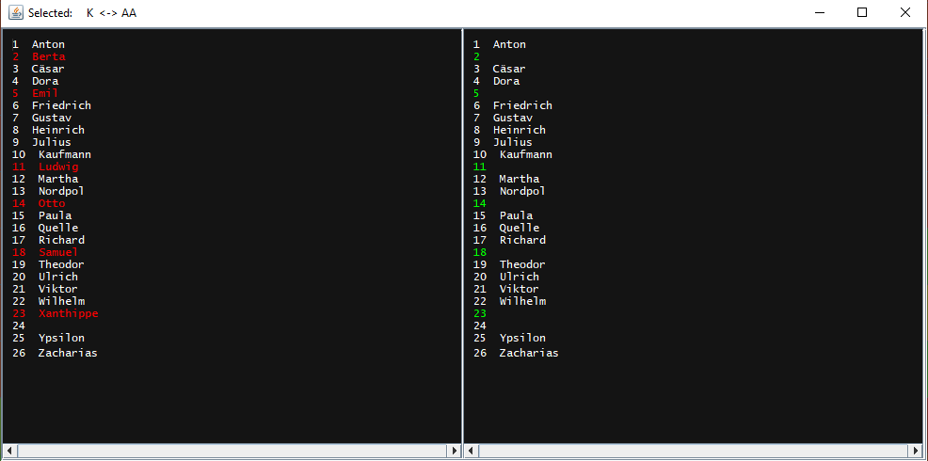

**Comparing three files**

You can select a cell as a reference-cell via holding *Ctrl* and clicking it. The matrix will be greyed out accordingly. 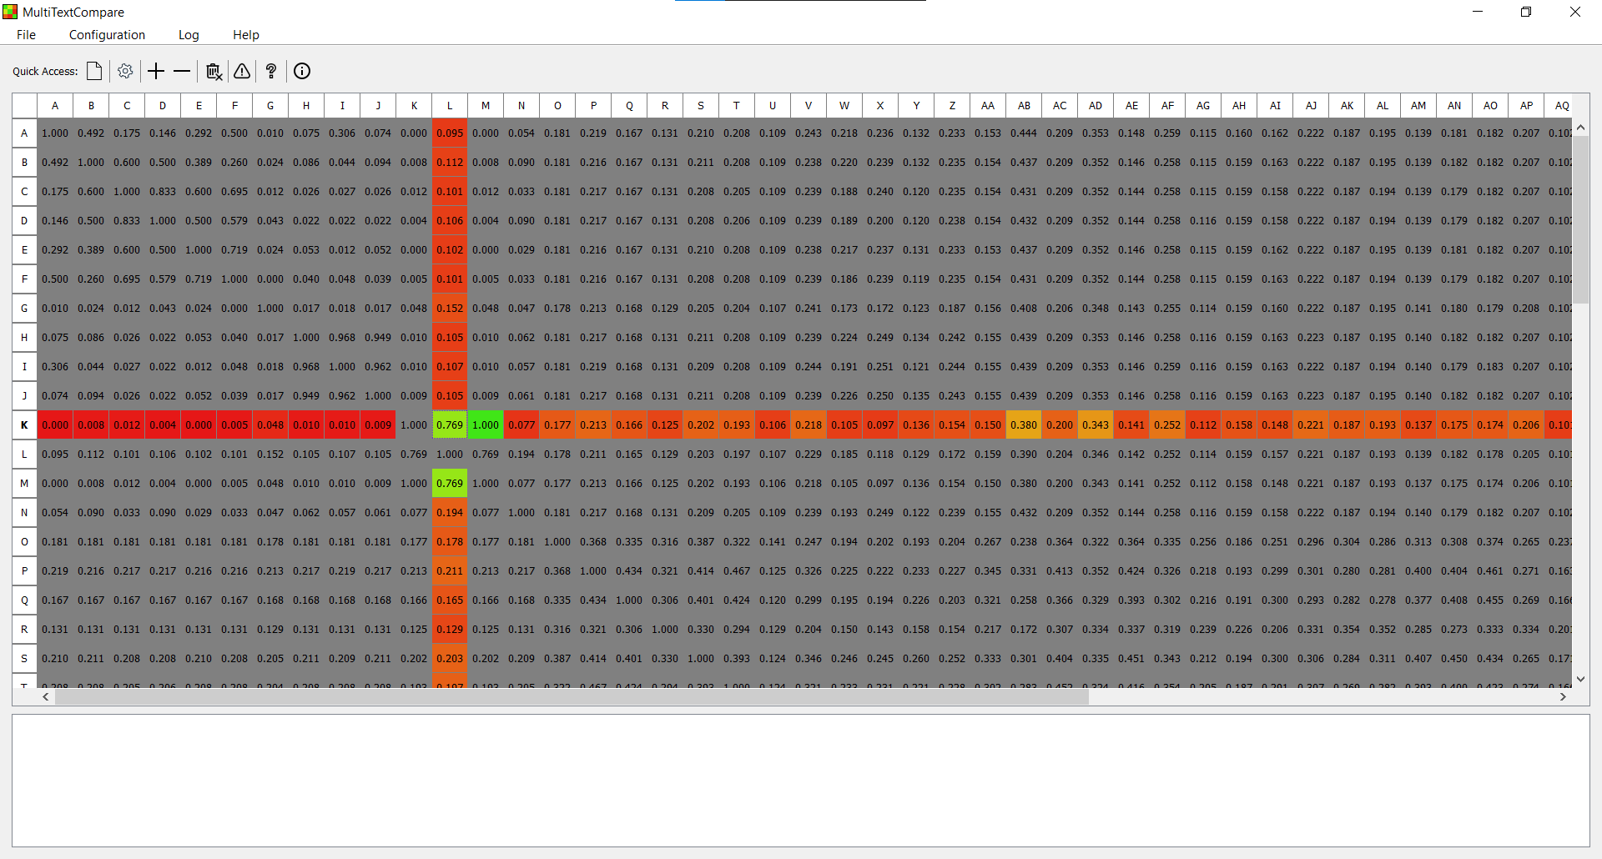

Now you can open a third file by clicking onto one of the colored cells. You will now see the two files which were selected as reference, plus the third file you just clicked.

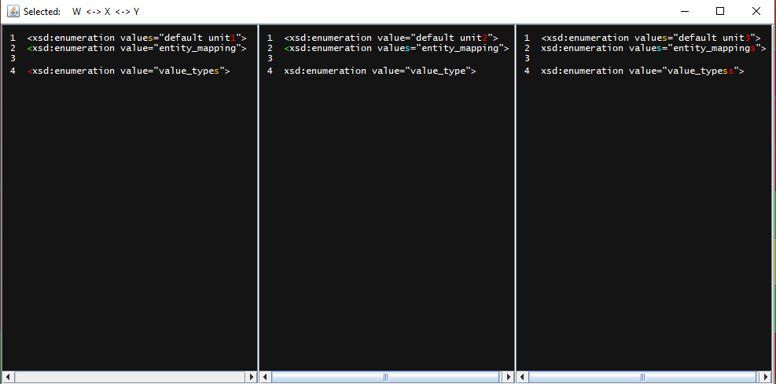

**Note**: Each of these panels is individually scrollable on the horizonal axis and synced on the vertical axis. Also, line wrap is disabled, so all lines are synchronized. All panels can be individually adjusted in width.

**Coloring**

To show the differences, the characters are highlighted in up to five colors:

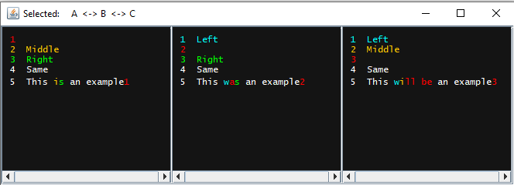

**Blue**: Difference to the left file

**Orange**: Difference to the middle file

**Green**: Difference to the right file

**Red**: Difference to both other files

**White**: No difference

## Configuration

**General:**

* **Keep**…: If these boxes are ticked, the comparison will take the respective parameter into consideration.
* **Maximum line length:** An optimization setting to limit the longest possible line length that will be compared. For most accurate results, this should be kept at a value of 0.
* **Comparison mode**: Selects the comparison mode. For *Compare lines,* the comparison value will be calculated on a line-to-line basis, as opposed to *Compare characters*, where the whole set of characters will be compared.
* **Root search path:** The application will search files within this directory and all of its child directories.
* **Open last comparison on startup:** If selected, the application will open your last saved comparison on startup.

**Matching:**

* **Match lines**: This box affects how the side-by-side comparisons are visualized. If ticked, it will show identical lines on the same line number, even if they were in different places originally.
* **Look for best match:**  Instead of stopping at the first matchable line, the program will try to find a better match
* **Match lines at x% similarity:** Sets the threshold at which lines are considered similar for matching
* **Matching lookahead:** Sets the number of lines that the matcher will try to match. After this limit, it will go over to the next line. If set to 0, the lookahead will not be enabled. This setting affects standard and best matching options.

**XML:**

* **Validation:** 
  + **None: T**he parser will not do any validation to the given files.
  + **Internal XSD:** The parser will validate the XML-file against any internally referenced XSD File.
  + **DTD**: If this box is ticked, the parser will validate the XML-file against any internally referenced DTD.
* **Print:**
  + **Pretty:** Normalizes tabulators and spaces as well as whitespaces on the comparison shown.
  + **Raw:** Will take the original whitespaces/tabulators/spaces etc. as found in the reference file.
  + **Compact:** Will make a compact one line out of the given XML-file.
* **Sort elements:** XML-Elements will be sorted alphabetically before the comparison is made.
* **Sort attributes:** XML-Attributes within Elements will be sorted alphabetically before the comparison is made.
* **Delete attributes:** XML-Attributes within Elements will be deleted before the comparison is made.
* **Delete comments:** XML-Comments within the XML-file will be deleted before the comparison is made.
* **Only tags:** Strips Attributes, Comments and Content from the XML-file. Only the Element Tags remain.  
  Since those Elements do no longer contain content, they are converted into the short notation.
* **Use semantic comparison:**  Instead of using the comparison algorithms set on the “General” tab, use a specialized comparison mode for XML, which focusses on comparing tree structures of documents.
* **Compare comments:**  In semantic comparison, decide if comments will be handled as nodes.

**JSON:**

* **Use semantic comparison:**  Instead of using the comparison algorithms set on the “General” tab, use a specialized comparison mode for JSON, which focusses on comparing tree structures of documents.
* **Keep JSON-Array order:**  If selected, JSON-Arrays will not be sorted when the sort keys option is ticked.
* **Sort keys:** JSON Key Value Pairs will be sorted in alphabetical order before the comparison is made.
* **Delete values:** JSON Key Value Pairs will be stripped of their Value, JSON Arrays will be emptied.

Clicking the “Defaults” Button will restore the default values. After you are done with the configuration, click the “OK” or “Save as” Button. The configuration will also be saved for the next time you start the application.

**Important**: If you change the settings while a matrix has already been generated, the changed will not apply for the current matrix. You need to generate a new matrix for the changes to be applied. The only exception is made for settings under the “Matching” tab

## Additional information

**Logging**

A log with timestamps is located in the main window, right beneath the matrix:

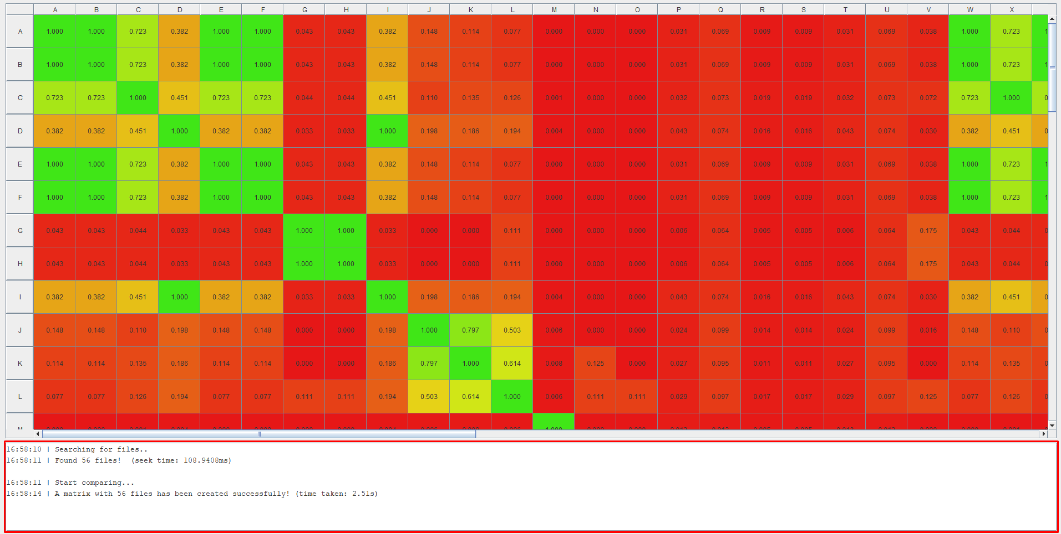

Here you will find feedback based on your interactions with the application. For example, you can see computation times for the comparison and root-search features as well as current information on the files you select for the side-by-side comparison.

**Important**: If you started a .xml or .json comparison, the list will display a list of errors that occurred while parsing. These errors can be viewed in detail via the error panel within the quick access bar.