**Evaluation**

create database evaluation;

use evaluation;

go

create table occupation(

occupationId int primary key not null,

job varchar(20)

)

go

create table customer(

customerId int primary key,

customerName varchar(20),

age int not null,

gender varchar(20) not null,

occupationId int foreign key references occupation(occupationId)

);

go

create table userDetail(

customerId int foreign key references customer(customerId),

hobbies varchar(20),

genre varchar(20),

food varchar(20)

);

go

insert into occupation(occupationId,job)

values(001,'Doctor'),

(002,'Software Engineer'),

(003,'Designer'),

(004,'Soldier'),

(005,'Contractor');

go

insert into customer(customerId,customerName,age,gender,occupationId)

values (101,'Gokul', 18, 'Male',005),

(102,'Smitha', 27, 'Female',004),

(103,'Priya', 24, 'Female',002),

(104,'Roy', 35, 'Male',001),

(105,'Ramesh',28, 'Male',003);

go

insert into userDetail(customerId, hobbies, genre, food)

values(102,'Painting','drama', 'pizza'),

(102,'Reading','horror', 'pizza'),

(101,'Gardening','comedy', 'Biriyani'),

(101,'Playing','action', 'pasta'),

(103,'Reading','drama', 'Fried Rice'),

(103,'Cycling','sci-fi', 'Burger'),

(103,'Playing','action', 'Biriyani'),

(104,'Reading','horror', 'pasta'),

(105,'Singing','comedy', 'Fried Rice'),

(105,'Playing','horror', 'Burger'),

(105,'Reading','drama', 'Mojito');

go

—------------------------------------------------

1) select hobbies as 'most prefered hobby' from userDetail

group by hobbies

order by count(*) desc

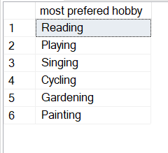

2)select customer.customerName, count(food) as ' More Favorite foods' from userDetail join customer on userDetail.customerId = customer.customerId

group by customerName having count(food) >1;

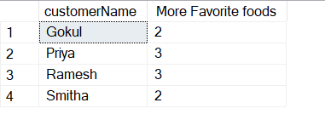

3)

select customerName,age,gender from customer join userDetail on customer.customerId userDetail.customerId

where age > = 40 and genre = 'horror'

and food = 'pizza'

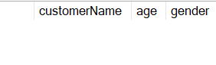

No one as max age we input is 35

4)db.collection.insertMany(

... [{"id" : 1,

..... "name":"Gokul",

..... "age":21,

..... "hobbies":["Swimming","Reading","Playing"],

..... "food":["Biriyani","Fried Rice","Pizza"],

..... "genre":["drama","horror"]

..... ,"gender":"Male",

..... "occupation":" Software Engineer"},

... {"id":2,

..... "name":"Rahul",

..... "age":17,

..... "hobbies":["Playing","Reading",”Gardening”],

..... "food":["Pizza","Biriyani"],

..... "genre":["horror","comedy"],

..... "gender":"Male",

..... "occupation":"Manager"},

... {"id":3,

..... "name":"Gowri",

..... "age":28,

..... "hobbies":["Reading","Gardening"],

..... "food":["Biriyani","Pizza"],

..... "genre":["Action"],

..... "gender":"Female",

..... "occupation":"Doctor"},

... {"id":4,

..... "name":"Arya",

..... "age":38,

..... "hobbies":["Dancing",”Reading"],

..... "food":["Fried Rice","Pasta"],

..... "genre":["action","drama"],

....."gender":"Female",

..... "occupation":"Designer"},

... {"id":5,

..... "name":"Rohit",

..... "age":47,

..... "hobbies":["Playing","Reading"],

..... "food":["Burger","Fried Rice"],

..... "genre":["action","comedy"],

..... "gender":"Male",

..... "occupation":"UI Designer"}])

5)db.collection.find().sort({id:-1}).limit(1);

[

{

_id: ObjectId("61de8183794333038f47f003"),

id: 5,

name: 'Rohit',

age: 47,

hobbies: [ ‘Playing’,’Reading’],

food: [ ‘Burger’,’Fried Rice’],

genre: [ 'action',’comedy’ ],

gender: 'Male',

occupation: 'UI Designer'

}

]

**Db design**

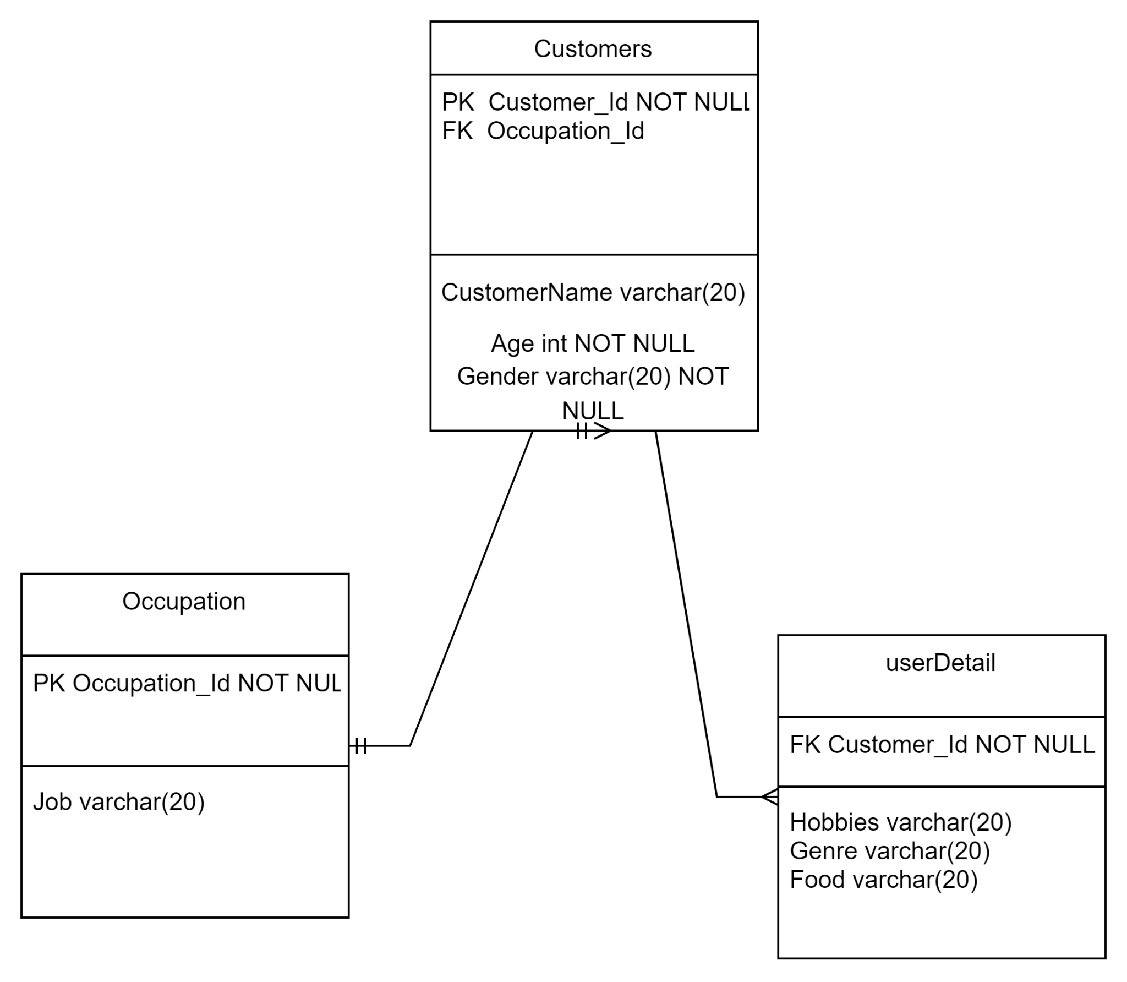

**Rest API**

| Description | For registering |
| --- | --- |
| Url | api.com/v2/dateregistrations |
| HTTP Method | POST |
| Data Passed |  |
| Data Received |  |
| Expected Response | 201 CREATED |
| Expected Error | 204 no content |

| Description | For Getting partner detail |
| --- | --- |
| Url | api.cms.com/v1/dateregistrations |
| HTTP Method | GET |
| Data Passed |  |
| Data Received | {“data”:  {“name”: “Rahul”,”age”: “25”,”hobbies”:”Reading”}} |
| Expected Response | 200 OK |
| Expected Error | 404 not found |