**Aklil T/Mariam id# mit/ur99829/08**

**Successive calculation method of risk analysis(Lichtenberg’s method)**

Risks can be defined as the likelihood and consequence of events, which if they occur, affect business objectives, project objectives, external environment or working environment in a negative way. Risk management is considered to be important in projects, and if managed well, helps project to keep within given budget and time. There are different methods that can be used when working with risks to describe them better, and be able to calculate more accurate budgets.

The quantitative risk analysis is the process that aims to numerically analyze the identified risks and determine how they affect the overall project objectives. It is performed on risks according to the prioritization from the qualitative risk analysis, where the risks are analysed regarding on the impact they may have. The input needed for this process consists risk list, risk management plan, plan for cost control, plan for timing and the organization’s existing practices. And the output from this process will be updated risk list, probability of the project, probability of achieving cost and time frames, priority list of quantified risks and trends on the qualitative risk analysis Examples of quantitative risk analysis methods are : Monte Carlo, Sensitivity Analysis and Successive calculation(Lichtenberg’method).

In this assignment we will discuss about the third quantitative method, successive calculation method that was developed by Steen Litchenberg in the 70’s. The goal for successive calculation is to create realistic cost estimations based on facts that the future is uncertain. The method gives a good estimation and statistical theory. All projects have uncertainties and risks, successive calculation aims at identifying those risks and uncertainties and minimise the impact they can have, also the probability for them to happen, at all.

The successive calculation method is an instrument for general managers, project managers, decision-makers and planners. The methods helps to be more proactive in projects and get good overview of the content, what consequence factors have, and what improvements that can be made in an early stage. There is more focus on the identification, analysis, evaluation and work with uncertainties, than traditional calculation methods.

Some fundamental principles of the successive principle:

*Accept uncertainty -* projects are involved with risks, best way to handle them is trying to identify, evaluate and hopefully eliminate those risks.

A *Top-down technology -*when cost elements are estimated, they are broken down from top to the bottom.

*Statistical calculation -*is used in the method to evaluate the results based on the probability of achieving a result.

*General uncertainties* -refers to elements that aren’t described in the overall WBS but affect several cost items, for example, public opinion and political decisions.

An *analysis group* that has a broad range of expertise in different field, and they should meet the requirements of the actual issue.

The successive principle also requires that the qualitative phase of risk management has been performed in a satisfying way. One of the thing that the analyses group needs do decide at is how detailed the analyses should be for the project, programme or the tasks,this is important to decide at an early stage.

The ‘Triple group estimate method’ is used for each main item in the project. The group decides the extreme minimum, most likely and extreme maximum for each item and this will result in a variance for each item. The item is then broken down into smaller pieces to see how much uncertainty that the item has.

Calculate with the successive calculation principle

*factor mean value(m)(EV) =(min + 3 x most likely + max )/5*

*local conditional uncertainty (s) = (max-min)/5*

*relative or percentage uncertainty s/m %*

the *local mean value(M)* of the local item is calculated by multiplying the m-values of related factors to get M=m.

The related uncertainty linked to the local item: local standard deviation(So) is not defined for the item, but for the underlying factor as M x s/m , if the item is evaluated directly, then :So=s

The effect of a single local uncertainty on the grand total S=TF x So ,TF=transformation figure

The transformation figure is used to convert the local So-values into the related effect(S) on the grand total value. The size of (TF) equals the final effect on the grand total from one unit of the local item,(TF)=1 in master estimate or top level estimate.

The global mean value of the total result is calculated all the M-figures as normal fixed,deterministic figures. The priority figures(P) =SxS for all factors and items at the lowest level of detailing

The uncertainty of the grand total, the standard deviation (Sglobal) is calculated as the square root of the sum of all priority figures.

Let’s see an example :

first the main item must be calculated see figure-1

after this, the main items are calculated further see figure-2

The main item 1 has been broken down into smaller sub-items to reduce uncertainty. This procedure

can be done on all the main items, or the ones the analysis group choose to work further with.

After working with the main items and calculating them into sub-groups, the corrections need to be

broken down into smaller groups to reduce the uncertainty, or to find the source for the uncertainty.

The corrections with the highest priority figure (P) are the one that the group should start with.

Overall corrections are broken down, and calculated with a triple estimate as figure-3 shows.

The uncertainty is expressed as the global standard deviation and is the sum of all priority figures,

and gives the decisions-makers a good input when they decide how the project should plan for

further work.

As figure-4 shows the overall correlations have been related to value on the base case total, using

(s/m). This factor is multiplied with the grand total in order to get the standard deviation of the total

result (S). This corrects the error that people underestimate the uncertainty of overall correlations.

The transformation figure (TF) is used on the main items if they are not broken down further, in

figure-5 (TF) is 1,61 and are multiplied by the local standard deviation s in order to get the standard

deviation of the total result (S),

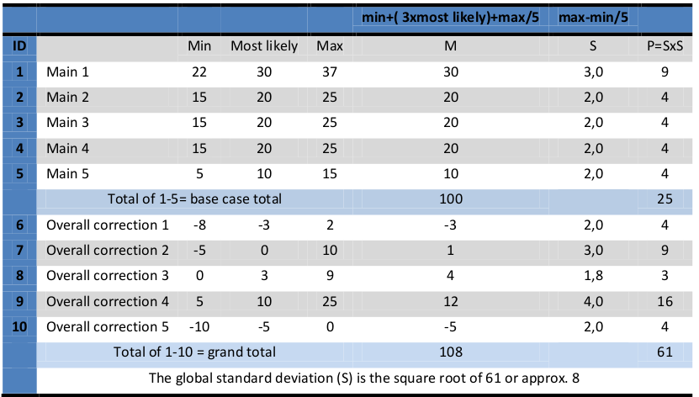

figure-1

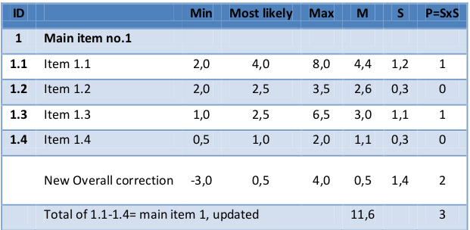

figure-2

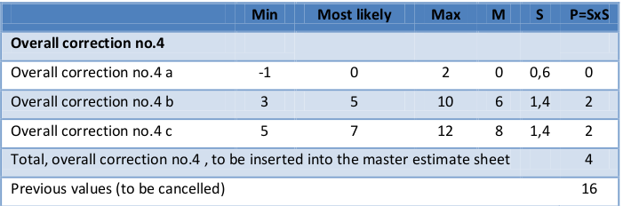

figure-3

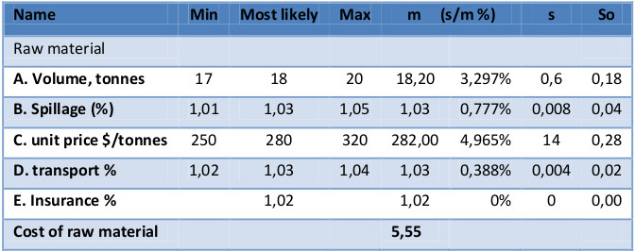

figure-4

