Exploring Weather Trends

Anna Lindquist

Project outline

1. Access data using SQL and export as CSV file
   1. Data exported as a single CSV with columns for year, Minneapolis average annual temperature (mpls_temp), and global average annual temperature (global_temp)
   2. Limited the data to 1750-2013 because data was available for both Minneapolis and globally in this range
2. Import CSV to pandas dataframe using python/spyder
   1. Set index to year values
   2. Calculate moving average using df.rolling(window=7).mean()  
      This function calculates the mean of the previous 7 values because the window was selected as 7, and the calculation used is mean  
      In other words, this calculates the mean of a current value and the six preceding values and assigns that mean to the last of those seven values.
3. Create a plot with the global and Minneapolis data together
   1. I chose to plot these on the same figure to facilitate comparisons between the datasets. The values for the Minneapolis data were a couple degrees lower than the global temperatures, so I could easily plot these together without the plots interfering and becoming difficult to read.
   2. I added grid lines to the plot. Though this makes the plot less visually appealing, I also think it makes it easier to draw comparisons.
   3. I included axis labels, a title, and a legend to make it easier to interpret the data and understand the plot without a figure caption (or similar).
   4. The lines are different colors to make them distinguishable.

SQL Query

SELECT c.year, c.avg_temp AS mpls_temp, g.avg_temp AS global_temp

FROM city_data AS c

INNER JOIN global_data AS g

ON c.year = g.year

WHERE c.city

LIKE 'Minneapolis';

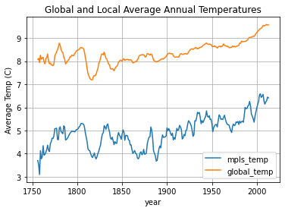

**Observations**

1. Minneapolis is colder than the global temperature by about 3-3.5 degrees. This makes sense because Minneapolis is fairly far north and the global temperature averages over the whole planet.
2. The Minneapolis city data is more variable than the global data, even with the 7-day moving average.
3. Overall, both the Minneapolis average and the global average temperature have increased over the last 250-ish years. They seem to both show a somewhat stable average temperature until ~1900 when the temperature begins to increase noticeably.
4. Minneapolis is especially cold at the start of the time series – possibly related to the Little Ice Age? This is less visible in the global data, which makes sense because I believe the Little Ice Age was primarily a northern hemisphere climate feature.
5. The data from 1750-1850 show larger decadal-scale variations, since the 1900s the global data seems dominated by increasing temperatures – is this because of changes in measuring global average temperature or because global temperatures are increasingly dominated by climate change.