On the first two pages of this Template are examples of the various types of headings and text that should be used when preparing an STO paper, as well as the format for the top portion of the 1st page of the paper which notes the title and author information). Note that the formatting for each of these is stored as a ‘style’ available from the “Styles and Formatting” menu . The third page provides information on to how to populate the information contained in the Headers and Footers using the document PROPERTIES menu.

Paper Title (in Title Case)
Author Name
Author Address
Author Address
COUNTRY (UPPERCASE)
Author email address
Abstract
Abstract text Abstract text Abstract text Abstract text Abstract text Abstract text Abstract text Abstract text Abstract text Abstract text Abstract text.
1.0 STO fIRST LEVEL HEADING
STO text STO text STO text STO text STO text STO text STO text STO text STO text STO text STO text STO STO text.
1.1 STO Second Level Heading
STO text STO text STO text STO text STO text STO text STO text STO text STO text STO text STO text STO STO text.
1.1.1 STO Third Level Heading
STO text STO text STO text STO text STO text STO text STO text STO text STO text STO text STO text STO STO text.
      - STO Fourth Level Heading
STO text STO text STO text STO text STO text STO text STO text STO text STO text STO text STO text STO STO text.

Figure 1-1: Enter text.
(STO Figure Caption – appears below the figure)

Table 1-1: Enter text.
(STO Table Caption – appears above the table)

NOTE: http or www Internet addresses appear as ‘dark blue’ text.

- STO Bullet (1st Level)
- STO Bullet (2nd Level)

- STO Reference Text
See following page for “Header/Footer” information
The Headers and Footers in the templates contain specific information about the STO Publication and the document itself. In order to automatically generate this information, the following data must be entered into the Document Properties Summary Tab as follows – see Figure 1 and Table below:
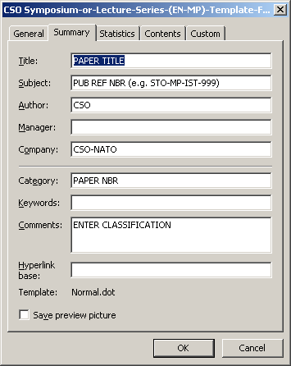
Figure 1: Document Properties Summary Tab.
(From the Menu: File → Properties → Summary Tab)
Title | Enter the title of the Paper
Subject | Enter the Report Reference STO-MP-AVT-211
Author/  Company | Leave the text as CSO/  CSO-NATO
Category | Enter the Paper Number as a simple numeric entry (e.g. 1, 2, 3 . . . .)
Comments | Enter the CLASSIFICATION of the Report in CAPITAL LETTERS. This field can be left BLANK if the Report is open for public release NATO Unclassified – Releasable to AUS and SWE

Please note that the Headers and Footers will NOT be visible until you display the document in Print Preview mode (from the Menu: File → Print Preview → Close).


