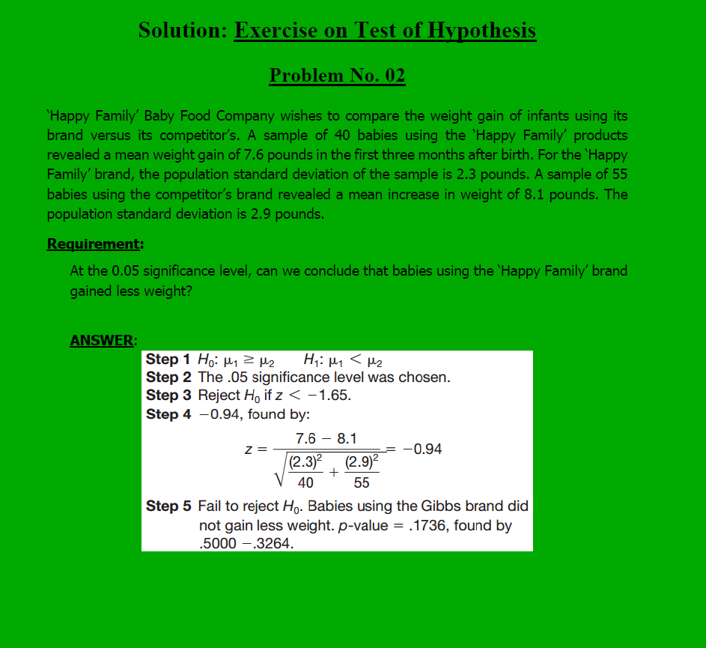

Through Z-test, we calculate the Z value which is in this case Z = -0.94. Next step is to pay a visit to Z-table, look for row with value 0.9 and column value 0.04. The intersection of row and column contains the probability of this Z-value value. In the following image,
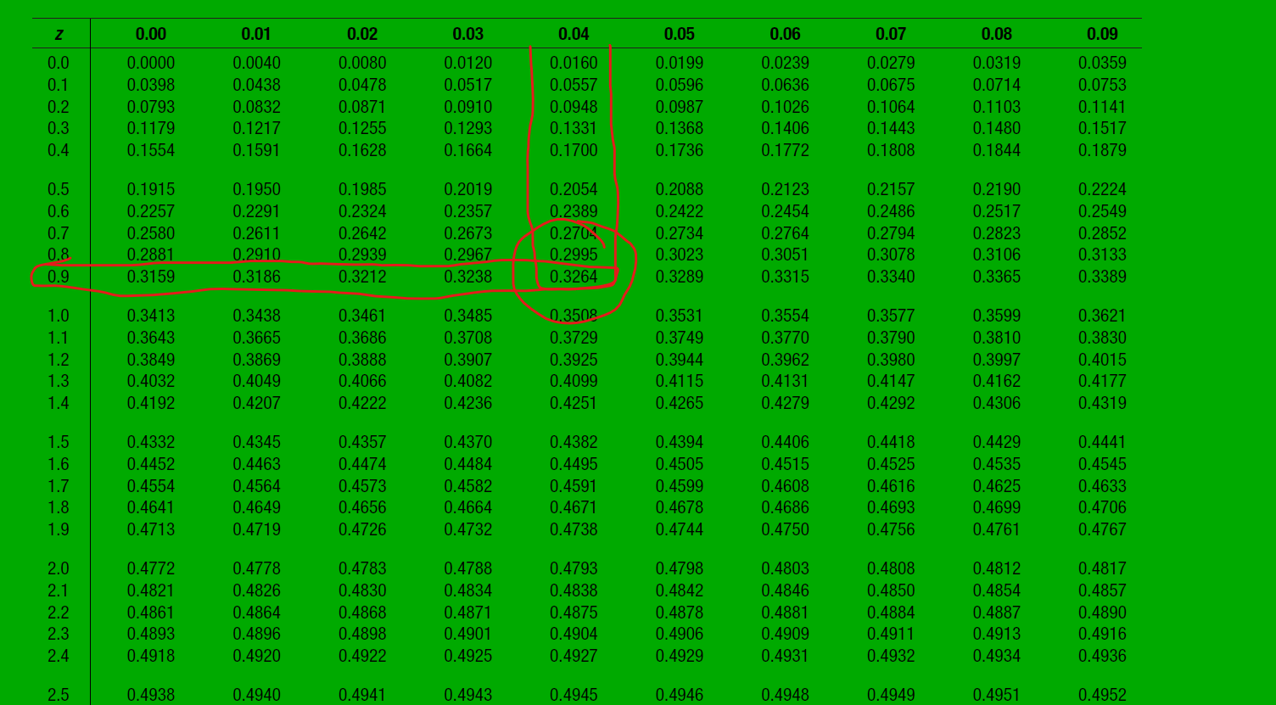

So for |z| = 0.94 the probability is 0.3264. If we subtract this, from 0.5-0.3264 = 0.1736 is the p-value in this case it is greater than 0.05 alpha or significance level therefore, we cannot reject the null hypothesis. If it is less than significance level then we have to reject the null hypothesis.

How to pick null and alternate hypothesis
1. The "Equality" Rule
The most important rule is that the Null Hypothesis must contain an equal sign. The Alternative Hypothesis never does.
Null hypothesis(H₀): Always uses =, >=, <=. It represents the "status quo"—the assumption that nothing has changed or there is no effect.
Alternative (H₁): Always uses !=, >, <. It represents the claim you are actually trying to prove (the "challenge").
2. The "Burden of Proof" Logic
Think of a hypothesis test like a court trial
(Innocent): We assume this is true from the start.
(Guilty): This is what the "prosecutor" (you, the researcher) is trying to find evidence for.
Example: A company claims their lightbulbs last 1,000 hours. You think they last less.
- H₀: u = 1000 (The claim is true).
- H₁: u < 1000 (The suspicion\alternate)

