Problem 1:


Your solution showed followings,
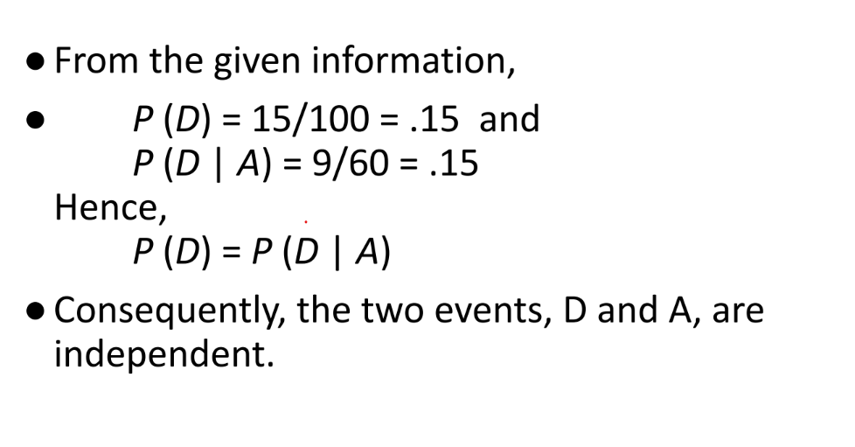
But the above two events are dependent. If you change the total defective CD to 16. Then
P(D) = 16/100 = 0.16
And the other measurement is still P(D|A) = 9/60 = 0.15. Another way to say.
Using Tree method, P(D) = P(M1) * P(D|M1) + P(M2) * P(D| M2) = (60/100)*(9/60) + (40/100)*(7/40)=(9/100) + (7/100) = 0.09 + 0.07 = 0.16
So, the two event are dependent as P(D|A) != P(D) where A= event that represent CD manufactured by machine one (M1) and, D = event that represent a randomly selected CD is defected.

