**CNN Model for Digit Classification using SVHN Dataset**

Name: Akmal Ali

Roll No: GIL-DSAI-249

Section: 05

Email: [akmal.aleee@gmail.com](mailto:akmal.aleee@gmail.com)

Github Profile Link: <https://github.com/akmal-05>

# Objective:

The objective of this project was to design, train, and evaluate a Convolutional Neural Network (CNN) model for the classification of digits (0-9) using the SVHN (Street View House Numbers) dataset. Initially, the model exhibited high training accuracy but suffered from over fitting, as demonstrated by lower performance on the test set. To combat this, regularization techniques such as **L2 Regularization** and **Dropout** were introduced to enhance generalization and prevent over fitting.

# Steps Involved:

## 1. Dataset Overview:

The SVHN dataset contains images of house numbers taken from Google Street View. We used the cropped digit format consisting of 32x32 RGB images. The task was to classify digits (0-9) based on the image data.

## 2. Preprocessing:

- The dataset was loaded using .mat files.

- The images were reshaped from (32, 32, 3, num_samples) to (num_samples, 32, 32, 3) for compatibility with TensorFlow/Keras models.

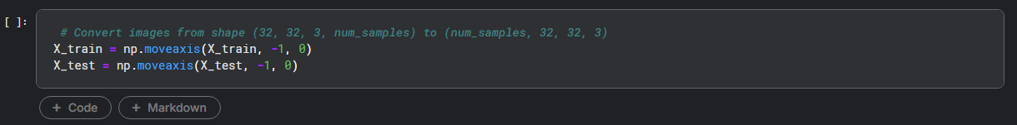

- The pixel values were normalized (scaled between 0 and 1) for better model training.

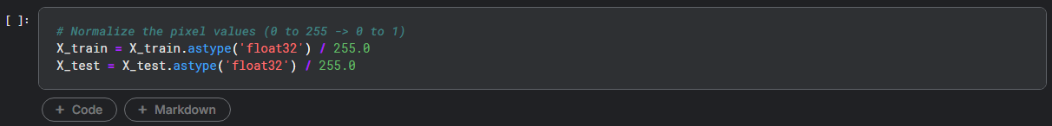

- Labels were one-hot encoded to make them compatible with the categorical crossentropy loss function.

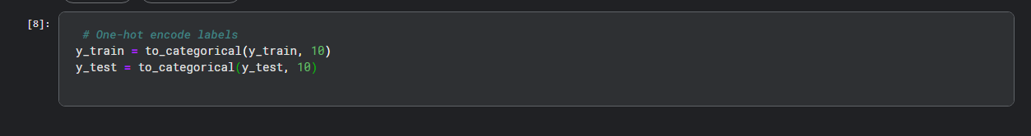

## 3. Model Architecture:

A simple CNN was designed using the Keras Sequential API:

- Three Conv2D layers with ReLU activation.

- L2 Regularization added to the convolutional and dense layers to penalize large weight values, encouraging smaller, more generalized weights.

- Dropout Applied between layers to randomly drop neurons during training, forcing the network to learn more robust features.

- A Flatten layer to convert the 2D output into 1D for fully connected layers.

- One Dense layer (fully connected) with 128 neurons and ReLU activation.

- An output Dense layer with 10 neurons and softmax activation to output class probabilities for each digit.

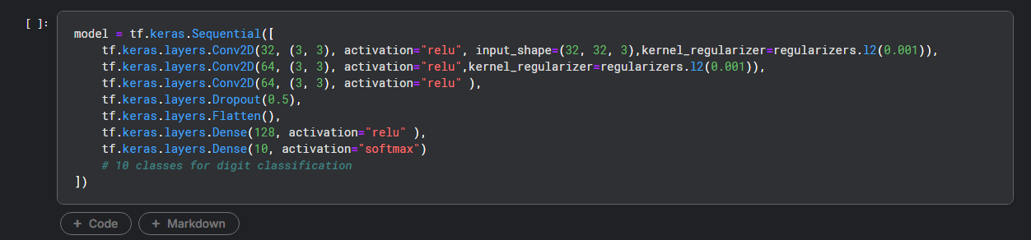

## 4. Model Compilation and Training:

- Optimizer: Adam

- Loss Function: Categorical Crossentropy

- Metrics: Accuracy

The model was trained using the following parameters:

- Epochs: 10

- Batch Size: 64

- Validation Data: Test set

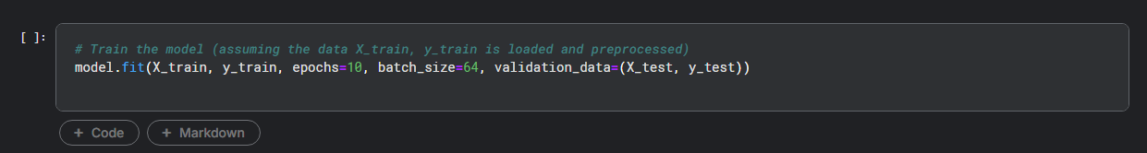

## 5. Model Evaluation:

The model was evaluated on the test dataset to ensure it generalized well to unseen data. The following metrics were computed:

- Test Accuracy: This was obtained using the model.evaluate() function, which returned the loss and accuracy on the test set.

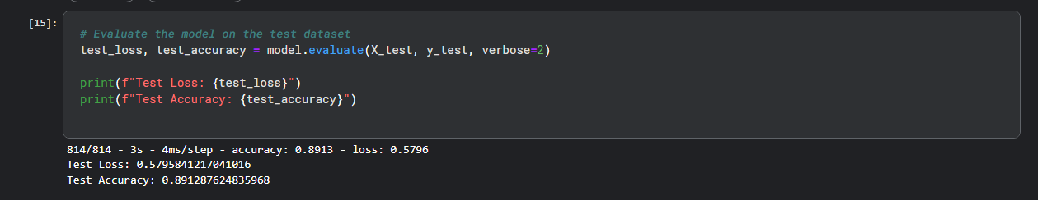

## 6. Detailed Performance Metrics:

To measure additional performance metrics like precision, recall, and F1-score, the predictions were made on the test set and compared with true labels using the classification report from scikit-learn. A confusion matrix was also generated to visualize misclassifications.

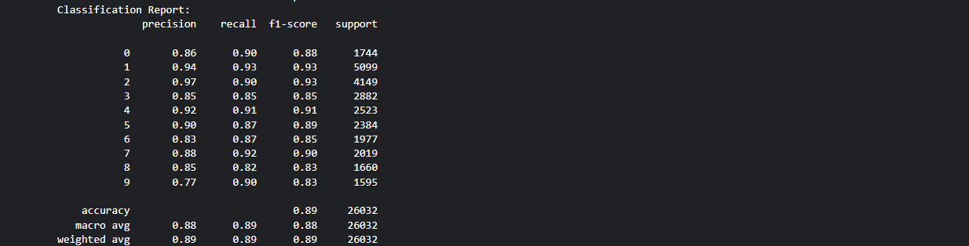

# Results:

## 1. Accuracy:

The model achieved a test accuracy of approximately 89% (replace with actual value after running the code)

## 2. Confusion Matrix:

The confusion matrix visualized the model’s performance in predicting each digit. Misclassifications mainly occurred between digits that are visually similar, such as 1 and 7, or 9 and 4.

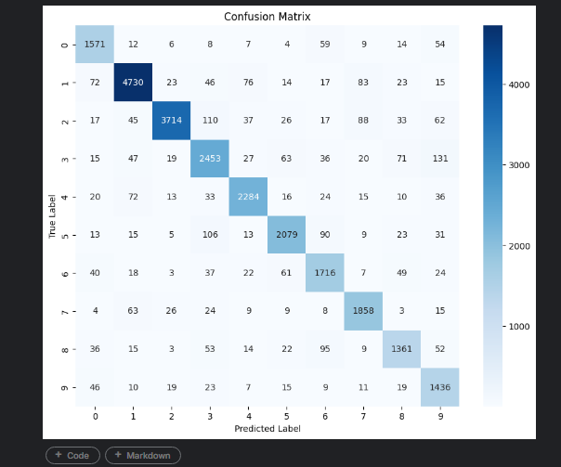

# Conclusions:

- The CNN model performed well on the SVHN dataset, achieving high accuracy and balanced precision/recall for each digit.

- Misclassifications observed in the confusion matrix can be attributed to visual similarities between certain digits, which might require more advanced architectures or additional data augmentation.

- The model could potentially be improved further by increasing the number of epochs, tuning hyperparameters, or adding more layers.

# Future Work:

- Data Augmentation: Apply transformations such as rotation, flipping, and zooming to increase the robustness of the model.

- Hyperparameter Tuning: Experiment with different optimizers, learning rates, and batch sizes.

- Advanced Architectures: Explore deeper networks like ResNet or use transfer learning techniques to improve performance.