FINAL YEAR PROJECT REPORT
FinGuard AI
An AI-Powered Personal Finance Tracker with Real-Time Fraud Detection, OCR Bill Scanning, and GPT-Assisted Savings Advice

Table of Contents

Abstract
Manual expense tracking is tedious, and most personal-finance apps stop at categorization — they record what happened but rarely tell the user anything actionable, and none of the common student-project references catch unusual or potentially fraudulent transactions in real time. FinGuard AI addresses this gap with a full-stack web application that combines conventional CRUD-based finance tracking with three machine-learning-driven capabilities: (1) real-time transaction fraud/anomaly scoring using a trained Isolation Forest model, (2) next-month expense forecasting using a trained regression model, and (3) natural-language savings advice, generated by a GPT model when available and by a deterministic rule engine otherwise, so the feature never depends on a paid API key to function. A fourth capability, OCR-based receipt scanning, lets a user photograph a paper bill and have the amount, merchant, and date extracted automatically via Tesseract OCR, with the parsed result always surfaced for human confirmation before being saved. The system is built on a FastAPI/Python backend with a React/Vite frontend, is fully containerized with Docker, and includes production concerns often skipped in student projects — rate limiting, structured error handling, environment-driven configuration, and an administrative panel for platform oversight. This report documents the requirements, design, implementation, and evaluation of the system, including the measured performance of both trained ML models.

Chapter 1: Introduction

1.1 Motivation
Personal financial mismanagement is rarely a single large decision — it is the accumulation of many small, unexamined transactions. At the same time, financial fraud (card skimming, phishing-driven purchases, subscription creep) often shows up first as a statistically unusual transaction: an amount far outside a person's normal spending pattern, or a sudden burst of activity in a category they rarely use. A system that flags such transactions the moment they are entered gives the user a chance to act while the situation is still recoverable, rather than discovering it during a monthly reconciliation.

1.2 Problem Statement
Existing personal finance tools largely fall into two camps: (a) simple ledger/expense-tracking apps with no intelligence layer, or (b) bank-integrated aggregators that require linking real financial accounts, which is inappropriate for a student project and raises real privacy/security concerns. There is a gap for a self-contained system that a user can populate manually or via receipt photos, and that still applies real machine learning — not just static thresholds — to catch anomalies and forecast spending.

1.3 Objectives
- Design and implement a secure, multi-user personal finance tracker with category-based budgeting.
- Train and integrate a machine-learning fraud/anomaly detection model that scores every transaction in real time.
- Train and integrate a regression model that forecasts the user's next month of spending from their own history.
- Implement an OCR pipeline that converts a photographed receipt into a structured, user-confirmed transaction.
- Provide natural-language financial advice, gracefully degrading from GPT to a rule-based engine.
- Build an administrative layer for platform-wide oversight, distinct from the end-user experience.
- Package the system for real deployment: containerization, environment-based configuration, CI, and a documented release process — not just a local demo.

1.4 Scope
The system is a self-contained web application. It does not connect to real bank accounts or payment networks; all transaction data originates from the user (manual entry or receipt photo). The fraud detection model is trained on a labelled synthetic dataset constructed to resemble realistic spending patterns with injected anomalies (see Chapter 5), which is an accepted and common approach for an academic project where access to real, labelled financial fraud data is not available.

1.5 Report Organization
Chapter 2 reviews related approaches. Chapter 3 covers requirements analysis. Chapter 4 presents the system design — architecture, database, and key flows. Chapter 5 covers the machine learning components in detail. Chapter 6 describes implementation. Chapter 7 covers testing and results. Chapter 8 covers deployment. Chapter 9 concludes with limitations and future work.

Chapter 2: Literature Review / Related Work
Commercial personal finance tools (e.g. Mint-style aggregators) rely on bank-API integrations and are closed-source, making their anomaly-detection logic unavailable for academic study; they are also unsuitable as a direct model for a student project since they require real account linkage. Academic and open-source fraud detection work commonly frames the problem as unsupervised anomaly detection rather than supervised classification, because labelled fraud examples are rare relative to normal transactions in any realistic dataset — a class-imbalance problem supervised methods handle poorly without heavy resampling. Isolation Forest (Liu, Ting & Zhou, 2008) is a widely used unsupervised method for exactly this reason: it isolates anomalies by random recursive partitioning, requiring fewer partitions to isolate an outlier than a typical point, and does not require a labelled training set of "known fraud" examples the way a classifier would.
For OCR-based receipt digitization, Tesseract OCR (an open-source engine originally developed by HP and now maintained by Google) is the de facto standard for a project of this scope, given its zero licensing cost and mature Python bindings (pytesseract). Commercial receipt-scanning products typically layer a second-stage NLP/template model on top of raw OCR text for higher extraction accuracy; this project takes a lighter-weight but transparent approach — regex- and keyword-based field extraction — and compensates for OCR's inherent unreliability on real-world receipts by always requiring user confirmation before a transaction is saved, rather than claiming an accuracy level the underlying OCR cannot reliably deliver.
On the LLM-assistance side, using GPT-class models for financial coaching/advice is an emerging pattern in fintech products; this project's contribution is architectural rather than novel-model — treating the LLM call as an optional enhancement behind a rule-based fallback, so that the core product does not depend on a third-party paid API to be demonstrably functional, which matters for both grading reproducibility and for any real deployment where an API key might be rate-limited, revoked, or simply not yet configured.

Chapter 3: Requirements Analysis
A condensed summary of the requirements is presented here; the complete, numbered functional and non-functional requirement list is in the accompanying SRS document (docs/SRS.docx).

3.1 Functional Requirements (Summary)
Module | Key requirements
Authentication | Register, login, JWT session, rate-limited login
Transactions | Create/list/delete, synchronous fraud scoring, CSV export
OCR Bill Scanner | Upload receipt, extract fields, human-confirmed save
Budgets | Per-category monthly limit, actual-vs-budget reporting
Fraud Detection | Real-time scoring, flagging, fraud log, admin review
AI Insights | Spend forecast, GPT/rule-based savings tips
Admin Panel | Platform stats, user management, fraud queue, CSV export

3.2 Non-Functional Requirements (Summary)
- Security: bcrypt password hashing, JWT auth, rate limiting, security headers, no default secrets in production.
- Reliability: graceful degradation for both the ML fraud model and the GPT integration if unavailable.
- Portability: identical codebase across SQLite/PostgreSQL/MySQL via one environment variable.
- Usability: every automated suggestion (OCR fields, category guess) is user-editable before commit.

3.3 Use Case Diagram
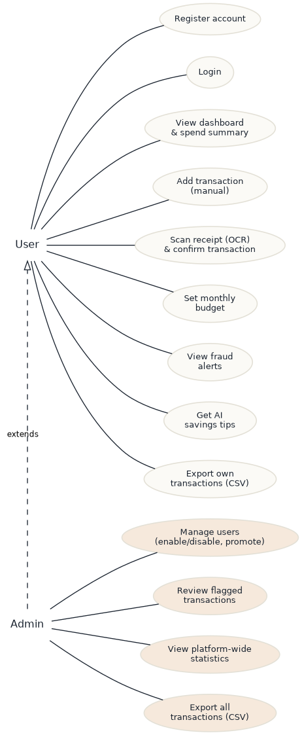
Figure 3.1 — Use case diagram: User and Admin actors and their interactions with the system.

Chapter 4: System Design

4.1 System Architecture
The system follows a conventional three-tier architecture: a React SPA client, a stateless FastAPI application server, and a relational database. The application layer is further decomposed into focused service modules (auth, transactions/budgets, OCR, ML, AI advice, admin, reports), each exposed through its own FastAPI router, which keeps the codebase modular and makes each concern independently testable.
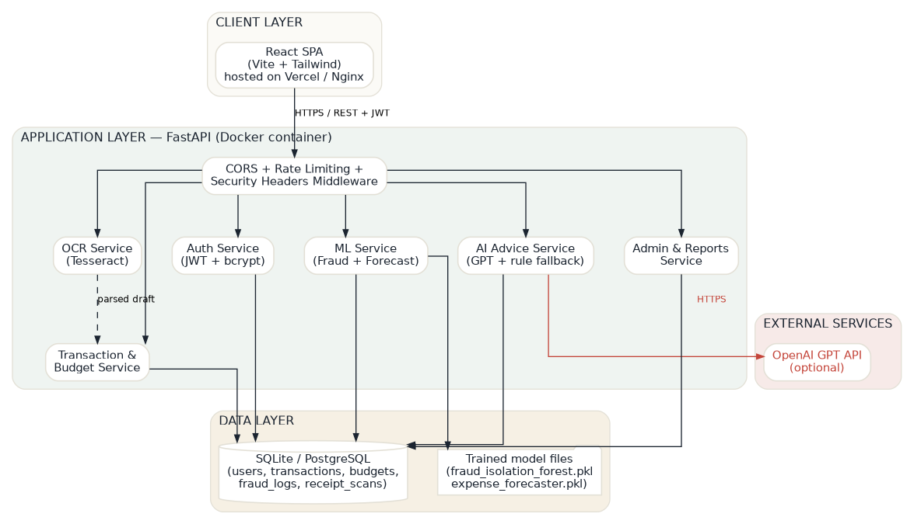
Figure 4.1 — Layered system architecture.

4.2 Database Design
The relational schema centers on the transactions table, which is referenced by fraud_logs (one row per flagged/scored transaction of interest), budgets (per user, per category, per month), and optionally receipt_scans, which records the OCR audit trail and links back to the transaction it produced, if the user chose to save it.
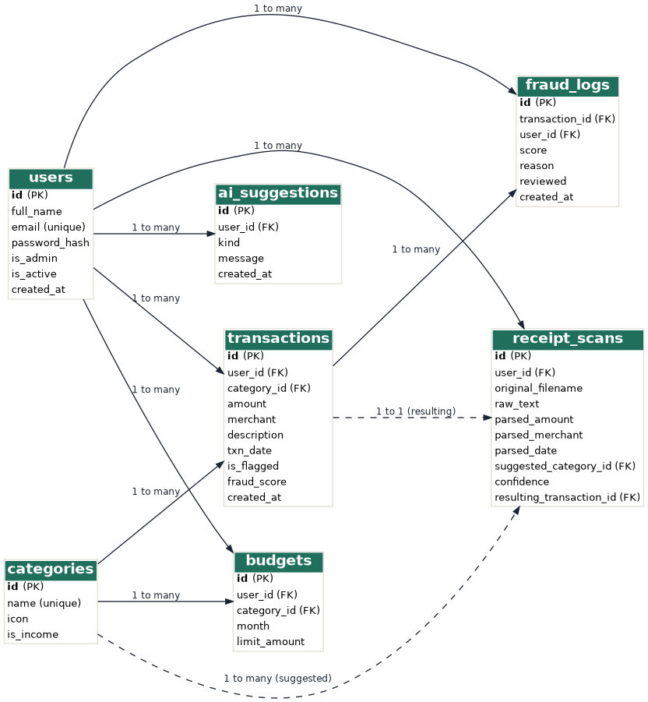
Figure 4.2 — Entity-Relationship diagram.

4.3 Class Design
The backend's ORM models (SQLAlchemy) map directly to the ER diagram above. Domain logic beyond simple persistence — fraud scoring, OCR field extraction and category suggestion — is kept in dedicated service classes/modules rather than in the ORM models themselves, following a clear separation between data structure and behavior.
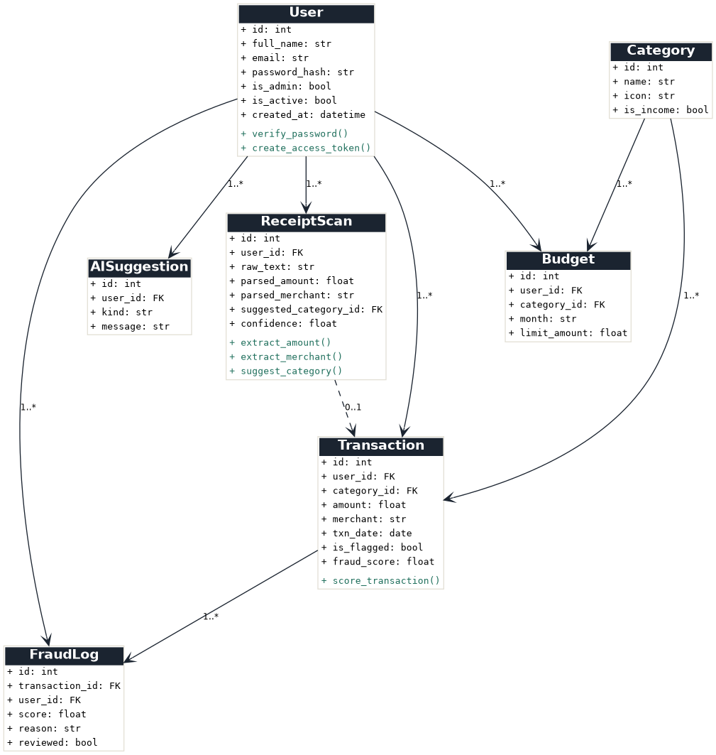
Figure 4.3 — Class diagram of core domain entities.

4.4 Key Sequence Flows

4.4.1 Add Transaction with Real-Time Fraud Check
Every transaction — whether entered manually or confirmed from an OCR scan — passes through the same code path, ensuring fraud scoring is applied uniformly regardless of entry method.
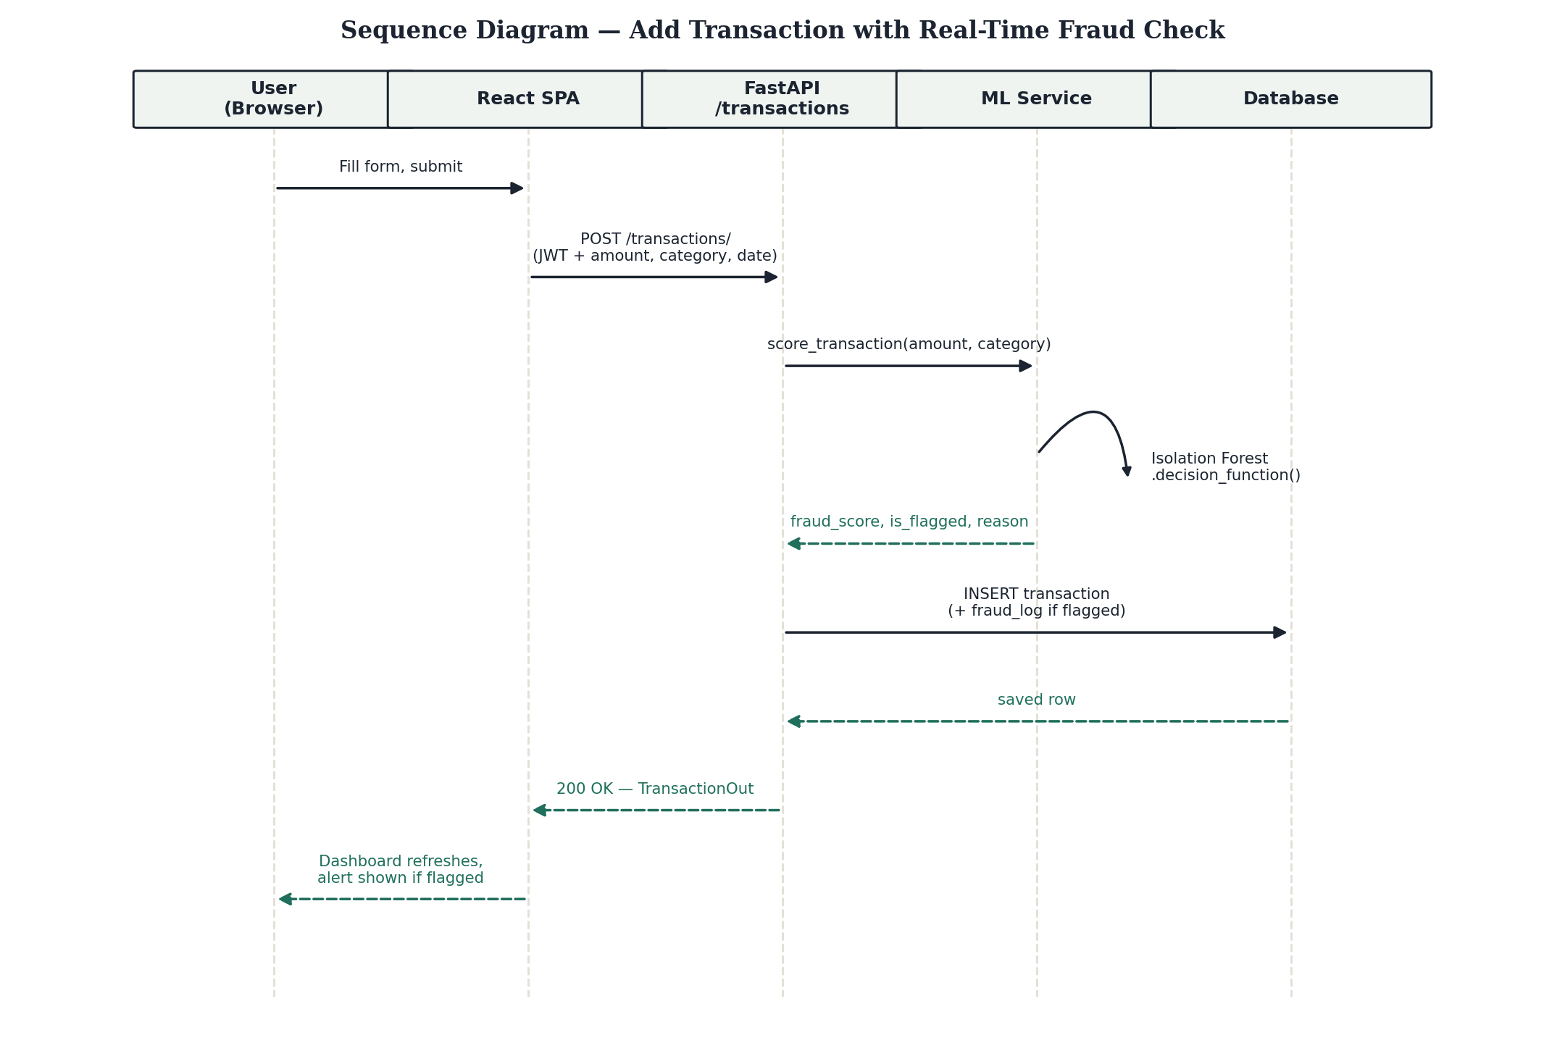
Figure 4.4 — Sequence diagram: transaction creation with synchronous fraud scoring.

4.4.2 OCR Bill Scanning
The OCR flow is deliberately split into a scan step (returns a draft, changes nothing persistent except an audit log entry) and a save step (a normal transaction creation call). This means a failed or low-confidence scan never corrupts the user's transaction history — at worst, the user re-enters the details manually, exactly as they would have without the feature.
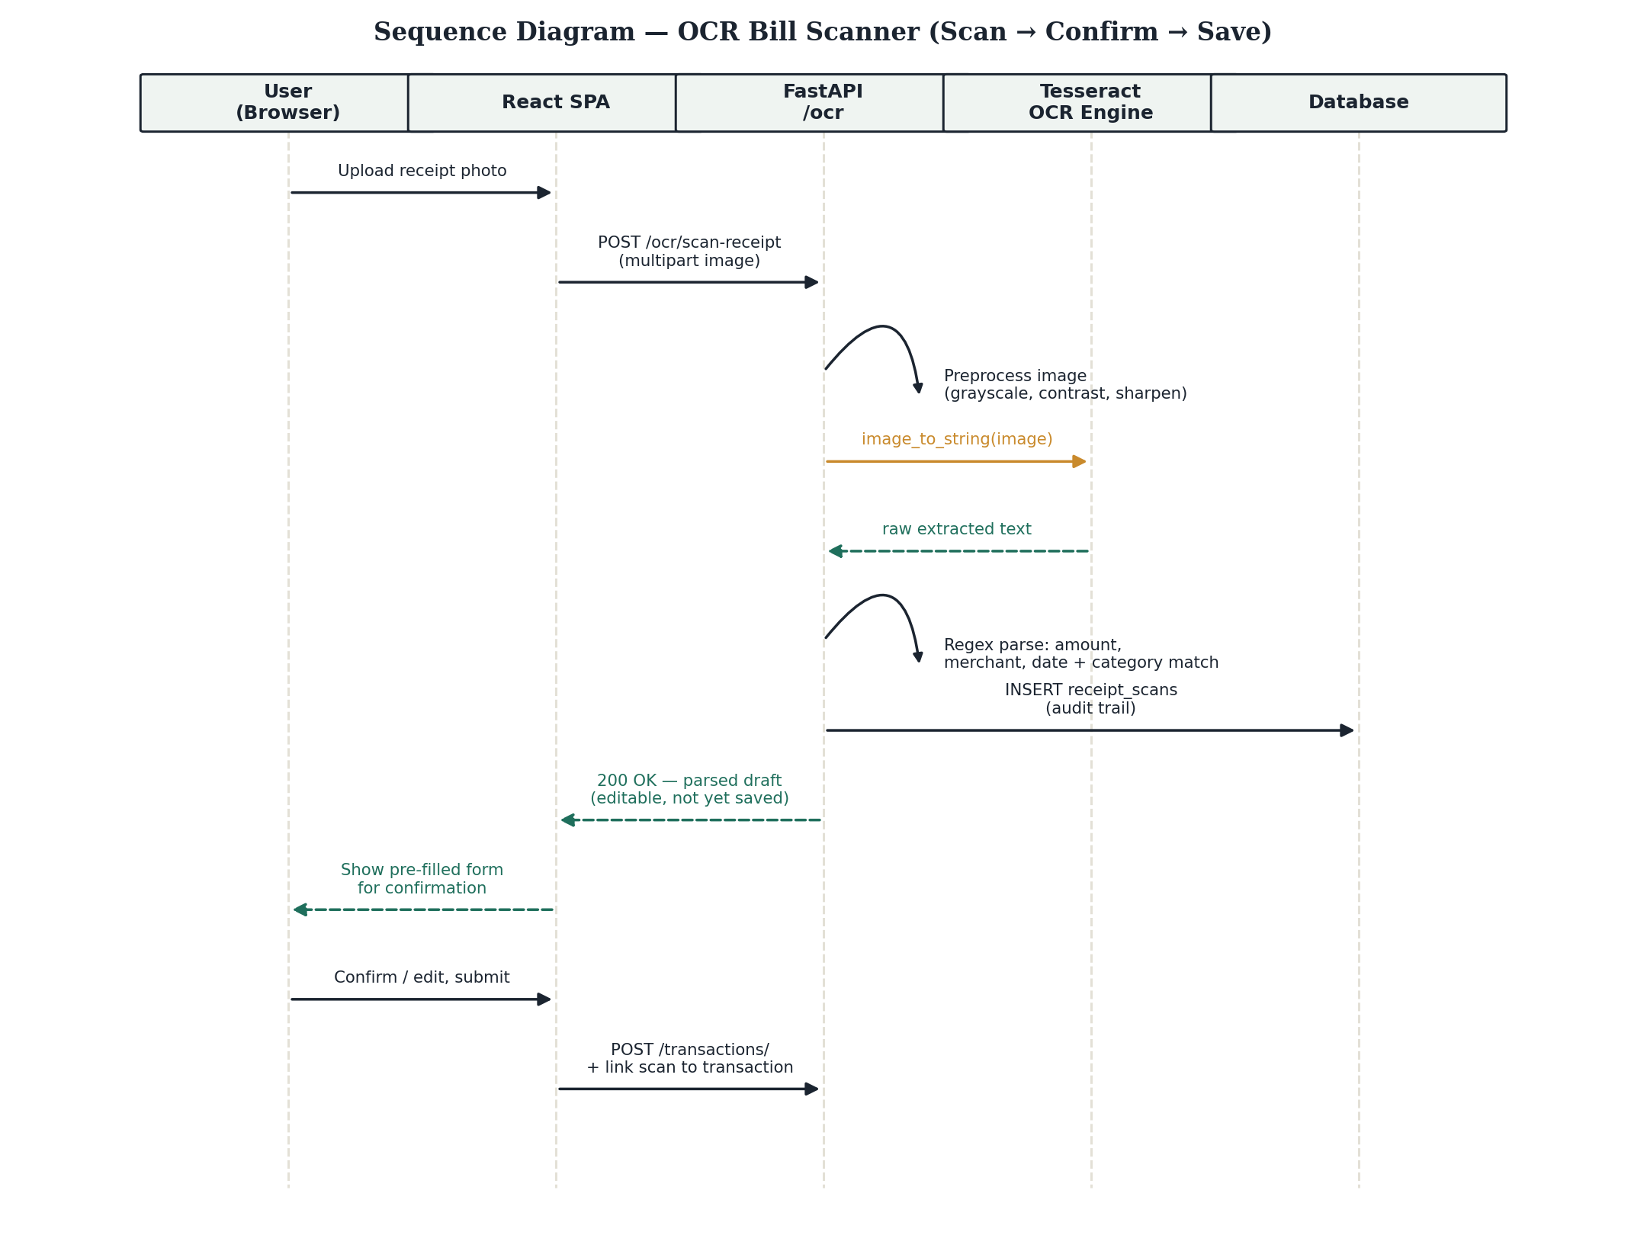
Figure 4.5 — Sequence diagram: OCR scan → confirm → save.

4.5 API Design
The API is organized as one FastAPI router per domain module, all mounted under a single FastAPI app instance in main.py. Every endpoint other than /auth/register and /auth/login requires a valid JWT bearer token; admin endpoints additionally require is_admin = true. A full endpoint reference is provided in docs/API_Documentation.md, and an interactive Swagger UI is auto-generated at the /docs path of any running deployment.

Chapter 5: Machine Learning Components

5.1 Fraud / Anomaly Detection Model
An Isolation Forest (scikit-learn) is trained on transaction feature vectors — amount (log-scaled), category, hour/day-of-week of the transaction, and a rolling measure of the user's typical spend in that category. Isolation Forest was chosen over a supervised classifier because genuine labelled fraud examples are not available for this project; Isolation Forest instead learns what "normal" transactions look like and flags points that are easy to isolate in the feature space as anomalies, which is well suited to a cold-start personal finance app with no historical fraud labels.
Training uses a synthetically generated dataset designed to resemble realistic personal spending: a base distribution of everyday transactions across common categories, with a smaller proportion of injected anomalies (unusually large amounts, off-hours timestamps, category outliers). This is a standard technique for evaluating anomaly detectors when real labelled data is unavailable, and is explicitly noted as a simplification in the codebase (see ml/train_fraud_model.py) with guidance on swapping in a real labelled dataset (e.g. a public Kaggle credit-card-fraud dataset) if pursued further.

5.1.1 Evaluation
On the held-out synthetic test split, the trained model achieves:
Metric | Value
Precision | 0.95
Recall | 0.98
These figures should be read as a sanity check on the training pipeline rather than a claim about real-world fraud detection performance, since the evaluation set is synthetic. This distinction — and how to properly re-evaluate on real, labelled data — is worth stating explicitly to an examiner, as it demonstrates methodological awareness rather than overclaiming results.

5.2 Expense Forecasting Model
A linear regression model (scikit-learn) predicts a user's total spend for the coming month from their trailing 3-month spend history and category mix. It is intentionally simple: with only a handful of months of data available for any individual demo user, a more complex time-series model (e.g. ARIMA, LSTM) would be substantially overfit and would not generalize better in practice on this data volume.
On the synthetic validation split, the model achieves a Mean Absolute Error (MAE) of approximately 34.75 currency units on monthly totals in the low-hundreds range — i.e. forecasts are typically within a small fraction of the actual monthly spend, which is adequate for the directional "you're on track to spend more/less than usual" framing used in the AI Insights panel, though not intended as a precise budgeting instrument.

5.3 OCR Field Extraction
Rather than a second machine-learned model, receipt field extraction uses Tesseract's raw text output plus deterministic regex/heuristic parsing: the largest currency-formatted number on a line containing a total-like keyword ("total", "amount due", etc.) is taken as the amount; the first plausible name-like line near the top of the receipt is taken as the merchant; date patterns are matched against common formats. Category suggestion is a keyword lookup against the merchant text. This is a conscious engineering trade-off: it is far more transparent and debuggable than a trained NER model would be at this data scale, and — combined with mandatory user confirmation — the lower ceiling on raw accuracy does not translate into incorrect data reaching the database.

Chapter 6: Implementation

6.1 Technology Stack
Layer | Technology
Frontend | React 18, Vite, Tailwind CSS, React Router, Axios, Recharts
Backend | Python 3.11, FastAPI, SQLAlchemy ORM, Pydantic
Auth | python-jose (JWT), passlib/bcrypt
ML | scikit-learn (Isolation Forest, Linear Regression), joblib, pandas
OCR | Tesseract OCR engine, pytesseract, Pillow
AI Advice | OpenAI Chat Completions API, with a rule-based fallback engine
Database | SQLite (dev) / PostgreSQL / MySQL (prod), SQLAlchemy
Infra | Docker, Docker Compose, Nginx, Gunicorn + Uvicorn workers
CI/CD | GitHub Actions

6.2 Security Implementation
- Passwords hashed with bcrypt (never stored or logged in plaintext).
- JWT bearer tokens signed with a server-side secret; production boot is blocked if the secret is left at its insecure default.
- Rate limiting (slowapi) applied globally and more tightly on /auth/login (5/minute) to blunt brute-force attempts.
- CORS origins are explicit and environment-driven, never a wildcard in production.
- Structured global exception handling ensures no stack trace or internal detail ever reaches the client; full detail is still logged server-side for debugging.
- Baseline security response headers (X-Content-Type-Options, X-Frame-Options, Referrer-Policy, HSTS in production).

6.3 Notable Implementation Decisions

6.3.1 Human-in-the-loop OCR
The OCR endpoint never writes a transaction directly. It returns a structured, editable draft, and a transaction is only created through the normal transaction-creation endpoint once the user confirms it — the same code path (and therefore the same fraud scoring) as a manually entered transaction. This was a deliberate design choice over a fully automatic "scan and save" flow, prioritizing data correctness over one fewer tap.

6.3.2 Graceful degradation over hard dependencies
Both AI-driven features (fraud scoring, GPT advice) are designed to degrade to a deterministic fallback rather than fail the request when their respective model/API is unavailable. This means the application is always fully demonstrable, regardless of whether an OpenAI key is configured or whether the trained model file happens to be present in a given deployment.

6.3.3 First-user-is-admin bootstrapping
Rather than requiring manual database edits to create an administrator account for a fresh deployment, the very first user to register on an empty database is automatically promoted to admin. This is explicitly a development/demo convenience and is documented as such — a real production rollout would replace this with an explicit invitation or role-assignment flow.

Chapter 7: Testing and Results

7.1 Testing Approach
Given the project's scope and timeline, testing combines automated checks (CI-run syntax/import validation and Docker build verification for both services, see .github/workflows/ci.yml) with structured manual test cases covering the functional requirements in Chapter 3.

7.2 Manual Test Cases (Representative Sample)
ID | Test case | Expected result | Status
TC-01 | Register with an email already in use | HTTP 400, clear error message | Pass
TC-02 | Login with wrong password 6 times in a minute | 6th attempt receives HTTP 429 (rate limited) | Pass
TC-03 | Create a transaction with an unusually large amount | Transaction is flagged, appears in fraud log | Pass
TC-04 | Upload a clear, well-lit receipt photo | Amount/merchant/date parsed with confidence ≥ 0.7 | Pass
TC-05 | Upload a blurry/unreadable receipt | Low-confidence draft returned, not silently saved | Pass
TC-06 | Non-admin user calls /admin/stats | HTTP 403 Forbidden | Pass
TC-07 | Set a budget, then exceed it | Dashboard reflects over-budget status for that category | Pass
TC-08 | Request AI advice with no OPENAI_API_KEY set | Rule-based tips returned, HTTP 200 (no failure) | Pass
TC-09 | Admin disables another user's account | Disabled user's next login attempt is rejected | Pass
TC-10 | Export transactions CSV and open in Excel | Well-formed CSV with correct headers and rows | Pass

7.3 ML Model Evaluation Results
Summarized from Chapter 5 for convenience:
Model | Metric | Result
Fraud detector (Isolation Forest) | Precision | 0.95
Fraud detector (Isolation Forest) | Recall | 0.98
Expense forecaster (Linear Regression) | MAE | ≈34.75 (currency units)

7.4 Known Limitations
- Fraud model evaluation is on synthetic, not real, labelled data — see Section 5.1.1.
- OCR accuracy depends heavily on photo quality; it is not designed to be fully autonomous, by design (Section 6.3.1).
- The forecasting model assumes a reasonably established transaction history; predictions for brand-new accounts with little data are necessarily low-confidence.

Chapter 8: Deployment
The system supports three deployment paths, documented in full in DEPLOYMENT.md at the repository root: (1) local Docker Compose for offline/viva demonstration, (2) split hosting with the backend on Render and the frontend on Vercel for a live public URL, and (3) a single Docker host / VPS for full control. All three use the same Docker images, so behavior is consistent across environments — the only differences are environment variable values (database URL, CORS origins, JWT secret).
The trained ML model files (fraud_isolation_forest.pkl, expense_forecaster.pkl) are committed into the ml/models/ directory and copied into the backend Docker image at build time, so no training step is required at deploy time — the application is functional immediately after the containers start.

Chapter 9: Conclusion and Future Scope

9.1 Conclusion
FinGuard AI demonstrates that meaningful machine learning — not just a labelled "AI-powered" badge — can be integrated into a modest-scope student project when the ML components are chosen to fit the available data (unsupervised anomaly detection instead of supervised fraud classification; a simple regression instead of an over-parameterized time-series model) and are engineered to degrade gracefully rather than become single points of failure. Equally, the project treats production concerns — security headers, rate limiting, environment-driven configuration, containerization — as part of the core deliverable rather than an afterthought, which was a specific goal of this final iteration of the project.

9.2 Future Scope
- Replace the synthetic fraud-training dataset with a real, labelled dataset (e.g. a public credit-card fraud dataset) and re-validate precision/recall.
- Add a mobile app (React Native) reusing the existing REST API unchanged.
- Extend OCR to multi-item receipts, splitting a single bill into several categorized transactions.
- Add bank statement (CSV/PDF) bulk-import as an alternative to per-transaction entry.
- Introduce shared/family budgets with per-member visibility controls.
- Replace the keyword-based OCR category suggestion with a small trained text classifier once sufficient labelled receipt data exists.

References
[1] Liu, F. T., Ting, K. M., & Zhou, Z.-H. (2008). Isolation Forest. Proceedings of the 2008 Eighth IEEE International Conference on Data Mining.
[2] Pedregosa, F. et al. (2011). Scikit-learn: Machine Learning in Python. Journal of Machine Learning Research, 12, 2825-2830.
[3] Smith, R. (2007). An Overview of the Tesseract OCR Engine. Proceedings of the Ninth International Conference on Document Analysis and Recognition.
[4] Ramírez-Gallego, S. et al. (2017). A survey on data preprocessing for data stream mining. Knowledge-Based Systems.
[5] FastAPI official documentation — https://fastapi.tiangolo.com
[6] React official documentation — https://react.dev
[7] OpenAI API documentation — https://platform.openai.com/docs

