# UNIVERSITI MALAYSIA TERENGGANU

**CSM3023 – WEB-BASED APPLICATION DEVELOPMENT (K1)**

**BACHELOR OF COMPUTER SCIENCE (MOBILE COMPUTING) WITH HONOURS**

**LAB 7 – JSP: PERFORM CREATE, UPDATE, RETRIEVE AND DELETE (CRUD)**

**SEMESTER 2 2023/2024**

**Prepared for:**

DR MOHAMAD NOR BIN HASSAN

SIR MOHD ARIZAL SHAMSIL BIN MAT RIFIN

# Prepared by:

SUFYAN AKMAL BIN DRON (S67579)

Task 1 Output

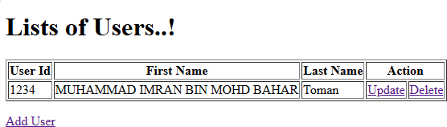

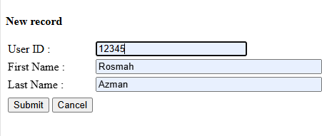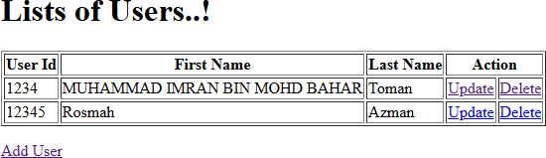

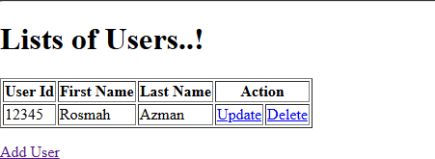

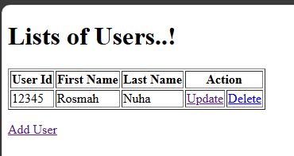

Reflection:

1. Why we use servlet for Java Web Application?

Implementation of MVC as for servlet it act as controller for dynamic web content.

Exercise 1

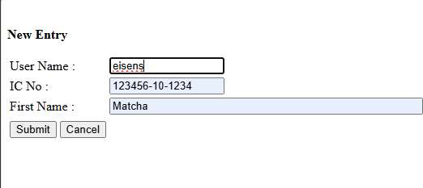

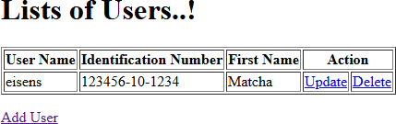

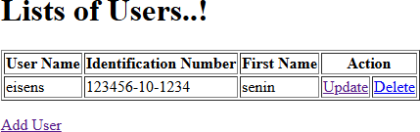

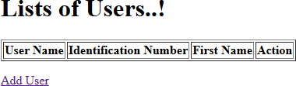

Exercise 2 Output

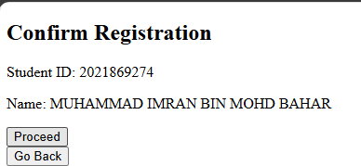

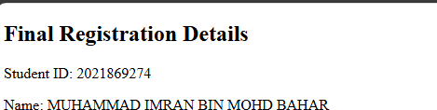

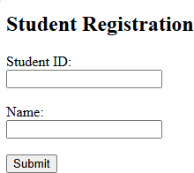

Code

