# UNIVERSITI MALAYSIA TERENGGANU

**CSM3023 – WEB-BASED APPLICATION DEVELOPMENT (K1)**

**BACHELOR OF COMPUTER SCIENCE (MOBILE COMPUTING) WITH HONOURS**

**LAB 8 – AN MVC EXAMPLE WITH SERVLETS AND JSP**

**SEMESTER 2 2023/2024**

**Prepared for:**

DR MOHAMAD NOR BIN HASSAN

SIR MOHD ARIZAL SHAMSIL BIN MAT RIFIN

# Prepared by:

SUFYAN AKMAL BIN DRON (S67579)

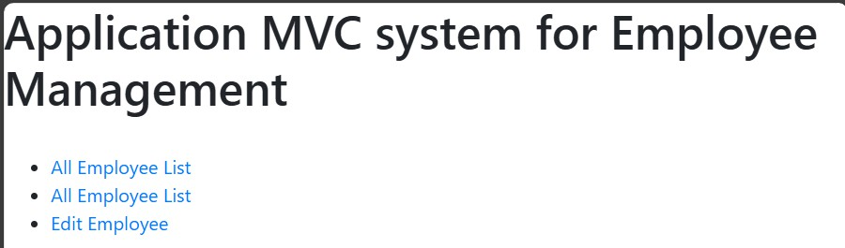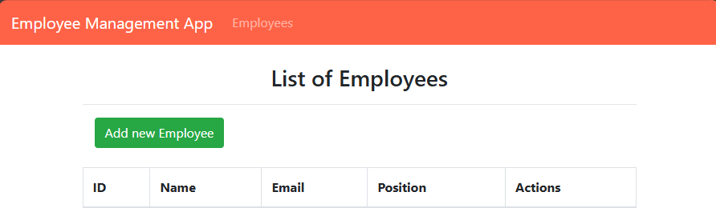

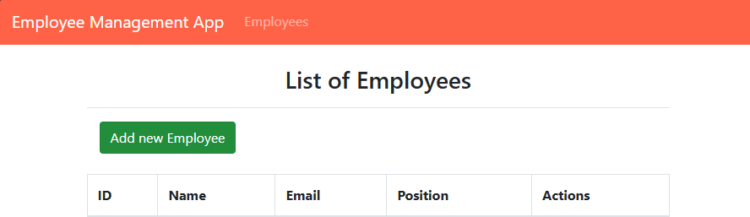

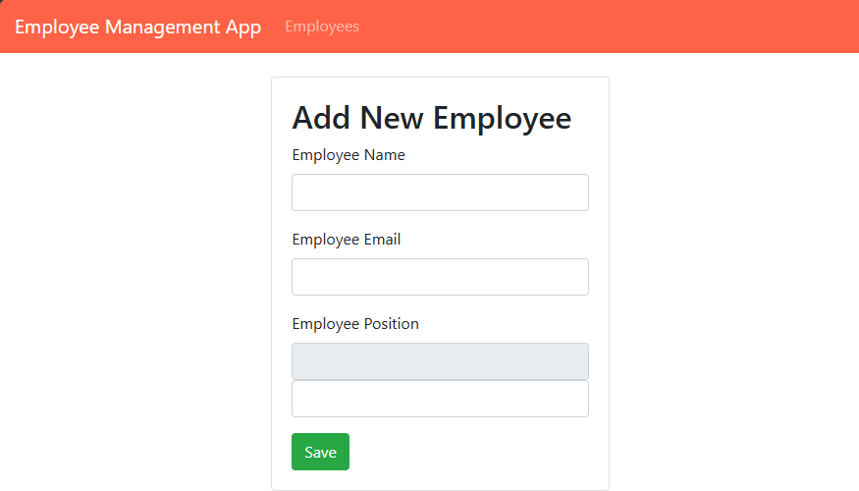

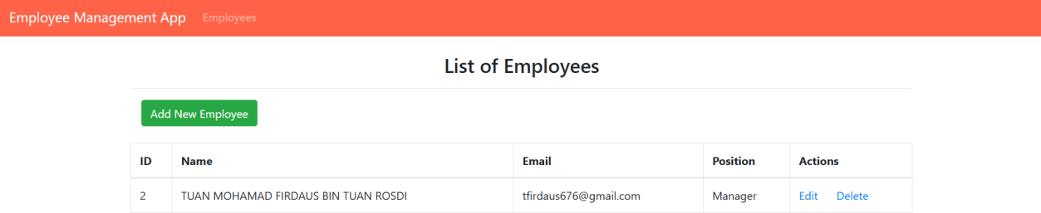

Exercise Exercise

Using this database shema, please create MVC Application [CRUD] for Car Shop, using JSP, Servlet, and MySQL.

CREATE DATABASE if not EXISTS carshop; USE carshop;

CREATE TABLE if not EXISTS CarPricelist( Car_id INT NOT NULL AUTO_INCREMENT, Brand VARCHAR(15), Model VARCHAR(30), Cyclinder INT, Price DOUBLE, PRIMARY KEY (Car_id) );

The application should be able to handle these activities:

1. View all data
2. Add new data
3. Edit/Update current data
4. Delete the specific data

